Ascot Population Profile

This Population Profile provides a high-level summary of the demography and health of people living in Ascot. This has been compared against the Royal Borough of Windsor & Maidenhead (RBWM) and Frimley Integrated Care System (ICS) to provide further context.

Geographies used in these profiles

Ascot: Ascot & Sunninghill and Sunningdale & Cheapside wards

Population and demographic factors

Ascot was estimated to have a population of 18,390 in 2020, which was 12% of the total RBWM population (Office for National Statistics (ONS) 2021).

Figure 1: Population by broad age groups (2020 mid-year estimates)

 | Under 18 | 18 to 39 | 40 to 59 | 60 to 79 | 80 and over
Ascot | 4,346 | 3,237 | 5,774 | 3,791 | 1,242

Source: Office for National Statistics (2021); Ward level population estimates

Figure 2 illustrates the population profile for the Ascot area. Ascot’s population profile is very different to RBWM and the Frimley ICS area, with higher proportions of children aged 10 to 14 and adults aged 45 and over. In contrast, the proportion of younger children (aged 0 to 9) and adults aged 25 to 44 in Ascot are much lower than RBWM and the Frimley ICS area

Figure 2: Population pyramid for Ascot (2020 mid-year estimates)

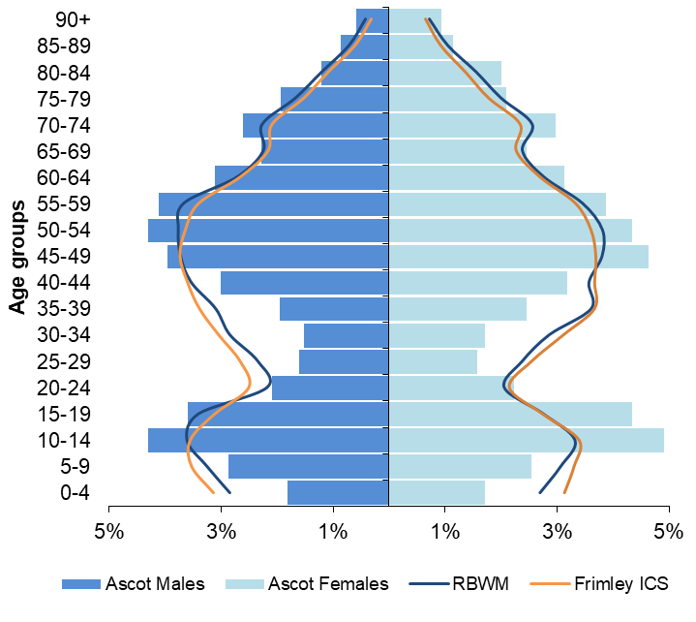
Source: Office for National Statistics (2021); Ward level population estimates

Ethnicity
The latest ethnicity information is based on the 2011 Census, which may not reflect the current population. It is anticipated that the 2021 Census will show increases in the proportion of the population from Black, Asian and Minority Ethnic (BAME) groups and non-White British groups.

In 2011, 10.3% of Ascot’s population were recorded as coming from a BAME group, which was significantly lower than RBWM (13.9%) and the wider Frimley ICS area (18.6%). People from an Asian/Asian British background were the largest non-White population in Ascot and were estimated to make-up 6.1% of the population. In addition, 10.8% of the population were from a non-White British background (ONS 2012).

Wider determinants of health

Deprivation and poverty
RBWM is one of the most affluent areas in England with over 50% of the Borough’s Lower Super Output Areas (LSOAs) in the least deprived 10% of neighbourhoods nationally.

Ascot has a lower deprivation score than the whole of RBWM, with 9 out of the 10 neighbourhoods in the area classified as being in the least deprived 10% of areas nationally (Ministry of Housing, Communities and Local Government 2019).

Figure 3 shows the number and proportion of children and older people living in income deprived households in 2020. Overall, Ascot has lower proportions of these populations compared to RBWM and the wider Frimley ICS footprint, although these is some variation across the Ascot area. One neighbourhood in Ascot & Sunninghill (017D) has 10% of children and 15% of older people living in income deprivation (Ministry of Housing, Communities and Local Government 2019).

Figure 3: Population living in income deprived households (2020 mid-year estimates)
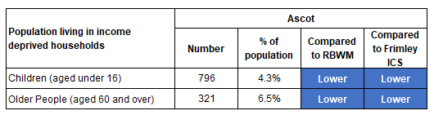
Statistical significance is based on 95% confidence intervals
Source: Deprivation scores – Ministry of Housing Communities and Local Government (2019); English indices of deprivation 2019. Population estimates - ONS (2021); LSOA population estimates

In 2018, approximately 5.4% of households in Ascot were living in fuel poverty, compared to 6.1% in RBWM and 6.4% across Frimley ICS (Department for Business, Energy and Industrial Strategy 2021). It is important to note that these figures will not reflect the impact of the recent rise in energy costs.

Employment and benefits
Recent employment data is not available at a sub-LA level. The previous 2011 Census indicates that 70% of 16 to 74 year olds were economically active in Ascot, compared to 74% across RBWM (ONS 2012).

At Feb-22, approximately 238 people in Ascot were claiming Universal Credit (average over the 12 month period), which was 2.2% of 16 to 64 year olds. This was significantly lower than the proportion of people claiming in RBWM and Frimley (ONS 2022).

Housing
The type of housing provision in Ascot is different to the whole of RBWM, with a significantly higher proportion of detached houses and a lower proportion of semi-detached and terraced houses (Valuations Office Agency 2021). A higher proportion of people also own their home outright compared to the whole of the Borough with fewer socially renting (ONS 2012).

Ascot’s housing provision has a higher proportion of detached houses than the whole of RBWM. A higher proportion of people also own their home outright or through a mortgage compared to the rest of the Borough (ONS 2012).

In 2011, 26% of older people in Ascot were living alone, which was significantly lower than the RBWM figure of 29% (ONS 2012).

Crime
Ascot consistently has lower levels of recorded crime compared to the rest of RBWM. From Mar-21 to Feb-22, there were 983 recorded crimes in Ascot at a rate of 53 per 1,000 population, compared to 69 per 1,000 across the whole of RBWM. The main cause of recorded crime was violence and sexual offences. The rate of vehicle crime is marginally higher in Ascot compared to the rest of RBWM, while all other broad crime types have lower rates compered to RBWM (National Police Service data 2022).

Lifestyle and health behaviours

Childhood obesity
The levels of obesity and overweight in Reception children (aged 4 to 5) are similar across Ascot, RBWM and Frimley ICS. The prevalence of overweight in Year 6 children (aged 10 to 11) is significantly lower in Ascot compared to RBWM and Frimley ICS. RBWM’s rates of childhood obesity have not significantly changed over the last 5 years (Office for Health Improvement & Disparities 2021).

Figure 4: Prevalence of overweight and obesity in childhood (3 year data combined 2017/18 to 2019/20)
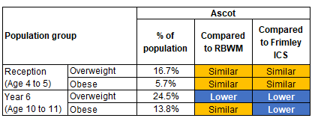
Statistical significance is based on 95% confidence intervals
Source: National Child Measurement Programme data taken from Office for Health Improvement & Disparities Local Health Profile

Health behaviours for young people and adults
The prevalence rates for different health behaviours are not available at a sub-local authority level. However, national and local prevalence rates can be used to model the estimated number of people affected in Ascot. These do not take into account the demographic or deprivation profile of these local geographies and should be used as a guide only.

Figure 5: Estimated number of people aged 11 to 15 who smoke, drink and take drugs (based on national prevalence rates and 2020 mid-year estimates)

 | Estimated number of children aged 11 to 15 who:
 | Current smokers  (at prevalence of 4%) | Drank alcohol in the last week  (at prevalence of 9%) | Took drugs in the last month  (at prevalence of 8%)
Ascot | 71 | 159 | 141

Source: Prevalence from NHS Digital (2019) Smoking, Drinking and Drug Use Among Young People in England - 2018; Population estimates - ONS (2021); LSOA population estimates

Figure 6: Estimated number of adults aged 18 and over who smoke, have excess weight and are physically inactive (based on 2020 mid-year estimates)

 | Estimated number of adults aged 18 who are:
 | Smokers  (at prevalence of 10.3%) | With excess weight (at prevalence of 63.9%) | Physically inactive  (at prevalence of 21.4%)
Ascot | 1,447 | 8,974 | 3,005

Source: Prevalence data taken from Office for Health Improvement & Disparities Public Health Outcomes Framework. Population estimates - ONS (2021); LSOA population estimates

Health outcomes

Life expectancy and premature mortality
RBWM’s life expectancy for males and females is significantly better than the national average. Ascot’s life expectancy at birth (2018-20) was similar to RBWM’s at 82.1 years for males and 85.0 years for females (NHS Digital Primary Care Mortality Dataset).

Ascot has a similar premature mortality rate to the whole of RBWM. From 2018-20, 130 residents of Ascot died aged under 75 at a rate of 242 per 100,000 population (NHS Digital 2022, Primary Care Mortality Dataset). The main cause of premature death was cancer, followed by cardiovascular disease.

Figure 7: Proportion of premature deaths (people aged under 75) by underlying cause (2018-20)
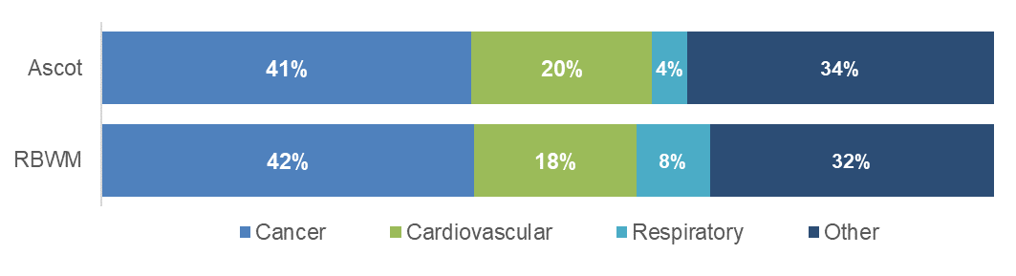
Source: NHS Digital (2022) Primary Care Mortality Dataset

Prevalence of long-term conditions and disease
Figure 8 shows how the recorded prevalence of long-term conditions and diseases in Ascot compare to the whole of RBWM and the Frimley ICS footprint.

Figure 8: Recorded prevalence of long-term conditions and disease (based on monitoring QOF Registers at 11th May 2022)

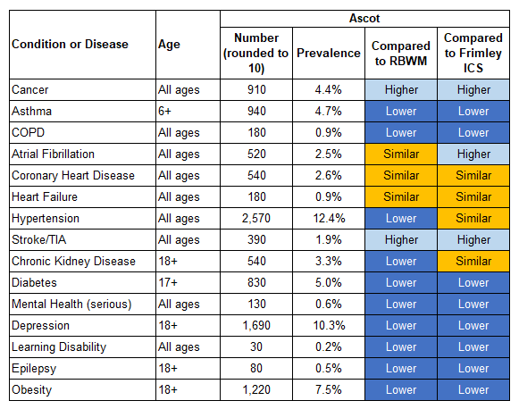
Statistical significance is based on 95% confidence intervals
Source: Frimley System Insights

The population’s health needs can be mapped into broad categories to indicate the level of health resources required to support them. Ascot has 37% of the population identified as ‘Healthy users’ with minimal support required, 19% as low users, 29% as medium users and 8% as high/very high users. These proportions are broadly similar to both RBWM and the Frimley ICS footprint, with lower proportions in the high/very high user category (Frimley System Insights at 11th May 2022).

