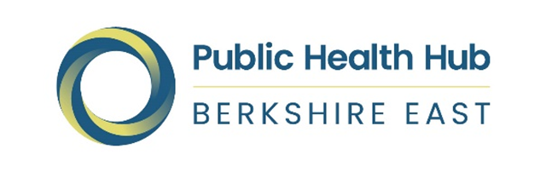

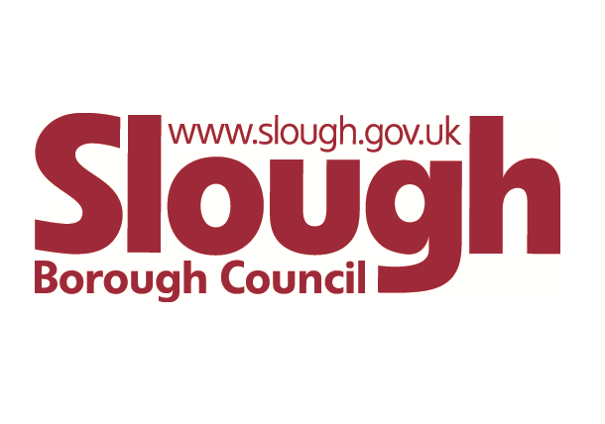
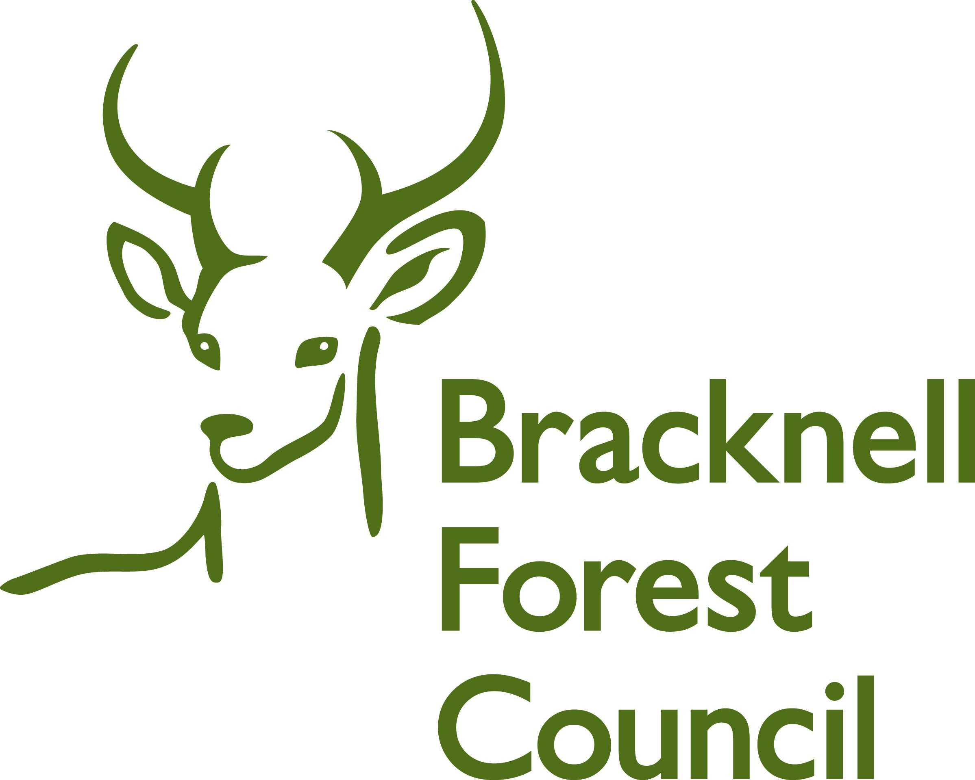

Berkshire East Health Needs Assessment for
Children and Young People aged 0 to 19

January 2022

Written by the Berkshire East 0-19 Health Needs Assessment Working Group

Tanvi Barreto | Senior Public Health Strategist | Bracknell Forest Council
Becky Campbell | Public Health Intelligence Manager | Berkshire East Public Health Hub
Daniel Devitt | Senior Public Health Practitioner | Slough Borough Council
Charlotte Littlemore | Public Health Programme Officer | Royal Borough of Windsor and Maidenhead

Contents

Executive Summary 4
1. Introduction and aims 8
1.1 What are the aims of Berkshire East 0-19s HNA? 9
1.2 How was the Berkshire East 0-19s HNA developed? 9
1.3 The Healthy Child Programme (HCP) 11
1.4 The context for the 0 to 19 HNA – Children and Young People’s Health – Wider determinants of health, health inequalities and health equity 12
1.5 Local context 13
2. What do we know about the children and young people in Berkshire East? 15
2.1 How many children and young people are there? 16
2.2 Who are the children and young people in Berkshire East? 18
2.3 Where do children and young people live in Berkshire East? 20
2.4 What else do we know about where children and young people live? 22
2.5 What do we know about their health and wellbeing? 28
2.6 What do we know about children who are at greater risk of poor outcomes? 44
2.7 So what is this telling us? 56
3. Current service provision in Berkshire East 62
3.1 Health Visiting Service 62
3.2 School Nursing Service and other relevant services for children and young people 72
4. Feedback from professionals, current service providers, families and service users 84
Health Visiting service 84
School Nursing Service 85
5. Best practice and evidence 87
5.1 What does National Guidance tell us? 87
5.2 What does the legislation outline? 90
5.3 What does Best Practice for Health Visiting and School Nursing tell us? 91
5.4 Examples of best practice models 96
6. Conclusions and recommendations for action 99

Executive Summary

Welcome to the Berkshire East 0 to 19 Health Needs Assessment (HNA)

This HNA seeks to outline the main issues, trends, challenges and opportunities for the health and wellbeing of Children and Young People in the three local authorities that comprise Berkshire East - Bracknell Forest Council, Slough Borough Council and the Royal Borough of Windsor and Maidenhead. This area is covered by Frimley Clinical Commissioning Group (CCG) which will, subject to legislative processes, become the Frimley Integrated Care System (ICS).

The three local authorities and CCG are supported by the Berkshire East Public Health Hub, which includes a jointly appointed Director of Public Health and specialist Team. The Hub Team includes support for commissioning, health protection, public health intelligence, communications and marketing. The Hub, three local authorities and CCG work collaboratively at a Berkshire East level where appropriate. This HNA:

- Is a collaborative product produced jointly by the Public Health Teams across Berkshire East
- Seeks to outline some of the key data and issues at both a Berkshire East and a local authority level
- Is focussed on the 0 to 19 service offer for children and young people and seeks to give an overview of public health priority agendas and current performance across each local area
- Is utilised to inform the commissioning and service specifications of the school nurse and health visiting service contracts across East Berkshire

Two key areas for development - explicitly referenced in both system and local recommendations - are the twin challenges of delivering the new Healthy Child Programme (HCP) whilst ensuring inclusion of children and young people with Special Educational Needs and Disabilities (SEND), neurodiversity and vulnerabilities are at the heart of both local and system level work. With this in mind, the HCP 0 to 19 offer is expanded to a 0 to 25 year provision where required to ensure inclusion and accessibility.

There are a number of key features of the local children and young people population (see section 2) and contextual issues at local authority level (see Sections 3 to 5) which address specific issues. These include key challenges, such as the recent Section 114 proceedings and OFSTED SEND inspection in Slough Borough Council, as well as the differences in population, demographics and needs of children and young people, their parents and communities in each borough.

Other system level issues also impact on the delivery of services for children and young people, such as the ongoing Covid-19 pandemic and the challenge of implementing the revised HCP, Family Hubs and Start Well Agendas in a complex resource environment that has significant workforce challenges.

The pandemic has had a significant disruption on service delivery and this has also impacted on the availability of data for inclusion in this HNA. The HNA Production Team are hopeful that this HNA will be refreshed in a timely and ongoing manner as more data becomes available. Following on from the HNA the following recommendations for future action are made:

Berkshire East recommendations
For 0 to 19 Service across Berkshire East

1 | Service specifications need to recognise how they can incorporate the ‘Universal in Reach – Personalised in response’ health visiting and school nursing model, (OHID, 2021) within existing and future 0-19s services across Berkshire East.
2 | Improve systems for collecting data on vulnerable groups within the service remit i.e., mothers with perinatal mental health issues, children in care and children with adverse childhood experiences in order to identify how the services can be improved and gaps be filled.
3 | To explore a Berkshire East wide digital platform based on best practice models to assist delivery of the 0-19 offer. This could be delivered through existing channels or a new one if warranted.
4 | Ensure that all areas are able to capture and articulate the local responses to specific needs of parent and carers and CYP aged 0 to 25 with additional needs including Special Educational Needs and disabilities, Neurodiverse CYP, LGBTQ CYP, CYP from minority communities and other vulnerable groups at risk of health inequalities and health equity issues.

For Public Health Teams across Berkshire East

1 | Consider how the Public Health teams across Berkshire East can partner and collaborate more closely with education settings including schools, colleges and local education teams and leadership in the council and other key partners to develop and adopt a Healthy Schools programme across the region
2 | Review and consider how Public Health can support school nurses to deliver the National Child Measurement Programme and consider how the information and results are communicated to the children and families, consider how families and children can receive support following on from the delivery of the results

Overall recommendations

1 | Public Health teams and partners will develop an innovative workforce strategy to inform recruitment and retention of sufficient health visitors and school nurses across East Berkshire.
2 | Review how 0-19 teams could work more collaboratively with other health and social care colleagues and linked agendas such as Safeguarding, Family Hubs, CYP Mental Health and Wellbeing and SEND to strengthen existing relationships in support of the 0 to 19 (0 to 25 with SEND) Healthy Child Programme and earlier and more effective identification of needs across local and neighbouring systems.
3 | Explore opportunities and risks associated with commissioning children and young people services across Berkshire East with stakeholders.

Bracknell Forest’s recommendations
1 | More training for the health visiting team in topics like autism, perinatal mental health, breastfeeding, how to deal with behavioural issues
2 | For Public Health to work closely with other stakeholders across the council, CCG and voluntary sector to identify and target CYP with additional needs, those from minority communities and other vulnerable groups, to improve their access to support and services and reduce health inequalities.
3 | For Public Health to work with early years, health visitors and voluntary services to develop peer support groups and activities to support with breastfeeding and reduce feelings of loneliness and anxiety in new parents.
4 | For the School Nursing team to take a whole school’s approach to promoting and supporting physical and mental health and wellbeing in schools working closely with children and young people, parents, carers and school staff
5 | For the Public Health team to review outcomes from the current school nurse drop ins and review this option for future service specifications.

Slough’s recommendations
1 | Ensure that the recent Section 114 and SEND Written Statement of Action requirement are drivers of innovation and collaboration in the local system to meet the needs of parents, carers and CYP in an earlier and more effective manner
2 | Ensure the delivery of a comprehensive new service specification for the upcoming re-procurement of the Slough O to 19 Healthy Child Programme to go live by 1st October 2022.
3 | Ensure that service user voice and co-production and participation elements are visible and producing tangible inputs to improve the quality of service offers across the life course form the perinatal/ early years, school aged and transitioning age ranges with specific additional input in support of CYP with complexity and potential vulnerabilities as set out in the 0 to 19 (recommendation 5 above).
4 | Explore the potential linkages across borough boundaries with neighbouring systems and pathways to ensure local and regional service reach and responsiveness.
5 | Develop a framework of support for commissioning for outcomes and robust, sustainable quality improvement inputs to internal and wider system to improve attainment of key national regional and local outcomes for the 0 to 19 HCP service.

Royal Borough of Windsor and Maidenhead’s recommendations
1 | To acknowledge and celebrate the areas where we are performing well.
2 | To improve the quality of local breast-feeding data to enable us to monitor our rates, compare them with other boroughs and promote further uptake of breast-feeding.
3 | To better understand why we are not performing as well as Berkshire and/or England averages for some outcomes; in particular: childhood development (2-2 ½ years); risk taking behaviours (smoking, alcohol and drugs); 16-17 year olds not in employment, education and training.
4 | To better understand why children and young people in some wards / communities in the borough have worse outcomes than others and to work collaboratively to reduce these differences; in particular differences in school readiness (between those who are and aren’t eligible for free school meals) and differences between wards in the proportion of children who are overweight/obese.
5 | To better understand the health needs of children in care and care leavers in the borough.
6 | To explore how we implement the new best practice guidance into the delivery of health visiting and school nursing.
7 | To get feedback from a broad range of professionals and families about their views on the health visiting and school nursing services available to local residents.
8 | Explore how we can effectively engage with children and young people across the borough to understand their views on their own health and wellbeing and how to improve outcomes.
9 | To ensure that any work to better understand the long-term impact of COVID-19 acknowledges children and young people.

Introduction and aims

The foundations of a healthy and fulfilled adult life are established in childhood and adolescence. The Marmot Review (2010) clearly emphasises that healthy development during childhood is essential in providing the building blocks for lifelong health, educational achievement, social and emotional development, strong communities and economic productivity. The 1,001 days from pregnancy to the age of two are critical for setting the foundations for an individual’s cognitive, emotional and physical development (HM Government, 2021). These fundamental early years from birth to 5 years of age establish the standards for the learning development and care of the child while children and young people progress through numerous transition stages as part of the journey into adulthood. During this transition young people may experience significant physical, psychological and behavioural changes, including but not limited to:
- physical development - for example, growth spurt and sexual maturation
- cognitive development - for example, evidence suggests brain development continues up to age 25 (Association for Young People’s Health 2017)
- emotional development - for example, identity, self-esteem, and resilience
- social development - for example, peer influences, sexual identity
- behavioural development - for example, risk taking and the beginning of lifelong behaviours (Public Health England 2019)

And so, it is particularly important that the health and wellbeing of children and young people aged 0-19 is prioritised during these transitions into adulthood.
In order to ensure that the health and wellbeing of children and young people is monitored from the outset, the Healthy Child Programme was introduced to provide a universal service for both children and their families. The evidence-based, early intervention and prevention public health programme is founded on best practice to ensure that ‘every child has the best start in life’ (Public Health England 2018). Even though this universal service was implemented by the Department of Health in 2009, it has since been modernised and expanded to support additional public health priorities, including:
      - ensure high quality services for children, young people and families from actions to improve women’s health before, during and after pregnancy (Maternity Transformation Programme 2020)
      - give every child the best start in life (childhood obesity, speech, language and communication, immunisations)
      - support school readiness and improve resilience for school-aged children
      - support young people transitioning to adult services

The 0 to 5-year-old element of the Healthy Child Programme is led by health visiting services, while the 5 to 19-year-old element is led by school nursing service. These services work together in collaboration with education and other providers where needed. The universal reach of the programme provides an opportunity from early on to identify families that may require additional support and children who are at risk of associated poor outcomes. The responsibility for commissioning the Healthy Child Programme was transferred to local authorities in October 2016, including the delivery of local Health Visiting and School Nursing Services. This joined-up the commissioning of services for all children and young people aged 0 to 19, as well as young people aged up to 25 with Special Educational Needs and Disabilities (SEND).

The three local authorities in Berkshire East (Bracknell Forest, Slough and the Royal Borough of Windsor & Maidenhead) all commission different providers to the deliver the Healthy Child Programme.

What is Berkshire East?

The Berkshire East area is made up of three unitary local authorities, - Bracknell Forest, Slough and the Royal Borough of Windsor & Maidenhead. This area is covered by Frimley Clinical Commissioning Group (CCG).

The three local authorities and CCG are supported by the Berkshire East Public Health Hub, which includes a jointly appointed Director of Public Health and specialist Team. The Hub Team includes support for commissioning, health protection, public health intelligence, communications and marketing. The Hub, three local authorities and CCG work collaboratively at a Berkshire East level where appropriate.

What are the aims of Berkshire East 0-19s HNA?

The aim of this Health Needs Assessment (HNA) is to:

- understand the level of current and future need of children and young people across the whole of Berkshire East, as well as within the three local authority areas
- summarise the existing service provision across the three local authorities
- incorporate feedback from local families and professionals, where available
- assess how we are currently doing against best practice and identify opportunities for improvement
- inform the commissioning and service specifications of the school nurse and health visiting service contracts across Berkshire East

The population that will be focused on includes children and young people aged from 0 to 19. The HNA aims to identify and quantify vulnerable groups that may have different experiences to understand the inequalities that are present for children and young people locally. The HNA will not include detailed information about mental health prevalence or services for children and young people’s mental health needs, as this is not commissioned through the 0 to 19 Service.

How was the Berkshire East 0-19s HNA developed?
HNA Approaches
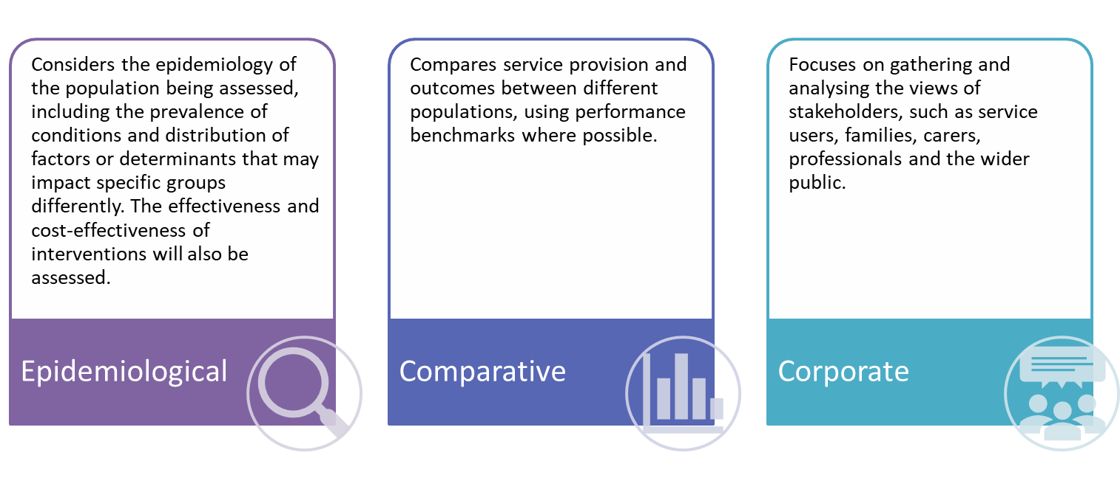
A Berkshire East 0 to 19s Working Group was established to deliver the HNA. This was co-ordinated by Bracknell Forest Council’s Public Health Team and included representatives from the local Public Health Teams in Slough Borough Council and the Royal Borough of Windsor & Maidenhead, the Berkshire East Hub and Frimley CCG.

The Working Group agreed a methodology to complete the HNA, which included elements of epidemiological, comparative and corporate/ stakeholder approaches. This methodology ensured that a comprehensive assessment of the health and wellbeing of 0 to 19s could be completed. The majority of the HNA was completed for the whole of Berkshire East, with local authorities writing their own sections on aspects that were specifically relevant to their area (service provision, consultation and engagement, recommendations).
Source: Stevens and Rafferty (1994)

Epidemiological approaches used

A variety of data sources were utilised to understand the local picture of the 0-19 population in Berkshire East, including population demographics, prevalence and modelled estimate of conditions and wider determinants of health. Information has been analysed and shown at a Berkshire East level with a summary of individual local authority information at the end of each section. Any significant differences within or between the three local authority areas are also highlighted to identify local inequalities.

National and regional comparators have been included where possible, as these are relevant benchmarks for all local authority areas in Berkshire East. The Berkshire East Public Health Teams usually compare local authority data with other local authorities in the same deprivation decile group. This gives a fairer comparison for many indicators, as levels of deprivation are often one of the key inequalities that impact on health and wellbeing measures. This methodology was intentionally not used for this HNA, as the focus was on the needs of children and young people within Berkshire East as a whole to inform future joint commissioning. Comparisons to other benchmarking groups, such as deprivation decile, can be accessed through the Office for Health Improvement and Disparities Child Health Profiles.
The Working Group agreed that the HNA would not include detailed analysis on the prevalence and impact of both diagnosed mental health conditions and indicators of emotional wellbeing and poor mental health, due to the existing work already being conducted at an ICS level and felt that this was outside of the HNA scope. The epidemiological section is included in Section 2 – Sociodemographic data.

Comparative approaches used

Performance and activity information for the current Health Visiting and School Nursing provider were included in the HNA and national benchmarks were used where possible. Other indicators of health and wellbeing were incorporated to show the difference between and within local authority areas. The Public Health Outcomes Framework and other Fingertips Profiles provided much of this information.

Evidence of intervention of what works in both Health Visiting and School nursing is also summarised in Section 4: Best Practice and evidence.

Corporate/stakeholder approaches used

Bracknell Forest completed a stakeholder consultation event to ensure that the HNA captured and reflected the experiences of professionals in the local area. This workshop included representatives from NHS Frimley Clinical Commissioning Group, Berkshire Active, Berkshire Healthcare Foundation Trust, Education, Early Years and Children’s Social Care teams. Other key local authority departments, such as Housing, Planning and Business Intelligence were also asked for their input on specific aspects of the HNA. Bracknell Forest also developed a number of online surveys to gain insight, views and opinions from parents/carers, young people, and stakeholders of the service. Feedback from these consultations is included in Section 4.

Slough and the Royal Borough of Windsor & Maidenhead did not complete specific consultation or engagement process for this HNA.

The Healthy Child Programme (HCP)

A major contribution to addressing the health needs identified across this HNA is the Healthy Child Programme. From 2009 the Healthy Child Programme (HCP) has been a universal programme available to all children aimed at ensuring that every child is given the best start in life needed to lay the foundations of a healthy life by bringing together health, education and other main partners to deliver an effective programme for prevention and support.

Responsibilities for commissioning for school nursing and health visiting transferred from NHS England to local authorities in 2013 and 2015 respectively. Since that time Public Health in each of the Berkshire East local Authorities have been the lead commissioner for these Public Health nursing services for the local area.

From 2019, the HCP has been substantially updated to reflect the new demand and opportunities presented by the child health agenda in the 21st Century. The modernised model is universal in reach and personalised in response. The modernised HCP seeks to enable effective, focused service delivery where additional needs are identified along with use of the latest evidence on effective practice and helping to bring councils, the NHS and partners together to achieve priority outcomes for children and families. Delivering this vision is reliant upon a wide range of partners working together and embracing change to:

- ensure high quality services for children, young people and families from actions to improve women’s health before, during and after pregnancy
- give every child the best start in life
- support school readiness and improve resilience for school-aged children.
- support young people transitioning to adult services

All Berkshire East authorities will need to refresh and re procure their HCP 0 to 19 service offer by March 2024, in order to accurately reflect the updates included within the new modernised HCP. The current service contracts within Berkshire East with three separate providers expire as follows:

- Slough Borough Council (SBC) – expires 30th Sept 2022
- Bracknell Forest Council (BFC) – expires 31st March 2023
- The Royal Borough of Windsor & Maidenhead (RBWM) expires 31st March 2024

This timescale presents a series of challenges and opportunities. Primarily, it prompts the use of this HNA to inform local commissioning of the modernised HCP programme.

Alongside the evolution of the ICS the development of supportive offers across maternity, education employment and training systems present a range of opportunities to explore integration and alignment of statutory and voluntary and community service offers across the broad range of spaces and places where professionals and the public can work together to support child health. Each area has a very different starting point and many key local system features or population health needs that must be addressed if a collaborative approach is to be helpful in delivering on the 0 to 19 agenda. Works are now needed to explore the possibilities this presents and the scope of any alignment or collaboration that might support local or sub regional HCP commissioning.

The 0 to 19 HNA can help provide commissioning insight and focus to explore areas for collaboration, new best practice models of delivery or possible alignment. Through this is can support efforts to maximise the positive impact of available capacity, expertise and resources in line with the Health Needs identified across this document across each individual local authority area and potentially Berkshire East as a whole.

The context for the 0 to 19 HNA – Children and Young People’s Health – Wider determinants of health, health inequalities and health equity

This Health Needs Assessment and the wider Joint Strategic Needs Assessment (JSNA) provide a wide range of health indicators and outcomes data, which highlights the level of need and the health inequalities present within each area and across Berkshire East as a whole. It is important to acknowledge that these “health metrics” and the data that support them can only ever show a partial picture of the health context and needs for the groups assessed.

Whilst individual behaviours, genetics and access to medical care are crucial in determining good or bad health outcomes they are only part of the picture that we need to understand. Good or bad health outcomes are not simply the result of health services. A substantial element in health outcomes is determined by the social, economic and environmental factors that shape people’s lives. These factors are collectively described as the wider determinants of health.

The Wider Determinants of Health were explored by Dahlgren and Whitehead (1991) and have had an enduring impact on the understanding of how social level, relative economic status, the environment, and accessibility have a direct and lasting impact on the health of all populations.

There are a vast range of factors that impact on individual or groups health outcomes. Many of these are not directly related to the delivery of Health or Care services themselves but instead arise from the broad social and economic circumstances that we live in and the way in which these factors interact with individual’s physical or mental health and wellbeing in positive or negative ways.

The Wider Determinants include influences from the built and natural environment, education, income, work and the labour market, crime and social capital. These influences exert significant supportive or challenging influences on all individuals across the life course from birth, through childhood and on into adulthood and are known as the ‘social determinants of health’. There is in addition to this a social gradient across the determinants that contribute to a consistent pattern of inequality where poorer individuals experience worse health outcomes than their more affluent neighbours.

Systematic differences in these social determinants can collectively be called social inequalities, and these inequalities can determine the extent to which different individuals have the physical, psychological, social and personal resilience or resources they need to meet their needs, identify and achieve goals, and deal with changes to their positive or negative circumstances. Recently in light of the Covid 19 pandemics marked impact on Black people and other minorities the Dahlgren and Whitehead model has been updated to include the role of racism as a “driving force “, on a structural level, for inequality (Dahlgren and Whitehead 2021).

The link between social inequalities and differences in health outcomes is strong and enduring. Addressing the wider determinants of health will help improve health equity – the fair and just opportunity available to all to be healthy - as well as overall health.

Local context

It is important to consider the current climate and operational structure that the 0-19s services have been operating in when interpreting the findings and recommendations within the Health Needs Assessment.

Current Climate
Moreover, it is vital to highlight the impact that the ongoing COVID pandemic has had on the operation of the 0-19s services in the past two years. The services over this period have been significantly impacted and the way in which they have been delivered has had to be adapted. Both the health visiting, and school nursing services have had to move into a hybrid model, offering both in-person visits and online appointments, making data collection highly challenging. And so, when reviewing the data metrics included the service provision section for each local authority, the data must be intercepted with the understanding that COVID may or may not have impacted it.

Operational Structure
The Berkshire East area is made up of three unitary local authorities – Bracknell Forest, Slough and RBWM. This area is covered by the Frimley Clinical Commissioning Group (CCG).

The three local authorities and CCG are supported by the Berkshire East Public Health Hub, which includes a jointly appointed Director of Public Health and specialist team. The Hub team includes support for commissioning, health protection, public health intelligence, communications, and marketing. The Hub, three local authorities and CCG work collaboratively at a Berkshire East Level where appropriate.

Berkshire also share a joint Child Death Overview Panel (CDOP) which looks at the causes of death and services provided for all Berkshire children that die. The CDOP panel works across the six local authorities in the county, Bracknell Forest Council, Reading Borough Council, Slough Borough Council, West Berkshire Council, the Royal Borough of Windsor & Maidenhead and Wokingham Borough Council. CDOP members come from services that surround children, keeping them safe and well and caring for them and their families when they need it.

Bracknell Forest
Berkshire Healthcare Foundation Trust (BHFT) are commissioned to provide the Health Visiting and School Nursing Services for Bracknell Forest. This commissioning arrangement has been in place since October 2015 for Health Visiting. The current contract comes to and end at the end of March 2023. Public Health will be using findings from this Health Needs Assessment to support the commissioning of the new model of delivery post April 2023. Bracknell Forest’s new Joint Health and Wellbeing Strategy 2022-2026 is currently being finalised. The framework for the strategy has six principles, six key priorities that are interlinked, and four cross-cutting themes that are embedded within each of the priority areas to reflect a health in all policies approach. These are owned by partners and their members to take joint responsibility as sponsors for each of the priority areas. The first priority in the strategy is giving all children the best start in life and support emotional and physical health from birth to adulthood. The importance of this priority is recognised in evidence-based guidance and a number of national policies.

RBWM
Achieving for Children (AfC) are commissioned to provide the Health Visiting and School Nursing Services for RBWM. This commissioning arrangement has been in place since October 2015 for Health Visiting.

Throughout RBWM there are numeorus strategies and policies in place to support the health and wellbeing of children and young people locally.
RBWM’s new Joint Health and Wellbeing Strategy 2021-2025 is driven by four core principles: community-centric, strengths based, effective use of resources, and outcomes focused. The strategy has 4 priority areas: (1) coordinating integrated services around those residents who need it most (2) championing mental wellbeing and reducing social isolation; (3) targeting prevention and early intervention to improve wellbeing and (4) investing in the borough as a place to live in order to reduce inequalities. All four priorities will contribute to improving health and wellbeing in the borough. Each priority has dedicated co-leads (one health and one local authority) who are tasked with developing more detailed action plans for each priority, in collaboration with colleagues across all organisations. The Strategy has been developed in line with the Frimley Health and Care Integrated Care System (ICS) Five Year Strategy ambitions.

RBWM’S newly developed Corporate Plan 2021 -2026 has been designed to focus on driving change in order to enable thriving communities where families and individuals are empowered to achieve their ambitions and fulfil their potential, by promoting health and wellbeing and focusing on reducing inequalities across all areas.

Slough Borough Council
Solutions 4 Health are commissioned to provide the 0 to 19 Service incorporating Health Visiting and School Nursing Services in an integrated offer. The existing contract ends on the 30th September 2022 and subject to approval, a procurement process is being undertaken from early 2022 to ensure that there is continuity of provision.

Slough benefits from two Lead Members (Children and Young People and Adults Communities and Public Health) involved in the 0 to 19 agenda and provision for CYP with additional needs including Special Education Needs and Disabilities (SEND).

Slough Borough Councils’ Health and Wellbeing Strategy 2021 to 2026 outlines a number of key actions addressing CYP health and wellbeing and specific works focussed on Immunisation, Obesity and Oral Health alongside an “attainment gap” in the Early Years and Foundation Stage and reflection of the ongoing Covid 19 pandemic and its impact on CYP, Parents, Carers and the communities in which they live. The Slough Children and Young People’s Partnership Board will progress work against these aims alongside other key strategic agendas for CYP including Maternal and Baby Health, Mental Health and Wellbeing ( including linked works with regional Self Harm and Suicide Prevention across the life course), SEND Safeguarding and Child Death Review with both local partnership boards and regional work streams.

Slough faces significant challenges arising from the Section 144 proceedings and the recent joint SEND inspection by Ofsted and the CQC which has required a written statement of action.

These key agendas are driving a refresh of the Slough CYP facing offer and work streams associated with all areas of provision and are a key starting point for the escalation of local system quality improvement works.

What do we know about the children and young people in Berkshire East?

This section provides a high-level summary of what we know about the children and young people in Berkshire East. This gives an insight into the demographics of children living in the local area and highlights their health needs and inequalities.

Current population profile and projections

Demographic profile of 0-19s in Berkshire East

Detailed analysis of geographical areas within Berkshire East that have higher proportions of children and young people

Wider determinants of health, including deprivation and poverty, housing, education and employment

Summary of key health and wellbeing information for 0-19s. This section also highlights areas of increased need that may require further investigation

More detailed information about specific groups within Berkshire East

Additional information for Bracknell Forest, Slough and Windsor and Maidenhead is included at the end of each section. These local authority summaries aim to highlight any variations across the Berkshire East area.

How many children and young people are there?

The population of Berkshire East was estimated to be 426,035 in mid-2020. Children and young people aged 0 to 19 made up 27.2% of this population, compared to 23.6% in England.

Berkshire East’s population profile shows that the local area had higher proportions of children aged 5 to 14 compared to England.
Figure 1: Population of Berkshire East compared with England (mid-2020)

Age group | Berkshire East |  | England
 | Number | % of total population | % of total population
0 to 4 | 28,089 | 6.6% | 5.7%
5 to 9 | 30,763 | 7.2% | 6.3%
10 to 14 | 31,318 | 7.4% | 6.1%
15 to 19 | 25,582 | 6.0% | 5.5%
Total (Under 20s) | 115,752 | 27.2% | 23.6%
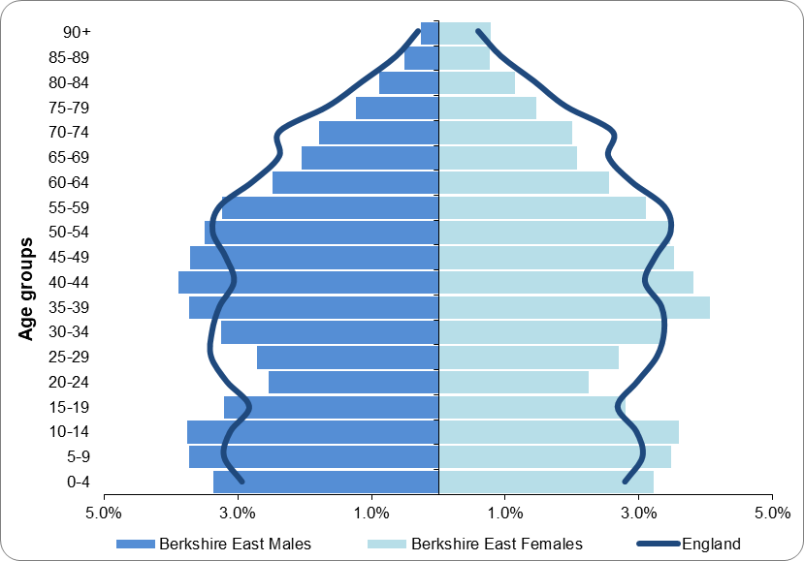

Source: Office for National Statistics (2021); Estimates of the population for the UK mid-2020

Bracknell Forest | Slough | Windsor and Maidenhead
31,231 aged 0-19, which is 25.1% of the population. | 46,777 aged 0-19, which is 31.1% of the population. This is the highest proportion in Berkshire East.  Slough has significantly higher proportions of children aged 0-14 than the rest of Berkshire East and England. | 37,744 aged 0-19, which is 25.0% of the population.

Population projections
Population projections for Berkshire East indicate that there will be an initial increase in the number and proportion of 0-19s in the population until 2023. There will then be a steady decrease from this point. Population projections for people aged 20 and over in Berkshire East show a continued increase over this time. Figure 2 shows how numbers are projected to change for children and young people in 5-year age bands. These indicate that younger age groups (0-9s) are already declining in number, while those aged 10-14 will start to decline in 2024 and those aged 15-19 will decline from 2028 onwards. Berkshire East is expected to continue to have a higher proportion of children compared to England, as shown in Figure 3.

Figure 2: Population projections for people aged 0 to 19 in Berkshire East Figure 3: Proportion of population aged 0 to 19 in Berkshire East and England
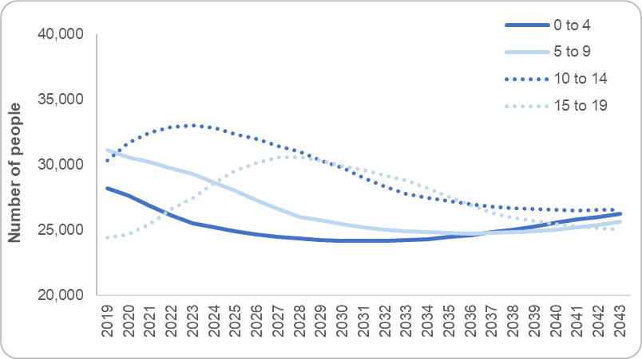
(2019 to 2043) (2019 to 2039)
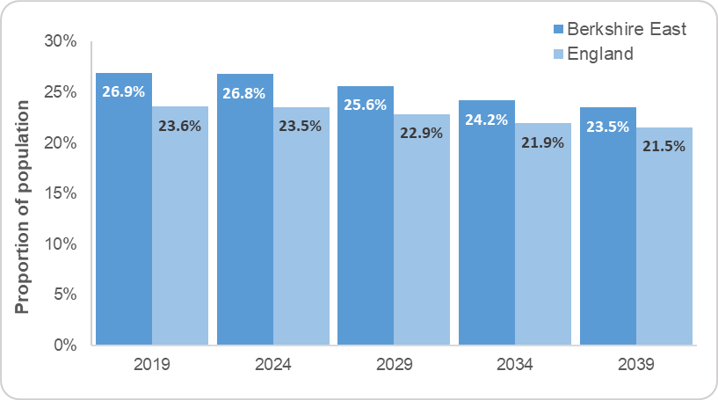
Source: Office for National Statistics (2020); Population projections for local authorities

Bracknell Forest | Slough | Windsor and Maidenhead
Bracknell Forest’s 0-19s population change follows a similar pattern to Berkshire East. The overall reduction in the 0-19s population will be the largest in Berkshire East over the next 10 years (6.6% reduction). | Slough’s 0-19s population changes follow a similar pattern to Berkshire East’s, although the current population profile is quite different in this LA with a much higher proportion of younger children. | Windsor and Maidenhead’s 0-19s population has already started to decline, according to projections. The overall reduction in the 0-19s population is not expected to be as large as other areas in Berkshire East though.

Who are the children and young people in Berkshire East?

Ethnicity and language
Figure 4: Proportion of the 0-19 population by minority ethnic group (2011)
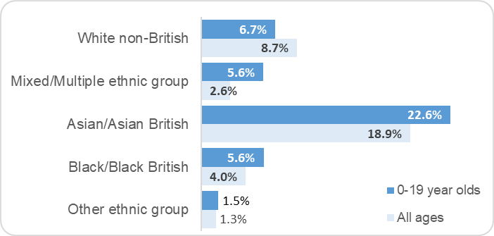
26% of Berkshire East’s 0-19 population were from a non-White British background in the 2011 census, compared to 25% in England. The largest minority ethnic group were children and young people from an Asian/Asian British background. The ethnic minority population varies significantly across Berkshire East, with Slough having a more ethnically diverse population (Office for National Statistics 2012). Figure 4 shows that the younger population in Berkshire East also has a higher proportion of people from minority ethnic groups.

More recent information about the ethnic background and nationality of children and young people in Berkshire East can be gathered from births and schools data.

Births
In 2019, 44% of births in Berkshire East were to mothers who were not born in the UK. This compares to 29% across England (Office for National Statistics 2020). This proportion has increased, both nationally and locally, since figures were collected in 2009.
Source: Office for National Statistics (2012); DC2101EW- Ethnic group by sex by age

School pupils
In January 2021, 58% of pupils who attended state-funded primary schools in Berkshire East were from a minority ethnic group, compared to 55% of state-funded secondary school pupils. The largest minority ethnic groups within Berkshire East schools were children from Asian/Asian British backgrounds, followed by those from White non-British groups and mixed/multiple ethnic groups.

Figure 5: Pupils from minority ethnic groups in Berkshire East schools (January 2021)

Area | State-funded primary school |  | State-funded secondary school
 | Number of pupils from a minority ethnic group | % of pupils from a minority ethnic group | Number of pupils from a minority ethnic group | % of pupils from a minority ethnic group
Bracknell Forest | 2,671 | 26.3% | 1,692 | 21.9%
Slough | 14,913 | 86.5% | 12,310 | 87.4%
Windsor and Maidenhead | 4,438 | 41.9% | 4,075 | 36.6%
Berkshire East | 22,022 | 57.9% | 18,077 | 54.9%
Source: Department for Education (2021); Schools, pupils and their characteristics: January 2021

The School Census also provides information about the proportion of pupils in Berkshire East schools who have a first language other than English. In January 2021, 33% of state-funded primary school pupils in Berkshire East did not have English as a first language, compared to 26% from state-funded secondary school pupils.

Figure 6: Pupils whose first language is not English in Berkshire East (January 2021)

Area | State-funded primary school |  | State-funded secondary school
 | Number of pupils whose first language is not English | % of pupils whose first language is not English | Number of pupils whose first language is not English | % of pupils whose first language is not English
Bracknell Forest | 1,434 | 13.8% | 772 | 9.9%
Slough | 9,633 | 55.2% | 6,637 | 45.7%
Windsor and Maidenhead | 1,732 | 16.1% | 1,330 | 11.7%
Berkshire East | 12,799 | 33.3% | 8,739 | 26.1%
Source: Department for Education (2021); Schools, pupils and their characteristics: January 2021
Bracknell Forest | Slough | Windsor and Maidenhead
17% of the 0-19 population were from a non-White British background in 2011, which is the lowest proportion in Berkshire East and lower than England. 6% of the population were Asian/Asian British, which was the largest minority ethnic group.  25% of births in 2019 were to mothers who were not born in the UK. Bracknell Forest’s proportion has increased by 17% since 2009, which is a faster increase than other Berkshire East LAs and England.  26% of primary school pupils are from a minority ethnic group and 14% do not have English as a first language. These are both significantly lower than the rest of Berkshire East.  22% of secondary school pupils are from a minority ethnic group and 10% do not have English as a first language. These are both significantly lower than the rest of Berkshire East. | 73% of the 0-19 population were from a non-White British background in 2011, which is the highest proportion in Berkshire East and higher than England. 44% of the population were Asian/Asian British, which was the largest minority ethnic group.  62% of births in 2019 were to mothers who were not born in the UK. This is the 2nd highest proportion in England.  87% of primary school pupils are from a minority ethnic group and 55% do not have English as a first language. These are both significantly higher than the rest of Berkshire East and England.  87% of secondary school pupils are from a minority ethnic group and 46% do not have English as a first language. These are both significantly higher than the rest of Berkshire East and England. | 26% of the 0-19 population were from a non-White British background in 2011. 12% of the population were Asian/Asian British, which was the largest minority ethnic group.  31% of births in 2019 were to mothers who were not born in the UK.  42% of primary school pupils are from a minority ethnic group and 16% do not have English as a first language.  37% of secondary school pupils are from a minority ethnic group and 12% do not have English as a first language.

Where do children and young people live in Berkshire East?
Figure 7: Estimated percentage of Berkshire East’s population aged 0 to 4 years old by Lower Super Output Area (mid-2020)

Children aged 0 to 4
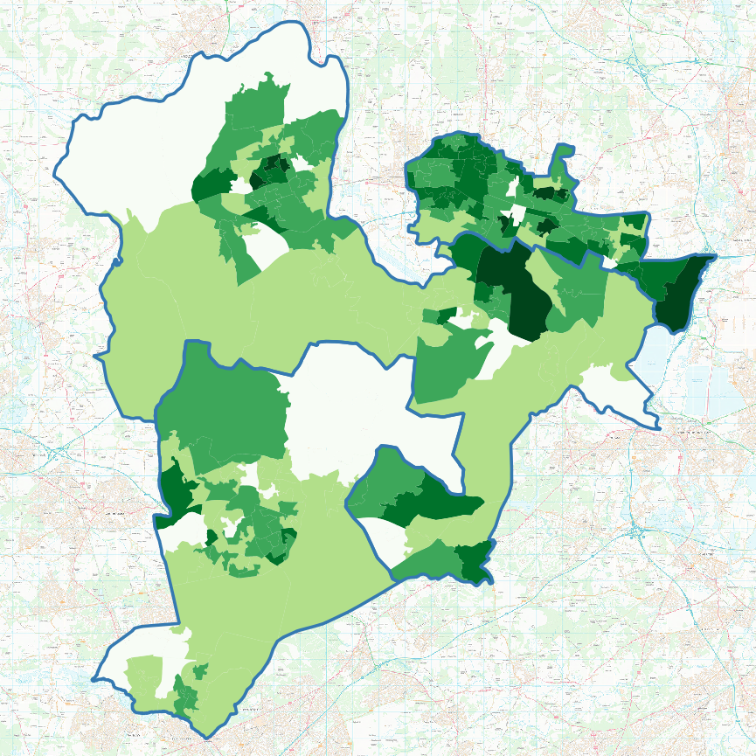
The mid-2020 population estimates indicated that there were 28,089 children aged 0 to 4 living in Berkshire East, which was approximately 6.6% of the total population (Office for National Statistics 2021)

Figure 7 gives a more detailed picture of where higher proportions of young children live in Berkshire East. Lower Super Output Areas (LSOAs) with higher proportions of young children are highlighted in darker green shades.
Slough

An LSOA in Cippenham Meadows ward (Slough) has the highest proportion of 0 to 4 year olds in Berkshire East at 12.0% of the LSOA’s total population. An additional 6 LSOAs in Slough have 10% or more of their population aged 0 to 4. 8.3% of Slough’s total population is aged 0 to 4, which is significantly higher than the rest of Berkshire East.
RBWM

RBWM has one LSOA with over 10% of the population aged 0 to 4 and this is in the Clewer & Dedworth West ward. 5.5% of RBWM’s total population is aged 0 to 4.

5.9% of Bracknell Forest’s population is aged 0 to 4.

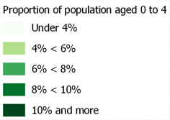
Bracknell Forest

© This map has been produced using the Public Health England Covid-19 Data and Ordnance Survey OpenData 2021

Children aged 5 to 19
Figure 8: Estimated percentage of Berkshire East’s population aged 5 to 19 years old by Lower Super Output Area (mid-2020)
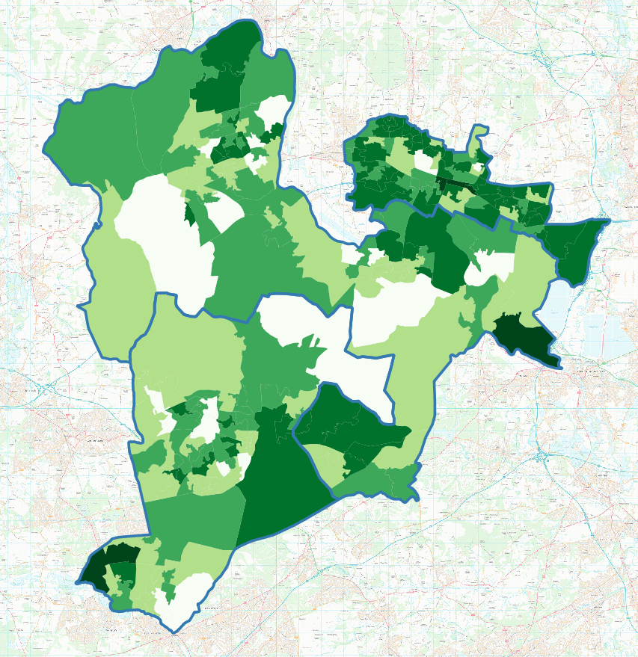
The mid-2020 population estimates indicated that there were 87,663 children aged 5 to 19 living in Berkshire East, which was approximately 20.6% of the total population (Office for National Statistics 2021).

Figure 8 gives a more detailed picture of where higher proportions of young children live in Berkshire East. Lower Super Output Areas (LSOAs) with higher proportions of children and young people are highlighted in darker green shades. Berkshire East has a number of residential schools and colleges and the location of these will significantly increase the number of school-aged children living in some LSOAs.
Slough
Bracknell Forest
RBWM

An LSOA in Little Sandhurst and Wellington (Bracknell Forest) has the highest proportion of 5 to 19 year olds in Berkshire East at 54.0% of the LSOA’s total population. 19.2% of Bracknell Forest’s total population is aged 5 to 19.

RBWM has two LSOA with over 30% of the population aged 5 to 19 and these both have residential schools located in them (Eton College and St Mary’s School). 19.4% of RBWM’s total population is aged 5 to 19.

22.8% of Slough’s population is aged 5 to 19, which is significantly higher than the rest of Berkshire East.

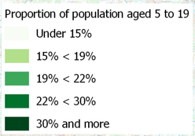

© This map has been produced using the Public Health England Covid-19 Data and Ordnance Survey OpenData 2021

What else do we know about where children and young people live?
Figure 9: Proportion of children aged 0 to 15 by IDACI quintiles (2019)

Deprivation and poverty
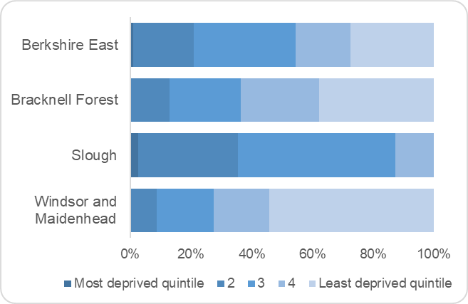
The Income Deprivation Affecting Children Index (IDACI) measures the proportion of children aged 0 to 15 living in income deprived families. The definition of low income includes people that are out-of-work, as well as those that are working but who have low earnings.

In 2019, 11% of children aged 0 to 15 were affected by income deprivation in Berkshire East, which was approximately 10,168 children. This was a reduction from 14% in 2015, when IDACI was last released (Ministry of Housing, Communities and Local Government 2019).

Levels of deprivation varied significantly across Berkshire East local authorities and also at smaller neighbourhood levels. Figure 9 illustrates this by showing the proportion of children aged 0 to 15 living in different national IDACI quintiles in each local authority. Overall, 27% of 0 to 15 year olds in Berkshire East were living in the least deprived IDACI quintile nationally and 1% were in the most deprived quintile. The most deprived neighbourhoods in Berkshire East included areas in Colnbrook with Poyle and Britwell and Northborough wards in Slough. Figure 10 shows a detailed picture for each LSOA in Berkshire East.
Source: Ministry of Housing, Communities and Local Government (2019); English indices of deprivation 2019

Bracknell Forest | Slough | Windsor and Maidenhead
9% of children aged 0 to 15 are affected by income deprivation. This ranges between 1% to 21% of children in different neighbourhoods.  No 0 to 15 year olds live in the most deprived quintile nationally for IDACI. The most deprived neighbourhood in the area is in Wildridings and Central ward. | 15% of children aged 0 to 15 are affected by income deprivation. This ranges between 6% to 29% of children in different neighbourhoods.  3% of 0-15 year olds live in the most deprived quintile nationally for IDACI. These include 2 neighbourhoods in Colnbrook with Poyle and Britwell and Northborough wards. | 7% of children aged 0 to 15 are affected by income deprivation. This ranges between 1% to 19% of children in different neighbourhoods.  No 0 to 15 year olds live in the most deprived quintile nationally for IDACI. The most deprived neighbourhood in the area is in Datchet, Horton & Wraysbury ward.

Figure 10: Income Deprivation Affecting Children (IDACI) for Berkshire East by Lower Super Output Area (2019)
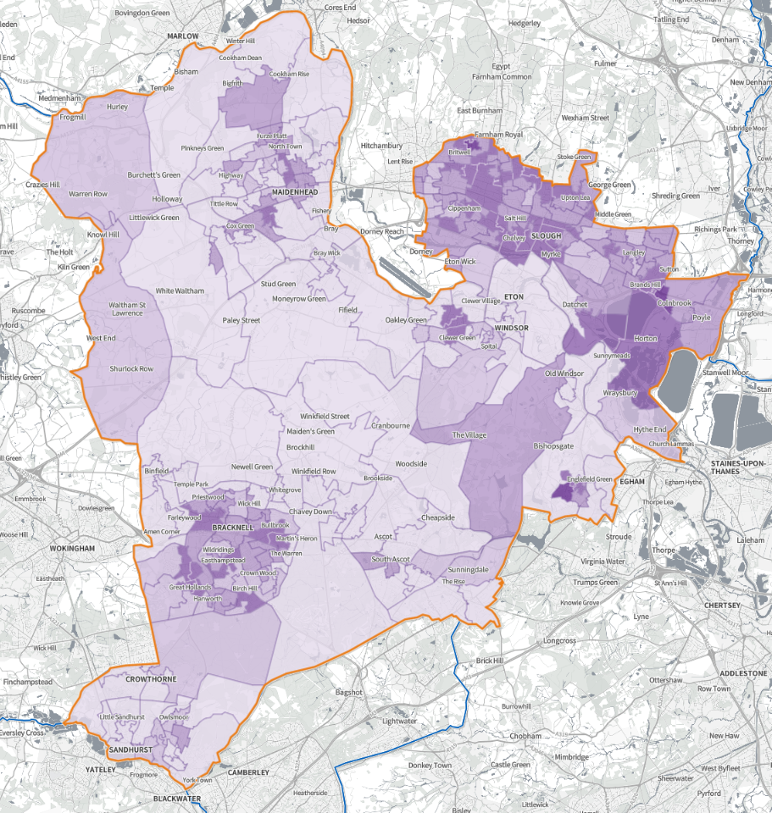

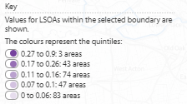

Source: English Indices of Deprivation 2019 © Crown copyright 2019 https://shapeatlas.net/place 9 Apr 21

Education
There are 144 state-funded schools in Berkshire East, with an additional 3 pupil referral units and 32 independent schools. A summary of the school profile across Berkshire East is shown at Figure 11.

Figure 11: Number of schools and pupils in Berkshire East local authorities (January 2021)
Type of school | Bracknell Forest |  | Slough |  | Windsor and Maidenhead
 | Number of schools | Number of pupils | Number of schools | Number of pupils | Number of schools | Number of pupils
Primary schools (state funded) | 29 | 10,392 | 28 | 17,449 | 46 | 10,737
Secondary schools (state funded) | 7 | 7,783 | 15 | 14,514 | 14 | 11,374
Special schools  (state funded and non-maintained) | 1 | 196 | 2 | 356 | 3 | 442
Pupil referral unit | 1 | 44 | 1 | 139 | 1 | 23
Total | 38 | 18,415 | 46 | 32,458 | 64 | 22,568
Independent schools | 8 | 3,130 | 6 | 722 | 18 | 5,333

Source: Department for Education (2021); Schools, pupils and their characteristics: January 2021

The proportion of pupils who are eligible and claiming free school meals in Berkshire East is significantly lower than the national figure. In 2018, 7.6% (5,364) of pupils in Berkshire East’s state-funded nursery, primary, secondary or special schools claimed free school meals (Office for Health Improvement and Disparities 2021).

Parents of children of compulsory school age (aged 5 to 15 at the start of the school year) are required to ensure that they receive a suitable education by regular attendance at school. Improving attendance in schools is crucial to the Government's commitment to increasing social mobility and to ensuring every child can meet their potential. In 2018/19, 4.4% of school sessions were missed due to pupil absence in Berkshire East. Local pupil absence rates have not changed significantly over the last five years and are similar to the national figures (Office for Health Improvement and Disparities 2021). In 2018/19, 8% (2,497) of primary school pupils and 10% (2,714) of secondary school pupils were identified as persistent absentees in Berkshire East schools. This means that they missed 10% or more of the possible sessions.

Educational achievement varies across Berkshire East. Figure 12 shows a RAG rating for key educational achievement indicators across primary and secondary school and compares the three local authority results against England’s.

Figure 12: Summary of educational achievement for school pupils in Berkshire East

Indicator | Date | Bracknell Forest |  | Slough |  | Windsor and Maidenhead
 |  | Outturn | Compared to England | Outturn | Compared to England | Outturn | Compared to England
School readiness: % of pupils who had a good level of development at the end of reception | 2018/19 | 76.4% | Significantly better | 74.3% | Significantly better | 74.3% | Significantly better
School readiness: % of pupils with free school meals who had a good level of development at the end of reception | 2018/19 | 60.3% | Similar | 68.8% | Significantly better | 53.0% | Similar
School readiness: % of Year 1 pupils achieving expected level in the phonics screening | 2018/19 | 84.7% | Significantly better | 85.7% | Significantly better | 83.5% | Significantly better
School readiness: % of Year 1 pupils with free school meals achieving expected level in the phonics screening | 2018/19 | 69.0% | Similar | 77.8% | Significantly better | 61.6% | Similar
Key Stage 2: % of pupils achieving expected standard in reading, writing and maths | 2019/20 | 64.7% | Similar | 69.1% | Significantly better | 67.1% | Similar
Average Attainment 8 score | 2019/20 | 50.0 | Similar | 52.5 | Significantly better | 55.1 | Significantly better

Source: Office for Health Improvement and Disparities (2021); Child Health Profile

Bracknell Forest | Slough | Windsor and Maidenhead
6.7% of pupils were eligible and claiming free school meals in 2018. This was a reduction on recent years and significantly better than national figures.  Pupil absence rates in Bracknell Forest schools are lower than the rest of Berkshire East at 4.1%. This is significantly better than the national rate. The proportion of persistent absentees is 5.7% in primary and 11.1% in secondary schools. | 9.1% of pupils were eligible and claiming free school meals in 2018. This was a reduction on recent years and similar to national figures.  Pupil absence rates in Slough are similar to Berkshire East and England’s at 4.5%. The proportion of persistent absentees is 8.9% in primary and 9.4% in secondary schools. | 6.1% of pupils were eligible and claiming free school meals in 2018. This was a reduction on recent years and significantly better than national figures.  Pupil absence rates in RBWM are similar to Berkshire East and England’s at 4.4%. The proportion of persistent absentees is 7.1% in primary and 11.0% in secondary schools.

Housing and homelessness
The 2011 Census showed that there were nearly 155,000 households in Berkshire East with a mixture of housing tenure across and within the local authorities. 68% of Bracknell Forest and RBWM households were owned by the occupant, whether outright or with a mortgage or loan, compared with 53% in Slough. In contrast, the proportion of households that were privately or socially rented in Slough was much higher than in the other two local authorities (Office for National Statistics 2013). The proportion of households that were overcrowded (had one fewer bedrooms than the standard requirement) in 2011 was significantly higher in Slough (13% of all households), compared to the rest of Berkshire East (4% in RBWM and 2% in Bracknell Forest) (Office for Health Improvement and Disparities 2021).

The affordability of home ownership index indicates that RBWM is the least affordable area in the South East for residents to purchase a home, based on the current median house price and median earnings in the area (Office for Health Improvement and Disparities 2021). This will particularly affect young people and first time buyers who may not be able to afford to live in the area that they have grown up in. The House Price Index for Sept-21 indicated that the average house price for first-time buyers in RBWM was £390,770, compared to £290,042 in Slough and £288,892 in Bracknell Forest (Land Registry 2021).

The Homelessness Reduction Act (HRA) introduced new homelessness duties in April 2018, which has led to more households being provided with a statutory service by local housing authorities than before the Act came into force. The HRA introduced new prevention and relief duties that are owed to all eligible households who are homeless or threatened with becoming homeless. In 2019/20, 873 households with dependent children or pregnant women in Berkshire East were owed a duty under the HRA, with over half of these based in Slough. 369 households headed by a young person aged 16 to 24 were owed a duty under the HRA and the majority of these were also in Slough. Slough’s rates are significantly higher than England’s, while RBWM’s are significantly lower (Office for Health Improvement and Disparities 2021).

Bracknell Forest | Slough | Windsor and Maidenhead
45,878 households in the 2011 Census. 69% of these houses were owned by the occupant, whether outright or with a mortgage or loan. 13% were privately rented and 17% were socially rented.  221 households with dependent children were identified as being owed a duty under the HRA in 2019/20. Bracknell Forest’s rate of 14.4 per 1,000 households was similar to England’s.  120 households headed by a person aged 16 to 24 were identified as being owed a duty under the HRA in 2019/20. Bracknell Forest’s rate of 2.4 per 1,000 households was similar to England’s. | 50,766 households in the 2011 Census. 53% of these houses were owned by the occupant, whether outright or with a mortgage or loan. 24% were privately rented and 21% were socially rented.  461 households with dependent children were identified as being owed a duty under the HRA in 2019/20. Slough’s rate of 21.4 per 1,000 households was significantly higher than England.  178 households headed by a person aged 16 to 24 were identified as being owed a duty under the HRA in 2019/20. Slough’s rate of 3.3 per 1,000 households was significantly higher than England and the rest of Berkshire East. | 58,349 households in the 2011 Census. 68% of these houses were owned by the occupant, whether outright or with a mortgage or loan. 16% were privately rented and 13% were socially rented.  191 households with dependent children were identified as being owed a duty under the HRA in 2019/20. RBWM’s rate of 10.4 per 1,000 households was significantly lower than England.  71 households headed by a person aged 16 to 24 were identified as being owed a duty under the HRA in 2019/20. RBWM’s rate of 1.2 per 1,000 households was significantly lower than England and the rest of Berkshire East.

Employment
Employment, unemployment and economic inactivity rates vary across Berkshire East, due to the nature of the labour markets across the area. In 202, Bracknell Forest and RBWM had higher employment rates for people aged 16 to 64 than the national average at 80% and 79% respectively. Slough’s employment rate, which has previously been similar to the national figures, saw a large decrease in 2020 to 69.5%. Slough’s unemployment rate is also notably higher than the other two areas in Berkshire East and increased from 4.2% to 7.4% during 2020 (Office for National Statistics 2021).

Approximately 11,400 households across Berkshire East were defined as workless in 2019, meaning that no occupant aged 16 to 64 was in employment. This was 9% of all households, compared to 13% nationally (Office for National Statistics 2019).

Young people not in education, employment or training (NEET)
Young people who are not in education, employment or training are at greater risk of a range of negative outcomes, including poor health, depression or early parenthood (Public Health England 2014). To support more young people to study and gain the skills and qualifications that lead to sustainable jobs and reduce the risk of young people becoming NEET, legislation was introduced in 2013 to raise the participation age for education and training. This required all young people to remain in some form of education or training until the end of the academic year in which they turn 17.

In 2019, there were 440 16 and 17 year olds who were NEET in Berkshire East. This was 4.9% of the age group, which was significantly better than the national figure of 5.5%. The proportion of NEET in RBWM was significantly worse than the rest of the area at 6.3%, while Slough’s was significantly better at 4.2%. Young men were also more likely to be NEET compared to young women, both locally and nationally (Office for Health Improvement and Disparities 2021).

Bracknell Forest | Slough | Windsor and Maidenhead
Significantly better employment and unemployment rates than England for people aged 16 to 64.  Economic inactivity rate includes a larger proportion of people aged 16 to 64 who state that they are retired (22%), compared to the national average (13%).  7% of households with at least one occupant aged 16 to 64 are ‘workless’. Data on workless households with dependent children (aged under 20) is not available.  100 NEET in 2019 at 4.6%. This was similar to the national figure. | Significantly worse employment and unemployment rates than England for people aged 16 to 64.  Higher economic inactivity rate than the rest of Berkshire East, partly due to the larger student population and a higher proportion of adults looking after the family or home.  11% of households with at least one occupant aged 16 to 64 are ‘workless’. 6% of households with dependent children (aged under 20) are workless.  160 NEET in 2019 at 4.2%. This was significantly better than the national figure and the rest of Berkshire East. | Significantly better employment and unemployment rates than England for people aged 16 to 64.  Economic inactivity rate includes a larger proportion of people aged 16 to 64 who state that they are students (33%), compared to the national average (27%).  8% of households with at least one occupant aged 16 to 64 are ‘workless’. 4% of households with dependent children (aged under 20) are workless.  180 NEET in 2019 at 6.3%. This was significantly worse than the national figure and the rest of Berkshire East.

What do we know about their health and wellbeing?

This section looks at the health and wellbeing of children and young people in Berkshire East to provide an understanding of specific needs within the local area.

Areas that may require further investigation have been highlighted. These include:
  - where Berkshire East’s figures are significantly worse than England
  - where Berkshire East’s figures have declined significantly
  - where there is significant variation and possible health inequalities across Berkshire East

Maternal and infant health

Fertility rates and still births
In 2020 there were 5,088 live births in Berkshire East. The total fertility rate (TFR) across the local authority areas ranged from 1.6 in Bracknell Forest and RBWM to 2.3 in Slough. Slough’s TFR is currently the highest in England. Local fertility rates have all decreased over the last 5 years, reflecting the national picture. Bracknell Forest has seen a slight increase over the last year, however this is still lower than 5 years ago (Office for National Statistics 2021).

Stillbirth rates in the United Kingdom have shown little change over the last 20 years and the rate remains among the highest in high income countries. Risk factors associated with stillbirth include maternal obesity, ethnicity, smoking, pre-existing diabetes, history of mental health problems, antepartum haemorrhage and foetal growth restriction. In 2015 the government announced an ambition to halve the rate of stillbirths by 2030.

There were 72 stillbirths in Berkshire East between 2017-19 at a rate of 4.4 per 1,000 live births. This was similar to the national rate of 4.0 per 1,000 live births (Office for Health Improvement and Disparities 2021).

Smoking in pregnancy
Smoking during pregnancy has a detrimental effect on the health of both the mother and the baby. Smoking increases the risk of serious pregnancy-related health problems, including miscarriage, premature birth, still birth and low birth weight. The Tobacco Control Plan contains a national ambition to reduce the rate of smoking throughout pregnancy to 6% or less by the end of 2022.

In 2019/20, 6.5% of women who gave birth in Berkshire East were smokers at the time of delivery, which was 320 mothers. This prevalence rate continues to be better than the national figure of 10.4%. The proportion of pregnant women in Berkshire East who were smokers at the point of their maternity assessment booking was also significantly better than the national figure at 7.9%, compared to 12.8% (Office for Health Improvement and Disparities 2021).

Perinatal mental health
Figure 13: Estimated number of women in Berkshire East with perinatal mental health problems (2020)
Mental health issues | National prevalence | Estimated number of women
Postpartum psychosis | 0.2% | 10
Chronic serious mental illness | 0.2% | 10
Severe depressive illness | 3% | 153
Mild-moderate depressive illness and anxiety | 10 - 15% | 510 - 765
Post-traumatic stress disorder | 3% | 153
Adjustment disorders and distress | 15 - 30% | 765 - 1,530
Perinatal mental health problems are estimated to affect 10% to 20% of women during pregnancy or within the first year of having a baby (Centre from Mental Health and London School of Economics, 2014). Modelled estimates for Berkshire East suggest that between 545 and 1,020 mothers experienced perinatal mental health problems in 2020. Many of these women will not have identified, sought or received support for these problems.

Figure 13 provides estimated prevalence rates for different perinatal mental health problems and approximates the number of women in Berkshire East who may have been affected by these in 2020. The number of live and still births in 2020 have been used to create an estimate for the total number of maternities (5,101).

Source: Office for Health Improvement and Disparities (2019); Perinatal Mental Health Profiles

Low birth weight
A baby is defined as being a low birth weight if they are under 2,500g and a gestational age of at least 37 complete weeks. Low birth weight increases the risk of childhood mortality, developmental problems in childhood and also indicates a risk of poorer health in later life. In 2019, 3.0% of term babies born in Berkshire East had a low birth weight, compared to 2.9% nationally (Office for Health Improvement and Disparities 2021). Slough’s figure of 3.9% of babies is the highest in the South East and significantly worse than the national and Berkshire East figures.

Infant mortality
Infant mortality rates reflect the health and care of mothers and new-borns, as well as being an indicator of the general health of an entire population. Rates of infant mortality are higher in areas of greater deprivation and the Government’s Public Health Strategy (2010) aims to reduce this gap.
From 2018-20, 45 infants aged under 1 who were resident in Berkshire East died. This was 2.9 per 1,000 live births and significantly lower than the national rate of 3.9 per 1,000 live births. Infant mortality rates vary across Berkshire East with Bracknell Forest having the lowest rates in the South East, while Slough has the 4th highest (Office for Health Improvement and Disparities 2021).

Breastfeeding
Breastfeeding has health benefits for both mother and baby. Babies who are breast-fed experience lower levels of gastro-intestinal and respiratory infection and evidence also suggests that they will have lower levels of child obesity. Benefits for mothers include reduced risk of breast and ovarian cancer, as well as a faster return to pre-pregnancy weight. Current national and international guidance recommends exclusive breastfeeding for newborns for at least six months.

76% of babies in Berkshire East were fed breastmilk for their first feed in 2018/19. All Berkshire East local authorities had significantly higher rates than the national figure of 64%.

In 2020/21, 65% of infants were totally or partially breastfed at 6-8 weeks in Slough and 59% in Bracknell Forest. These are both significantly higher than the national prevalence of 48%. Data for RBWM is not available for the last 6 years, as the proportion of babies with a breastfeeding status recorded has not reached the data validation threshold of 95% each year (Office for Health Improvement and Disparities 2021). Additional information about local breastfeeding prevalence can be found in Section 3.1.3.

Bracknell Forest | Slough | Windsor and Maidenhead
2.2% of term babies were a low birth weight in 2019. This was similar to the national rate. | 3.9% of term babies were a low birth weight in 2019. This was significantly worse than the national rate. | 2.4% of term babies were a low birth weight in 2019. This was similar to the national rate.
7 infants died in 2018-20, which was 1.7 per 1,000 live births. This rate is a reduction on the previous 4 years and is significantly lower than the national rate. | 29 infants died in 2018-20, which was 4.1 per 1,000 live births. This rate is the 4th highest in the South East and similar to the national rate. | 9 infants died in 2018-20, which was 2.0 per 1,000 live births. This rate is significantly lower than the national rate.
15 stillbirths in 2017-19 at a rate of 3.6 per 1,000 live births. This is similar to the national rate. | 38 stillbirths in 2017-19 at a rate of 5.2 per 1,000 live births. This rate has decreased and is now line with the national figure. It remains the 2nd highest rate in the South East. | 19 stillbirths in 2017-19 at a rate of 4.0 per 1,000 live births. This is similar to the national rate.
72% of babies were fed breastmilk for their first feed. 59% of infants were breastfed at 6-8 weeks | 76% of babies were fed breastmilk for their first feed. 65% of infants were breastfed at 6-8 weeks. | 79% of babies were fed breastmilk for their first feed. Data was not published for breastfeeding prevalence in 2020/21 as the proportion of babies with a breastfeeding status recorded did not meet the minimum data quality standard of 95%.

Early years and primary school children

Child development at 2 to 2 ½ years
Since 2015, all children in England became eligible for a Healthy Child Programme development review around the time of their 2nd birthday, which is delivered as part of the universal health visitor service. Health visiting teams should be using the Ages and Stages Questionnaire (ASQ-3) as part of the 2 to 2 ½ year review. This questionnaire provides an objective measure of development and helps to identify children who may not be developing as expected, supporting decisions for continued monitoring or referral onto early intervention services where required. The ASQ-3 includes several domains to monitor the development of a range of skills, including communication, gross motor, fine motor, problem solving and personal-social skills.
In 2020/21, 69% of eligible 2 to 2 ½ year olds received a development review in Berkshire East and 93% of these were completed using the Ages and Stages Questionnaire (ASQ-3). The completion of these reviews varied considerably across Berkshire East and were impacted on by the Covid-19 restrictions. Bracknell Forest’s completion of reviews appears particularly low at 57% of all 2 to 2 ½ year olds, however this has a data caveat that this does not include activity for the full-year. In previous years Bracknell Forest’s level of reviews has been significantly higher than the rest of Berkshire East and the national figure at 90%.

83% of children in Berkshire East who received the 2 to 2 ½ year ASQ-3 development review were meeting the expected levels in all 5 skill areas. Berkshire East’s overall figure was similar to the national level of 83%, however this varied significantly across the local area from 80% in Slough to 93% in Bracknell Forest. In total, 590 children in Berkshire East did not meet the expected level for at least one of the 5 skill areas, with the most support needs identified for communication skills.

Dental health
Information about dental health and tooth decay in children is collected through the Dental Public Health Epidemiology Programme for England. In 2018/19, 38% of 5 year olds in Slough had visually obvious dental decay, which was the highest level in the South East. RBWM and Bracknell Forest had lower levels of visible decay at 20% and 12% respectively. This compared to 23% nationally. (Office for Health Improvement and Disparities 2021).

Healthy weight
The National Child Measurement Programme (NCMP) measures the height and weight of 4-5 year olds (Reception) and 10-11 year olds (Year 6) in primary schools. This surveillance data helps to identify patterns in obesity and excess weight in the child population, as well as those that are underweight. Figure 14 provides a summary of 2019/20 NCMP results for Berkshire East, compared to England.

Although Berkshire East’s levels of excess weight (being overweight or obese) are similar to the national average for both age groups, there is variation across and within the three local authorities. Figures 15 and 16 show information at a ward level. Figure 17 highlights the association between excess weight and deprivation, which is more evident for the older age group.

Figure 14: Number and proportions of children in each weight group for Berkshire East and England (2019/20)

 | Reception (aged 4-5) |  |  |  | Year 6 (aged 10-11)
Weight group | Berkshire East |  | England |  | Berkshire East |  | England
 | Number of children | Percentage of children | Percentage of children |  | Number of children | Percentage of children | Percentage of children
Healthy weight | 2,500 | 76% | 76% |  | 3,275 | 63% | 63%
Under weight | 70 | 2% | 1% |  | 85 | 3% | 1%
Overweight | 355 | 11% | 13% |  | 790 | 15% | 14%
Obese | 355 | 11% | 10% |  | 1,060 | 20% | 21%
Excess weight (obese and overweight) | 700 | 21% | 23% |  | 1,845 | 35% | 35%
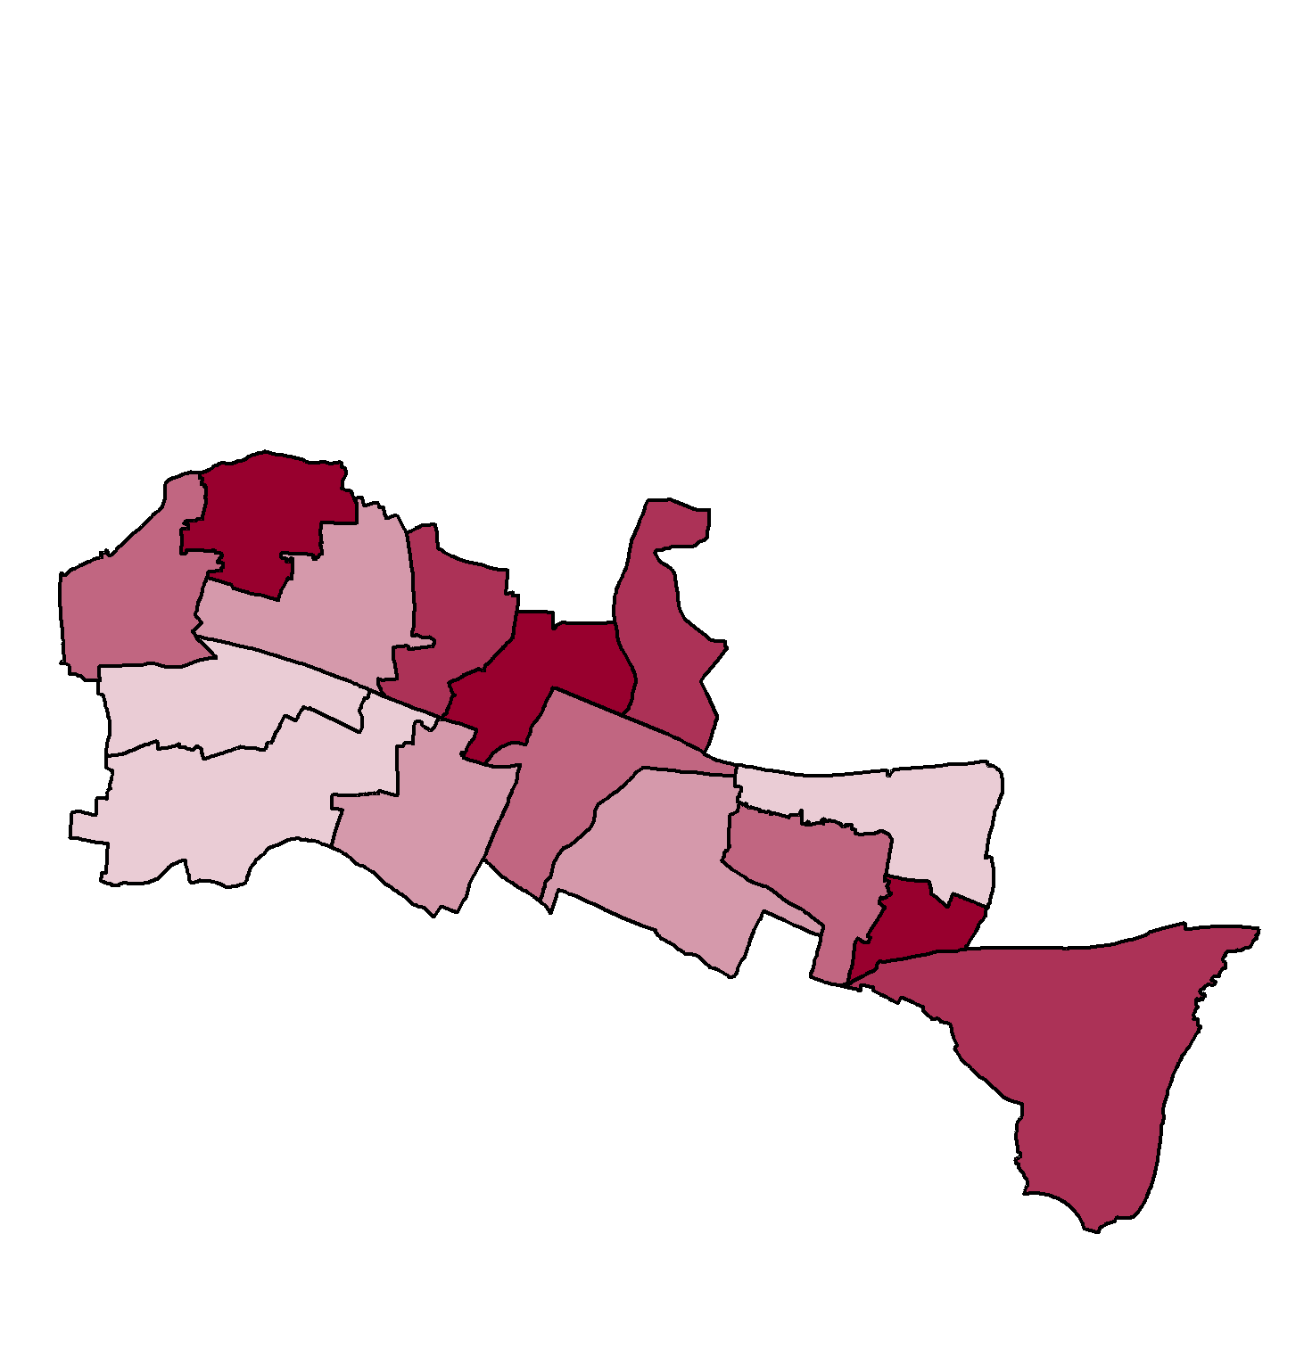
Source: Office for Health Improvement and Disparities (2021); Obesity Profile

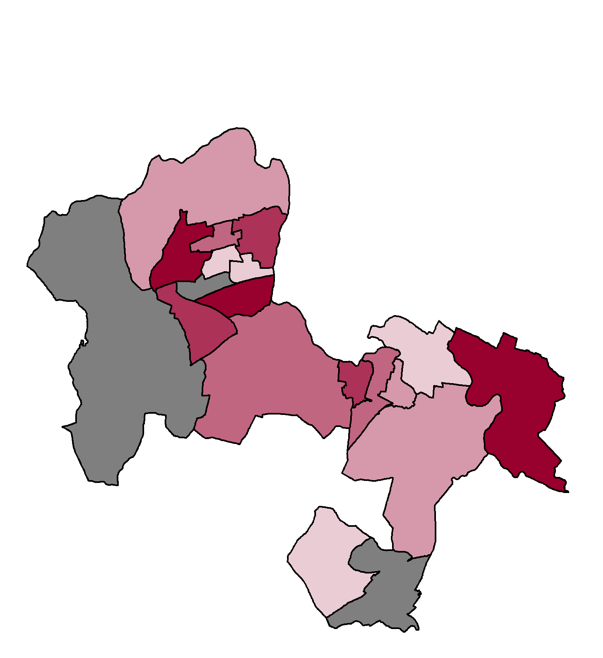
Figure 15: Children in Reception Year with excess weight (overweight or obese) by ward (2017/18 to 2019/20)
The data below is shown against national quintiles with the darker colours indicating higher prevalence of excess weight
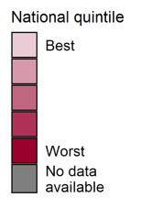
Bracknell Forest Slough Windsor and Maidenhead

Contains Ordnance survey data © Crown copyright and database right 2021; Contains National Statistics data © Crown copyright and database right 2021
Source: Public Health England (2021); Patterns and trends in Childhood Obesity – Local Authority Profiles

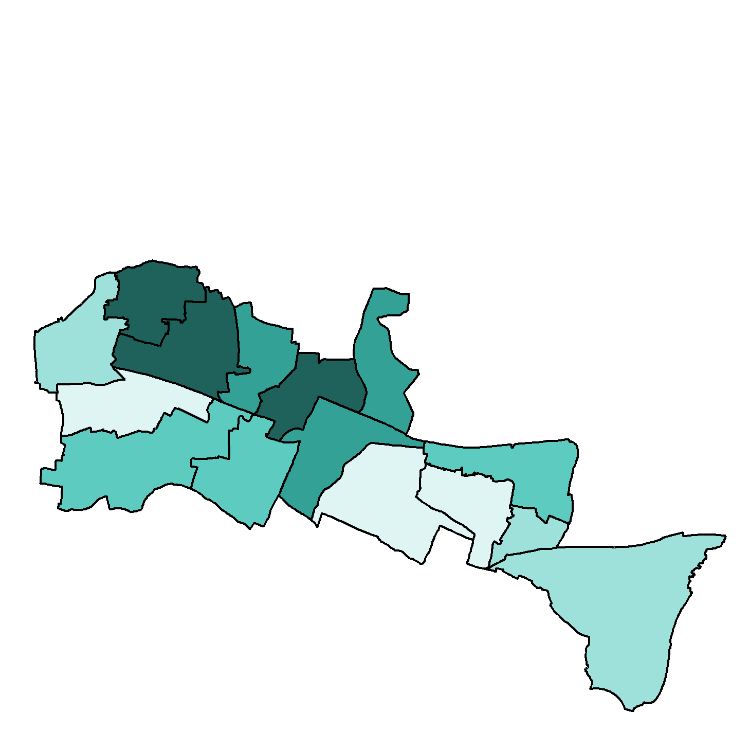
Figure 16: Children in Year 6 with excess weight (overweight or obese) by ward (2017/18 to 2019/20)
The data below is shown against national quintiles with the darker colours indicating higher prevalence of excess weight
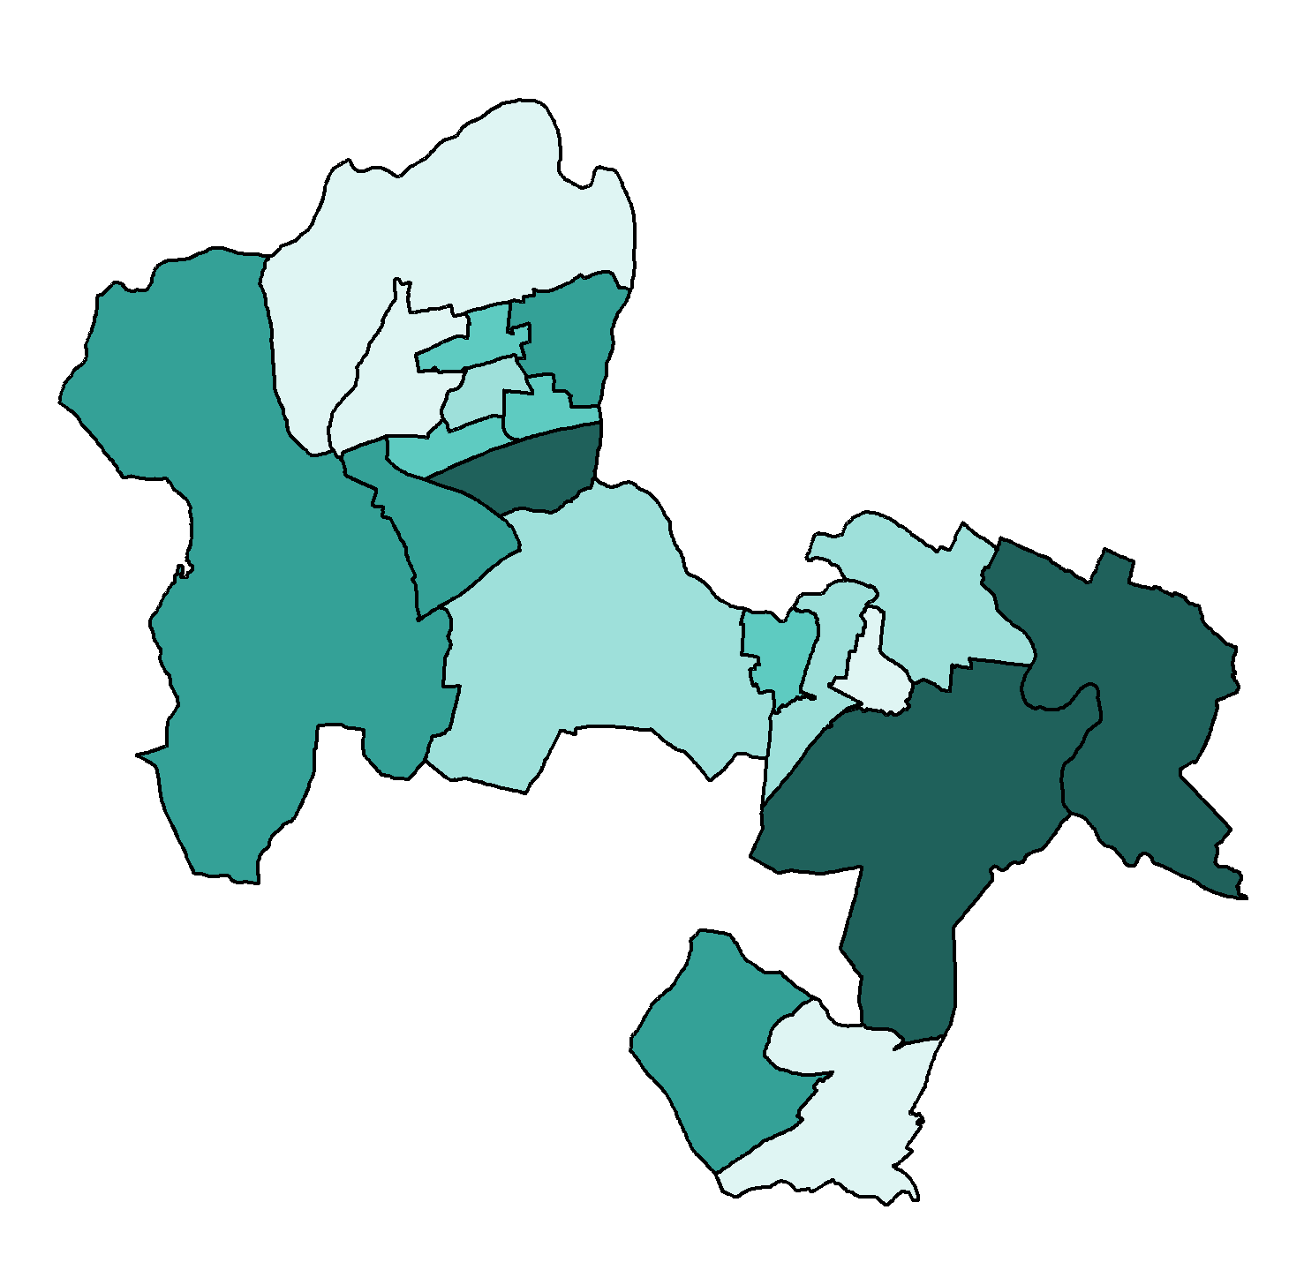
Bracknell Forest Slough Windsor and Maidenhead

Contains Ordnance survey data © Crown copyright and database right 2021; Contains National Statistics data © Crown copyright and database right 2021
Source: Public Health England (2021); Patterns and trends in Childhood Obesity – Local Authority Profiles

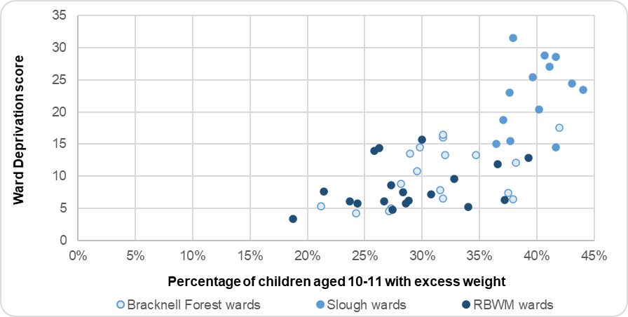
Figure 17: Proportion of children with excess weight (overweight or obese) by ward and deprivation score (2017/18 to 2019/20)
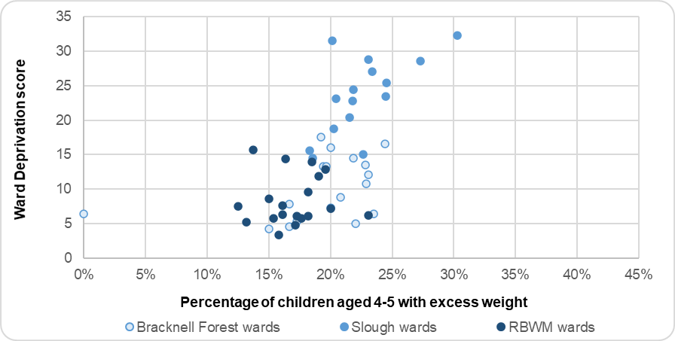
Source: Office for Health Improvement and Disparities (2021); Local Health Fingertips Profile

Reception children from Black ethnic groups have a higher prevalence of obesity in Berkshire East, compared to those from a White or Asian group. There is a significantly higher prevalence in RBWM. Year 6 children from a White ethnic group have a lower prevalence of obesity in Bracknell Forest and RBWM, compared to those from Black and Asian groups. The levels of obesity across ethnic groups in Slough are similar for Year 6 children (Office for Health Improvement and Disparities 2021).

Bracknell Forest | Slough | Windsor and Maidenhead
93% of 2 to 2 ½ year olds who received an ASQ-3 review in 2020/21 were meeting the expected levels of development in all 5 skill areas. This was significantly higher than the rest of Berkshire East and England. | 80% of 2 to 2 ½ year olds who received an ASQ-3 review in 2020/21 were meeting the expected levels of development in all 5 skill areas. This was significantly worse than England. | 81% of 2 to 2 ½ year olds who received an ASQ-3 review in 2020/21 were meeting the expected levels of development in all 5 skill areas. This was similar to England.
12% of 5 year olds had visually obvious dental decay in 2018/19, which was significantly better than the Berkshire East and national figures. | 38% of 5 year olds had visually obvious dental decay in 2018/19, which was the highest level in the South East and significantly worse than national figures. | 20% of 5 year olds had visually obvious dental decay in 2018/19, which was similar to national figures.
19.4% of 4-5 year olds had excess weight in 2019/20, with 10.2% being obese. These were both similar to the national figures. | 23.0% of 4-5 year olds had excess weight in 2019/20, with 11.9% being obese. These were both significantly worse than the national prevalence rates.  2.7% of 4-5 year olds were underweight in Slough (60 children), which was significantly worse than the national prevalence. | 16.2% of 4-5 year olds had excess weight in 2019/20, with 7.1% being obese. These were both significantly better than the national prevalence rates and rest of Berkshire East
32.7% of 10-11 year olds had excess weight in 2019/20, with 18.4% being obese. The levels of obesity were significantly better than the national figures. | 40.8% of 10-11 year olds had excess weight in 2019/20, with 24.9% being obese. The levels of obesity were significantly worse than the national prevalence rates.  2.3% of 10-11 year olds were underweight in Slough (55 children), which was significantly worse than the national prevalence. | 29.0% of 10-11 year olds had excess weight in 2019/20, with 14.7% being obese. These were both significantly better than the national prevalence rates and rest of Berkshire East.
From 2017/18 to 2019/20, the highest rates of excess weight for 4-5 year olds were in Priestwood and Garth (24.4%) and College Town (23.5%) wards.  Highest rates for 10-11 year olds were in Wildridings and Central (41.9%), Hanworth (38.2%), College Town (37.9%) and Central Sandhurst (37.5%) wards. | From 2017/18 to 2019/20, the highest rates of excess weight for 4-5 year olds were in Britwell and Northborough (30.2%) and Foxborough (21.8%) wards.  Highest rates for 10-11 year olds were in Farnham (48.6%) and Britwell and Northborough (45.7%). | From 2017/18 to 2019/20, the highest rates of excess weight for 4-5 year olds were in Cox Green (23.1%) and Clewer & Dedworth West wards (20.0%).  Highest rates for 10-11 year olds were in Datchet, Horton & Wraysbury (39.3%), Old Windsor (37.2%) and Oldfield (36.6%).

Secondary school children

General Health
The 2014/15 What About YOUth (WAY) survey asked a sample of 15 year olds about their health and lifestyle behaviours. 13% of 15-year olds in Berkshire East stated that they had a long-term illness, disability or medical condition diagnosed by a doctor, which was comparable to the national response of 14%. The proportion of 15 year olds who reported that they had excellent health was significantly higher in Berkshire East, compared to the national average, at 32% (Office for Health Improvement and Disparities 2021).

Diet and physical activity
The WAY survey indicated that a significantly higher proportion of 15 year olds in Berkshire East eat 5 portions of fruit and vegetables per day, compared to the national average. Bracknell Forest had a notably lower proportion at 53%, compared to 58% in Slough and 65% in RBWM. This indicator is used as a proxy measure to establish whether young people have a ‘good’ diet, however it does not take into account the intake of salt, sugar and fat and therefore needs to be treated with caution (Office for Health Improvement and Disparities 2021).

The Chief Medical Officer’s guidelines state that children aged 5 to 18 should take part in sport and physical activity for at least 60 minutes every day. Results from the 2019/20 Active Lives Children and Young People Survey showed that 42% of children were doing an average of 60 minutes of activity per day across the whole week. The local results for Berkshire were similar to the national picture and indicate that 58% of local children are not close to reaching the physical activity guidelines.

The level of physical activity varies across age groups and also between boys and girls. Nationally, 47% of boys are active every day compared to 43% of girls. Children from a White ethnic group are also more likely to be active (48%), compared to those in Asian (42%) and Black (35%) ethnic groups.

Young people who spend more time sedentary have a greater fat mass, higher BMI and increased risk of being overweight or obese, irrespective of their levels of physical activity when not sedentary. Nationally, 70% of 15 year olds are estimated to have a mean daily sedentary time of over 7 hours per day. Berkshire East’s levels of sedentary behaviour are significantly better than this, due to much lower levels in RBWM (59%). Bracknell Forest and Slough’s rates are similar to the national figure at 69% (Office for Health Improvement and Disparities 2021).

Lifestyle and risk behaviours
The 2018 Smoking, Drinking and Drug Use Among Young People in England Survey provides information about young people’s smoking, drinking and drug use habits. The figures from the survey can be used to provide modelled estimates for Berkshire East based on the mid-2020 population estimates and these are shown in Figure 18. These should only be used as a guide, as they do not take the demography of the area into account.

Figure 18: Smoking, drinking and drug use habits of young people aged 11 to 15

National Survey findings on smoking, drinking and drug use habits of people aged 11 to 15 | National  Prevalence | Modelled estimates for Berkshire East | Modelled estimates for Bracknell Forest | Modelled estimates for Slough | Modelled estimates for RBWM
Proportion that have ever tried smoking | 15% | 4,548 | 1,259 | 1,693 | 1,596
Proportion that are current smokers | 4% | 1,347 | 374 | 497 | 475
Proportion that smoked in the last week | 3% | 1,043 | 289 | 386 | 368
Proportion that have ever used an e-cigarette | 23% | 7,081 | 1,957 | 2,643 | 2,480
Proportion that are current e-cigarette users | 5% | 1,637 | 453 | 605 | 579
Proportion that have ever had an alcoholic drink | 41% | 12,536 | 3,469 | 4,700 | 4,367
Proportion that have drunk alcohol in the last week | 9% | 2,767 | 770 | 1,024 | 973
Proportion that have taken drugs | 22% | 6,743 | 1,867 | 2,521 | 2,354
Proportion that have taken drugs in the last month | 8% | 2,637 | 732 | 976 | 929
Source: Prevalence from NHS Digital (2019) Smoking, Drinking and Drug Use Among Young People in England - 2018; Population from Office for National Statistics (2021); Estimates of the population for the UK mid-2020

The 2014/15 What About YOUth (WAY) survey asked a sample of 15 year olds about their health and lifestyle behaviours. The results for 15 years olds in Berkshire East did show some variation with risk behaviours locally. Young people in Slough had significantly lower proportions of young adults that regularly drink, smoke or take cannabis, compared to the national figures. Bracknell Forest’s figures were higher than Slough’s, but still significantly better than the national average. RBWM’s self-reported prevalence of smoking, drinking alcohol and taking drugs (other than cannabis) was higher than the rest of Berkshire East and similar to England’s. 7% of RBWM 15-year olds said they has taken cannabis in the last month, which was significantly higher than England and the rest of Berkshire East (Office for Health Improvement and Disparities 2021).

11% of Berkshire East’s 15 year olds are estimated to have 3 or more risky behaviours (smoking, drinking, drug use, poor diet, physical inactivity), which is approximately 640 children. This is lower than the national prevalence of 16% Slough has a much lower rate compared to the rest of Berkshire East at 6% (Office for Health Improvement and Disparities 2021).

Bracknell Forest | Slough | Windsor and Maidenhead
35% of 15 year olds reported that they were in excellent health, which was significantly higher than England. | 28% of 15 year olds reported that they were in excellent health, which was similar to England and the lowest level in Berkshire East. | 34% of 15 year olds reported that they were in excellent health, which was significantly higher than England.
69% of 15 year olds reported that they were sedentary for over 7 hours a day, which was similar to the national figure. | 69% of 15 year olds reported that they were sedentary for over 7 hours a day, which was similar to the national figure. | 59% of 15 year olds reported that they were sedentary for over 7 hours a day, which was significantly better than England.
Self-reported prevalence of smoking, drinking alcohol and taking drugs (other than cannabis) for 15 year olds was significantly lower in Bracknell Forest compare to England. | Self-reported prevalence of smoking, drinking alcohol and taking drugs for 15 year olds was lower in Slough compared to the rest of Berkshire East. These rates were all significantly lower to England’s. | Self-reported prevalence of smoking, drinking alcohol and taking drugs (other than cannabis) for 15 year olds was higher in RBWM compared to the rest of Berkshire East. These rates were similar to England’s.  7% of RBWM 15-year olds said they has taken cannabis in the last month, which was significantly higher than England the rest of Berkshire East.

Mental health

Prevalence of mental health disorders

The 2017 Mental Health of Children and Young People in England survey found that 13% of children and young people aged 5 to 19 had at least one mental health disorder and 5% met the criteria for 2 or more disorders. The prevalence of mental disorders was shown to rise through the age groups from pre-school children to young adults. The 2020 follow-up survey suggests that the prevalence of mental health disorders has increased during the pandemic with 16% of children aged 5 to 16 now estimated to have a probable mental disorder compared to 11% in 2017. Key findings from the 2017 survey are shown at Figure 19 to provide additional information at an age group level.

Figure 19: Key findings from the 2017 Mental Health of Children and Young People in England for children aged 2 to 19 years

Source: NHS Digital (2017); 2017 Mental Health of Children and Young People in England

The prevalence of mental health disorders is expected to be higher in Slough than the rest of Berkshire East due to the impact of socio-economic factors. However, the higher proportion of people from a BAME group does provide an additional protective factor, as rates are highest in young people from White-British backgrounds. Figure 20 provides modelled estimates for the numbers of children and young people in Berkshire East who may have a mental health disorder. These are based on the prevalence rates identified in the 2017 national survey and take the age and sex of the local population into account. These have not been adjusted for other risks or protective factors that will impact on a child’s risk of developing a mental health disorder.

Figure 20: Estimated prevalence of mental health disorders for children and young people in Berkshire East (total)

 | 5 to 10 year olds |  | 11 to 16 year olds |  | 17 to 19 year olds |  | 5 to 19 year olds  (Total)
Type of mental health disorder | Prevalence | Estimated number | Prevalence | Estimated number | Prevalence | Estimated number | Prevalence | Estimated number
Mental health disorder (all) | 9.5% | 3,522 | 14.4% | 5,239 | 16.6% | 2,337 | 12.7% | 11,099
Emotional disorder | 4.1% | 1,526 | 8.9% | 3,251 | 14.7% | 2,053 | 7.8% | 6,830
Behavioural disorder | 5.0% | 1,852 | 6.3% | 2,282 | 0.8% | 113 | 4.8% | 4,247
Hyperactivity disorder | 1.7% | 637 | 2.0% | 736 | 1.0% | 141 | 1.7% | 1,514
Other less common disorder | 2.2% | 814 | 2.2% | 800 | 1.8% | 248 | 2.1% | 1,863

Source: Prevalence from NHS Digital (2017); 2017 Mental Health of Children and Young People in England Population from Office for National Statistics (2020); Estimates of the population for the UK mid-2020

In 2019/20, there were 95 hospital admissions for children and young people aged 0 to 19 in Berkshire East that were for mental health conditions. 67% of these were for girls and young women. Berkshire East’s overall admission rate of 89 per 100,000 population is comparable to England’s and has not seen a significant change over the last 5 years. However, there is local variation in the rate of admissions across Berkshire East with Slough having the lowest rate in the South East and Bracknell Forest having one of the highest (Office for Health Improvement and Disparities 2021).

Self-harm is not a psychiatric disorder, but it is indicative of major mental distress (McManus et al, 2016). Self-harm is often a very private behaviour and sensitive topic, which means that there is limited reliable information about young people’s healthcare usage associated with self-harm events. It is important to note that the majority of young people who do self-harm will either not harm themselves in a way that needs medical treatment or they will deal with it themselves.

Bracknell Forest | Slough | Windsor and Maidenhead
40 admissions for mental health conditions for children and young people aged 10 to 19. This is a rate of 141 per 100,000 population and significantly worse than England. | 20 admissions for mental health conditions for children and young people aged 10 to 19. This is a rate of 93 per 100,000 population and significantly better than England. | 35 admissions for mental health conditions for children and young people aged 10 to 19. This is a rate of 101 per 100,000 population and similar to England.

Sexual Health

Sexually Transmitted Infections (STIs)
Chlamydia is the most commonly diagnosed sexually transmitted infection. It causes avoidable sexual and reproductive ill-health, including symptomatic acute infections and complications such as pelvic inflammatory disease (PID), ectopic pregnancy and tubal-factor infertility. Chlamydia screening is recommended for all sexually active people under 25 and on partner change. Office for Health Improvement and Disparities recommends that local authorities should be working towards achieving a diagnosis rate of at least 2,300 per 100,000 population.
Figure 21: Chlamydia detection rate per 100,000 population (aged 15 to 24)
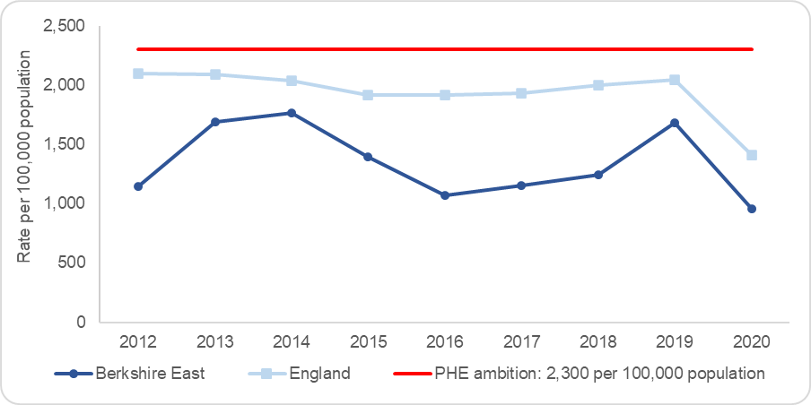
In 2019, 17% of 15 to 24 year olds in Berkshire East were screened for chlamydia, which was lower than the national figure of 20%. The younger age group of 15 to 19 year olds had a lower proportion of people screened in Berkshire East at just under 11%. This was higher for young women at 17%, compared to 5% for young men (Chlamydia Testing Activity Database 2021).

In 2019, 767 cases of chlamydia were detected for 15 to 24 year olds in Berkshire East at a rate of 1,681 per 100,000 population. This was significantly below Public Health England’s recommendation of 2,300 per 100,000 population and also below the national rate, as shown in Figure 21 (Office for Health Improvement and Disparities 2021). 332 of these chlamydia diagnoses were in young people aged 15 to 19 in Berkshire East. The rate of detection in this age group was higher for young women at 2,043 per 100,000 population, compared to 656 per 100,000 population for young men (Chlamydia Testing Activity Database 2021).
Source: Public Health England (2019); Sexual and Reproductive Health Profiles

Data for 2020 is available and shows a significant decline in screening and detection rates both nationally and locally, due to Covid-19 restrictions.
Young people aged 15 to 19 have the second highest rate of new STI diagnoses in Berkshire East, following those aged 20 to 24. In 2019 there were a total of 361 new STI diagnoses for young people aged 15 to 19 at a rate of 1,392 per 100,000 population. Slough’s rate of diagnoses is more than double Bracknell Forest and Windsor and Maidenhead’s.

Figure 22: Number and rate of new STI diagnoses in Berkshire East (2019)

 | Under 15 |  | 15 to 19 |  | All ages
 | Number of diagnoses | Rate per 100,000 population | Number of diagnoses | Rate per 100,000 population | Number of diagnoses | Rate per 100,000 population
Bracknell Forest | 0 | 0 | 43 | 1,139 | 346 | 569
Slough | <5 | Suppressed | 212 | 2,415 | 1,255 | 839
Windsor and Maidenhead | 5 | 120 | 106 | 1,149 | 802 | 530
Berkshire East | Suppressed | Suppressed | 361 | 1,392 | 2,403 | 567
Source: Office for Health Improvement and Disparities (2021); HIV and STI Web Portal

Teenage pregnancy
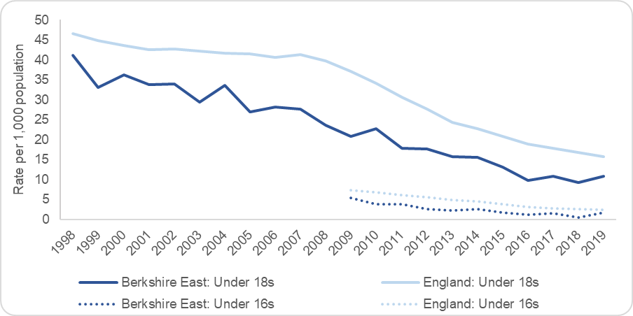
The Local Government Association (2016) explains that teenage pregnancy is both a cause and consequence of health and education inequalities. Most teenage pregnancies are unplanned and around half end in an abortion. Longitudinal studies show that teenage pregnancy is associated with poorer outcomes for both young parents and their children. Teenage mothers are less likely to finish their education, are more likely to bring up their child alone and in poverty and have a higher risk of poor mental health than older mothers. Infant mortality rates for babies born to teenage mothers are around 60% higher than for babies born to older mothers. The children of teenage mothers have an increased risk of living in poverty and poor quality housing and are more likely to have accidents and behavioural problems (Office for Health Improvement and Disparities 2021).
Figure 23: Under 18 and under 16 conception rates per 1,000 population

Teenage conception rates in Berkshire East have shown a steady decline since 1998, reflecting the national picture (Figure 23). In 2019, 83 females aged 15 to 17 and 14 females aged 13 to 15 had a pregnancy that either led to a birth or legal abortion in Berkshire East. Berkshire East’s rate of teenage pregnancy has historically been lower than the national picture, with slightly higher levels in Slough. 59% of under 18 conceptions led to an abortion in 2019 (49 in total) (Office for Health Improvement and Disparities 2021).
Source: Office for Health Improvement and Disparities (2021); Sexual and Reproductive Health Profiles

Female genital mutilation (FGM)
Female Genital Mutilation (FGM) refers to procedures that intentionally alter or remove part or all of the external female genital organs for non-medical reasons. The practice is medically unnecessary, has no health benefit and is extremely painful and harmful to victims, both at the time the mutilation is carried out and in later life. The practice is associated with initiation rites for young girls originating in a number of countries across North and West Africa. In some cases, these practices have continued to be taken up by certain minority and immigrant communities living in countries in Europe and North America, including the UK. FGM has been a criminal offence in the UK since 1985 and there has been a duty of mandatory reporting for health and social care professionals in England and Wales since 2015 (2015 Serious Crime Act).

The number of women who have been victims of FGM locally is unknown, although the prevalence in any area is likely to be linked to migration patterns from countries where FGM is a normative cultural practice (UNICEF 2013). In 2019/20, approximately 55 women were identified as being victims of FGM in Berkshire East and all of these were Slough residents. Most of these women were recorded through Obstetric services who typically oversee more risky pregnancies. The majority of these women self-reported their FGM, although some were identified by practitioners on examination. All of the women were born in Africa and the FGM was also undertaken there (NHS Digital 2020).

Bracknell Forest | Slough | Windsor and Maidenhead
15% of 15 to 24 year olds were screened for chlamydia in 2019 and 12% in 2020. This is significantly lower than the national rate.  In 2019, 225 cases of chlamydia were detected for young people at a rate of 1,653 per 100,000 population. This dropped to 159 cases in 2020 at a rate of 1,166 per 100,000 population. These rates are both significantly lower than the national rate.  In 2019, there were 19 conceptions to females aged 15 to 17 at a rate of 8.5 per 1,000 population. This rate has consistently been lower than the national rate. There were 2 conceptions to females aged 13 to 15 at a rate of 0.9 per 1,000 population.  84% of under 18 conceptions led to an abortion in 2019 (15 in total). | 21% of 15 to 24 year olds were screened for chlamydia in 2019 and 10% in 2020. This is significantly lower than the national rate and the biggest decrease locally during the pandemic.  In 2019, 342 cases of chlamydia were detected for young people at a rate of 2,077 per 100,000 population. The rate had continually increased since 2016 and was the highest in Berkshire East. In 2020, this dropped to 161 cases at a rate of 972 and was the biggest decrease locally during the pandemic.  In 2019, there were 36 conceptions to females aged 15 to 17 at a rate of 13.3 per 1,000 pop. This was higher than the rest of Berkshire East and similar to England. There were 6 conceptions to females aged 13 to 15 at a rate of 1.9 per 1,000 population.  36% of under 18 conceptions led to an abortion in 2019 (12 in total). | 15% of 15 to 24 year olds were screened for chlamydia in 2019 and 12% in 2020. This is significantly lower than the national rate.  In 2019, 199 cases of chlamydia were detected for young people at a rate of 1,280 per 100,000 population. This dropped to 120 cases in 2020 at a rate of 762 per 100,000 population. These rates were the lowest in Berkshire East for both years and significantly lower than the national rate.  In 2019, there were 28 conceptions to females aged 15 to 17 at a rate of 10.3 per 1,000 population. This rate remains consistently lower than the national rate. There were 6 conceptions to females aged 13 to 15 at a rate of 2.1 per 1,000 population.  82% of under 18 conceptions led to an abortion in 2019 (22 in total).

What do we know about children who are at greater risk of poor outcomes?

This section looks at children who have been identified as being at greater risk of poor health and life outcomes - sometimes termed ‘vulnerable’ children. All children can be seen as vulnerable, as they are reliant on being cared for, however some children will be more exposed to risk due to other factors impacting on their life. This can include family and household circumstances, disability and health conditions. For the purposes of this report, vulnerable children are defined as any children at greater risk of experiencing physical or emotional harm and/ or experiencing poor outcomes because of one or more factors in their lives.

The Childhood Vulnerability in England Report 2019 found that across a typical class of 30 in England, 6 children were growing up at risk due to family circumstances, 4 had identified special educational needs (SEN) and 2 had a mental health issues. These groups are not mutually exclusive and it is possible for a child to appear in all three groups. Importantly, it is also possible for a child in one of these ‘risk’ groups to live in good health and succeed in their childhood and adult life – however factors in their life make this harder.

Public Health England published “No Child Left Behind” in September 2020, as a companion document to the ongoing refresh of the Healthy Child Programme with supporting narrative reports for each local authority. It sought to frame and accelerate understanding of a number of key concepts addressing vulnerable groups of children and young people within the context of the ongoing pandemic and beyond.

Key to this are a number of central actions that consider:
- The individual level, where the approach emphasises that poorer circumstances and adverse experiences in a person’s early life do not lead inevitably to poorer opportunities and outcomes but places children at increased risk of disadvantage
- Family and other care settings which provide a safe and secure environment are an essential protective factor so that, even when circumstances may mean that a child is at greater risk of poorer outcomes, they are more resilient, thus reducing the potentially harmful impact
- A place based public health approach to prevention emphasises the role of the community in creating environments where the right conditions are in place to support children to thrive

The effect of the ongoing pandemic is discussed in regard to three core groups of children:
- A group of children who may be more clinically vulnerable to COVID-19 because they have underlying health conditions or the pandemic has in some way delayed or curtailed their access to health services.
- Children and families who are at increased risk due to family and social circumstances where there is a statutory entitlement for care and support (education, health and care plan and those with a social worker)
- Children who may be at higher risk due to being negatively impacted through wider determinants of health and/or family stressors and social circumstances and may not be known to services Children may be in more than one group, and children not previously identified as vulnerable may have become so, as the economic and social impact of the pandemic are felt in the family.

The companion report No Child Left Behind: Quantifying Vulnerability (Public Health England 2020) presents an overview of:
- the extent and nature of vulnerability in childhood
- the evidence of increased risk and impact, associated with factors at individual, family and community levels
- the protective factors which, where present, can mean that children go on to prosper even where they experience vulnerability or adversity

Responses and protective or supportive systems will need to be alert to a wide range of factors including:
- the child’s physical, emotional, health and educational needs
- any harm the child has experienced or may be at risk of experiencing – these can include a specific set of childhood experiences known as ‘adverse childhood experiences’
- the capability of the child’s carers and wider family environment to meet the child’s needs, or indeed to cause harm – these might include homelessness or poor housing conditions, the presence of adults in the home with mental health problems, alcohol and drug dependence, or contact with the criminal justice system, domestic abuse and poverty
- the absence of supportive relationships in a child’s life
- the wider community and social conditions beyond the family including crime, the built environment, community cohesion and resilience

The Childhood Local Data on Risks and Needs (CHLDRN) profiles collate over 100 indicators across different age ranges and types of risk. Many of these are analysed in more detail within this section of the HNA to understand how these impact on children and young people in Berkshire East.

Adverse Childhood Experiences (ACEs)
Adverse Childhood Experiences (ACEs) are stressful events that occur during childhood, which can have a significant impact on outcomes in later life. Public Health England (2019) explain that ACEs can be directly related to the child (psychological, physical and sexual abuse or neglect) or related to the household that they live in (parental separation, domestic violence, mental illness, alcohol abuse, substance misuse, imprisonment).

A national study on ACEs in England found that almost half of the adult population in England had one ACE, while 8% had 4 or more (Bellis et al, 2014). Risk behaviours for adults with 4 or more ACEs during childhood were much higher than those who had no ACEs, including being:
- 4 times more likely to be a high-risk drinker
- 6 times more likely to be a current smoker
- 6 times more likely to have had sex under 16 years of age
- 11 times more likely to have smoked cannabis
- 16 times more likely to have used heroin or crack cocaine

These increased risk behaviours will impact on health outcomes for people with higher number of ACEs, as well as the socio-economic effects that are also associated with these. While detailed local data on the prevalence and impact of ACEs is not known, it is clear that the prevention and early identification of these events is essential to the future health and wellbeing of children in Berkshire East.

Modelled estimates indicate that 17,500 children and young people in Berkshire East are currently living in households where domestic violence and abuse, parental substance misuse or parental mental health issues are affecting an adult in the household. These factors are termed the ‘toxic trio’. 1,100 children and young people in Berkshire East are living in households where all three of these factors are present. Figures 24 and 25 provide a summary for each local authority.

Figure 24: Modelled number and rate of children and young people (aged 0 to 17) living in a household with all/any of the toxic trio factors

 | Any of the toxic trio factors present in household |  | All of the toxic trio factors present in household
 | Number of children in households affected | Rate per 1,000 population  (aged 0 to 17) | Number of children in households affected | Rate per 1,000 population  (aged 0 to 17)
Bracknell Forest | 4,500 | 159 | 300 | 9
Slough | 7,700 | 178 | 500 | 11
RBWM | 5,300 | 151 | 300 | 9
Berkshire East | 17,500 | 164 | 1,100 | 10
Source: Children’s Commissioner (2021); Childhood Local Data on Risks and Needs (CHLDRN)

Figure 25: Modelled number and rate of children and young people (aged 0 to 17) living in a household with toxic trio factors

 | Parent suffering domestic abuse |  | Parent suffering alcohol/drug dependency |  | Parent suffering severe mental health problem
 | Number of children in households affected | Rate per 1,000 population  (aged 0 to 17) | Number of children in households affected | Rate per 1,000 population  (aged 0 to 17) | Number of children in households affected | Rate per 1,000 population  (aged 0 to 17)
Bracknell Forest | 1,600 | 56 | 1,100 | 37 | 3,200 | 113
Slough | 2,700 | 63 | 1,700 | 39 | 5,400 | 126
RBWM | 1,900 | 55 | 1,200 | 34 | 3,800 | 108
Berkshire East | 6,200 | 58 | 4,000 | 37 | 12,400 | 117
Source: Children’s Commissioner (2021); Childhood Local Data on Risks and Needs (CHLDRN)

Children in need
A child in need is defined under the Children Act 1989 as a child who is unlikely to reach or maintain a satisfactory level of health or development, whose health or development will be significantly impaired without the provision of services, or who is disabled (Department of Education 2020). These children are supported by children’s social care and include those on child in need plans, child protection plans, looked after children, young carers and disabled children.
Figure 26: Rate of children in need on 31st March (2013 to 2020)

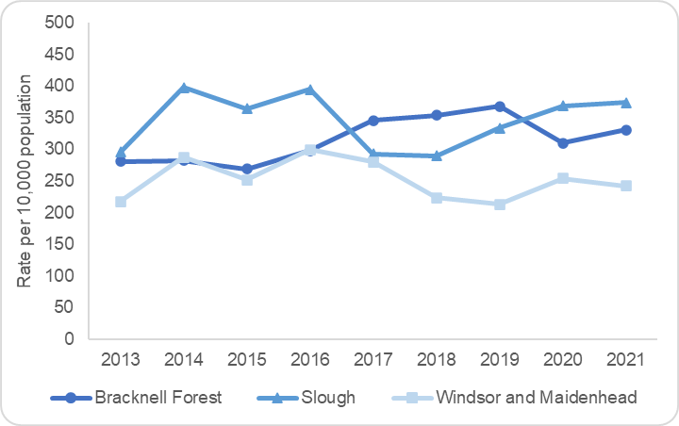
The Department of Education’s (2019) longitudinal analysis found that approximately 6% of children in England are in need at some point over the course of a year. Children in need have poorer outcomes at every stage of education than their peers, with a widening attainment gap as they progress through school. They are also more likely than other children to not be in education, employment or training (NEET).

During 2020/21, Berkshire East had 6,876 children who had at least one episode of need in the year with nearly half of these children living in Slough.

On the snapshot date of 31st March 2021 there were 3,427 children in need in Berkshire East. The rate of children in need varied across the area – Slough’s rate of 374 per 10,000 population was significantly higher than the rest of the local area and the national rate, while RBWM’s rate was significantly lower at 242 per 10,000 population. Figure 26 shows the change in rates for each local authority over the last 8 years.

Figure 27 provides a breakdown of children in need on 31st March 2021 by their primary need group. Abuse or neglect was the main primary need group across all Berkshire East local authorities accounting for 60% of all children in need locally. 73% of children in need in Slough had abuse or neglect as a main primary group, which is significantly higher than the rest of Berkshire East and the national picture.
Source: Department for Education (2021); Characteristics of children in need 2021
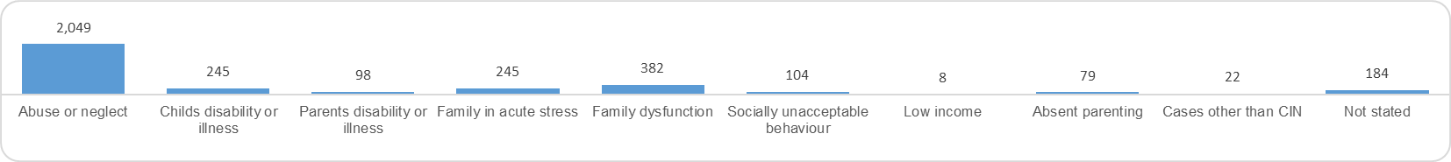
Figure 27: Number of children in need by primary need group for Berkshire East at 31st March 2021

Source: Department for Education (2021); Characteristics of children in need 2021

11% of Berkshire East’s children in need had a disability recorded on 31st March 2021. Figure 28 shows the types of disability that were recorded for these children. Autism and learning disabilities are the most common disabilities across Berkshire East.

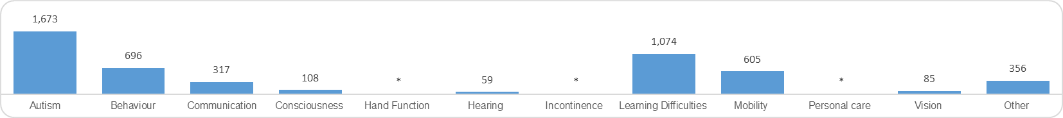
Figure 28: Number of disabilities recorded for Berkshire East’s children in need at 31st March 2021

*shows suppressed figures (under 10 children)
Source: Department for Education (2021); Characteristics of children in need 2021

Child Protection
Figure 29: Rate of child protection plans at 31 March (2013 to 2021)

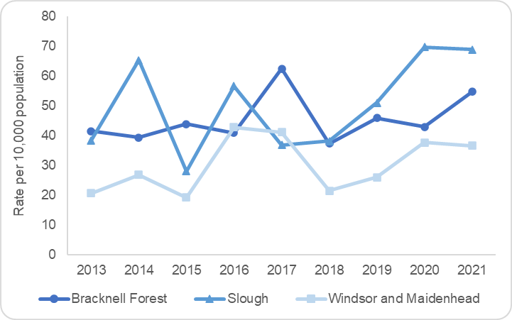
Local authorities have a responsibility to provide child protection plans for children who are at significant risk of harm through physical, emotional or sexual abuse or neglect. Child protection plans are developed with multi agencies and reviewed regularly to ensure that plans are in place to keep children safe.

On 31st March 2021, there were 586 children who were subject to a child protection plan in Berkshire East. This was a rate of 55.2 children per 10,000 population. The local child protection profile is similar to that of all children in need, with half of those subject to a child protection plan living in Slough. Slough’s rates remain significantly higher than the rest of the local area and the national rate, while RBWM’s rates remain significantly lower. Figure 29 shows the change in rates for each local authority over the last 8 years.

Source: Department for Education (2021); Characteristics of children in need 2021

Looked after children
Figure 30: Demographics of looked after children in Berkshire East on 31st March 2021
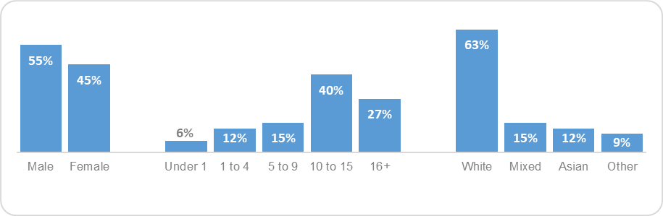
Children and young people in care are among the most socially excluded children in England. There are significant inequalities in health and social outcomes compared with all children and these contribute to poor health and social exclusion of care leavers later in life.

On 31st March 2021, there were 499 looked after children in Berkshire East at a rate of 47 per 1,000 population. All Berkshire East local authorities had a significantly lower rate of looked after children compared to the national figure, although Bracknell Forest has shown an increasing trend over the last 5 years (Department for Education 2021).
Gender Age group Ethnic group
Source: Department for Education (2021); Children looked after in England 2020 to 2021

The local demographics of looked after children are shown at Figure 30. Berkshire East’s profile closely aligns with the national picture with a higher proportion of boys and children aged 10 and over. Berkshire East does have a lower proportion of children in care from a White ethnic group compared to England, which is largely explained by Slough’s more ethnically diverse population. This proportion of cases from a White ethnic group is also lower than the estimated White population of the local area (Department for Education 2021).

Nationally, most children become looked after as a result of abuse and neglect. This is also the case in Berkshire East with 71% of children who entered the care system in 2020/21 doing so for this reason (Department for Education 2021).

Approximately 5% of children and young people looked after in England were unaccompanied asylum seekers on 31st March 2021. Slough and RBWM had similar proportions of unaccompanied asylum seekers, at 4% and 5% respectively, while Bracknell Forest’s figures were supressed due to small numbers. Nationally, this sub group of looked after children are older (aged 16 years and above) boys and are in need due to absent parenting (Department for Education 2021). Many of these children and young people will have additional health needs that are specific to their asylum status, including poorer physical health and increased prevalence of emotional, behavioural and mental health problems (Public Health England 2019).

Although looked after children have many of the same health issues as their peers, the extent of these is often greater because of their past experiences. The Department for Education (2015) explains that almost half of children in care have a diagnosable mental health disorder and two-thirds have special educational needs. Delays in identifying and meeting these needs can have far reaching effects on all aspects of their lives, including their chances of reaching their potential and leading happy and healthy lives as adults. Outcomes for Berkshire East children and young people who have been in care for over a year show that 54% have an identified Special Educational Need, 12% are persistent absentees at school and approximately 10% have had at least one fixed-term exclusion in the year. Educational attainment scores are also significantly lower than children who have not been in care (Department for Education 2021).

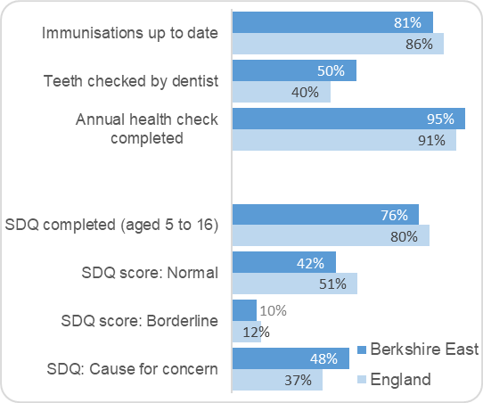
Local authorities are responsible for safeguarding and promoting the welfare of looked after children, which includes a child’s physical, emotional and mental health and acting on any early signs of health issues (Department for Education 2015). As part of this local authorities should ensure that children have access to regular health check-ups. Figure 31 shows that a number of looked after children in Berkshire East were not up to date with their health care checks in 2021. The proportion of looked after children who had their teeth checked by a dentist dropped significantly on the previous year’s figures and this is likely to be an impact of the Covid-19 restrictions. Immunisations and annual health check completions were similar to previous years.
Figure 31: Proportion of children in care who received health checks and outcomes of these checks (2021)

76% of looked after children aged 5 to 16 in Berkshire East had a Strengths and Difficulties Questionnaire (SDQ) score recorded in 2020/21. This short behavioural screening questionnaire is used as a tool to assess the emotional and behavioural health of children. 42% of these children had ‘normal’ emotional and behavioural health, 10% had borderline scores and 48% had scores which were a cause for concern (Department for Education 2021). Bracknell Forest had one of the highest proportions of looked after children whose emotional wellbeing was a cause for concern in the South East at 58% and this was significantly higher than the rest of Berkshire East.

Source: Department for Education (2021); Children looked after in England 2020 to 2021

Bracknell Forest | Slough | Windsor and Maidenhead
Bracknell Forest has similar rates of children in need and child protection plans compared to the national figures. The rates of children in care are significantly lower than England, but are now the highest in Berkshire East. On 31st March 2021:  - 954 children in need at a rate of 331 per 10,000 population  - 158 children subject to a child protection plan at a rate of 55 per 10,000 population  - 146 looked after children at a rate of 51 per 10,000 population | Slough has significantly higher rates of children in need and on child protection plans compared to the national figures. However, the rates of children in care are significantly lower. On 31st March 2021:  - 1,634 children in need at a rate of 375 per 10,000 population  - 301 children subject to a child protection plan at a rate of 69 per 10,000 population  - 223 looked after children at a rate of 51 per 10,000 population | RBWM has significantly lower rates of children in need, child protection plans and looked after children compared to national figures. These are also significantly lower than the rest of Berkshire East. On 31st March 2021:  - 839 children in need at a rate of 242 per 10,000 population  - 127 children subject to a child protection plan at a rate of 37 per 10,000 population  - 130 looked after children at a rate of 37 per 10,000 population

Care leavers
Young people leaving care have often had difficult childhoods and start living independently much earlier than their peers. The previous section has already indicated that abuse and neglect is the main reason for children entering the care system, both nationally and locally, which will have significant and lasting impact on their mental health and emotional wellbeing. The National Audit Office (2015) evidence how a care leaver’s transition to adulthood may also lead to them facing challenging social problems with minimal support. Young people with a background in care are more likely than their peers to have poor social outcomes in later life, including higher risks of homelessness, contact with the criminal justice system, becoming a teenage parent and self-harm.

Local authorities have a responsibility to provide statutory support to help care leavers transition to living independently up to the age of 25. Data reported to the Department for Education shows the accommodation and activity status for care leavers aged 17 to 21 for each local authority. These numbers are small for the Berkshire East local authorities and many of the outcomes have been suppressed to ensure that individuals are not identifiable. The key summary for 2019/20 shows that there were 287 care leavers in Berkshire East aged 17 to 21. 100% of these aged 17 to 18 were in suitable accommodation and 80% of those aged 19 to 21. The proportion of care leavers in education, employment and training (EET) was higher in Berkshire East compared to the national picture – with 71% of 17 to 18 year olds in EET and 55% of 19 to 21 year olds.

Young carers
Young carers are children and young people who provide unpaid care and support to family members, friends, neighbours or others because of a long-term sickness, disability, mental ill health or problems relating to old age. Caring responsibilities can be difficult and stressful at any age, but for young carers the additional responsibility of supporting other people can have long-term effects on their health and wellbeing. The Carers Trust (2014) explain that young carers often talk about feeling tired and under pressure, with many experiencing traumatic life changes such as bereavement, family breakup, losing income or housing and seeing the effects of an illness or addiction on the person that they care for. Their survey of young carers also found that 29% reported that their own physical health was ‘just OK’ and that 38% reported a mental health problem.

In the 2011 census, 801 children aged 0 to 15 were identified as providing unpaid care in Berkshire East. This was approximately 0.9% of the population. A further 1,952 young people aged 16 to 24 were identified as carers, which was 4.7% of this population. The amount of care provided by young carers varies on an individual basis, however 131 children (aged 0-15) and 490 young people (aged 16-24) in Berkshire East regularly provided 20 hours or more care a week at the last census (Office for Health Improvement and Disparities 2021). The Carers Trust (2014) explain that further analysis of the 2011 census showed that young carers providing this level of care (between 20 and 49 hours a week) were over 3 times more likely to report their health as not good compared to other children without caring responsibilities.

Young carers are defined as children in need and are therefore entitled to support from local children’s social care. In 2019/20, the impact of being a young carer was factored into 55 children social care assessments across Berkshire East (Department of Education 2021).

Special Educational Needs and disabilities (SEN)
A child or young person aged from 0 to 25 years has special educational needs or disability (SEN) if they:
- Have a learning difficulty or disability which makes it much harder for them to learn than other pupils of the same age
- Require special educational provision to be made for them

SEN could include needs related to a child’s communication and interaction, their cognition and learning difficulties, their social, emotional and mental health and/or their sensory and physical needs. Children and young people with identified needs can be given specific SEN support at school, such as speech therapy. Those with more complex needs may require an Education, Health and Care (EHC) plan that provides additional support that mainstream schools cannot usually deliver (Department for Education 2015).

In January 2021, 14.9% (12,448) of all pupils in Berkshire East schools had a special educational need (SEN) identified. 3.5% (2,950) of these pupils had an Education, Health and Care (EHC) Plan, while 11.4% (9,498) received SEN support. The proportion of children with SEN has remained static in Berkshire East over the last five years, while national figures have seen a steady increase (Department for Education 2021). A summary of the proportion of children with SEN in January 2021 is shown at Figure 32.

Figure 33 shows that the majority of children with identified SEN were in Berkshire East’s state-funded primary schools in January 2020 (44%). 32% were in state-funded secondary schools, 13% in independent schools and 8% in special schools (state-funded and non-maintained) (Department for Education 2021).
Figure 32: Proportion of children in Berkshire East schools who have a Figure 32: Number of children with identified SEN in Berkshire East schools
Special Educational Need (SEN) (January 2021) (January 2021)

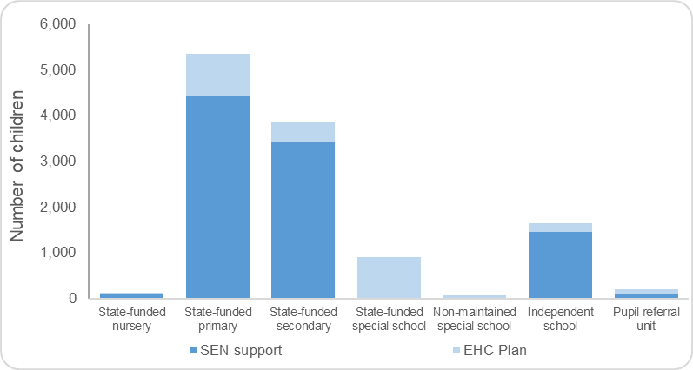
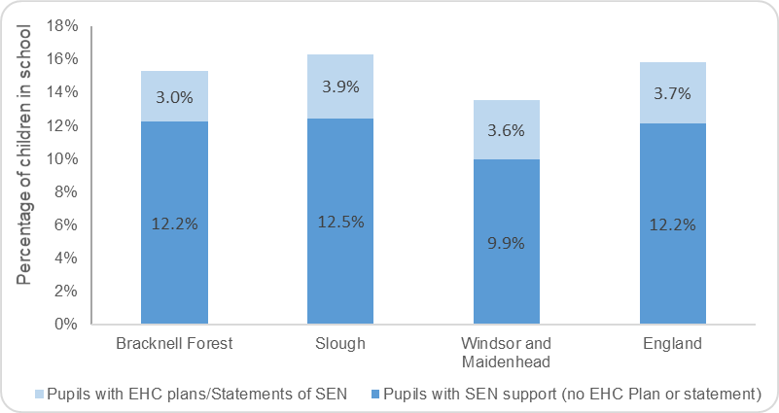
Source: Department for Education (2021); Special educational needs in England: January 2021

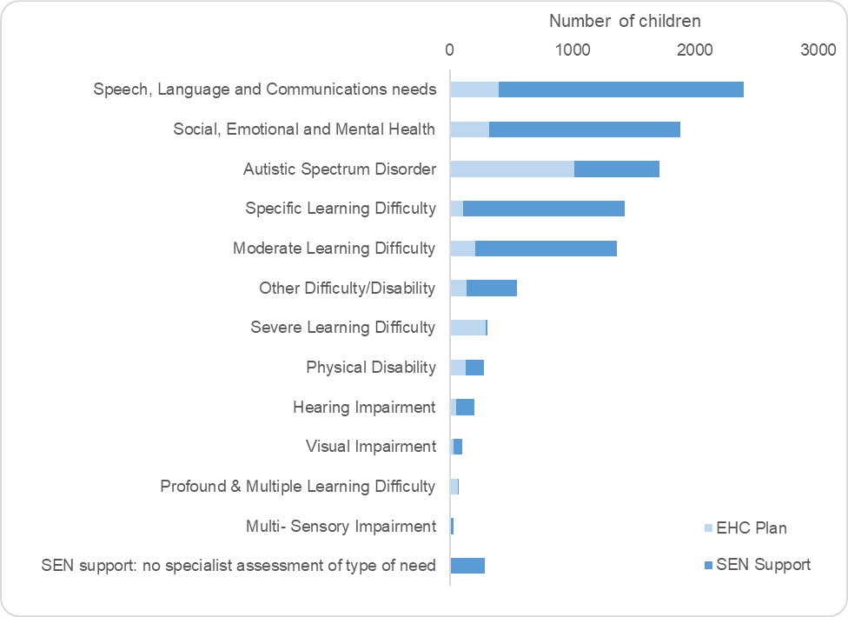
Speech, Language and Communication Needs and Social, Emotional and Mental Health are the most common primary types of need for children with SEN in Berkshire East. These account for 23% and 18% of all children with SEN respectively. Children with Autistic Spectrum Disorders as their primary need make up 37% of all children with a EHC Plan. A further breakdown is shown at Figure 34.
Figure 34: Number of SEN children in Berkshire East schools by primary need type (January 2021)

National data from January 2021 shows that the distribution of each primary type varies greatly between those identified as SEN Support and those who have an EHC Plan. A much higher proportion of children with ASD have an EHC Plan, while children with Speech, Language and Communication Needs, Moderate Learning Difficulties and Social, Emotional and Mental Health needs receive more SEN Support. This information is not available at a local level, but is likely to be a reflection of the national picture (Department for Education 2021).

Local data is also not available on the demographics of children with SEN. However, nationally it is clear that special educational needs are more prevalent in certain groups:
- Boys are almost twice as likely to be receiving SEN support than girls
- SEN support is most prevalent in primary school age groups and decreases through secondary age groups. The most prevalent ages are aged 9 for boys and age 10 for girls.
- The proportion of children with an EHC Plan increase with age from 2% at age 5 to 4% at age 15.
Source: Department for Education (2021); Special educational needs in England: January 2021

- Children from a Gypsy/Roma or Irish traveller heritage have the highest prevalence of SEN, compared to all other ethnic groups. Those from Indian and Chinese backgrounds have the lowest.
- Pupils with free school meal eligibility are more than twice as likely to have SEN compared to those without eligibility
- Pupils with English as a first language are slightly more likely to be identified with SEN than those whose first language is other than English.
(Department for Education 2021)

Bracknell Forest | Slough | Windsor and Maidenhead
15.3% (3,292) of pupils in Bracknell Forest schools were identified as SEN in January 2021. 3.0% had an EHC and 12.1% received SEN support.  5.9% (196) of children with SEN are in special schools within the Borough. | 13.5% (4,558) of pupils in Slough schools were identified as SEN in January 2021. 3.6% had an EHC and 9.9% received SEN support.  7.8% (356) of all children with SEN are in special schools within the Borough. | 16.3% (4,598) of pupils in RBWM schools were identified as SEN in January 2021. 3.9% had an EHC and 12.5% received SEN support.  RBWM’s prevalence of SEN is the highest in Berkshire East and this is partly due to the number of children in special schools within the Borough. 9.4% (434) of all children with SEN are in special schools within RBWM. It is important to note that many of these children may live in the surrounding area and not be resident in the Borough.

Gypsy Roma and Travellers (GRT)
The umbrella term of Gypsy, Roma and Traveller (GRT) describes a diverse minority group who come from a range of ethnic groups. These include Gypsies (English, Scottish, Welsh and Romany), those with Irish Traveller roots, and Roma who are understood to be more recent migrants from Central and Eastern Europe (UK Government 2019). GRT are among the most disadvantaged people in the country and have poor outcomes in key areas such as health and education:
- Pupils from Gypsy or Roma backgrounds and those from Traveller Heritage have the lowest attainment of all ethnic groups through their school years
- Almost half of GRT students are classed as persistent absentees at school with many ‘missing’ from education altogether
- Life expectancy is 10 to 12 years less than that of non-Traveller populations
- 42% of GRT are affected by a long-term condition, compared to 18% of the general population
- One in five GRT mothers will experience the loss of a child, compared to one in a hundred in the non-Traveller community

In 2011, the census collected information about Gypsy and Traveller people for the first time. This identified that there were 557 people from this group in Berkshire East, including 234 children and young people aged 0-19. It is acknowledged that the census count is likely to be an underestimation of the number of people from a GRT background living in local areas.

Bracknell Forest | Slough | Windsor and Maidenhead
0.1% of the population are from a Gypsy and Traveller group (118 people, 45 who are aged 0-19).  College Town has the highest proportions of people from a Gypsy Traveller Group in Bracknell Forest (0.6% of total population in ward; 30% of all GRT in Bracknell Forest). | 0.2% of the population are from a Gypsy and Traveller group (220 people, 97 who are aged 0-19).  Colnbrook with Poyle has the highest proportions of people from a Gypsy Traveller Group in Slough (0.6% of total population in ward; 36% of all GRT in Slough). | 0.2% of the population are from a Gypsy and Traveller group (219 people, 92 who are aged 0-19).  Datchet, Horton & Wraysbury has the highest proportions of people from a Gypsy Traveller Group in RBWM (0.7% of total population in ward; 31% of all GRT in Slough).

So what is this telling us?

This section summarises the key points about Berkshire East’s children and young people that have been highlighted through this data review and areas that may require further investigation.

Berkshire East
Population | Berkshire East’s population is younger than the national profile with higher proportions of the population aged 5 to 14.  Projections show that the number of 0 to 19s will decrease over the next 20 years and that the proportion of the total population in this age group will also reduce. Berkshire East will still continue to have a younger population than the national profile.
Ethnicity and language | The levels of ethnic diversity across Berkshire East vary significantly. Bracknell Forest has a lower proportion of children and young people from a non-White British group compared to England, while Slough has one of the highest proportions in England. Children and young people from Asian/Asian British background makeup the largest minority group in Berkshire East and this is the case across all three local authorities. The ethnic profile of all areas in Berkshire East is continuing to change and this can be evidenced by the ethnic backgrounds of children in Berkshire East schools and the proportion of births from mothers who were born outside of the UK.  Over 21,500 children who attend Berkshire East schools do not have English as a first language. 75% of these are in Slough schools.
Deprivation | 11% of Berkshire East children aged 0 to 15 are living in income-deprived households, which is a reduction on the 2015 figure. This is over 10,000 children.  Levels of deprivation vary significantly across Berkshire East. Slough has more deprived areas than the rest of Berkshire East, however Bracknell Forest and RBWM both have neighbourhoods where approximately 20% of children are affected by deprivation.
Child development at 2 – 2 ½ years | 69% of 2 to 2 ½ year olds received a development review in 2020/21, which was significantly lower than the national figure.  The proportion of 2 to 2 ½ year olds who meet the expected level in the 5 skill areas varies across Berkshire East from 80% in Slough to 93% in Bracknell Forest.
Healthy Weight | Although Berkshire East’s levels of excess weight (being overweight or obese) are similar to the national average for both age groups, there is variation across and within the three local authorities. Locally there is an association between excess weight and deprivation, which is more evident for the older age group. This reflects the national picture.  Reception children from Black ethnic groups have a higher prevalence of obesity in Berkshire East, compared to those from a White or Asian group.

Mental Health | The prevalence of mental health disorders has increased during the pandemic with 16% of children aged 5 to 16 now estimated to have a probable mental disorder compared to 11% in 2017.
Sexual Health | The proportion of 15 to 24 year olds screened for chlamydia is lower in Berkshire East than the national figure. The case detection rate of 1,681 per 100,000 population in 2019 was also significantly below the national rate and the PHE recommendation of 2,300 per 100,000 population. Screening and detection rates dropped significantly in 2020, due to Covid-19 restrictions.  Young people aged 15 to 19 have the second highest rate of new STI diagnoses in Berkshire East, following those aged 20 to 24.
Adverse Childhood Events and vulnerabilities | Local data on the prevalence and impact of Adverse Childhood Events is not known. However, it is clear that the prevention and early identification of these events is essential to the future health and wellbeing of children in Berkshire East.  Modelled estimates indicate that there are 17,500 children and young people in Berkshire East living in households where domestic violence and abuse, parental substance misuse or parental mental health issues are affecting an adult in the household. 1,100 children and young people are living in households where all three of these factors are present.

Bracknell Forest
Population | Bracknell Forest’s 0 to 19 population will see the largest decrease in Berkshire East over the next 10 years (6.6%).
Ethnicity and language | Bracknell Forest has a significantly lower proportion of children and young people from a non-White British background compared to the rest of Berkshire East and England. The proportion of school-children who do not have English as a first language is also significantly lower.  The proportion of births from mothers who were born outside of the UK is increasing at a faster pace in Bracknell Forest than the rest of Berkshire East.
Deprivation | No 0 to 15 year olds live in the most deprived quintile nationally. The most deprived neighbourhood in the area is in Wildridings and Central ward with 21% of children living in income-deprived households.
Child development at 2 – 2 ½ years | Bracknell Forest’s published Health Visiting data for 2020/21 was incomplete, as it did not include activity for 3 months. The scaled-up data for the full-year indicated that the proportion of children receiving a 2 to 2 ½ year development check was particularly low at 57%. In previous years Bracknell Forest’s level of reviews has been significantly higher than the rest of Berkshire East and the national figure at approximately 90% of eligible children.
Healthy Weight | Data from 2015/16 to 19/20 shows an association between deprivation and obesity in Bracknell Forest.  Reception children and Year 6 children from a White ethnic group have a lower prevalence of obesity in Bracknell Forest, compared to those from Black and Asian groups.
Mental Health | Bracknell Forest has significantly higher rates of under 18 hospital admissions for mental health conditions compared to the rest of Berkshire East (141 admissions per 100,000 population). These are also significantly worse than England.
Looked after children | Results from Strengths and Difficulties Questionnaires indicate that Bracknell Forest has one of the highest proportions of looked after children whose emotional wellbeing is a cause for concern in the South East. This is also significantly higher than the rest of Berkshire East.  The rate of Looked After Children in Bracknell is significantly lower than the national figure, however there has been an increase over the last 5 years.

Slough
Population | Slough has the largest number of children and young people aged 0 to 19 in Berkshire East and these make up 31% of the total population. The proportion of Slough’s population from the 0 to 14 age group is significantly higher than the rest of Berkshire East and the national picture.
Ethnicity and language | 73% of children and young people in Slough are from a non-White British background, which is significantly higher than the rest of Berkshire East and England. 86% of school-children in Slough do not have English as a first language.  Slough has the 2nd highest proportion of births from mothers who were born outside of the UK in England at 69%.
Deprivation | 15% of children aged 0 to 15 in Slough are from income-deprived households and 3% of 0 to 15 year olds live in the most deprived quintile nationally. Deprivation is more wide-spread across Slough rather than being in specific neighbourhoods.
Housing | 13% of households in Slough are overcrowded, which is significantly worse than the rest of Berkshire East and England.  The rate of households that are homeless or threatened with homelessness are significantly higher in Slough compared to England. This is the case for households with dependent children and also those headed by a young person (aged 16 to 24).
Employment | Slough has significantly worse employment and unemployment rates than England for people aged 16 to 64.
Maternal and infant health | Fertility - Slough has the highest Total Fertility Rate in England. This has decreased over the last 5 years, but still remains much higher than the rest of Berkshire East.  Low birth weight – Slough has the highest proportion of babies born with a low-birth weight in the South East and this has increased over the last 5 years.  Infant mortality – Slough has the 2nd highest infant mortality rate in the South East, although this is similar to the national figure.
Child development at 2 – 2 ½ years | 80% of children in Slough who received the 2 to 2 ½ year ASQ-3 development review in 2020/21 were meeting the expected levels in all 5 skill areas. This proportion was significantly lower than the national figure and was the lowest level in Berkshire East.
Dental Health | In 2018/19, 38% of 5 year olds in Slough had visually obvious dental decay. This was the highest level in the South East and significantly worse than the national figure.
Healthy Weight | Data from 2015/16 to 19/20 shows an association between deprivation and obesity in Slough, particularly for the Reception aged group.  The difference in obesity prevalence between ethnic groups is not as great in Slough compared to the rest of Berkshire East. Reception children and Year 6 children from a Black ethnic group do have higher prevalence than those in White and Asian groups, however this is not significantly different.

Sexual Health | All local authorities saw a drop in chlamydia screening and detection from 2019 to 2020, as a result of the Covid-19 restrictions. However, the decrease in Slough’s screening and detection was much greater than other areas in Berkshire East. Screening dropped from 21% of the 15 to 24 year old age group in 2019 to 10% in 2020.
Children in Need | Slough has the highest rate of children in need and children on a protection plan in Berkshire East. These rates are also significantly higher than England’s.
Adverse Childhood Events and vulnerabilities | Modelled estimates indicate that the rate of children and young people from Slough who living in households where domestic violence and abuse, parental substance misuse or parental mental health issues are affecting an adult in the household are higher than the rest of Berkshire East.

Windsor and Maidenhead
Population | RBWM’s 0-19 population has already started to decline. The overall reduction in this age group is not expected to be as large as the other areas in Berkshire East.
Ethnicity and language | The proportion of children and young people from a non-White British ethnic group is similar to England’s. The school census suggests that this is increasing over time with a higher proportion of primary-school children from a BAME group.
Deprivation | RBWM has the lowest levels of children living in income-deprive households in Berkshire East and no 0 to 15 year olds live in the most deprived quintile nationally. The most deprived neighbourhood in the area is in Datchet, Horton & Wraysbury ward with 19% of children living in income-deprived households.
Housing | RBWM is the least affordable area in the South East for residents to purchase a home, based on the current median house price and median earnings in the area. This will particularly affect young people and first time buyers who may not be able to afford to live in the area that they have grown up in.
Breastfeeding | Breastfeeding prevalence data for RBWM has not been published for the last 5 years, as the proportion of babies with a breastfeeding status has not met the minimum data quality standard of 95%.
Child development | The proportion of children receiving a 2 to 2 ½ year development review in RBWM increased significantly in 2020/21. However, the proportion of children who completed the ASQ-3 as part of this review was still significantly lower than England and the rest of Berkshire East at 82%.

Attainment gap | RBWM has the largest school readiness attainment gap in Berkshire East between all children and those who are eligible for Free School Meals.
Healthy Weight | Data from 2015/16 to 19/20 does not show a clear association between deprivation and obesity in RBWM, unlike other areas in Berkshire East and the national picture.  Reception children from a Black ethnic group have a higher prevalence of obesity compared to those from White and Asian groups.  Reception children and Year 6 children from a White ethnic group have a lower prevalence of obesity in RBWM, compared to those from Black and Asian groups.
Lifestyle behaviours in 15 year olds | RBWM’s self-reported prevalence of smoking, drinking alcohol and taking drugs (other than cannabis) in 15-year olds is higher than the rest of Berkshire East and similar to England’s. The proportion of 15-year olds who said they had taken cannabis in the last month was also significantly higher than England and the rest of Berkshire East.
Not in Employment, Education or Training (NEET) | 6.3% of young people aged 16 to 17 are not in employment, education or training (NEET). This is significantly worse than the rest of Berkshire East and England.
Special Educational Needs | The number and rate of children with Special Educational Needs in RBWM is the highest in Berkshire East. This is partly due to the number of children in special schools within the Borough. It is important to note that many of these children may live in the surrounding area and not be resident in the Borough.

Current service provision in Berkshire East

Range of services available to CYP and Others
This HNA seeks to describe an environment where a very wide range of service offers from local authorities, the NHS and voluntary and community sector partners are involved. It primarily looks at agendas and data associated with the key Public Health commissioned CYP service offers, the 0 to 19 Health Visiting and School Nursing Services, but it is important to note the very broad range of other service offers from local authorities, the NHS and the Voluntary and community sector. If we consider the different locations that a child can access or visit from birth, all the way through childhood and on into adulthood we see a wide range of settings including health, education, social care and leisure, alongside the homes, neighbourhoods and communities in which we live. It would be impossible to reflect all of the differing inputs across all elements of the statutory offer for children from Health, Education and Social Care let along reflect the breadth of support available from community and commercial services.

To be deliverable this HNA has had to narrow its scope to a narrow range of CYP agendas and the services or the metrics available. We would of course welcome any and all suggestions on key additional areas for consideration in future versions or supporting materials that will emerge as the Berkshire East JSNA takes shape.

Current service provision – Healthy Child Programme
This section looks at the current service provision for the Healthy Child Programme across Berkshire East. The three local authorities all commission different providers, as detailed below.

Bracknell Forest | Slough | Windsor and Maidenhead
Berkshire Healthcare Foundation Trust (BHFT) are commissioned to provide the Health Visiting and School Nursing Services for Bracknell Forest. This commissioning arrangement has been in place since October 2015 for Health Visiting. | Solutions 4 Health are commissioned to provide the 0 to 19 Service incorporating Health Visiting and School Nursing Services in an integrated offer. | Achieving for Children (AfC) are commissioned to provide the Health Visiting and School Nursing Services for RBWM. This commissioning arrangement has been in place since October 2015 for Health Visiting.

The information included in this section includes nationally published data and performance metrics that have been supplied by current providers. Data for 2020/21 has been included where possible, but this will have been impacted by the Covid-19 restrictions and should be treated with caution.

Health Visiting Service

The health visiting service leads on the delivery of the Healthy Child Programme (HCP), which was set up to improve the health and wellbeing of children aged 0-5 years. These teams consist of specialist community public health nurses (SCPHN), registered midwives and nurses who specialise in working with families with a child aged 0 to 5 to identify health needs as early as possible and improve health and wellbeing by promoting good health behaviours, preventing ill health and reducing inequalities (NHS 2019). This is accomplished through health and development reviews, health promotion and education, parenting support and screening and immunisation programmes. In addition, these services provide expert information, assessments and interventions for babies, children and families, including first time mothers and fathers who have more complex needs.

In October 2015, the responsibility for commissioning children’s public health for 0 to 5 year olds transferred from NHS England to local authorities (Public Health England 2019). Since this time, Berkshire East’s three local authorities have commissioned separate providers to deliver this service. All of the local Health Visiting providers complete quarterly performance information reports for their respective local authorities. These capture progress against the key service delivery metrics that have been outlined nationally, which include health reviews for pregnant women, children and their families at several stages. Local providers also share metrics against locally agreed priorities and backing data to provide more detailed information about how children and families have been supported.

Antenatal contact
The antenatal health promoting visit is usually carried out by the health visiting service between 28-32 weeks of pregnancy. This is often the health visiting service’s first contact with the family and is crucial for developing the relationship. Research suggests this is important because an effective first contact positively impacts on the parents’ use of the service in the long-term (Baldwin et al 2017).
The antenatal health promoting visit does not replace the care provided by midwifery services and instead complements it by working across the antenatal service continuum encompassing hospital, primary care and community services.

Comparable metrics around antenatal contacts are not available. A summary of the local metrics shared by local providers is summarized below.

Bracknell Forest – Berkshire Healthcare Foundation Trust
In 2019/20, 579 mothers received a first face to face antenatal contact with a health visitor at 28 weeks or above. In 2020/21 Q2, Q3 and Q4, BHFT received 736 antenatal notifications for mothers in Bracknell Forest. This was 86% of the New Birth Visit rate in Q4. 225 were sent electronic information including Solihull access details and 18 received face to face family health needs assessment. Due to COVID service suspension, antenatal contacts reduced, and only targeted assessments completed. All other mothers were sent electronic information and signposted to online Solihull courses.

Figure 35: Proportion of pregnant women who were offered or received an Figure 36: BHFT Antenatal activity for pregnant women in Bracknell Forest
antenatal contact in Bracknell Forest (2020/21) (2020/21)

Source: Berkshire Healthcare Foundation Trust (2021)

Slough – Solution 4 Health

The operational data included below presents challenges in completeness and does not reflect all of the operational impacts inherent to community delivery. This should therefore be viewed with caution. It presents a useful snapshot of performance data for Universal and Targeted antenatal contacts as an indication only (pending verification of data through the community data set collection).

There has been a marked decline in the number of mothers receiving a first face to face antenatal contact, with a decline of all notified antenatal face to face contacts. Notwithstanding issues in data collection and completeness in Q1-Q4 2019/20 the 2021 to 2022 data shows ongoing activity with the crucial delivery pressures of the pandemic (face to face service offer disruption, take up of the offer alongside ongoing capacity and delivery issues) for the Universal offer with a decline in offer and take up from the Q2 20/21 highpoint of 61% of notifications seen to the most recent Q2 21/22 of 22%.

Figure 37: Antenatal contacts – Universal offer in Slough

 | Number notified to antenatal team in quarter | Number offered contact | % of notifications offered contact | Number of offered seen | % of offered seen | % seen out of all notified
2020/21 Q1 | 373 | 373 | 100 | 173 | 46% | 46%
2020/21 Q2 | 269 | 212 | 79% | 164 | 77% | 61%
2020/21 Q3 | 312 | 272 | 87% | 174 | 64% | 56%
2020/21 Q4 | 328 | 174 | 53% | 154 | 89% | 47%
2021/22 Q1 | 332 | 146 | 44% | 86 | 59% | 26%
2021/22 Q2 | 373 | 146 | 39% | 81 | 55% | 22%

Source: Solutions 4 Health 2021

The Service continues to prioritize the targeted support offer but has faced a decline in face-to-face contacts since Q1 20/21. As above date completeness and quality issues are a key factor, especially within the targeted offer working environment. Fluctuations in performance data do not necessarily reflect operational reality or caseloads and contacts established. However, there has been a decline in reported activity and appropriate action plans initiated to address the decline in contacts.

Figure 38: Antenatal contacts – Targeted offer in Slough

 | Number notified to antenatal team in quarter | Number offered contact | % of notifications offered contact | Number of offered seen | % of offered seen | % seen out of all notified
2020/21 Q1 | 54 | 54 | 100 | 40 | 74% | 74%
2020/21 Q2 | 94 | 82 | 87% | 68 | 83% | 72%
2020/21 Q3 | 87 | 75 | 86% | 54 | 72% | 62%
2020/21 Q4 | 93 | 66 | 71% | 57 | 86% | 61%
2021/22 Q1 | 97 | 64 | 66% | 49 | 77% | 51%
2021/22 Q2 | 109 | 70 | 64% | 42 | 60% | 39%

Source: Solutions 4 Health 2021

RBWM – Achieving for Children
Figure 39: Number of mothers receiving a first face-to-face antenatal contact with a Health Visitor

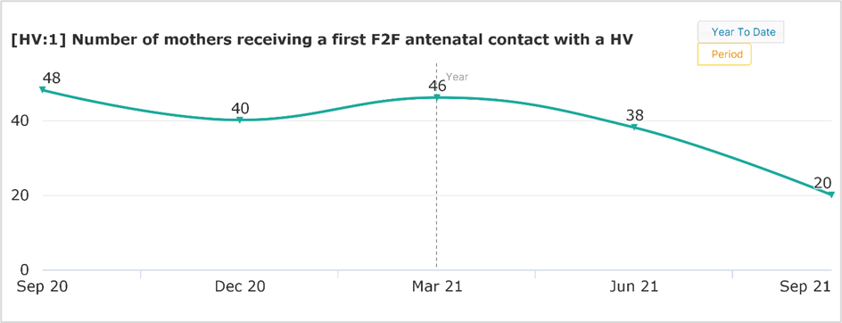
The number of mothers receiving a face-to-face visit has decreased substantially by over 50%, from September 2020 to September 2021. It is important to note that this data only reflects those who received a face-to-face visit, however the services over the COVID period were significantly impacted and moved into a hybrid model, offering both in-person visits and online appointments, meaning the actual number of contacts may be higher, but this may not be reflected in the data.
Source: Q2 InPhase data provided by Achieving for Children (2021); Health Visiting data for RBWM data (as of September 21 – Afc data for Health Visitors and School Nurses is subject to update as figures are finalised, treat figures with caution)

New birth visits
All babies and families are eligible to receive a face to face visit from a Health Visitor within the first two weeks after birth. This New Birth Visit (NBV) helps to ensure a continuum of support following on from midwife visits that usually end at day 10. The NBV can identify development issues with the baby, including early referral to a specialist team where required, and also gives an opportunity to support safe sleeping, feeding and discuss any concerns or worries, including maternal mental health.

In 2020/21, 98% of babies that turned 30 days old in Berkshire East received a face to face NBV from commissioned Health Visiting Services. This was 4,855 visits in total. 91% of the NBVs were within 14 days of birth, which was significantly better than the national figure of 88% (Public Health England 2021). All three local authority areas saw an increase in the proportion of visits being completed within 14 days from 2018/19 to 2020/21. RBWM’s performance remained lower than the other two local authorities, but is now in line with the national figure.

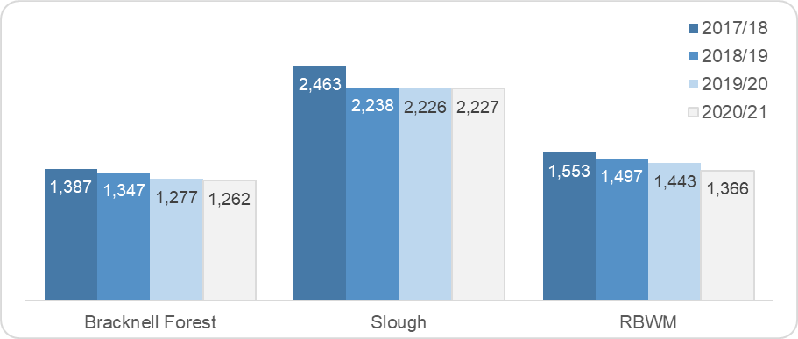
Figure 40: Total number of New Birth Visits completed for infants aged 30 days Figure 41: Proportion of New Birth Visits completed within 14 days of birth

Source: Public Health England (2021); Health visitor service delivery metrics: 2020-21 annual data

The number of infants aged 30 days has reduced by 10% (559 Infants) in Berkshire East over the last four years. The largest change has been in RBWM where there has been an 13% reduction over this time.
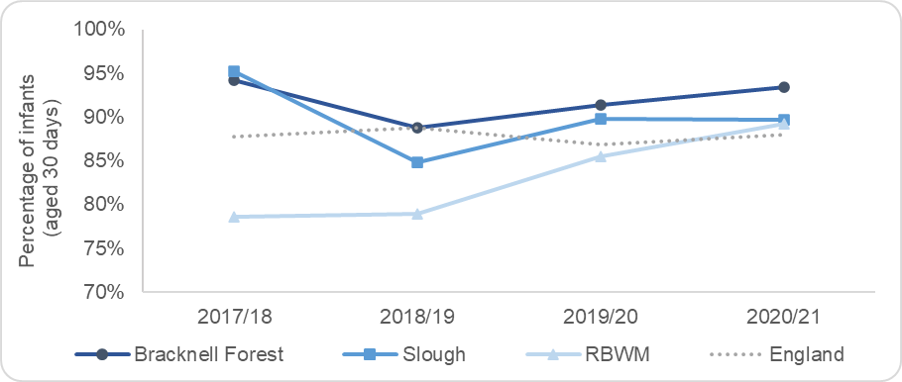

6-8 week reviews
In 2020/21, 4,376 6-8 week reviews were completed for babies in Berkshire East. 89% of babies received their review before they were 8 weeks old, compared to 85% nationally. There was some variation in the proportion of reviews completed in the three local authorities, as shown in Figure 43. Bracknell Forest and Slough’s proportion of reviews completed within 6-8 weeks remains higher than RBWM’s, however this has significantly improved in the Royal Borough over the last year and is also now higher than the national figure.

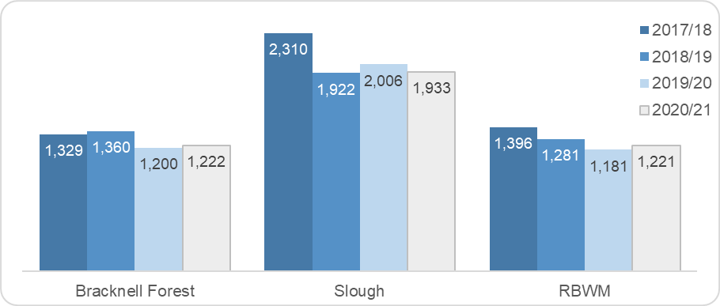
Figure 42: Total number of infants who received a 6-8 week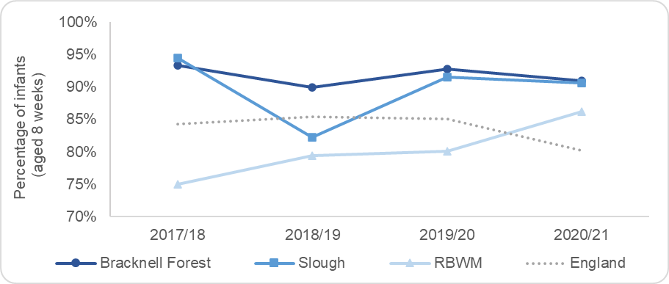 review Figure 43: Proportion of infants aged 8 weeks old who received a 6 week
review

Source: Public Health England (2021); Health visitor service delivery metrics: 2020-21 annual data

The number of infants aged 8 weeks has reduced by 16% (932 Infants) in Berkshire East over the last four years. The largest change has been in RBWM with a 25% reduction.

One of the key indicators collected through the 6-8 week review is the prevalence of breastfeeding. Breastfeeding is an important public health priority and one of the high impact areas included in the Healthy Child Programme. Breastfeeding can help to give babies the best possible start in life and also improve infant and maternal health and wellbeing. Health Visitors are well positioned to support mothers with breastfeeding as they provide continuous and active support.

Figure 42 shows the breastfeeding prevalence rates for infants aged 6-8 weeks in Berkshire East. Bracknell Forest’s rate has remained significantly higher than the national prevalence and Slough’s was also significantly higher in 2019/20 and 2020/21. Data for RBWM is not available for the last 6 years, as the proportion of babies with a breastfeeding status recorded has not reached the data validation threshold of 95% each year. This is also the case for Slough’s prevalence in 2017/18 and 2018/19 (Public Health England 2021).

Figure 44: Breastfeeding prevalence at 6-8 weeks in Berkshire East Figure 45: Breastfeeding status for infants aged 6-8 weeks in Berkshire East
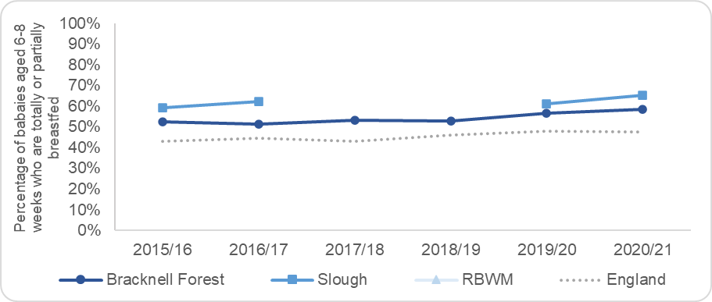
(2020/21)
Source: Public Health England (2021); Breastfeeding at 6 to 8 weeks after birth: annual data

12 month review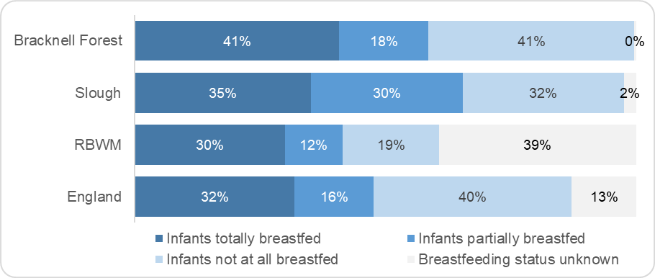
In 2020/21, Health Visiting Services completed 4,314 12 month reviews for children in Berkshire East. 95% of these were completed by the time a child turned 12 months and the other 5% were completed by the time they were 15 months old. 85% of eligible children received a 12-month review during this time period, with approximately 745 children not receiving this developmental check (133 in Bracknell Forest, 319 in Slough and 293 in RBWM).

Figure 46: Total number of infants aged 15 months who had received a Figure 47: Proportion of children who received a 12 month review by the
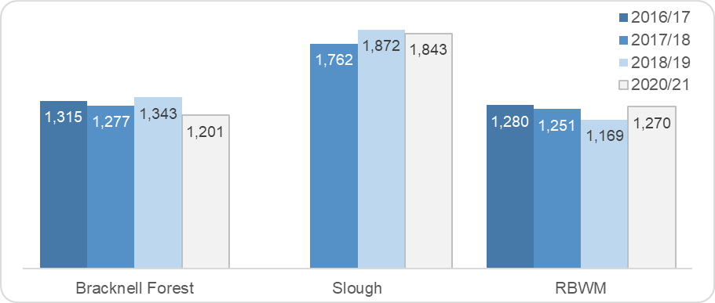
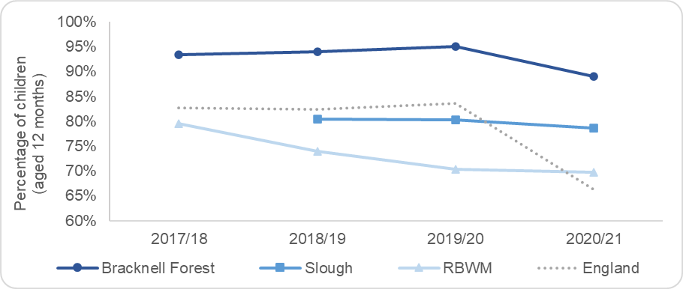
12-month review time they were 12 months old

Source: Public Health England (2021); Health visitor service delivery metrics: 2020-21 annual data

2 to 2 ½ year reviews
Disparities in child development are often recognisable in the second year of life and can have an impact by the time a child reaches school age. If left unsupported, these children will be more likely to not achieve their full potential (Public Health England 2021). Since 2015, all children in England became eligible for a Healthy Child Programme development review around the time of their 2nd birthday, which is delivered as part of the universal health visitor service. Health visiting teams should be using the Ages and Stages Questionnaire (ASQ-3) as part of the 2 to 2 ½ year review. This questionnaire provides an objective measure of development and helps to identify children who may not be developing as expected, supporting decisions for continued monitoring or referral onto early intervention services where required. The ASQ-3 includes several domains to monitor the development of a range of skills, including communication, gross motor, fine motor, problem solving and personal-social skills.

In 2020/21, Health Visiting Services completed 3,772 2 to 2 ½ year reviews and 94% of these were done using the Ages and Stages Questionnaire (ASQ-3). 69% of eligible 2 to 2 ½ year olds received a review during the year, which meant 1,698 children did not receive this development check (621 in Bracknell Forest, 640 in Slough and 437 in RBWM).

Bracknell Forest’s published Health Visiting data for 2020/21 was incomplete for this indicator, as it did not include activity for 3 months. The scaled-up data for the full-year indicated that the proportion of children receiving a 2 to 2 ½ year development check was particularly low at 57%. In previous years Bracknell Forest’s level of reviews has been significantly higher than the rest of Berkshire East and national figures at approximately 90%. RBWM’s completion of reviews increased in 2020/21 and is now in line with the national figure.

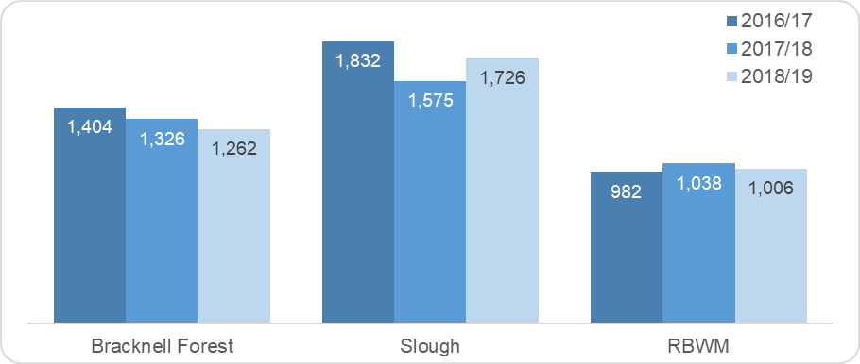
Figure 48: Total number of children who received a 2 to 2 ½ year review Figure 49: Proportion of children who received a 2 to 2 ½ year 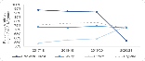review
Source: Public Health England (2021); Health visitor service delivery metrics: 2020-21 annual data

The number of children aged 2 ½ and therefore eligible for a review has reduced by 8% (500 children) in Berkshire East over the last four years.

The outcomes of the ASQ-3 questionnaires completed in 2020/21 indicated that 83% of 2 to 2 ½ year olds in Berkshire East were meeting the expected levels in all 5 skill areas. Figure 50 shows how this varies across Berkshire East and compared to England.

Figure 50: Proportion of children who were at or above the expected level of development in the 2 to 2 ½ year review – by skill area (2020/21)

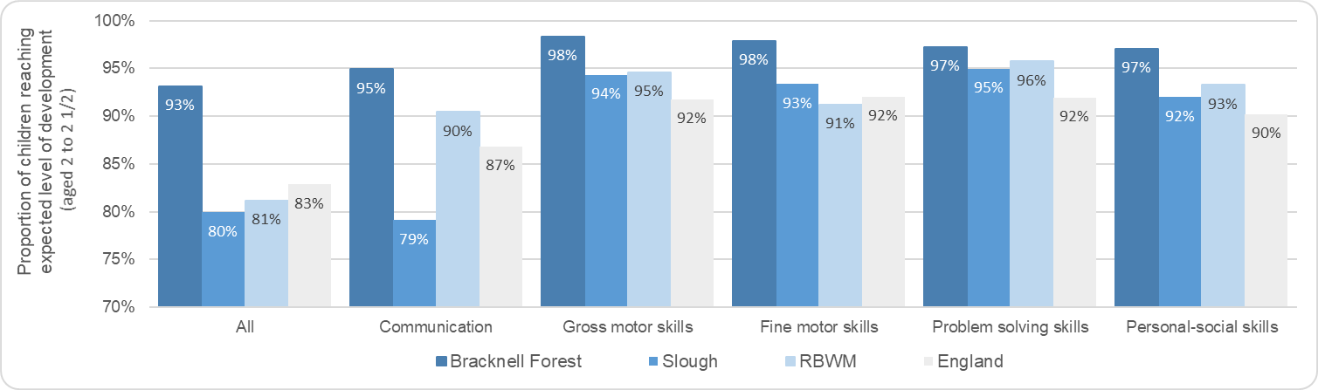
Source: Public Health England (2021); Child development outcomes at 2 to 2 and half years: experimental statistics 2020 to 2021 data

In 2020/21, 17% (590) of children in Berkshire East were identified as having one or more skill areas that did not meet the expected level. 83% of these children had a communication development need. Figure 51 shows the number of children who did not meet the expected level of development for each of the domains in the ASQ-3 and highlights local variation. The proportion of children in Slough not meeting expected levels of development is significantly higher than the national figures, particularly in communication skill, while Bracknell Forest’s remains significantly lower.
Figure 51: Number of children who did not meet expected level for each ASQ-3 development domain (2020/21)

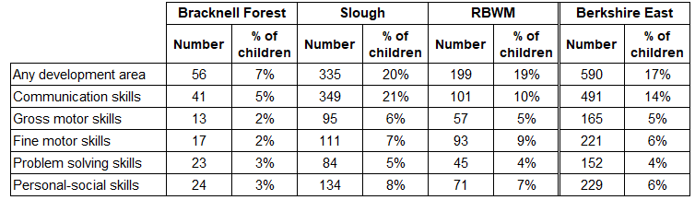
Source: Public Health England (2021); Child development outcomes at 2 to 2 and half years: experimental statistics 2020 to 2021 data

Health Visiting caseloads, clinics and drop-ins
Local authorities receive information about other Health Visiting activity from their providers. These are not national metrics and are therefore supplied differently, depending on the commissioning arrangements put in place locally. Information is shown below for Bracknell Forest’s provider.

BHFT provide information about the number and status of children on the Health Visiting caseload at the end of each quarter. In 2020/2021 Q4 (Jan-March 2021), there were 7187 children on the Health Visiting caseload in Bracknell Forest. This was a decrease (7922) from previous year (2019/20). Figure 52 provides a more detailed breakdown of BHFT’s health visiting caseloads for Bracknell Forest.

Figure 52: BHFT Health Visiting caseloads in Bracknell Forest (2020/21 Q4 – Jan to March 2021: Term 2)

 | Bracknell Forest
Health Visiting caseload (total) | 7187
Caseload per Health Visitor (1 FTE) | 589.1
Universal Partnership Plus caseload per Health Visitor (1 FTE) | 13.5
Universal Plus caseload per Health Visitor (1 FTE) | 11.06
Number of children on caseload with a Child Protection Plan (total) | 47
Number of Looked After Children on caseload (total) | 29
Number of Vulnerable Children on caseload (total) | 88

Source: Berkshire Healthcare Foundation Trust (2020/21); Health Visiting data for Bracknell Forest

BHFT has explained that the complexity of cases across Bracknell Forest has increased over recent years.

In the South East, where this figure had been reported (in 9 areas) the HV caseloads ranges from 339 per WTE to 800 per WTE. Median figure was 700. In the North West, where this figure had been reported (in 10 areas) the range was from 255 per WTE to 500 per WTE. Median 320 or 346. Which means the Caseloads for Bracknell Forest is slightly above the median figure for the South East.

In addition to the mandated visits, BHFT is also commissioned to provide baby clinics and other drop-ins across Bracknell Forest. These were usually based in Children Centres and other satellite buildings, as agreed with the local authorities. However, during COVID clinics were done virtually. From Jan to March 2021 there were 24 baby clinics in Bracknell Forest with an average footfall of 96 visitors per clinic.

School Nursing Service and other relevant services for children and young people

The School Nursing Service leads on the delivery of the Healthy Child Programme for children aged 5-19 years old, providing public health expertise and support to enable schools to have healthy environments and to improve the health outcomes of their pupils. The School Nursing teams are comprised of specialist community public health nurses (SCPHN) who work with school-aged children, young people and their families to improve health and wellbeing outcomes and reduce inequalities and vulnerabilities. In addition to the core, universal offer of health promotion and prevention education, the School Nursing Service provides targeted support to children and young people who require extra help or who are identified as vulnerable and at risk of poor health outcomes, such as those with long term health conditions, poor emotional health and well-being and where there are identified child protection and safeguarding concerns. The Service will also provide targeted support to the needs and priorities that are identified in local areas.

Since April 2013, local authorities have been responsible for commissioning public health services for school-aged children. Th three local authorities in Berkshire East all commission different providers to deliver this service and use the provider that also delivers the Health Visiting Service in their respective local area. The School Nursing providers share quarterly reports with their commissioning local authority, which include detailed updates on both the universal and targeted aspects of the service. This includes the delivery of the National Child Measurement Programme (NCMP), hearing screening and nocturnal enuresis clinics, caseloads and contacts made, safeguarding involvement, health promotion and drop-in contacts, service user feedback and case studies. This information is utilised to continuously monitor local service provision and highlight key areas of improvement needed within the existing service provision.

The key service delivery metrics for School Nursing Services are not collected and reported nationally, so it is not possible to directly compare the activity of the three Berkshire East commissioned services in the same way as the Health Visiting Services. The information provided by the three local School Nursing providers has therefore been summarised below.

Bracknell Forest’s School Nursing Provision – Berkshire Healthcare Foundation Trust
School nursing service in Bracknell Forest supports the health and wellbeing of school-aged children, young people and their families who attend state maintained schools, free schools and academy schools in Bracknell Forest. The service also support children living in Bracknell Forest who are home educated.

Services provided in Bracknell Forest include:
- Measuring the height and weight of children in Reception year and Year 6 as part of the National Childhood Measurement Programme (NCMP).
- Checking the vision and hearing of children at Reception (vision and hearing screening)
- Reviewing completed health questionnaires from parent and carers for all children in Reception year
- Providing confidential health advice and support to children and young people of school age and their families on a range of health-related topics and referral on to specialist services where needed. Topics include allergies, asthma, enuresis (bed wetting), emotional wellbeing
- Referring children on to other specialist services where needed like speech and language therapy, CAMHS
- Keeping school staff up to date on conditions such as asthma, epilepsy
- Playing an active role in keeping children safe in accordance with government policy and working closely with children and young people who have been identified as needing to be safeguarded or ‘looked after’ by the local authority

Support for parents, carers and young people is available via a dedicated phone line for parents and carers, and for young people in Year 9 and above. School nurse drop ins have also been started and will be rolled out in 2021 to 18 schools across Bracknell Forest (This includes 3 secondary schools and 15 primary schools)

Caseloads and contacts
In Bracknell Forest the total school aged caseloads is 17,323. In 2020/21 Term 2, BHFT’s School Nursing Service had 313 Bracknell Forest school-aged children on their active caseload, which was approximately 55% of the total number of school-aged children in the area. Figure 53 provides a summary of the caseload and indicates that over half of children had a child protection plan.

Figure 53: BHFT School Nursing Services caseloads in Bracknell Forest (2020/21 Term 2)

 | Bracknell Forest
Total number of school-aged children caseloads | 17,323
Number of pupils on caseload | 313
Number of pupils on Universal Plus caseload | 53
Number of pupils on Universal Partnership Plus caseload | 240
Caseload per School Nurse (1 FTE) | 131.98
Universal Plus caseload per School Nurse (1 FTE) | 23.87
Universal Partnership Plus caseload per School Nurse (1 FTE) | 63.69 active and 68.02 inactive caseloads
Number of children with a Child Protection plan (total) | 183
Number of Looked After Children on caseload (total) | 110
Number of Vulnerable Children on caseload (total) | 20

Source: Berkshire Healthcare Foundation Trust (2020/21); School Nursing additional data for Bracknell Forest

The number of contacts that the School Nursing Service has with each child or their family varies according to their need.

Child Protection

From Jan-Mar 2021, BHFT School Nurses had an average of 183 contacts for children who were on a child protection plan and who the service had an active involvement with (BHFT, 2021). This involved carrying out health assessments for these children and delivering targeted work to support emotional health, sexual health, hygiene, diet and growth monitoring. BHFT explain that once the child has had their holistic health assessment and no further health needs are identified, the school nurse withdraws from the core support group and no longer works directly with the family. However, the child remains on their caseload, so that professionals and the family can contact them to recall them to the core group if any health needs are identified.

Vulnerable Children

This caseload incorporates children who have Child in Need Plans, are in homes with domestic abuse being perpetrated or who have multiple professional involvement. The level of contact for this caseload is variable, as it includes children who already have a Child in Need plan, as well as those awaiting a strategy meeting or an Initial Child Protection Conference.

Looked After Children

Children who are taken into care have their health initially assessed by a paediatrician and a health care plan is put in place. School nurses complete annual health assessment reviews for all LAC pupils aged 5 to 16 and keep their health care plan up to date. BHFT explain that the average time spent per health assessment review is 7 ½ hours, which includes a 1:1 session with the child, a review of their records, a comprehensive health assessment and summary, discussion with foster carers and liaison with LAC Nurses and Social Workers as required. There is then often follow-up work that needs to be completed as part of this annual health review.

National Child Measurement Programme
School Nursing Services deliver the National Child Measurement Programme (NCMP) across primary schools in Berkshire East. This involves measuring the height and weight of children in the Reception Year and Year 6. After screening and measurements are completed, the information is provided to the national programme and parents are informed of their child’s results. If a child’s measurements fall outside the healthy weight range further advice and information will be included in a letter to their home address.

Information from BHFT shows that over 90% of eligible school pupils were screened in 2019/20. The main reasons for not attending screening were pupil absence and parent/child refusal (BHFT 2020).

In 2019/20, the prevalence of excess weight (19.4%) and obesity (10.2%) for children aged 4 to 5 in Bracknell Forest was similar to national figures. Prevalence rates for children aged 10 to 11 were significantly better than national figures at 32.7% for excess weight and 18.4% obese.

Hearing Screening
BHFT’s School Nursing Service provides hearing screening for Reception children in Bracknell Forest. This takes place at the same time as the National Child Measurement Programme.

Nocturnal enuresis (Bed wetting)
School Nurses run nocturnal enuresis clinics in Bracknell Forest that parents can refer to directly. From January to March 2021, the clinics had a caseload of 28 children with 74 contacts. This indicates that each child/family was seen 2 to 3 times on average over this period. BHFT note that all of the clinics are operating at capacity and there is no waiting list.

Figure 54: Nocturnal enuresis clinics in Bracknell Forest (August to December 2019)

Number of children on caseload | 28
Number of contacts for caseload | 74
Average time for a child to be supported by clinic | 3 weeks
Number of new referrals | 4
Number of children discharged | 14
Of those discharged: | (inc 2 inappropriate referral & 1 significant improvement)
Number who achieved dryness  Number assessed and not yet ready/motivated to make changes  Number referred onto other services | 8  1  2
Source: Berkshire Healthcare Foundation Trust (2020); School Nursing Reports - August to December 2019

Young people who attend further education colleges
BHFT’s School Nursing Service do not work directly with Young People that are in further education or NEET. However, the named nurses will attend any safeguarding meetings for these children. They also have access to the Young SHaRON on-line network, which is a peer-support health system that is run in partnership with the Emotional Health Academy. BHFT also provide a dedicated website providing 24/7 support and advice for 0-19 (25)’s physical and emotional development, as well as common health conditions. This can be accessed via https://cypf.berkshirehealthcare.nhs.

Other services for children and young people
Home-Start Bracknell Forest is a local charity which has provided invaluable support and friendship to families in the Bracknell Forest area and has achieved positive outcomes for hundreds of families living in the community. Support is provided to parents who have young children and are going through issues like mental health, isolation, sickness, disability, domestic abuse, multiple birth and difficult relationships.

Family Hubs: Family Hubs (previously known as Children’s Centres) provide activities, support and information for families in the community including things like Antenatal and post-natal advice and support for parents and carers

- Family support and parental outreach
- Information and guidance on breast feeding, hygiene, nutrition and safety
- Promoting positive mental health and emotional well-being
- Speech and language support
- School attendance support
- Support for young people and related activities
- Links with Jobcentre Plus
- Information and advice on childcare
- Links with local registered childminders
- Domestic abuse support

- Parenting programmes for ages 0 – 19 years
- Citizens Advice Bureau appointments

Getting Help Team - Mental Health Support for Young People (12-18 year): A team of Child Wellbeing Practitioners based within Bracknell Forest Council working under the CAMHS Getting Help Service offering interventions for children and young people with mild to moderate mental health difficulties, workforce training on emotional health and wellbeing, consultations for professionals

Child and Adolescent Mental Health Service (CAMHS) & (CMHT): CAMHS provides a specialist mental health service for children and young people. CMHT provides a service for individuals including 16 and 17 year olds who are no longer in full time education and who are suffering from mental illness or severe emotional distress.

Young Health Champions: Peer education programme to promote the health and wellbeing of young people across secondary schools

Slough’s School Nursing Provision – Solutions 4 Health
Solutions 4 Health offer a specialist school nursing service to support the positive health and wellbeing outcomes of children and young people who live or attend school in Slough, aged 5-19 years (25 years if there are special educational needs).

Delivery addresses a number of core priorities including Safeguarding, the National Child Measurement programme, School Health reviews, PSHE delivery and advice and training inputs for schools supporting children with additional medical needs including severe allergic reaction, asthma, epilepsy and type 2 diabetes

The Slough public health team of Specialist Community Public Health Nurses (SCPHN) health visitors and school nurses work together to provide support for the community, families and children. When a child starts school the health visiting team will transition care to the school nursing team. The school nursing team consists of SCPHN school nurses, staff nurses, nursery nurses and healthcare assistants who will deliver different aspects of care.

The community service is offered to every school aged child in the Borough through the delivery of public health messages and public health initiatives.

The universal service is offered to every school aged child attending a Slough state school. Comprising of 5 health reviews which will be carried out at school. These health reviews are designed to support the development of community, individual and national health initiatives.

Individual packages of care can be accessed through a student drop-in or referral service at secondary schools, parent or teacher referral at primary school or health and well-being clinics in the community.

Care needs are considered on an individual basis and the best support for the child or young person will be decided by the SCPHN school nurse. This might involve signposting or referral to services from local partner agencies. Recruitment, retention and capacity issues in the service continue to impact on delivery and the disruption to in school provision across the pandemic has impacted on provision in line with regional and national trends.

RBWM’s School Nursing Provision – Achieving for Children
The school nursing team in the Royal Borough of Windsor and Maidenhead is a public health nursing service that looks after the health and wellbeing of children attending a maintained, academy or free school in RBWM. The team consist of specialist practitioners, staff nurses and school health screeners who work with school-aged children, young people and their families to improve health and wellbeing outcomes and reduce inequalities and vulnerabilities, providing confidential advice and support. The school nursing team are the professional lead on the delivery of the Healthy Child Programme for children aged 5-19 years old, providing public health expertise to enable schools to have healthy environments and to improve the health outcomes of their pupils, (RBWM Achieving for Children, 2021).

School Nursing services have had to adjust their services over the years in RBWM, and now have limited involvement with schools. They have one mandated indicator, the annual National Child Measurement Programme, for Reception and Year 6 children. As this is just an annual event, AfC recruit a temporary staff member to deliver the service in schools. The current services included within the School Nurses contract includes:

- School Entrant Screening
- National Child Measurement Programme – Reception and Year 6 children
- Hearing & Vision Screening – vision screening is conducted via school entrant screening and hearing screening is conducted upon request
- Nocturnal enuresis – night-time bed wetting clinic for 5 – 18 year olds
- Health Assessments – only for targeted early help work or for child protection or child in need plans
- Child Protection & Safeguarding – report for initial child protection case conference

The RBWM School Nursing team, where appropriate, also make referrals into the Family Hub Service to provide more targeted support and interventions on a 1-1 basis (RBWM Achieving for Children, 2021). The key service delivery metrics within RBWM have been outlined below.

National Child Measurement Programme
The NCMP data collection is a mandated service delivered by the school nursing team in order to understand the prevalence of overweight and obesity in children aged 4 to 5 (reception) and 10 to 11, 92.3% of reception children in RBWM were measured as part of the NCMP in June 2021 (this was the only data provided at the time of formulating this HNA, meaning a comparison over the past year cannot be made). The prevalence of overweight (including obesity) of reception children in RBWM IN 2019/20 was noted to 16.2% significantly below the national average of 23.0% and the South East regional value of 21.9%, (Office for Health Improvement and Disparities 2021).

Figure 55: Percentage of Reception Year students measured
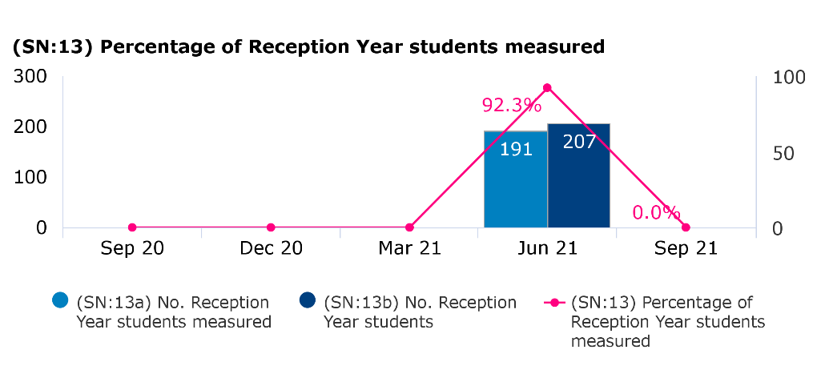
The NCMP data collection is a mandated service delivered by the school nursing team in order to understand the prevalence of overweight and obesity in children aged 4 to 5 (reception) and 10 to 11, 92.3% of reception children in RBWM were measured as part of the NCMP in June 2021 (this was the only data provided at the time of formulating this HNA, meaning a comparison over the past year cannot be made). The prevalence of overweight (including obesity) of reception children in RBWM IN 2019/20 was noted to 16.2% significantly below the national average of 23.0% and the South East regional value of 21.9% (Office for Health Improvement and Disparities 2021),

Source: Q2 InPhase data provided by Achieving for Children (2021); School Nursing data for RBWM (as of September 21 – Afc data for Health Visitors and School Nurses is subject to update as figures are finalised, treat figures with caution)

Figure 56: Percentage of Year 6 students measured
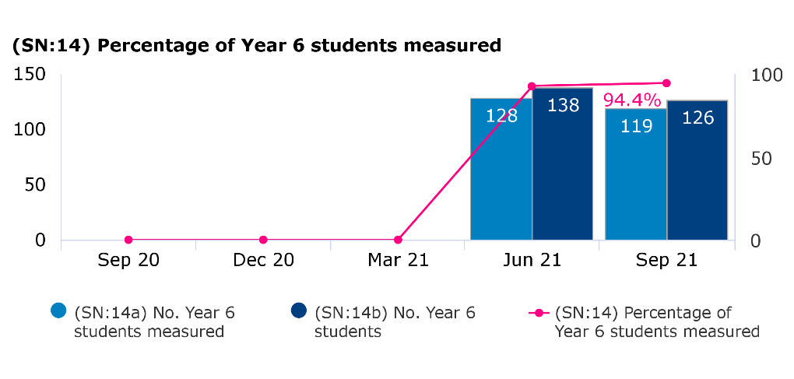
The NCMP data collection is a mandated service delivered by the school nursing team in order to understand the prevalence of overweight and obesity in children aged 4 to 5 (reception) and 10 to 11, 94.4% of year 6 students in RBWM were measured as part of the NCMP in September 2021 (this was the only data provided at the time of formulating this HNA, meaning a comparison over the past year cannot be made). The prevalence of overweight (including obesity) of year 6 students in RBWM IN 2019/20 was noted to 29% below the national average of 35.2% and the South East regional value of 31.7% (Office for Health Improvement and Disparities 2021),

Source: Q2 InPhase data provided by Achieving for Children (2021); School Nursing data for RBWM (as of September 21 – Afc data for Health Visitors and School Nurses is subject to update as figures are finalised, treat figures with caution)

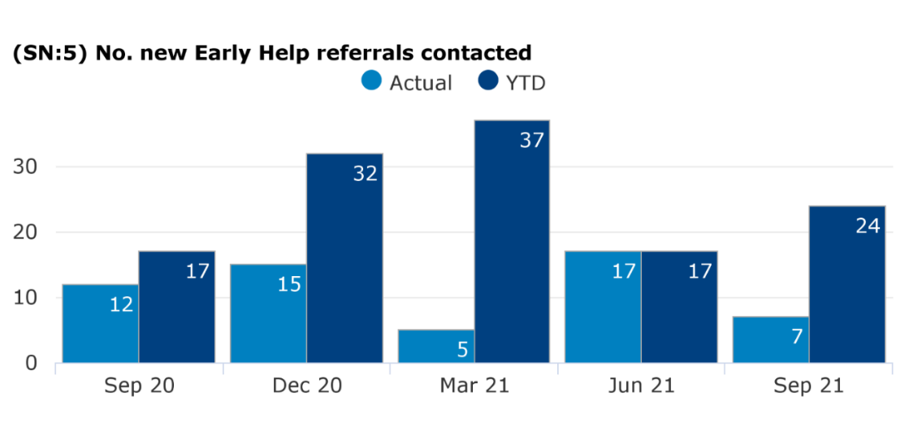
Early Help
Figure 57: Number of new Early Help referrals completed
A total of 56 referrals were made into the Early Help hub by school nurses in the past year. An early help hub referral is the single point of contact for all safeguarding and wellbeing concerns regarding children and young people in RBWM, the referral is reviewed by the Early Help services and hub to ensure children and their families can best the correct services for intensified support.

Source: Q2 InPhase data provided by Achieving for Children (2021); School Nursing data for RBWM (as of September 21 – Afc data for Health Visitors and School Nurses is subject to update as figures are finalised, treat figures with caution)

Children in Care Health Reviews & Child in Need and Child Protection Conference & Reports
A total of 59 health assessments were completed by the school nurses for children with a child protection plan in the past year. 24 children (from September 2020 to June 2021) in care were referred to another service by the school nursing team after identification of need was highlighted via a health review

Figure 58: No of child protection health assessments completed Figure 59: Number of Children in Care referred to another service after
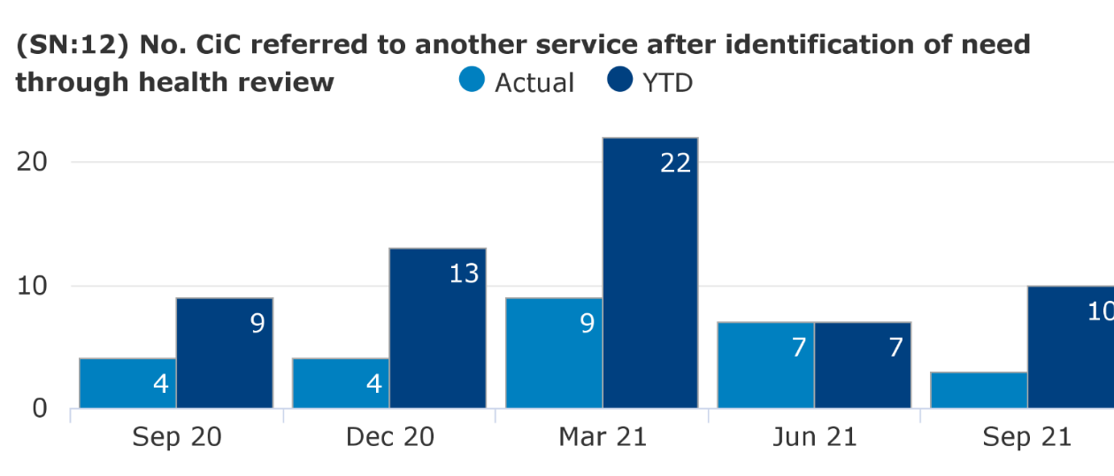
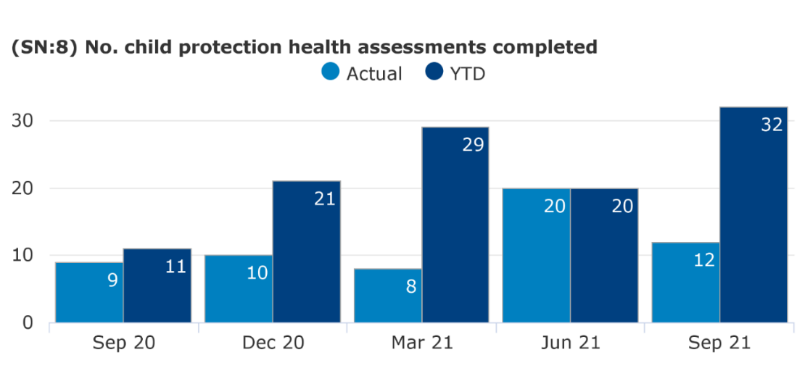
identification of need through health review
Source: Q2 InPhase data provided by Achieving for Children (2021); School Nursing data for RBWM (as of September 21 – Afc data for Health Visitors and School Nurses is subject to update as figures are finalised, treat figures with caution)

School-entrant Health Questionnaire
100% of parents who were eligible to fill out a school-entrant questionnaire were offered a school-entrant health questionnaire by the school nursing team throughout March 2021 to June 2021. 79.5% of parents who were offered a school-entrant health questionnaire returned it to the school nursing team in June 2021, (this was the only data provided at the time of formulating this HNA, meaning a comparison over the past year cannot be made). The school entry health questionnaire not only provides information on the health of children, but also provides an opportunity to bridge the gap between health visitors and school nursing and give parents the chance to flag up any concerns.

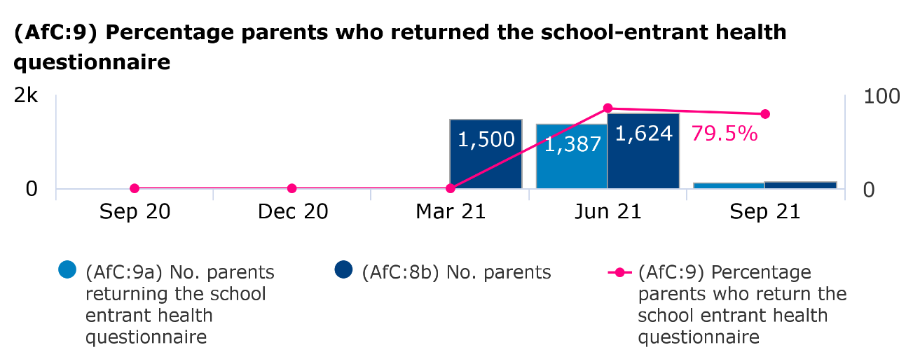
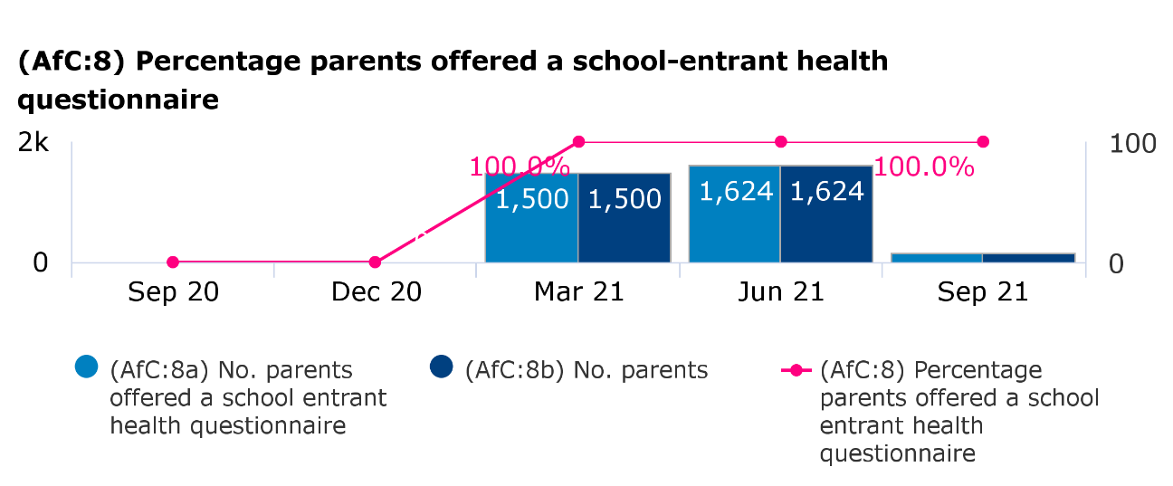
Figure 60: Percentage of parents offered a school-entrant health questionnaire Figure 61: Percentage of parents who returned a questionnaire

Source: Q2 InPhase data provided by Achieving for Children (2021); School Nursing data for RBWM (as of September 21 – Afc data for Health Visitors and School Nurses is subject to update as figures are finalised, treat figures with caution)

Hearing & vision screening
Figure 62: Number of new Early Help referrals completed
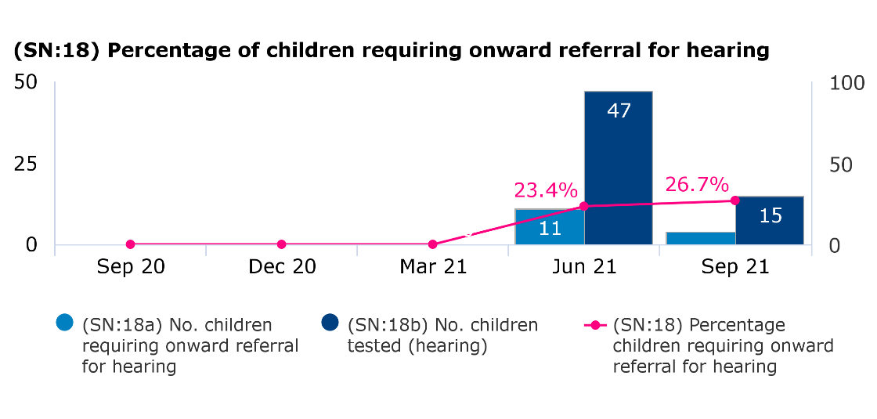
26.7% of children in September 2021 were referred for onward services for hearing team after a review was conducted by the school-nursing team in response to concerns raised about a child’s hearing.

Vision screening is conducted via the school-entrant health questionnaire, 100% were offered this screening throughout June 2021 to September 2021, there was a 100% uptake in June 2021, but only a 78.3% uptake in September 2021. A further 12 children were referred onward to an additional service for vision support by the school nursing team.

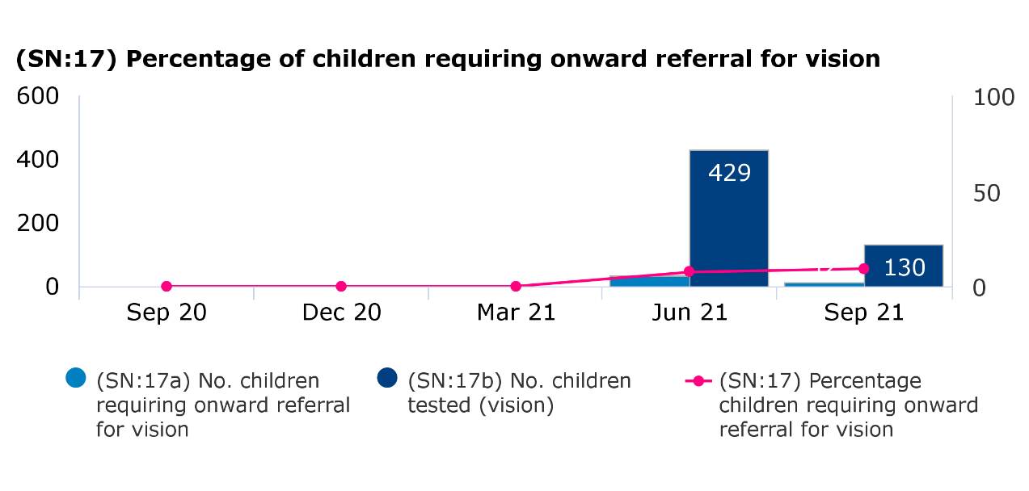
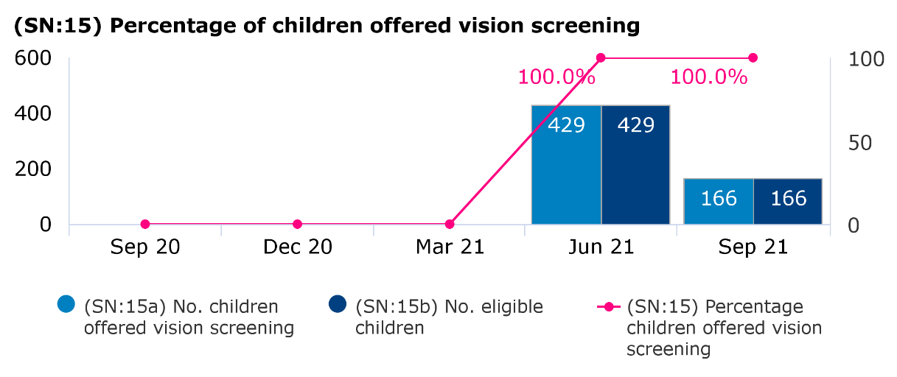
Figure 63: Percentage of children offered vision screening Figure 64: Percentage of children requiring onward referral for vision
Source: Q2 InPhase data provided by Achieving for Children (2021); School Nursing data for RBWM (as of September 21 – Afc data for Health Visitors and School Nurses is subject to update as figures are finalised, treat figures with caution)

Nocturnal enuresis (Bed wetting)
A total of 40 children from September 2020 to September 2021 were referred into the Enuresis service, ran by the School Nursing team.

Figure 65: Number of new referrals to Enuresis service Figure 66: Number of children supported by Enuresis service
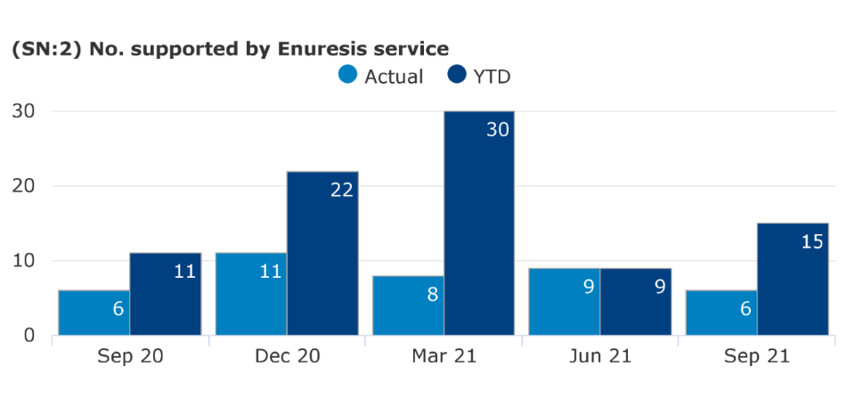
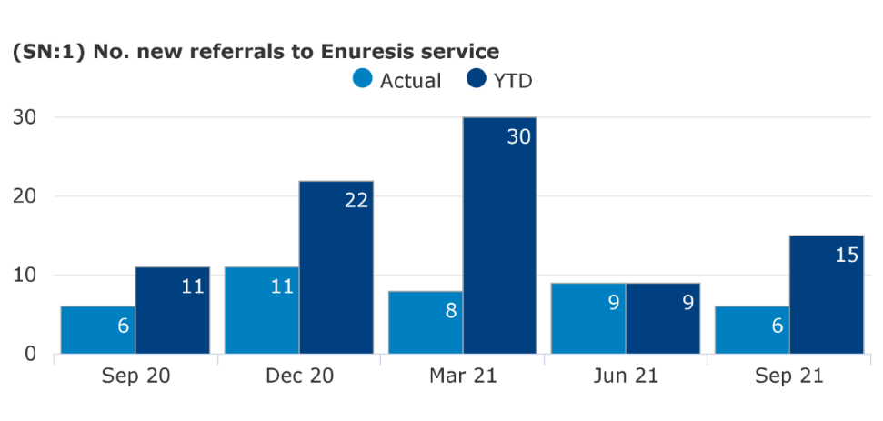

Source: Q2 InPhase data provided by Achieving for Children (2021); School Nursing data for RBWM (as of September 21 – Afc data for Health Visitors and School Nurses is subject to update as figures are finalised, treat figures with caution)

Feedback from professionals, current service providers, families and service users

Bracknell Forest undertook a number of stakeholder and consultation events to inform the Health Needs Assessment and these are detailed in this section. Slough and RBWM have not completed consultations specifically for the HNA.

Bracknell Forest Public Health had a key stakeholder ‘have your say’ event and conducted stakeholder surveys with parents, carers, young people and professionals on the Health Visiting and School Nursing services. The event was well attended by key stakeholders across the council and Frimley CCG. A total of 106 people responded to the surveys. The findings from the event and survey will be used to inform future service specification to identify the strengths and areas for improvement in service provision for Children aged 0-19 years. Key themes from the event and stakeholder surveys have been outlined below.

Health Visiting service

Accessibility
- Majority of parents/carers felt that their ability to access the HV service was either good or very good
- Both stakeholders and parents felt that Health Visitors could make better use of local venues in the community to improve accessibility

Reviews
- Stakeholders felt that there should be more contacts with families rather than the standard 5 statutory contacts/reviews. Possibly the addition of a 3–6-month contact.
- Some of the parents felt that the statutory reviews felt like a tick box exercise and would like more support following the reviews

Support received
There were mixed views from the parents/carers surveys regarding support received. Some mums were happy with the support received and felt that Health Visitors were approachable and found it easy to access the service. Others felt that they could have been supported more with breastfeeding and would have liked more support during the pandemic

Strengths of the service
Parents felt that the Health Visiting staff were knowledgeable, empowering, supportive, easily approachable and helpful

Improvements
- Additional training for HVs on breastfeeding, weaning, perinatal mental health
- Be able to provide relevant information and make appropriate referrals to specialist services and peer support groups
- Having key worker within the team for specialist topics like working with young families, traveller families, autism, immunisations
- More robust information sharing with other agencies to support vulnerable families who do not access universal services and are not yet known to services

- Improved multiagency working by returning to the family hubs/children centres
- Some parents said that they would have liked additional support during the covid-19 pandemic

Future Priorities for the service
Stakeholders felt that these where areas health visitors should focus on in the future
- Integrated 2-year development check in early year settings
- Follow up and information sharing on those families who don’t attend development reviews
- Supporting parents to understand stage of development to avoid inappropriate expectations
- Support parents to manage low level behavioural and anxiety issues and parental mental health
- Get involved in running group work sessions with other organisations like Home Start

School Nursing Service

Accessibility
- Majority of parents/carers who answered the survey were aware (85%) of the School Nursing service. However only 8% of respondents had actually used the service
- When Young people were asked for reasons as to why they would choose to speak to the School Nurse over any of the other services 38% said that the service was convenient, 38% said it was because the service was confidential, and 12% said the school nurse was approachable
- Some of the parents said that they saw the school nurse when their child was in reception but hadn’t seen the school nurse for the rest of the time their child was in primary school
- There was some lack of awareness among parents as to what support their could get from the SN

Support received
Parents felt like they would like more support after the National Child Measurement Programme results on what support is available

Strengths of the service
Young people liked the fact that the school nursing service is a confidential service that is convenient to access

Improvements
- More visibility and communication with parents on how to access
- More support with Mental health, stress management and sexual health
- Regular drop-ins/fixed site in primary and secondary schools (even if its half a day once a week)
- Named school nurse per school
- Meeting with children after weight, height and vision screening to discuss results
- More awareness of what support is provided apart from height and weight measurements and vaccines
- Stakeholders felt that school nurses should liaise better with school staff and spend more time in schools building those relationships
- Partners would like more updates and acknowledgement on referrals made into the service

Priorities for the future
Stakeholders felt that these where areas school nurses should focus on in the future
- Safeguarding health assessments for vulnerable children (Child protection, Children in care, Children in Need)
- 1:1 targeted health promotion to the most vulnerable members of society – families and children via a dedicated appointments based service at school
- Medical conditions support/ training/care plans for schools staff, enuresis service.
- Health promotion and reducing inequalities
- Training sessions for teaching and school staff
- Follow up on children who school feel need more support e.g. hearing checked
- Group work regarding some of the health issues e.g. sexual health, self-harm and healthy eating before it reaches eating disorder
- Support for children’s mental health issues

Best practice and evidence

National guidance, legislation and best practice for 0 to 19s provision all highlight the importance of delivering public health preventive and early intervention services that are needs led, evidence-based and targeted to meet the needs of children, young people and their families. This enables the promotion of healthy child development, improves child health outcomes and ensure that families who are identified as at risk are provided with the appropriate support at the earliest opportunity.

This section summarises the national guidance and legislation that underpin 0 to 19 service provision and highlights examples of best practice.

What does National Guidance tell us?

National guidance on delivering evidence-based services for children and young people provides imperative service specification and commissioning recommendations to ensure that services are in line and upheld with the best available evidence.
National Guidance | Summary
Healthy Child Programme | In 2009, the Department of Health published the Healthy Child Programme. This was introduced as an early intervention and prevention public health programme to provide a universal service for both children and their families, inclusive of screening programmes, immunisation, health and development reviews, supplemented by advice around health, wellbeing and parenting starting in pregnancy through the early weeks of life and throughout childhood.  Public Health England has since produced a Rapid Review of the evidence which underpinned the programme and included a systematic review about ‘what works’ in key areas around parental mental health, smoking, alcohol and other health behaviour indicators.  Public Health England, along with its associated partners, have also produced three guides with essential service specification guidance to support local authorities to deliver effective early intervention and public health preventative services. This guidance was republished in 2021 to reflect new available evidence, particularly providing further governance around commissioning public health services for children and young people. This focussed on the delivery of the Healthy Child Programme and the contribution of health visiting and school nursing services leading and co-ordinating the delivery of public health for children aged 0 to 19.  Public Health England (2015) Rapid Review to Update Evidence for the Healthy Child Programme  Public Health England (2021) Best Start in life and beyond - Commissioning Guide 1: Background information on commissioning and service model  Public Health England (2021) Best Start in life and beyond - Commissioning Guide 2: Model Specification  Public Health England (2021) Best Start in life and beyond - Commissioning Guide 3: Measuring Performance and Outcome
Working together to Safeguard Children | This statutory guidance distinguishes that everyone who works with children has a responsibility for keeping them safe. The guidance also highlights the Section 11 duties of the Children’s Act 2004 which need to be considered as part of any children and young people’s service.  Department of Education (2018) Working Together to Safeguard Children: Inter-agency guidance
Public Health Outcomes Framework | The Public Health Outcomes Framework for England (PHOF) highlights the vision for public health that is to ‘improve and protect the nation’s health and improve the health of the poorest fastest.’ The framework focuses on two high level outcomes: increased life expectancy and reduced differences in life expectancy and healthy life expectancy between communities. Children’s public health services contribute to this framework.  Office for Health Improvement and Disparities (2021) Public Health Outcomes Framework
Marmot Review into Health Inequalities | The Marmot Review (2010) into health inequalities in England examined the differences in health and wellbeing between social groups to attempt to address the social determinants of health. The findings of the review pointed towards the overarching conclusion that reducing health inequalities will require action on six policy objectives:  - Giving every child the best start in life  - Enabling all children, young people, and adults to maximise their capabilities and have control over their lives  - Creating fair employment and good work for all  - Ensuring a healthy standard of living for all  - Creating and developing sustainable places and communities  - Strengthening the role and impact of ill-health prevention  A further Marmot review of health inequalities in England was conducted in 2020, which evidenced a widening of health inequalities particularly for people living in more deprived areas. It also highlighted how health is closely linked to the conditions in which people are born, grow, live, work and age and inequities in power, money and resources – the social determinants of health. The findings of the review highlighted six further actions on health inequalities and social determinants.  - Develop a national strategy for action on the social determinants of health with the aim of reducing inequalities in health  - Ensure proportionate universal allocation of resources and implementation of policies  - Early intervention to prevent health inequalities  - Develop the social determinants of health workforce  - Engage the public  - Develop whole systems monitoring and strengthen accountability for health inequalities  Institute of Health Equity (2010) Fair Society, Healthy Lives – Marmot Review  Institute of Health Equity (2020) Health Equity in England: The Marmot Review 10 years on
Healthy Lives, Healthy People | The Healthy Lives, Healthy People White Paper sets out the government’s long-term ambition for the future of public health in England, the ambition is to establish a ‘wellness’ service to strengthen both national and local leadership.  Department of Health (2010) Healthy Lives, Healthy People: Our strategy for public health in England
Early Intervention | The Early Intervention Foundation’s report sets out the key strategic actions that must be undertaken to ensure an effective early intervention for children and young people is commissioned. These key actions have been highlighted to be fundamental to overcome significant barriers that may inhibit the potential success of early intervention, these include:  - Establish a new long-term investment fund to test the impact of a whole-system approach to early intervention in a small number of places  - Agree a clear vision that is founded on the benefits of effective early intervention to local communities and the local economy  - Foster a culture of evidence-based decision-making and practice  The Science and Technology Committee report (2018) highlighted some fundamental recommendations for what national and local government should do to ensure that every child has access to evidence-based early interventions if they need it.  Early Intervention Foundation (2018) Realising the potential of early intervention  HM Gov Science and Technology Committee (2019) Evidence-based Early Years Interventions
Supporting Families in the Foundation Years | This jointly published guidance by the Department of Education and the Department of Health and Social Care highlights the imperative nature of a joined-up system and the evidence to support this, in order to support families in the foundation years effectively. This guidance is for all those who commission, lead and deliver services for: mothers and fathers during pregnancy and children up the age of 5.  Department of Education & Department of Health and Social Care (2011) Supporting Families in the Foundation Years
A Better Start | The better start guide, published by the Local Government Association, highlights how essential the early years are to future health and wellbeing outcomes; the measures being taken by local authorities to bring together health, social care and early education services to create a more holistic approach to identifying and meeting the needs of young children and their families – making provision more efficient and effective; and an idea of the increasing range of interventions available to address particular issues early, before they escalate into more concerning issues.  Local Government Authority (2018) A Better Start: supporting child development in the early years

What does the legislation outline?

The legislation outlined below highlights the fundamental practices and policies that must be diligently upheld and maintained by all those who commission, deliver and utilise children and young people’s services in order to protect their safeguarding, wellbeing and rights
Legislation | Summary
The Children Act 2004 | The Children Act 2004 provides the legal basis for how social services and other agencies must deal with concerning issues relating to children and was designed with guiding principles in mind for the care and support of children. These are:  - To allow children to be healthy Allowing children to remain safe in their environments  - Helping children to enjoy life  - Assist children in their quest to succeed  - Help make a contribution – a positive contribution – to the lives of children  - Help achieve economic stability for our children’s futures  This Act was legalised in order for the government to work in conjunction with the social and health care service bodies to partner together to achieve and uphold these common goals. The Children Act 2004 was instrumental in improving the safety and welfare of children across England and ensuring that local authorities took the appropriate steps to provide services and systems for any children in need within their local area.
Public Services (Social Value) Act 2012 | The Public Services (Social Value) Act came into force on 31 January 2013 and requires local authorities that commission public services to consider how they can secure wider social, economic and environmental wellbeing benefits. Before the procurement process begins, commissioners should consider about whether the services they are going to buy, or the way they are going to buy them, could secure these benefits for their area or stakeholders.
Health and Social Care Act 2012 | The Health and Social Care Act 2012 highlights the statutory duty of Local Authorities to work to improve the health of their local population. Local authorities have, since 1 April 2013, been responsible for improving the health of their local population and the commissioning of public health services, including most sexual health services and services aimed at reducing drug and alcohol misuse. The Secretary of State continues to have overall responsibility for improving health – with national public health functions delegated to Public Health England.
Children and Families Act 2014 | The Children and Families Act 2014 was enabled to provide greater protection to vulnerable children, better support for children whose parents are separating, a new system to help children with special educational needs and disabilities and help for parents to balance work and family life. The act highlights the four key principles that Local Authorities have to follow when working children, young people and their families, they must: 1) consider the views, wishes and feelings of the child, young person and their parents; 2) involve the child, young person and their parents in decisions that affect them; 3) give the child, young person and their parents the information and support they need to be involved in decision making; 4) support the child, young person and their parents to achieve the best possible outcomes.

What does Best Practice for Health Visiting and School Nursing tell us?

This new model highlights the details of the modernised health visiting and school nursing service delivery model which aims to be ‘Universal in Reach – Personalised in response’, (Public Health England 2021). The details below highlight the ‘gold-standard’ model which we should aim, where feasible, to work towards and replicate across Berkshire East within service specification and provision for all 0-19s children services.

This supersedes the previous ‘4-5-6’ models for health visiting and school nursing. Universal, Universal Plus and Universal Partnership Plus have also been superseded and instead reference is made to universal, targeted and specialist services. The new model aims to capture the full extent of both the health visitor and school nurse offer – as many local services were offering so much more than the ‘5’ contacts. The model suggests opportunities for further contacts or opportunities to provide support; for example, within early years contacts at three and six months, to support breastfeeding, mental health, healthy diet and safer sleep. This revised model has been developed with a range of stakeholders to reflect changes to how services are commissioned and provided locally and aims to provide a greater emphasis on the assessment of children, young people and family’s needs and the skills mix to respond.

Figure 67 describes the core elements of the ‘Universal in Reach – Personalised in Response’ model, which is based on 4 levels of service depending on individual and family needs: community, universal, targeted and specialist levels of support.

Figure 67: Core elements of a ‘Universal in Reach – Personalised in response’ mode
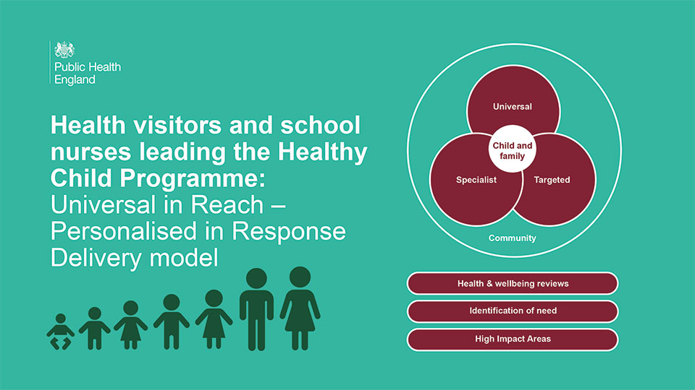

Source: Public Health England 2021

The availability and utilisation of community-based assets is central to the universal offer, while health visitors and school nurses are well placed to identify needs, provide evidence-based public health interventions and signpost to community-centred and asset based approaches (Public Health England 2018). Evidence-based interventions provided by health visitors and school nurses should be tailored to meet individual and family needs. The support required by most families and children or young people will predominantly be met through the universal offer.

Health visitors and school nurses will use a needs assessment to determine targeted interventions which can be met within the services or the need for more specialist interventions that require referrals or clear signposting. Whilst receiving specialist support health visitors and school nurses will still provide the universal offer and work in partnership with other agencies. Safeguarding children is embedded through the model because health visitors and school nurses have a vital role in keeping children safe and supporting local safeguarding arrangements. It is essential to define local roles and responsibilities including health visitors and school nurses, as identified within commissioning guidance (Public Health England 2021).
Figure 68 highlights the high-level approach that should be taken by health visitors and school nurses to identify and respond to family needs.
Figure 68: A high-level overview of health visitor and school nurse contributions
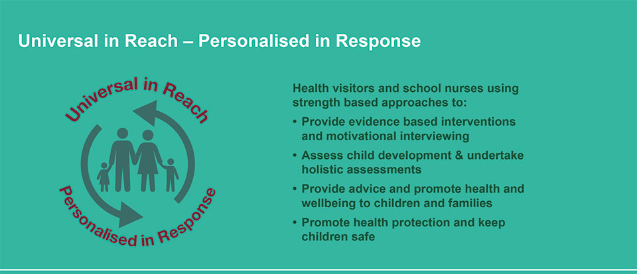

Source: Public Health England 2021

Health visitors and school nurses have a significant role as leaders of the Healthy Child Programme, which should form part of multi-professional care pathways and integration of services to support healthy pregnancy, children aged 0 to 19 years. Universal services remain essential for keeping children safe and for primary prevention. Early intervention, evidence-based programmes should be used to meet needs in a timely way.

Partnership, integration, communication and multi-agency work remain key to improving outcomes. All areas should be focussing on improving health outcomes and reducing inequalities at individual, family and community levels. Outcome measures should align between health and education or other early years and school age providers to enable shared outcomes across the health and social care system. Safeguarding responsibilities apply through all elements from identification of risk and need, to early help and targeted work, and formal child protection.

Health needs will be identified in partnership with parents, children and young people using an approach that builds on their strengths as well as identifying any difficulties. Outcomes are measured and reported in line with national outcome frameworks and commissioning reporting requirements, with other additional reporting requirements and measures for local determination (Public Health England 2021).

Key contact points or universal health and wellbeing reviews help identify needs and support or signposting if required. There are 5 mandated reviews for early years, which are offered to all families. These should be face to face, delivered by a health visitor, or under their supervision. Health visitors should use their clinical judgement to identify whether virtual, other digital or blended approaches can be used to support the needs of a child or family. Mandated reviews are not the full extent of the health visiting service offer where families may require additional contact and support, for example by a nursery nurse providing parenting support. Additional contacts are suggested for consideration where health visitors, or a member of their team, could respond to a family’s identified need.

Figure 69 describes universal health and wellbeing reviews and suggested contacts as part of overall support 0 to 5 years, detailing key aspects at the following stages:
- antenatal health promoting review
- new baby review
- 6 to 8 week review
- 3-month contact
- 6-month contact
- 1-year review
- 2 to 2 and a half year review

Figure 69: Universal health and wellbeing reviews and suggested contacts as part of overall support for 0 to 5year-olds
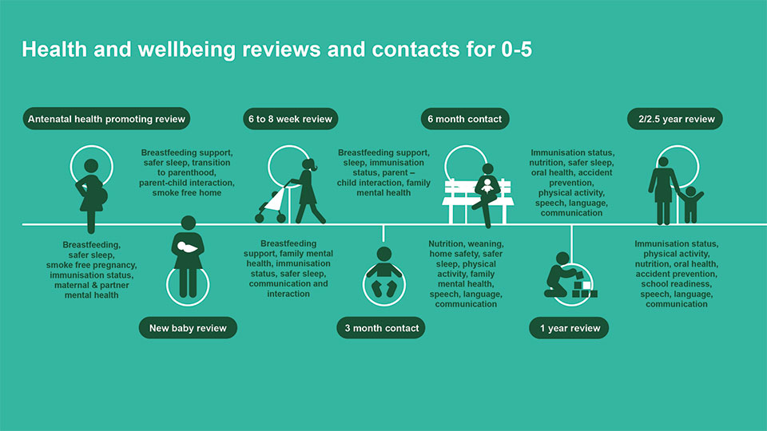

Source: Public Health England 2021

Figure 70 describes universal health and wellbeing reviews and contacts as part of overall support for 5 to 19 year olds (or 24 year olds if appropriate) including:
- 4 to 5 year old health needs review
- 7 to 8 year old health needs contact
- 10 to 11 year old health needs review
- 12 to 13 year old health needs review
- school leavers post-16 health needs review
- transition to adult services
- 18 to 24 year old health needs review

Figure 70: An approach to identify and meet ‘perceived, expressed and assessed need’ to improve outcome appropriate
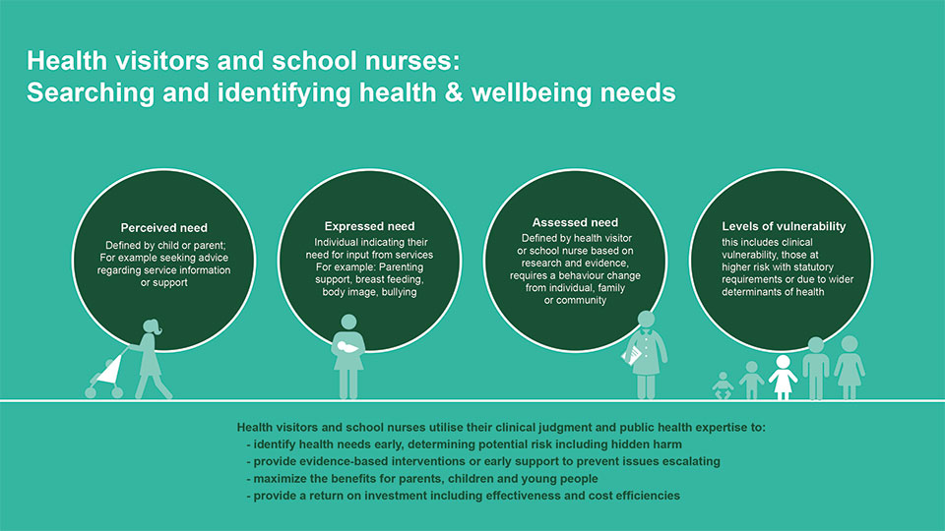
Source: Public Health England 2021

Figures 71 and 72 highlight the high impact areas which provide an evidence-based framework for those delivering maternal and child public health services from preconception onwards for both health visiting teams and school nursing teams.

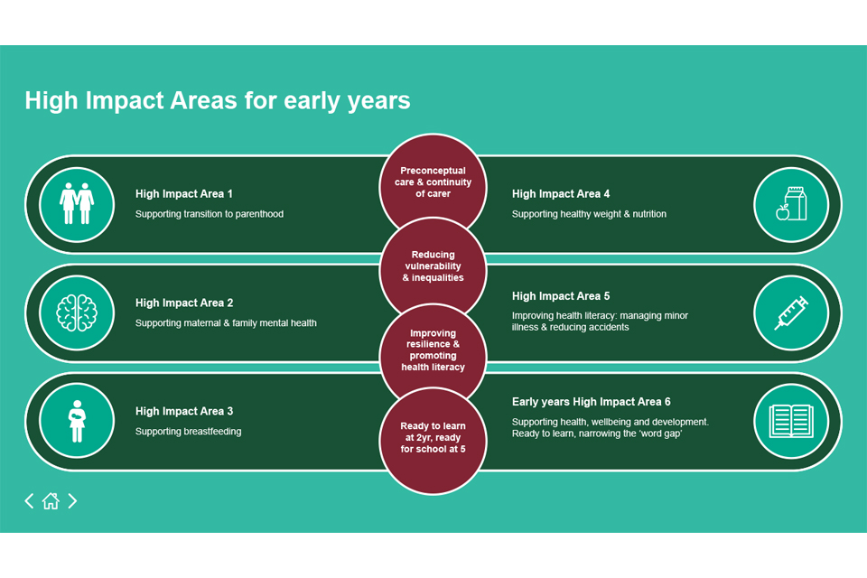
Figure 71: High Impact Areas for Early Years Figure 72: High Impact Area for school age years
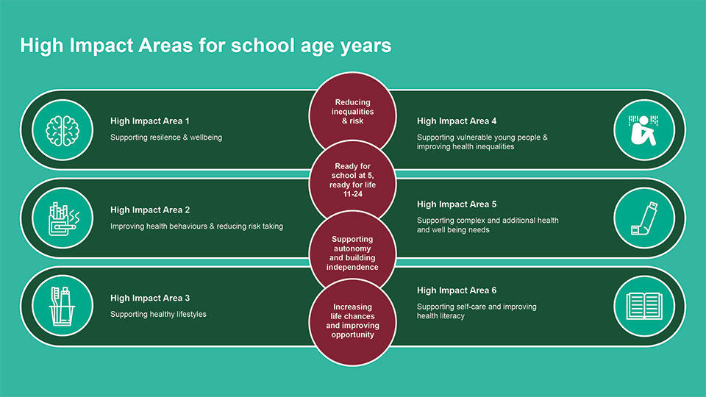

Source: Public Health England 2021

The model and High Impact Areas are designed to support local commissioners and providers to deliver the Healthy Child Programme effectively and efficiently. A place-based approach should be adopted to support development of local solutions drawing on all the assets and resources of an area, integrating services and building resilience in communities so that children, young people and families can take control of their health, (Public Health England 2021).

Examples of best practice models

When considering what a ‘good’ service model for a 0-19s service is defined by, we examined the integrated service model that is currently utilised by Portsmouth City Council and the three local authorities in Berkshire West.

Portsmouth model
The 0-19 children's services are implemented in Southampton City, Portsmouth City and parts of Hampshire, and support children, young people and their families from 0-19 years (up to 25 years for young people with special educational needs or disability,(Solent Children and Family Services, 2021). They offer a fully integrated service, inclusive of:

- Health Visiting team
- Universal Plus Partnership programme - service is provided to families and children that require targeted additional support from more than one organisation
- Specialist Health visiting team - Family Nurse Partnership (FNP) - a voluntary home visiting programme providing intensive support for vulnerable first-time young mothers and their families. Promoting healthy pregnancy, improving their child’s health and development and helping young parents plan their own futures and achieve their aspirations
- Southampton Homeless Healthcare Team - consists of 2 Health Visitors and a Family Support Worker who visit families who have been placed in emergency accommodation, woman’s refuges, Bed and Breakfast Houses, Hostel’s, mother and baby units and families seeking asylum in the UK.
- Specialist Health Visitors for Children with Disabilities - Health Visitors who have limited caseloads of children with additional needs and offer the families specialist support. They work very closely with specialist services and also act as a resource for their colleagues.
- School Nursing Team - registered and qualified nurses often with additional skills for the role
- Public Health Nurses – registered, qualified nurses who have been specially trained in public health. There is a named public health nurse for every school in Southampton
- Public Health Support Workers – a healthcare professional who is trained to provide the service under the supervision of a registered nurse
- Wellbeing Associate Practitioners – professional who have skills to support young people with a range of emotional problems

In addition to offering a fully integrated service with a wider variety of teams and skillsets than is seen within Berkshire East, they also utilise two digital platforms to complement their services:

- Baby Buddy App – this is a free multi-award-winning, interactive pregnancy and parenting app Baby Buddy. It has been created to support parents, co-parents and caregivers, and to back up frontline practitioners’ work and communication. Baby Buddy provides trusted, evidence-based information and self-care tools, based on the latest research and is NHS-approved. Baby Buddy aims to empower parents and care-givers to build their knowledge and confidence for the crucial first five years of their child’s life, when foundations are laid. It was co-created with parents, the Royal College of Midwives, health organisations and accredited by the NHS, the Baby Buddy App is available, free, through Google Play, the App Store and the NHS Apps library, as well as utilised by the Health Visiting Solent team to complement their existing service offer.

- Family Assist – a new innovative platform to provide a wide range of information and resources, both locally and nationally, for parents, carers and families.
- Family Assist has been designed to act as a library of trusted evidence-based information which can be accessed at any time, from your phone, tablet or PC, and will also send key pieces of information by e-mail which is sent to registered users at the relevant stages throughout pregnancy and the stages of a child's life according to a mother's due date or the age of a child. All information has been written or approved by local health professionals, so families can be sure that the information they will find on Family Assist is the most up to date and accurate information available.
- As a user of Family Assist, families will also have the ability to reach out to local professionals to ask a question and receive a response by e-mail within 2 working days so families can be sure that they have received reliable and relevant information. In addition, parents can also invite their family and friends to join them on their information pathway which enables them to receive the same information and ask questions and is a great way to include dads and partners who often feel like they aren't included in the pregnancy journey. This resource is utilised by the Health Visiting and School Nursing team.

These two platforms assist and compliment the current service offer, providing an innovative solution to information overload, service provision and workforce expectations. The learnings from this service model should be reviewed for consideration in order to explore the suitability of applying some similarities across East Berkshire and within each local authority’s children 0-19s service offer.

Berkshire West model
The three Berkshire West Local Authorities (LAs) – Reading Borough Council, West Berkshire Council and Wokingham Borough Council, have developed a service specification for the provision of 0-19’s Public Health Nursing Services across the Berkshire West region. The new service specification in line with the latest Healthy Child Programme guidance, seeks to align local variations in the mandated core service provision, however, there remains some variations across the region which reflect local need and or local preference.
In addition to the mandated core service delivery by the health visiting and school nursing teams, the new service specification includes some additional LA specific requirements. For example:

- Breastfeeding peer support (Reading): universal breastfeeding peer support arrangement for mums-to-be and new mums, with more intensive support targeted at women such as younger mothers or those who may be subject to social and cultural norms that discourage breastfeeding
- Virtual Post-natal group is being trialled as a pilot in Wokingham and will be evaluated in order to inform a future innovative approaches to supporting local families
- Targeted weight management service in Reading primary schools
- Provider to work closely with Public Health team to support Health and Wellbeing programme in schools in Wokingham

The new HCP model of delivery for health visiting and school nursing highlights the desirability of increasing the number of contacts that public health nursing has with families, children and young people. Commissioners in Berkshire West were keen to understand how a universal offer of additional contacts with families across Berkshire West could be delivered. These additional contacts would be based on parental choice and following an assessment of need. Commissioners in Berkshire West have included the following additional contacts for the 0-19 service to carry out:

Recommended review at 3 months and at 6 month

The 3-month contact might include:
- Continued assessment and discussion of issues around the home learning environment and importance of play, talking, reading & singing on bonding and for early language skills
- Discussing importance of physical activity (helping baby to move and play every day including providing plenty of floor-based tummy time and water activities in safe environments. Reduce/limit sitting time in buggies/car seats, baby walkers and bouncers.)
- Healthy couple relationships
- Family mental health
- Parent-child interaction
- Breastfeeding
- Promoting healthy nutrition including whole family - preparation for introducing healthy weaning choice from 6 months
- Managing minor illnesses, building health literacy and the prevention of SIDS
- Encouraging the uptake of immunisations
- Reducing unintentional injuries
- Sleep

The 6-month contact might include:
- Promoting healthy nutrition and weaning and advice and support on fad or picky eating
- Home safety – reducing unintentional injuries
- Physical activity
- Family mental health
- Speech, language and communication

Review at 3 - 3.5 years
If the Health Visitor or the parent/carer identifies any concerns about a child’s development (either as a direct result of the 2 – 2.5yr development review or anytime up until the child is age 3.5 years), then the Health Visitor will use their professional judgement, in collaboration with the family, to decide if contact/review is required at 3 – 3.5yrs to assess development. Commissioners envisage that the contact:
- could be a focussed, person-centred discussion to review speech, language and communication, social, emotional and physical development; as well as addressing any wider health concerns likely to have a detrimental impact on school readiness such as toileting, sleep patterns or family mental health concerns.
- may require a Health Visitor to re-assess or implement a holistic family needs assessment in order to pick up any parental risk factors such as mental health, substance misuse and domestic violence
- may be required to support children with developmental disorders, disabilities and complex health needs to help them prepare for transition to school and the school nursing service.

Specialist Health Visitor in Perinatal and Infant Mental Health within each local authority
The Royal College of Psychiatrists (RCP), the Institute of Health Visiting (iHV) and Association for Infant Mental Health recommend that there should be a Specialist Health Visitor (PIMH) in every health visiting service.

Specialist Health Visitors in Perinatal & Infant Mental Health (PIMH) are Health Visitors with post qualifying training and experience that equips them to fulfil specialist clinical, consultative, training and strategic roles on behalf of health visiting services within the fields of Perinatal and Infant Mental Health. They have a crucial role within multi-disciplinary pathways delivering effective mental health care to mothers, fathers and their infants during the perinatal period and usually up to the baby’s second birthday or beyond. They provide specialist training and consultation to the wider health visiting and early years workforce.

Commissioners within each local authority are seeking to work towards having a dedicated Specialist Health Visitor (PIMH) resource within Berkshire West who would take the lead and inform service provision.

Conclusions and recommendations for action

The Berkshire East 0 to 19s HNA has summarised what we know about children and young people living in Bracknell Forest, Slough and the Royal Borough of Windsor and Maidenhead. The collation of key epidemiological data, insights from current service providers and engagement with families and wider system partners have all helped to evidence the needs across the local area and have highlighted where these vary across Berkshire East. The HNA process has also identified gaps in knowledge, particularly around the needs of more vulnerable and hidden children and young people, which will need to be addressed.

The ongoing Covid-19 pandemic has impacted on the ability to gather complete, up-to-date service data for this HNA and has also limited the scope of the overall HNA process. However, this HNA report does provide an overarching summary that can be built on as more local intelligence becomes available. Berkshire East’s Public Health Network recently agreed a new, comprehensive approach for Health Needs Assessments and this will be adopted for future updates and iterations of the 0 to 19s HNA.

Recommendations for this HNA have been informed by the intelligence collated throughout the report, as well as the best practice guidance and models included. Recommendations have been separated into four categories, in order to reflect the different aspects of Berkshire East’s system. These include:
1. 0-19 Service recommendations
2. Public Health recommendations
3. Local authority recommendations
4. Overall recommendations

Berkshire East recommendations
For 0 to 19 Service across Berkshire East

1 | Explore how we can incorporate the ‘Universal in Reach – Personalised in response’ health visiting and school nursing model, (OHID, 2021) within existing and future service specifications for 0-19s service across Berkshire East.
2 | To explore how we can improve systems for collecting data on vulnerable groups within the service remit i.e., mothers with perinatal mental health issues, children in care and children with adverse childhood experiences in order to identify how the services can be improved and gaps be filled.
3 | To explore a Berkshire East wide digital platform based on best practice models to assist delivery of the 0-19 offer. This could be delivered through existing channels or a new one if warranted.
4 | Ensure that all areas are able to capture and articulate the local responses to specific needs of parent and carers and CYP aged 0 to 25 with additional needs including Special Educational Needs and disabilities, Neurodiverse CYP, LGBTQ CYP, CYP from minority communities and other vulnerable groups at risk of health inequalities and health equity issues.

For Public Health Teams across Berkshire East

1 | Consider how the Public Health teams across Berkshire East can partner and collaborate more closely with education settings including schools, colleges and local education teams and leadership in the council and other key partners to develop and adopt a Healthy Schools programme across the region
2 | Review and consider how Public Health can support school nurses to deliver the National Child Measurement Programme and consider how the information and results are communicated to the children and families, consider how families and children can receive support following on from the delivery of the results

Overall recommendations

1 | To explore how Public Health teams can work innovatively with partners to think of ways to recruit and retain sufficient health visitors and school nurses and develop a workforce strategy aligned to NHSE and other workforce strategies.
2 | Review how 0-19 teams could work more collaboratively with other health and social care colleagues and linked agendas such as Safeguarding, Family Hubs, CYP Mental Health and Wellbeing and SEND to strengthen existing relationships in support of the 0 to 19 (0 to 25 with SEND) Healthy Child Programme and earlier and more effective identification of needs across local and neighbouring systems.
3 | Explore opportunities and risks associated with commissioning children and young people services across Berkshire East with stakeholders.

Bracknell Forest’s recommendations
1 | More training for the health visiting team n topics like autism, perinatal mental health, breastfeeding, how to deal with behavioural issues.
2 | For Public Health to work closely with other stakeholders across the council, CCG and voluntary sector to identify and target CYP with additional needs, those from minority communities and other vulnerable groups, to improve their access to support and services and reduce health inequalities.
3 | For Public Health to work with early years, health visitors and voluntary services to develop peer support groups and activities to support with breastfeeding and reduce feelings of loneliness and anxiety in new parents.
4 | For the School Nursing team to take a whole school’s approach to promoting and supporting physical and mental health and wellbeing in schools working closely with children and young people, parents, carers and school staff.
5 | For the Public Health team to review outcomes from the current school nurse drop ins and review this option for future service specifications.

Slough’s recommendations
1 | Ensure that the recent Section 114 and SEND Written Statement of Action requirement are drivers of innovation and collaboration in the local system to meet the needs of parents, carers and CYP in an earlier and more effective manner
2 | Ensure the delivery of a comprehensive new service specification for the upcoming re-procurement of the Slough O to 19 Healthy Child Programme to go live by 1st October 2022.
3 | Ensure that service user voice and co-production and participation elements are visible and producing tangible inputs to improve the quality of service offers across the life course form the perinatal/ early years, school aged and transitioning age ranges with specific additional input in support of CYP with complexity and potential vulnerabilities as set out in the 0 to 19 (recommendation 5 above).
4 | Explore the potential linkages across borough boundaries with neighbouring systems and pathways to ensure local and regional service reach and responsiveness.
5 | Develop a framework of support for commissioning for outcomes and robust, sustainable quality improvement inputs to internal and wider system to improve attainment of key national regional and local outcomes for the 0 to 19 HCP service.

Royal Borough of Windsor and Maidenhead’s recommendations
1 | To acknowledge and celebrate the areas where we are performing well.
2 | To improve the quality of local breast-feeding data to enable us to monitor our rates, compare them with other boroughs and promote further uptake of breast-feeding.
3 | To better understand why we are not performing as well as Berkshire and/or England averages for some outcomes; in particular: childhood development (2-2 ½ years); risk taking behaviours (smoking, alcohol and drugs); 16-17 year olds not in employment, education and training.
4 | To better understand why children and young people in some wards / communities in the borough have worse outcomes than others and to work collaboratively to reduce these differences; in particular differences in school readiness (between those who are and aren’t eligible for free school meals) and differences between wards in the proportion of children who are overweight/obese.
5 | To better understand the health needs of children in care and care leavers in the borough.
6 | To explore how we implement the new best practice guidance into the delivery of health visiting and school nursing.
7 | To get feedback from a broad range of professionals and families about their views on the health visiting and school nursing services available to local residents.
8 | Explore how we can effectively engage with children and young people across the borough to understand their views on their own health and wellbeing and how to improve outcomes.
9 | To ensure that any work to better understand the long-term impact of COVID-19 acknowledges children and young people.

