Maidenhead Town Centre and Maidenhead Population Profile

This Population Profile provides a high-level summary of the demography and health of people living in Maidenhead Town Centre and Maidenhead. These areas have been compared against the Royal Borough of Windsor & Maidenhead (RBWM) and Frimley Integrated Care System (ICS) to provide further context.

Geographies used in these profiles

Maidenhead Town Centre: RBWM wards - Belmont, Boyn Hill, Furze Platt, Oldfield, Pinkneys Green, Riverside and St Marys.

Maidenhead: Wards included in Maidenhead Town Centre, plus Bisham & Cookham, Bray, Cox Green, Hurley & Walthams wards

Population and demographic factors

Maidenhead Town Centre was estimated to have a population of 52,176 in 2020 with the wider Maidenhead area estimated at 80,378 (Office for National Statistics (ONS) 2021).

Figure 1: Population by broad age groups (2020 mid-year estimates)

 | Under 18 | 18 to 39 | 40 to 59 | 60 to 79 | 80 and over
Maidenhead Town Centre | 12,243 | 13,705 | 14,735 | 8,766 | 2,727
Maidenhead | 18,583 | 19,155 | 23,266 | 15,020 | 4,354

Source: Office for National Statistics (2021); Ward level population estimates

Figure 2 illustrates the population profiles for Maidenhead Town Centre and Maidenhead area. Maidenhead Town Centre has a higher proportion of people aged 25 to 39, compared to RBWM and the Frimley ICS area. This is particularly higher for females. The proportion of young children (aged under 9) is also higher in the town centre than across the whole of RBWM. Maidenhead’s population profile is broadly the same as the RBWM picture. Maidenhead is older than the overall Frimley ICS population with a lower proportion of people in the under 35 age group.

Figure 2: Population pyramid for Maidenhead Town Centre and Maidenhead (2020 mid-year estimates)

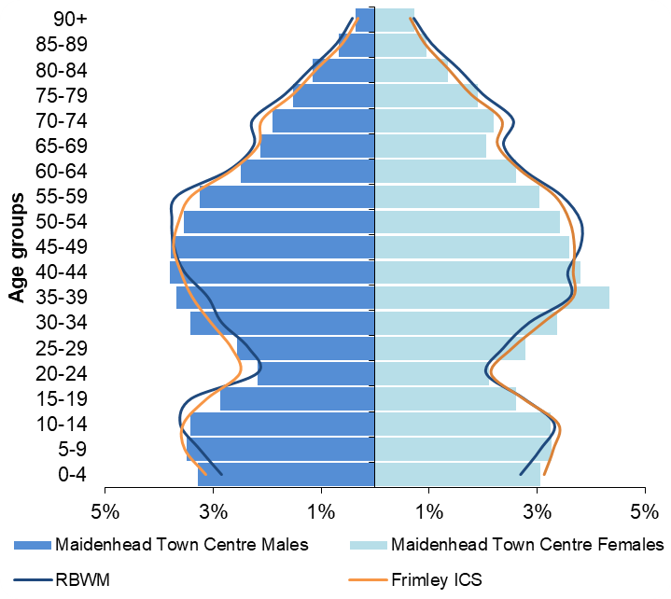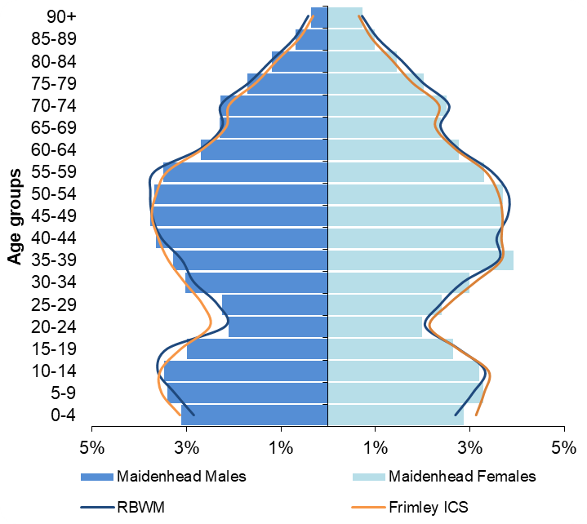

Source: Office for National Statistics (2021); Ward level population estimates

Ethnicity
The latest ethnicity information is based on the 2011 Census, which may not reflect the current population. It is anticipated that the 2021 Census will show increases in the proportion of the population from Black, Asian and Minority Ethnic (BAME) groups and non-White British groups.

In 2011, 18.7% of Maidenhead Town Centre’s population were recorded as coming from a BAME group. People from an Asian/Asian British background were the largest non-White population and were estimated to make-up 14.4% of the town centre’s population. In addition, 8.1% of the population were from a non-White British background. The Town Centre is more ethnically diverse than the wider Maidenhead area and RBWM as a whole, while similar to the Frimley ICS footprint.

The wider Maidenhead area’s ethnic profile is more reflective of RBWM’s overall population, with slightly higher proportions of people from an Asian/Asian British group. 13.9% of the Maidenhead population are from a BAME group, which is significantly lower than Frimley ICS (ONS 2012).

Wider determinants of health

Deprivation and poverty
RBWM is one of the most affluent areas in England with over 50% of the Borough’s Lower Super Output Areas (LSOAs) in the least deprived 10% of neighbourhoods nationally.

Maidenhead Town Centre has a slightly higher deprivation score than the whole of RBWM, however it would still be classified in the least deprived 20% of areas in its own right. The Town Centre does include 3 of the 4 most deprived neighbourhoods in RBWM and these are situated in St Mary’s (005G), Oldfield (007D) and Belmont (005C) wards. These are classed as being in the 40% most deprived areas nationally and approximately 5,300 people live in these neighbourhoods.

Maidenhead’s deprivation profile is very similar to RBWM’s. The most deprived areas within Maidenhead are within the Town Centre, as described above (Ministry of Housing, Communities and Local Government 2019).

Figure 3 shows the number and proportion of children and older people living in income deprived households in 2020. While Maidenhead Town Centre and Maidenhead both have lower proportions of these populations living in income deprivation compared to Frimley ICS, Maidenhead Town Centre’s figures are significantly higher than RBWM’s overall. Two neighbourhoods in Belmont (005C) and Oldfield (007D) wards have over 15% of children living in income deprivation. A neighbourhood in St Mary’s ward (005G) has nearly 35% of older people living in income deprivation, which is the highest level in RBWM. An additional neighbourhood in Belmont (005C) also has over 25% of older people living in income deprivation (Ministry of Housing, Communities and Local Government 2019).

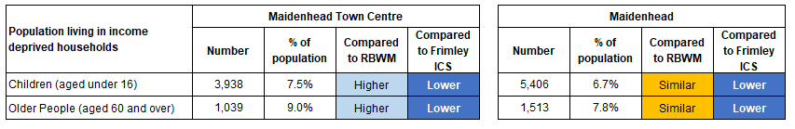
Figure 3: Population living in income deprived households (2020 mid-year estimates)
Statistical significance is based on 95% confidence intervals
Source: Deprivation scores – Ministry of Housing Communities and Local Government (2019); English indices of deprivation 2019. Population estimates - ONS (2021); LSOA population estimates

In 2018, approximately 6.4% of households in Maidenhead Town Centre were living in fuel poverty and 6.2% in Maidenhead. These were similar to RBWM and Frimley’s rates (Department for Business, Energy and Industrial Strategy 2021). It is important to note that these figures will not reflect the impact of the recent rise in energy costs.

Employment and benefits
Recent employment data is not available at a sub-LA level. The previous 2011 Census indicates that 75% of 16 to 64 year olds were economically active in Maidenhead Town Centre and Maidenhead with around 70% in employment. This reflected the wider picture across RBWM (ONS 2012).

At Feb-22, approximately 1,280 people in Maidenhead Town Centre and 1,745 people across Maidenhead were claiming Universal Credit (average over the 12 month period). 4% of 16 to 64 year olds in Maidenhead Town Centre were in receipt of Universal Credit, which was significantly higher than RBWM and similar to Frimley. 3.6% of 16 to 64 year olds in Maidenhead were in receipt of Universal Credit, which was similar to RBWM and significantly lower than Frimley (ONS 2022).

Housing
The type of housing provision in Maidenhead Town Centre is different to the whole of RBWM, with a significantly higher proportion of flat and maisonette dwellings and a lower proportion of detached houses and bungalows (Valuations Office Agency 2021). A higher proportion of people also rent their properties (private or social renting) compared to the whole of the Borough with fewer owning their home outright (ONS 2012).

Maidenhead’s housing provision has a higher proportion of detached houses than the whole of RBWM. A higher proportion of people also own their home outright or through a mortgage compared to the rest of the Borough (ONS 2012).

In 2011, 28% of older people in Maidenhead Town Centre and 27% of older people in Maidenhead were living alone. These were similar to the RBWM figure of 29%. St Mary’s ward in the town centre had the highest proportion of older people living alone in the Royal Borough at nearly 46% (ONS 2012).

Crime
The change in crime rates within Maidenhead Town Centre and Maidenhead do track alongside RBWM’s overall rates. From Mar-21 to Feb-22, there were 3,806 recorded crimes in Maidenhead Town Centre at a rate of 73 per 1,000 population and 5,245 recorded crimes in Maidenhead at a rate of 65 per 1,000 population. This compares to 69 per 1,000 population across the whole of RBWM. The main cause of recorded crime was violence and sexual offences. The levels of crime across wards within Maidenhead are very similar, apart from St Mary’s where rates are around 2.5 times higher than other wards (National Police Service data 2022).

Lifestyle and health behaviours

Childhood obesity
The levels of childhood obesity in Maidenhead Town Centre and Maidenhead are similar to RBWM’s and significantly lower than the whole Frimley ICS footprint. RBWM’s rates of childhood obesity have not significantly changed over the last 5 years (Office for Health Improvement & Disparities 2021).

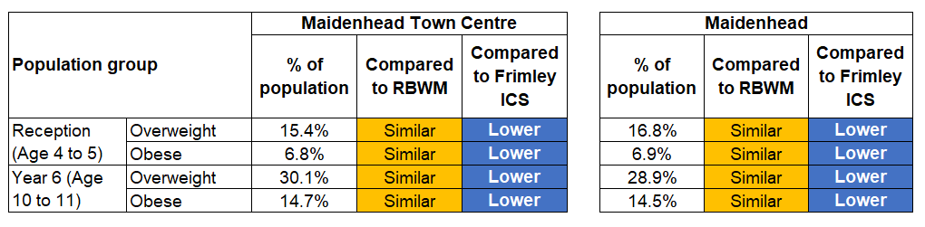
Figure 4: Prevalence of overweight and obesity in childhood (3 year data combined 2017/18 to 2019/20)
Statistical significance is based on 95% confidence intervals
Source: National Child Measurement Programme data taken from Office for Health Improvement & Disparities Local Health Profile
Health behaviours for young people and adults
The prevalence rates for different health behaviours are not available at a sub-local authority level. However, national and local prevalence rates can be used to model the estimated number of people affected in Maidenhead Town Centre and Maidenhead. These do not take into account the demographic or deprivation profile of these local geographies and should be used as a guide only.

Figure 5: Estimated number of people aged 11 to 15 who smoke, drink and take drugs (based on national prevalence rates and 2020 mid-year estimates)

 | Estimated number of children aged 11 to 15 who:
 | Current smokers  (at prevalence of 4%) | Drank alcohol in the last week  (at prevalence of 9%) | Took drugs in the last month  (at prevalence of 8%)
Maidenhead Town Centre | 135 | 304 | 270
Maidenhead | 209 | 471 | 419

Source: Prevalence from NHS Digital (2019) Smoking, Drinking and Drug Use Among Young People in England - 2018; Population estimates - ONS (2021); LSOA population estimates

Figure 6: Estimated number of adults aged 18 and over who smoke, have excess weight and are physically inactive (based on 2020 mid-year estimates)

 | Estimated number of adults aged 18 who are:
 | Smokers  (at prevalence of 10.3%) | With excess weight (at prevalence of 63.9%) | Physically inactive  (at prevalence of 21.4%)
Maidenhead Town Centre | 4,113 | 25,517 | 8,546
Maidenhead | 6,365 | 39,487 | 13,224

Source: Prevalence data taken from Office for Health Improvement & Disparities Public Health Outcomes Framework. Population estimates - ONS (2021); LSOA population estimates

Health outcomes

Life expectancy and premature mortality
RBWM’s life expectancy for males and females is significantly better than the national average. Maidenhead Town Centre and Maidenhead’s life expectancy at birth (2018-20) were similar to RBWM’s at 81.6 years for males and 85.2 years for females (NHS Digital Primary Care Mortality Dataset).

Maidenhead Town Centre and the Maidenhead area both have similar premature mortality rates to the whole of RBWM. From 2018-20, 340 residents of Maidenhead Town Centre died aged under 75 at a rate of 272 per 100,000 population. This compared to 520 residents of Maidenhead at a rate of 278 per 100,000 population (NHS Digital 2022, Primary Care Mortality Dataset). The main cause of premature death was cancer, followed by cardiovascular disease.

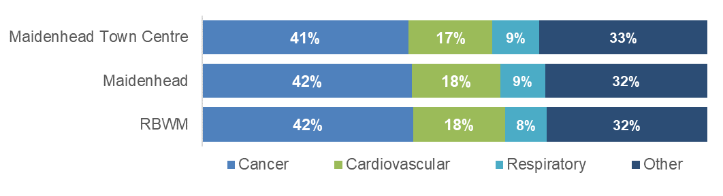
Figure 7: Proportion of premature deaths (people aged under 75) by underlying cause (2018-20)

Source: NHS Digital (2022) Primary Care Mortality Dataset
Prevalence of long-term conditions and disease
The recorded prevalence rates of different long-term conditions and diseases are similar across Maidenhead Town Centre and the wider Maidenhead area. Figure 8 shows how these compare to the whole of RBWM and the Frimley ICS footprint.

Figure 8: Recorded prevalence of long-term conditions and disease (based on monitoring QOF Registers at 11th May 2022)

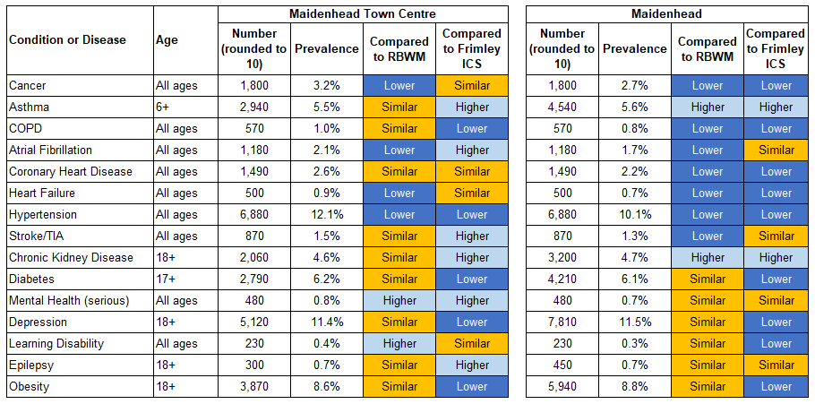
Statistical significance is based on 95% confidence intervals
Source: Frimley System Insights

The population’s health needs can be mapped into broad categories to indicate the level of health resources required to support them. Maidenhead Town Centre and Maidenhead areas have similar proportions of the population in these categories with 32% of the population identified as ‘Healthy users’ with minimal support required, 17% as low users, 36% as medium users and 11% as high/very high users. These proportions are similar to both RBWM and the Frimley ICS footprint as a whole (Frimley System Insights at 11th May 2022).

