Windsor Population Profile

This Population Profile provides a high-level summary of the demography and health of people living in Windsor. This has been compared against the Royal Borough of Windsor & Maidenhead (RBWM) and Frimley Integrated Care System (ICS) to provide further context.

Geographies used in these profiles

Windsor: Clewer and Dedworth West, Clewer and Dedworth East, Clewer East, Datchet, Horton and Wraysbury, Eton and Castle and Old Windsor wards.

Population and demographic factors

Windsor was estimated to have a population of 52,525 in 2020, which was 35% of the total RBWM population (Office for National Statistics (ONS) 2021).

Figure 1: Population by broad age groups (2020 mid-year estimates)

 | Under 18 | 18 to 39 | 40 to 59 | 60 to 79 | 80 and over
Windsor | 11,748 | 13,012 | 15,341 | 9,347 | 3,057

Source: Office for National Statistics (2021); Ward level population estimates

Figure 2 illustrates the population profile for the Windsor area. Windsor has a similar population profile to RBWM and the Frimley ICS area, apart from a notably higher proportion of males aged 15 to 19. Eton College and other residential schools are based in the area, which explains this anomaly. The Windsor area also has a slightly lower proportion of young children aged 5 to 14 compared to RBWM and the wider Frimley ICS area.

Figure 2: Population pyramid for Windsor (2020 mid-year estimates)

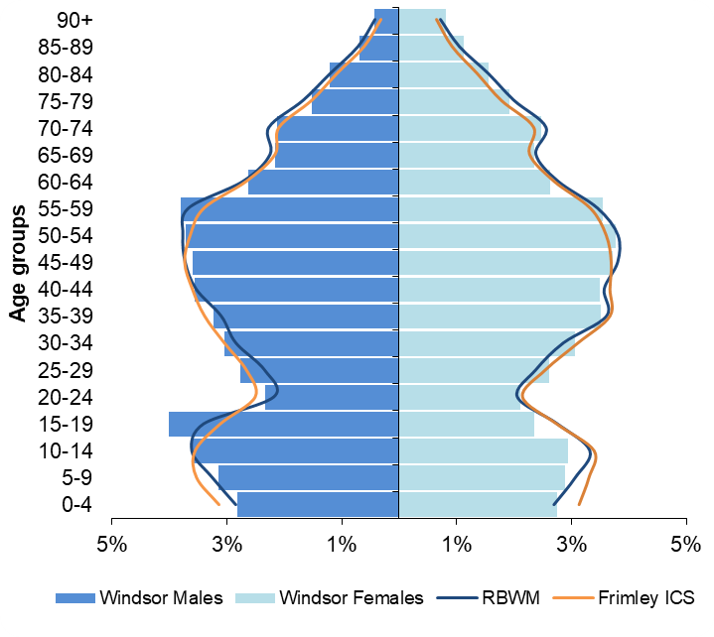

Source: Office for National Statistics (2021); Ward level population estimates

Ethnicity
The latest ethnicity information is based on the 2011 Census, which may not reflect the current population. It is anticipated that the 2021 Census will show increases in the proportion of the population from Black, Asian and Minority Ethnic (BAME) groups and non-White British groups.

In 2011, 13.4% of Windsor’s population were recorded as coming from a BAME group, which was significantly lower than RBWM (13.9%) and the wider Frimley ICS area (18.6%). People from an Asian/Asian British background were the largest non-White population in Windsor and were estimated to make-up 8.4% of the town centre’s population. In addition, 8.6% of the population were from a non-White British background (ONS 2012).

Wider determinants of health

Deprivation and poverty
RBWM is one of the most affluent areas in England with over 50% of the Borough’s Lower Super Output Areas (LSOAs) in the least deprived 10% of neighbourhoods nationally.

Windsor has a higher deprivation score than the whole of RBWM and would be classified in the 21%- 30% most deprived areas nationally in its own right. RBWM’s most deprived neighbourhood is located in Clewer & Dedworth East (014D) ward and is classed as being in the 30% most deprived areas nationally with approximately 1,870 people living in this neighbourhood (Ministry of Housing, Communities and Local Government 2019).

Figure 3 shows the number and proportion of children and older people living in income deprived households in 2020. While Windsor has lower proportions of these populations living in income deprivation compared to Frimley ICS, these are significantly higher than RBWM’s overall. Five neighbourhoods in Datchet, Horton & Wraysbury (011C and 011D) and Clewer & Dedworth East (014C, 014D and 014E) wards have over 15% of children living in income deprivation. A neighbourhood in Clewer & Dedworth East ward (005D) has nearly 35% of older people living in income deprivation, which is the 2nd highest level in RBWM (Ministry of Housing, Communities and Local Government 2019).

Figure 3: Population living in income deprived households (2020 mid-year estimates)
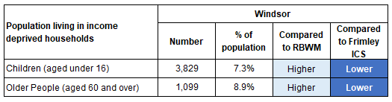
Statistical significance is based on 95% confidence intervals
Source: Deprivation scores – Ministry of Housing Communities and Local Government (2019); English indices of deprivation 2019. Population estimates - ONS (2021); LSOA population estimates

In 2018, approximately 6.0% of households in Windsor were living in fuel poverty, compared to 6.1% in RBWM and 6.4% across Frimley ICS (Department for Business, Energy and Industrial Strategy 2021). It is important to note that these figures will not reflect the impact of the recent rise in energy costs.

Employment and benefits
Recent employment data is not available at a sub-LA level. The previous 2011 Census indicates that 76% of 16 to 74 year olds were economically active in Windsor, compared to 74% across RBWM (ONS 2012).

At Feb-22, approximately 1,134 people in Windsor were claiming Universal Credit (average over the 12 month period), which was 3.5% of 16 to 64 year olds. This was similar to the proportion of people claiming in RBWM and significantly lower than Frimley ICS (ONS 2022).
Housing
The type of housing provision in Windsor is different to the whole of RBWM, with a significantly higher proportion of terraced houses, flats and maisonette dwellings and a lower proportion of detached houses (Valuations Office Agency 2021). A higher proportion of people also rent their properties (private or social renting) compared to the whole of the Borough with fewer owning their home outright or through a mortgage (ONS 2012).

In 2011, 33% of older people in Windsor were living alone, which was significantly higher than the RBWM figure of 29%. Eton & Castle ward has a one of the highest proportions of older people living alone in the Royal Borough at nearly 46% (ONS 2012).

Crime
The change in crime rates within Windsor track alongside RBWM’s overall rates. From Mar-21 to Feb-22, there were 4,206 recorded crimes in Windsor at a rate of 80 per 1,000 population, compared to 69 per 1,000 in RBWM. The main cause of recorded crime was violence and sexual offences. Rates of crime by crime type indicate that Windsor has higher rates of public order offences, anti-social behaviour offences and violence and sexual offences compared to the rest of RBWM. The levels of crime across wards within Windsor are similar, apart from Eton & Castle where rates are 120% higher than the rest of Windsor (National Police Service data 2022).

Lifestyle and health behaviours

Childhood obesity
The levels of childhood obesity and overweight in Windsor are generally similar to RBWM’s and Frimley ICS. RBWM’s rates of childhood obesity have not significantly changed over the last 5 years (Office for Health Improvement & Disparities 2021).

Figure 4: Prevalence of overweight and obesity in childhood (3 year data combined 2017/18 to 2019/20)
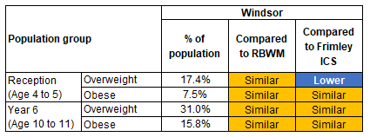
Statistical significance is based on 95% confidence intervals
Source: National Child Measurement Programme data taken from Office for Health Improvement & Disparities Local Health Profile

Health behaviours for young people and adults
The prevalence rates for different health behaviours are not available at a sub-local authority level. However, national and local prevalence rates can be used to model the estimated number of people affected in Windsor. These do not take into account the demographic or deprivation profile of these local geographies and should be used as a guide only.

Figure 5: Estimated number of people aged 11 to 15 who smoke, drink and take drugs (based on national prevalence rates and 2020 mid-year estimates)

 | Estimated number of children aged 11 to 15 who:
 | Current smokers  (at prevalence of 4%) | Drank alcohol in the last week  (at prevalence of 9%) | Took drugs in the last month  (at prevalence of 8%)
Windsor | 140 | 315 | 280

Source: Prevalence from NHS Digital (2019) Smoking, Drinking and Drug Use Among Young People in England - 2018; Population estimates - ONS (2021); LSOA population estimates

Figure 6: Estimated number of adults aged 18 and over who smoke, have excess weight and are physically inactive (based on 2020 mid-year estimates)

 | Estimated number of adults aged 18 who are:
 | Smokers  (at prevalence of 10.3%) | With excess weight (at prevalence of 63.9%) | Physically inactive  (at prevalence of 21.4%)
Windsor | 4,198 | 26,044 | 8,722

Source: Prevalence data taken from Office for Health Improvement & Disparities Public Health Outcomes Framework. Population estimates - ONS (2021); LSOA population estimates

Health outcomes

Life expectancy and premature mortality
RBWM’s life expectancy for males and females is significantly better than the national average. Windsor’s life expectancy at birth (2018-20) was similar to RBWM’s at 81.8 years for males and 85.1 years for females (NHS Digital Primary Care Mortality Dataset).

Windsor has similar premature mortality rates to the whole of RBWM. From 2018-20, 370 residents of Windsor died aged under 75 at a rate of 278 per 100,000 population, compared to 273 per 100,000 population in RBWM (NHS Digital 2022, Primary Care Mortality Dataset). The main cause of premature death was cancer, followed by cardiovascular disease.

Figure 7: Proportion of premature deaths (people aged under 75) by underlying cause (2018-20)

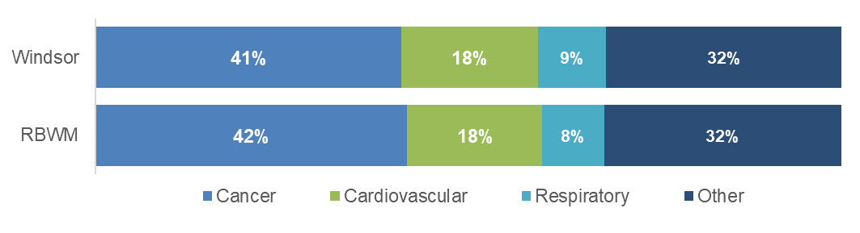
Source: NHS Digital (2022) Primary Care Mortality Dataset

Prevalence of long-term conditions and disease
Figure 8 shows how the recorded prevalence of long-term conditions and diseases in Windsor compare to the whole of RBWM and the Frimley ICS footprint.

Figure 8: Recorded prevalence of long-term conditions and disease (based on monitoring QOF 11th May 2022)
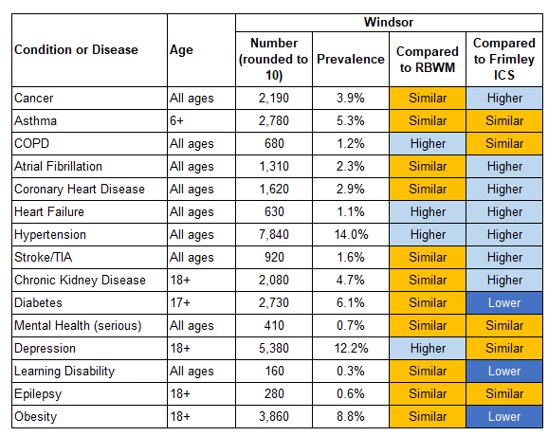
Statistical significance is based on 95% confidence intervals
Source: Frimley System Insights

The population’s health needs can be mapped into broad categories to indicate the level of health resources required to support them. Windsor has 33% of the population identified as ‘Healthy users’ with minimal support required, 20% as low users, 32% as medium users and 10% as high/very high users. These proportions are broadly similar to both RBWM and the Frimley ICS footprint (Frimley System Insights at 11th May 2022).

