Berkshire East Healthy Behaviours Health Needs Assessment

APPENDIX 2: Data Pack to Describe the Population

DATA CORRECT AT June 2022

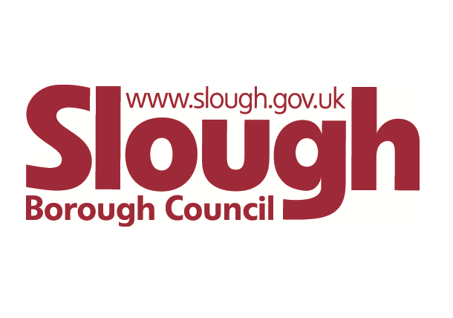
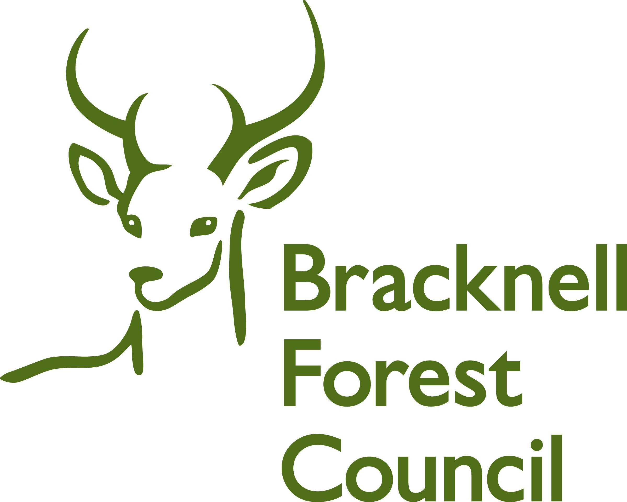

1 Introduction
This Data Pack supplements the Berkshire East Healthy Behaviours Health Needs Assessment (HNA), which was published in September 2022. The HNA focuses on health behaviours within the population of Berkshire East’s three local authorities – Bracknell Forest, Slough and the Royal Borough of Windsor and Maidenhead (RBWM). While the full HNA includes key data that have informed findings and recommendations, this Data Pack provides a more comprehensive analysis of the full datasets that were used as part of this analysis.
The scope of the HNA was agreed by the HNA Steering Group and included the following topics:
This includes information on people who are overweight, obese, their diet and any disordered eating

Looking at data for people who binge drink or drink in excess of the chief medical officer’s recommendations. Not including people who have a dependency on alcohol.

The HNA Steering Group also recognised the importance of looking at a number of specific groups to see how their health behaviours differed compared to the general population. The following groups were identified and a summary of the data available is included in this Data Pack.

The data included in the HNA focuses on Berkshire East’s resident population (people living in Bracknell Forest, Slough and RBWM) and is shown at the lowest geographical area available. Data at a registered population level (people registered with specific GP Practices or Primary Care Networks areas) were not included in the scope of the HNA and data analysis has therefore not been completed at this level.
The HNA has also primarily focused on the adult population (aged 18 and over), although additional analysis for children has been included around obesity and overweight as this is intrinsically linked to the prevalence of the current and future adult population.
A summary of the key information for each topic has been included at the beginning of that section as a ‘Key Finding’. Information specific to individual local authorities has been included at the end of each section in summary tables.

2 Methodology and datasets used
The data included in this Pack have come from a range of sources, including national surveys, audits and local health care information systems. These will all have restrictions and caveats associated with the data collection and will not always be comparable, due to the different methodologies used. These caveats have been included throughout the Data Pack, where relevant, and the impact that these have on the interpretation of the data have been clearly stated. A summary of the key data caveats, restrictions and approached used have been included below.

Self-reported surveys
Information about healthy behaviours is often collected through surveys, where respondents state how often they smoke, drink alcohol and exercise. The advantage of these surveys is that they can cover a large number of the population and that the information gathered can be used to identify difference and inequalities across the general public. However, self-reporting may not reflect a true picture with people more likely to over-state their healthy behaviours (such as physical activity) and under-state those that are seen as higher risk (such as smoking).

Information gathered through healthcare information systems, such as GP Practice records and registers
Data collected through healthcare information systems, such as GP Practice registers, provide detailed information about health behaviours, conditions and the prevalence of recorded disease within a registered population group. However, this will only include data about people who are registered with a GP Practice and who have contacted their GP for support. This will therefore skew some analysis towards population groups that are more likely to be in contact with their GP, such as the older population and those with long-term conditions. This particularly impacts on the analysis of health behaviours, like smoking and excess weight, as there will be large sections of the population that are not captured in this analysis.
The prevalence of disease is captured through the national Quality and Outcomes Framework (QOF), which identifies how many people are on disease registers at a snapshot in time. These can provide a useful picture of the health of the population and also how disease trends change over time. It is important to note that these show recorded prevalence of disease and will not indicate the proportion of the population that have an undiagnosed condition, such as diabetes and hypertension.
This HNA includes an analysis of data that comes from the NHS Frimley Integrated Care Board’s (ICB) local healthcare information system – Connected Care. This dataset has enabled the HNA to include a detailed analysis of the current health of the local population of Berkshire East. This will be impacted by the same caveats described above and will only include Berkshire East residents who are registered with a GP Practice.

Modelled estimates based on national data
Some health behaviour datasets are only available at a national level. In some instances, these national figures have been used to create modelled estimates for Berkshire East and the local authorities. These are only used as a guide to quantify the populations that may be impacted locally and will not always take age, sex, ethnicity and other demographic factors into account. Mid-year 2020 population estimates have been used to calculate these modelled estimates (Office for National Statistics 2021).

Comparator groups
National and regional benchmarks have been provided as comparators to the datasets included in this HNA, where available. The majority of these data are taken from the Office for Health Improvement and Disparities’ Fingertips Profiles. The Red-Amber-Green (RAG) approach used in the Fingertips Profiles has been adopted in this HNA to show how individual local authority and regional areas compare to the national (England) benchmark.
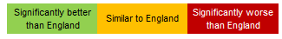

Data that has been taken from local healthcare systems includes Frimley Integrated Care System (ICS) as a benchmark, as this is the highest geography available in the local GP Record System (Connected Care). The ICS includes the Berkshire East local authorities, as well as people living within the local authority districts of Guildford, Hart, Runnymede, Rushmoor, Surrey Heath and Waverley. National and regional data are not available for Connected Care datasets.

3 Key demographics of Berkshire East’s population
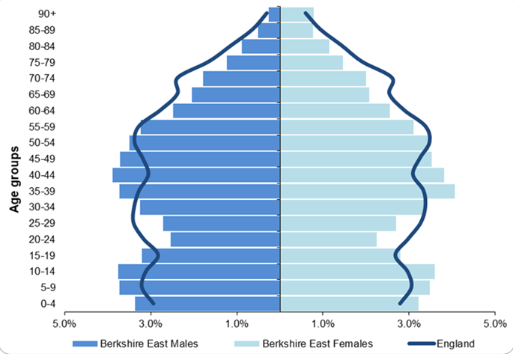
The Berkshire East Joint Strategic Needs Assessment (JSNA) includes a detailed analysis of the population living in Bracknell Forest, Slough and RBWM. The latest People and Place Summaries can be found on the main JSNA website.
An overarching summary of the key demographics for the Berkshire East population are included below to provide context for the HNA.
Figure 1: Population Pyramid for Berkshire East (mid-2020 estimates)

Age and sex
The population of Berkshire East was estimated to be 425,015 in mid-2020, with 75% of the population aged 18 and over (Office for National Statistics 2021). Berkshire East has a younger population than the national average, as shown in Figure 1, with higher proportions of young people (aged 0 to 19) and adults aged 35 to 49. In contrast, Berkshire East has lower proportions of the population aged 20 to 29 and 60 and over compared to the national picture.
Although all three local authorities have a higher proportion of the population aged under 18 compared to England, there are significant differences across Berkshire East. Slough’s population is much younger than Bracknell Forest and RBWM’s, while RBWM has a significantly higher proportion of people aged 65 compared to the other two local authorities.

Ethnicity
The 2011 census showed that 27% of people in Berkshire East came from a black, Asian or other minority ethnic group, compared to 15% in England (Office for National Statistics 2012). A further 9% of the Berkshire East population came from a white non-British background, compared to 6% nationally.
Source: Office for National Statistics (2021); Estimates of the population for the UK mid-2020

Ethnic diversity varies significantly across Berkshire East. Bracknell Forest has a significantly lower proportion of people from a black, Asian, or other minority ethnic group compared to England at 9%, RBWM has proportion similar to England at 14% and Slough has one of the highest proportions in England at 54%. People who identify as being from an Asian background are the largest minority ethnic group in all three local authority areas and make-up 19% of the Berkshire East population overall (Office for National Statistics 2012). The 2021 census is expected to show an increase in diversity across England and all of our local authority areas.
Deprivation
People living in more deprived areas have a shorter life expectancy and live more years in ill-health (The Health Foundation 2022), which makes deprivation one of the key measures of health inequality. Levels of deprivation vary significantly across Berkshire East. Slough is a more deprived area than the rest of Berkshire East with approximately 9% of its neighbourhoods (Lower Super Output Areas) in the 20% most deprived neighbourhoods nationally. In contrast, Bracknell Forest and RBWM are both in the 10% least deprived local authorities in England. However, they also have pockets of deprivation and neighbourhoods that are noticeably more deprived than the local authority area as a whole (Ministry of Housing, Communities and Local Government 2019).

Bracknell Forest | Slough | Windsor and Maidenhead
Population: Bracknell Forest has a population of 124,501.  Bracknell Forest’s population is younger than England’s profile with 23% of people aged under 18, compared to 21% nationally. The proportion of working-aged adults in Bracknell Forest is also slightly higher than England’s profile with notably higher proportions of 35 to 54 year olds.  People aged 65 and over make-up 15% of Bracknell Forest’s population, compared to 18% nationally. | Population: Slough has a population of 149,577.  Slough’s population is significantly younger than England’s profile with almost a third of people aged under 18. This compares to 21% nationally. While the proportion of working-aged adults in Slough is the same as England’s (60%), the proportion of people aged 65 and over is significantly lower at only 10% of the population.  People aged 65 and over make-up 19% of the population nationally | Population: RBWM has a population of 151,187.  23% of RBWM’s population are aged under 18, compared to 21% of England’s. The proportion of people aged 20 to 34 in RBWM is notably lower than then national profile, while those aged 40 to 59 make-up a higher proportion of the population.  People aged 65 and over make-up 19% of RBWM’s population, compared to 18% nationally.
Ethnicity: In 2011, nearly 85% of Bracknell Forest’s population were from a white British background. 10% of Bracknell Forest’s population were from an ethnic minority background, compared to 15% in England. 6% of both Bracknell Forest and England’s population were from a white non-British background.  People from an Asian background made up 5% of Bracknell Forest’s total population and were the largest ethnic minority group. | Ethnicity: Slough is one of the most ethnically diverse Boroughs in England with 54% of the population coming from an ethnic minority background. A further 11% of the population are from a white non-British background. In comparison, 15% of England’s population are from an ethnic minority background and 5% from a white non-British group.  People from an Asian background make up 40% of Slough’s total population and are the largest ethnic minority group. | Ethnicity: In 2011, almost 78% of RBWM’s population were from a white British background. 14% of RBWM’s population were from an ethnic minority background, compared to 15% in England. 9% of RBWM’s population were from a white non-British background, compared to 6% nationally.  People from an Asian background made up nearly 10% of RBWM’s total population and were the largest ethnic minority group.
Deprivation: Bracknell Forest’s overall deprivation ranking sits within the least deprived decile (10%) in England with 26% of all Bracknell Forest’s LSOAs in the least deprived decile nationally. None of Bracknell Forest’s LSOAs are in the 20% most deprived areas in England. Bracknell Forest’s most deprived LSOAs are in Wildridings & Central, Crowthorne and Great Hollands North wards. | Deprivation: Slough’s overall deprivation ranking sits within the 5th most deprived decile in England. None of Slough’s LSOAs are in the 10% most deprived in the England, however 7 out of Slough’s 80 LSOAs fall within the 10%-20% most deprived neighbourhoods nationally. These are in areas of Britwell & Northborough, Central, Chalvey, Colnbrook with Poyle and Elliman wards. | Deprivation: RBWM’s overall deprivation ranking sits within the least deprived decile (10%) in England with over 50% of all RBWM’s LSOAs in the least deprived decile nationally. None of RBWM’s LSOAs are in the 20% most deprived areas in England. The most deprived neighbourhoods of RBWM are in areas of Clewer North, St Mary’s and Oldfield wards.
3.1 Understanding Weight Behaviours
Obese: Body Mass Index (BMI) of 30kg/m² or over
Overweight: BMI of 25 to 30kg/m²
Excess weight (overweight or obese): BMI of 25kg/m² or over
Obesity is a major public health problem both nationally and globally (Office for Health Improvement and Disparities 2022). Obesity and being overweight are leading causes of premature death and are associated with reduced life expectancy and life-limiting conditions such as type 2 diabetes, cardiovascular disease and some cancers. They can also have a significant impact on mental health and wellbeing. High Body Mass Index (BMI) is currently the 3rd largest risk factor for ill health, disability and premature death in England and contributes to 9% of all healthy life years lost (Global Burden of Disease 2019).

Underlying causes of obesity are complex and multifactorial, often stemming from biological factors, poor diet and sedentary behaviour that are influenced by social factors, individual choices and underlying health conditions, with some evidence for life course epidemiological factors (Lee et al. 2019). Obesity and overweight has an estimated cost of £27bn to the wider UK economy (UK Health Security Agency 2015) and as a result, the Government's Call to Acton on Obesity included national ambitions relating to excess weight in adults (Department of Health and Social Care 2011). This recognises and plans to rectify overweight and obesity as a major determinant of premature mortality and avoidable ill health. Overweight and obesity therefore represent one of the most widespread threats to health and wellbeing nationally with approximately 25% of adults being obese and 64% having excess weight (Office for Health Improvement and Disparities 2022).

Key Findings
Obese and overweight adults
National and regional trends indicate increasing rates of obesity and overweight in the adult population, based on the Active Lives Survey results. There has been some fluctuation in local figures, which can be partly attributed to small numbers, however it is expected that local authorities are following the national trend. While Bracknell Forest and Slough’s prevalence has generally remained similar to England’s, RBWM currently has significantly better prevalence rates.

Population groups that have higher levels of obesity and overweight nationally include:
- Males
- People aged 45 and over
- People from black and white-British groups
- People with disabilities
- People from more deprived neighbourhoods (most to 5th most deprived deciles)

The prevalence of obesity and overweight is also recorded on GP Practice Registers and this includes people aged 18 and over who have had their BMI measured and recorded over the last year. In January 2022, 24% of Frimley ICS’s registered population had had their BMI recorded in the last year. Of this population, 37% were recorded as obese. A follow-up analysis in June 2022, identified an additional 37% of people who were recorded as overweight. This means approximately 74% of the Frimley ICS adult population with a recent BMI recorded are overweight or obese.
The Quality and Outcomes Framework’s methodology for obesity has been used in this analysis to calculate the prevalence of recorded obesity and overweight against the whole adult population. The obesity prevalence for the whole of Frimley ICS’s adult population was 8.7% in January 2022, with a higher prevalence in Berkshire East at 9.5%. The prevalence of overweight in June 2022 was 8.7% in Frimley ICS and 9.0% in Berkshire East.

In Frimley ICS, recorded obesity prevalence is highest in:
- Females
- Adults aged 60 to 69, followed by adults aged 70 to 79
- People from black or black British ethnic groups, followed by white ethnic groups
- People from more deprived neighbourhoods
In Frimley ICS, recorded overweight prevalence is highest in:
- Adults aged 70 to 79, followed by adults aged 80 to 89
- People from Asian or Asian British ethnic groups, followed by black or black British groups

(This will only include people who have contacted their GP Practice and had their BMI recorded in the previous 12 months, which will skew figures to older populations and those with long-term health conditions).

The profile of obesity and overweight differs between males and females in Frimley ICS. A significantly higher proportion of females with excess weight are recorded as obese, as opposed to being overweight. In contrast, a significantly higher proportion of males with excess weight are recorded as overweight, as opposed to being obese.

Obese and overweight children
The National Child Measurement programme (NCMP) monitors the height and weight of primary school-children in Reception Year (aged 4 to 5) and Year 6 (aged 10 to 11). This allows the prevalence of obesity and overweight to be calculated for these age groups and gives an indication of the levels and trends in childhood obesity.
In 2019/20, 21% of 4 to 5 year olds and 35% of 10 to 11 year olds in Berkshire East had excess weight (overweight or obese). Although Berkshire East’s levels of excess weight are similar to the national average for both age groups, there is significant variation across the three local authorities and also within them. Slough has one of the highest rates of childhood obesity in the South East, while RBWM’s rates are significantly lower than the national average.

Nationally, children from the following groups are more likely to be obese or have excess weight:
- From more deprived areas, compared to those in least deprived decile - this association is also visible in Bracknell Forest and Slough, although RBWM’s figures do not clearly show this.
- Non-white ethnic groups, compared to white ethnic groups – there is also local evidence to show significant differences in some parts of Berkshire East, including Bracknell Forest (both age groups) and RBWM (Reception Year). Slough has less difference between white and non-white ethnic groups, although those from a black group have a higher prevalence of obesity compared to children from white and Asian ethnic groups.

Diet
The 2019/20 Active Lives Adult Survey reported that 55.4% of England’s population met the recommended ‘5-a-day’ fruit and vegetable portions with considerable variation across Berkshire East’s local authorities. Slough consistently has a significantly worse proportion of people meeting this recommendation compared to England, while RBWM’s levels are significantly better. Bracknell Forest’s levels are similar to England’s.

Population groups that have lower levels of people who meet the recommended levels of fruit and vegetables nationally include:
- Males
- People aged 16 to 54
- People from Chinese, Asian and black ethnic groups
- People with disabilities
- People from more deprived areas (most deprived to 3rd most deprived decile)

Disordered eating
Disordered eating is the development of (typically restrictive) eating habits that are potentially harmful to wellbeing that may otherwise be recommended as part of a ‘healthy behaviour’ or be due to food insecurity. There is no data available to quantify the level of disordered eating in Berkshire East or the population groups that may be more impacted by this.

3.1.1 Self-reported prevalence of obese and overweight adults in the general population
Sport England’s Active Lives Survey monitors the proportion of adults who are overweight or obese, based on a self-reported survey. In 2020/21, 63.5% of adults in England were classified as obese or overweight. The South East region has a significantly better level of excess weight compared to England, although this continues to rise regionally and nationally. The prevalence of excess weight has fluctuated across Berkshire East over the last 6 years. While Bracknell Forest and Slough’s prevalence have generally remained similar to England, RBWM currently has a significantly better prevalence rate.

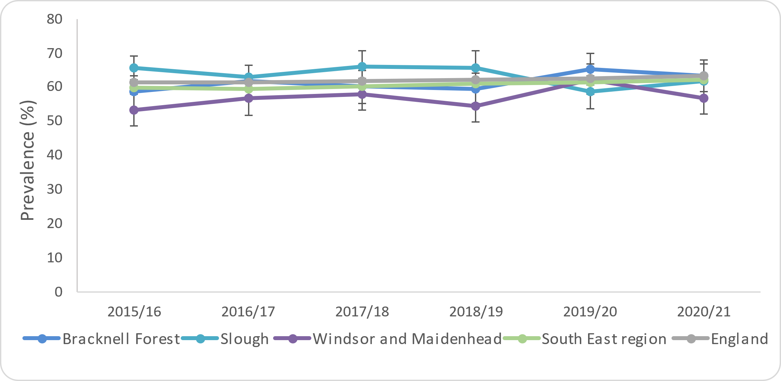
Figure 2: Percentage of adults (18+) classified as overweight or obese in Berkshire East

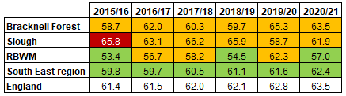

Source: Office for Health Improvement and Disparities (2022); Obesity Profile
Additional analysis from the latest Active Lives Survey highlights a number of different groups within the population that have significantly higher levels of obesity and overweight. These are based on national figures and are not available at a local level:

- Males (69%), compared to females (58%)
- People aged 45 and over, compared to those aged 18 to 34
- People from black (72%) and white-British (65%) groups, compared to all other ethnic groups
- People with disabilities (73%), compared to those who are not disabled (61%)
- People from more deprived areas (most deprived to 5th most deprived decile), compared to other less deprived areas

Bracknell Forest | Slough | Windsor and Maidenhead
The proportion of adults aged 18 and over classified as overweight or obese in Bracknell Forest have remained similar to the South East region and England prevalence since 2013/14. | The proportion of adults aged 18 and over classified as overweight or obese in Slough have remained similar to England since 2016/17. They were significantly worse in 2015/16. | The proportion of adults aged 18 and over classified as overweight or obese in RBWM were significantly better than England and the South East region in 2020/21. This was also reflected in 2015/16 and 2018/19.

3.1.2 Prevalence of recorded obesity on GP Practice Records (Connected Care)
The prevalence of recorded obesity is monitored through the Quality and Outcomes Framework (QOF) and measures the proportion of adults who have a BMI of 30kg/m² or over recorded on their GP Record in the previous 12 months. This is regarded as an underestimation of the true level of obesity in the GP practice population, as it will only include people who have required support from their GP and have subsequently had a BMI measurement recorded. Recorded prevalence data will therefore be skewed towards the older population and those that have ongoing health needs and conditions. In addition, the Covid-19 restrictions will also have reduced the number of people who would have had their BMI measured as part of a face-to-face consultation. However, this information can still provide a useful tool to monitor trends and inequalities in local obesity prevalence.

The information included in this section of the report focuses on the local population aged 18 and over that had a BMI measurement of 30kg/m² recorded on their GP Practice record in January 2022. Across Frimley ICS, there are over 150,000 people aged 18 or over with a BMI recorded, making up approximately 24% of the population. Of those where BMI is recorded, almost 56,000 people are obese – 37% of all those with a BMI recorded.

The Quality and Outcomes Framework’s methodology for obesity has been used in this analysis to calculate the prevalence of recorded obesity against the whole adult population. In January 2022, 8.7% of Frimley ICS’s total adult population were recorded as obese, compared to 9.5% in Berkshire East.

Sex
Females have a higher recorded prevalence of obesity (10%) in Frimley ICS, compared to males (7.5%).

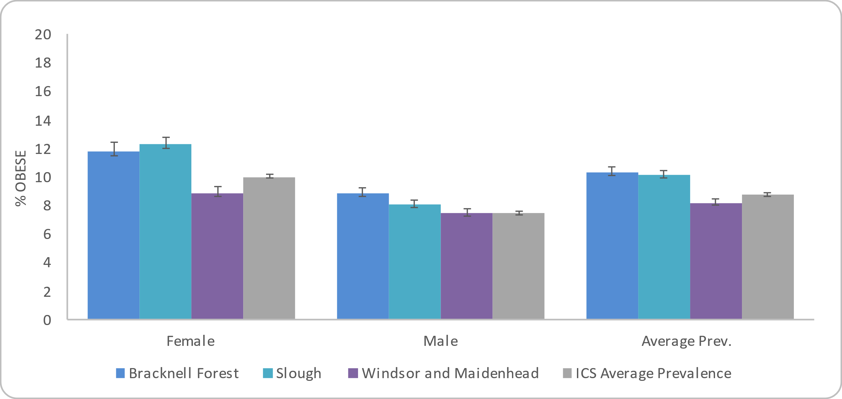
Figure 3: Prevalence of adult (18+) Obesity by sex in Frimley ICS and Berkshire East local authorities

Source: Connected Care - Frimley ICB Analytics Team (Jan 2022)

Age

The highest prevalence of recorded obesity in Frimley ICS is for adults aged 60 to 69, followed by adults aged 70 to 79.
Figure 4: Prevalence of adult (18+) Obesity by age group in Frimley ICS and Berkshire East local authorities

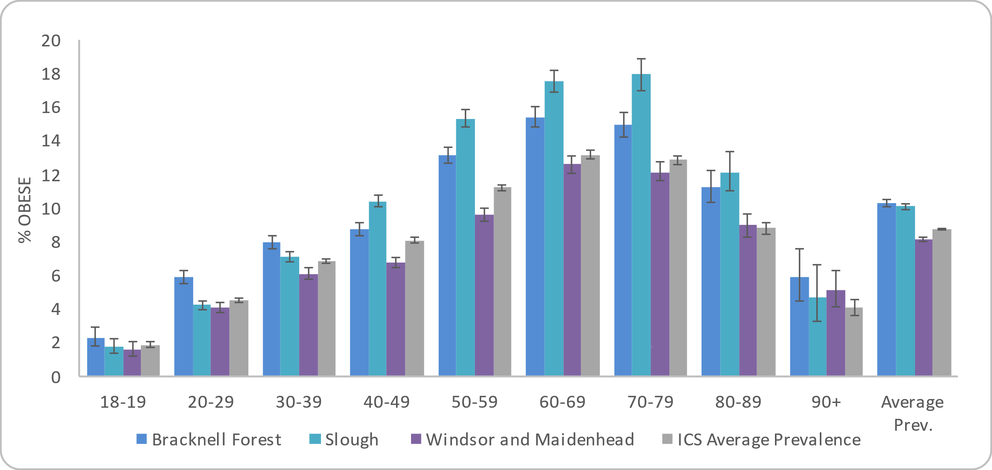

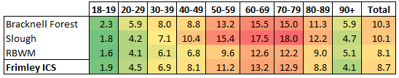
The colour-coding used above indicates higher (red) and lower (green) levels of obesity. This does not infer significance and is only for information.

Source: Connected Care - Frimley ICB Analytics Team (Jan 2022)

Ethnicity
People from a black or black British ethnic group have the highest recorded prevalence of obesity (12.5%) in Frimley ICS, followed by those from a white ethnic group (9.4%) and Asian or Asian British ethnic group (9.1%). The lowest prevalence is seen in people from ‘other ethnic groups’.

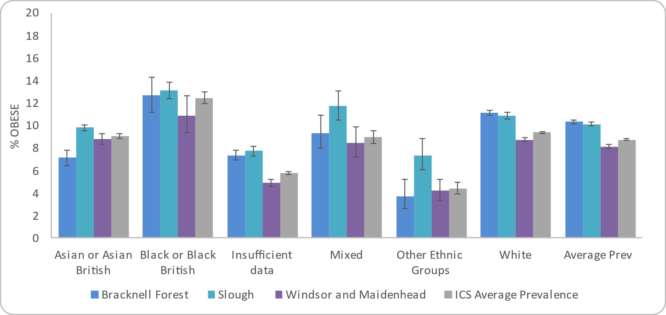
Figure 5: Prevalence of adult (18+) Obesity by ethnicity in Frimley ICS and Berkshire East local authorities
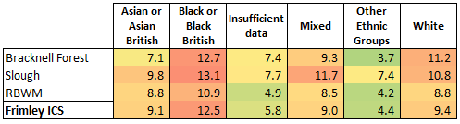
The colour-coding used above indicates higher (red) and lower (green) levels of obesity. This does not infer significance and is only for information.

Number of adults (18+) with GP recorded Obesity by ethnicity

Source: Connected Care - Frimley ICB Analytics Team (Jan 2022)

Deprivation

Each neighbourhood in England, or Lower Super Output Area (LSOA), has a deprivation score that indicates how deprived that area is compared to the rest of England. Frimley ICS and Berkshire East do not have any LSOAs in the 10% most deprived neighbourhoods nationally and this group is therefore not included in the analysis below.
The most deprived area in Frimley ICS (2nd most deprived decile nationally) has the highest recorded prevalence of obesity at 11.5%. This is followed by those in the 3rd and 5th deprived deciles at 10.9% each. The least deprived decile has the lowest recorded prevalence of obesity at 6.8%.

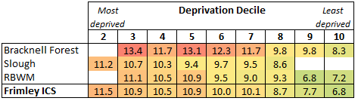
Figure 6: Prevalence of adult (18+) Obesity by deprivation decile in Frimley ICS and Berkshire East local authorities
The colour-coding used above indicates higher (red) and lower (green) levels of obesity. This does not infer significance and is only for information.

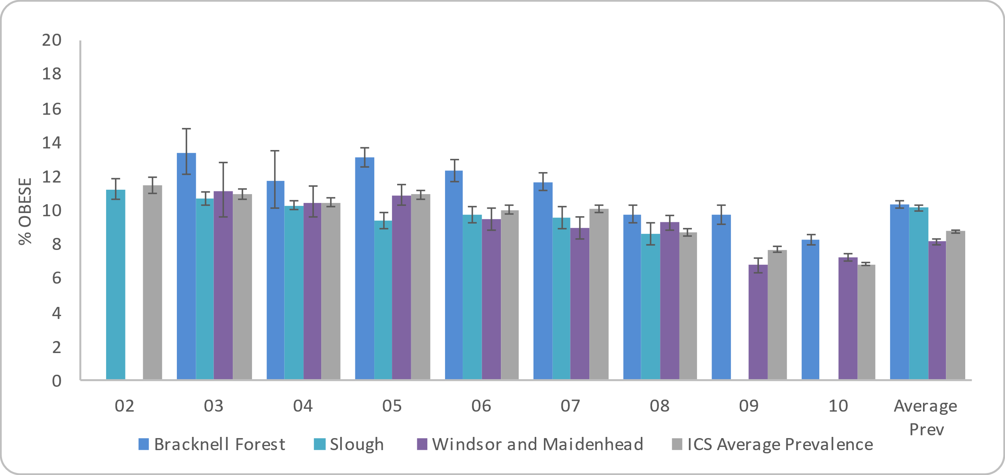

Source: Connected Care - Frimley ICB Analytics Team (Jan 2022)

Bracknell Forest | Slough | Windsor and Maidenhead
10.3% of people aged 18 or over are registered on the QOF Obesity register with a BMI of 30kg/m² or more. | 10.1% of people aged 18 or over are registered on the QOF Obesity register with a BMI of 30kg/m² or more. | 8.1% of people aged 18 or over are registered on the QOF Obesity register with a BMI of 330kg/m² or more.
Sex: 11.8% of females aged 18 or over are registered on the QOF Obesity register as obese.  8.9% of males aged 18 or over are registered on the QOF Obesity register as obese. This is the highest prevalence rate for males by local authority across Frimley ICS. | Sex: 12.3% of females aged 18 or over are registered on the QOF Obesity register as obese. The highest prevalence rate for females by local authority across Frimley ICS.  8.1% of males aged 18 or over are registered on the QOF Obesity register as obese. | Sex: 8.8% of females aged 18 or over are registered on the QOF Obesity register as obese.  7.4% of males aged 18 or over are registered on the QOF Obesity register as obese.
Age: The highest prevalence of obesity is in adults aged 60 to 69, followed by adults aged 70 to 79. | Age: The highest prevalence of obesity is in adults aged 70 to 79, followed by adults aged 60 to 69. | Age: The highest prevalence of obesity is in adults aged 60 to 69, followed by adults aged 70 to 79.
Ethnicity: The highest prevalence of people aged 18 or over, registered on the QOF Obesity register as obese by ethnicity is 12.7% for those with a black or black British ethnicity.  11.2% have a white ethnicity recorded.  The lowest prevalence is recorded in the other ethnic group category with a prevalence rate of 3.7%. | Ethnicity: The highest prevalence of people aged 18 or over, registered on the QOF Obesity register as obese by ethnicity is 13.1% for those with a black or black British ethnicity, with the second highest rate of 11.7% in the mixed ethnicity.  10.8% have a white ethnicity recorded.  The lowest prevalence is recorded in the other ethnic group category with a prevalence rate of 7.4%. | Ethnicity: The highest prevalence of people aged 18 or over, registered on the QOF Obesity register as obese by ethnicity is 10.9% for those with a black or black British ethnicity.  8.8% have a white ethnicity recorded, as does the ethnic category of Asian or Asian British.  The lowest prevalence is recorded in the other ethnic group category with a prevalence rate of 4.2%.
Deprivation: Bracknell Forest has LSOAs in deprivation deciles 3 to 10.  The highest prevalence of obesity is 13.4% for the 3rd most deprived decile, followed by the 5th most deprived decile (13.1%) and the 4th most deprived decile (11.7%).  People living in the least deprived areas have the lowest prevalence of obesity with a rate of 8.3%. | Deprivation: Slough has LSOAs in deprivation deciles 2 to 8.  The highest prevalence of obesity is 11.2% for the 2nd most deprived decile, followed by the 3rd most deprived decile (10.7%) and the 4th most deprived (10.3%).  People living in the 3rd least deprived area have the lowest prevalence of obesity with a rate of 8.6%. | Deprivation: RBWM has LSOAs in deprivation deciles 3 to 10.  The highest prevalence of obesity is 11.1% for the 3rd most deprived decile, followed by the 5th most deprived decile (10.9%) and the 4th most (10.5%).  People living in the 2nd least deprived areas have the lowest prevalence of obesity with a rate of 6.8%.

Location
Figure 7: Prevalence of recorded obesity in adults (18+) by LSOA in Bracknell Forest

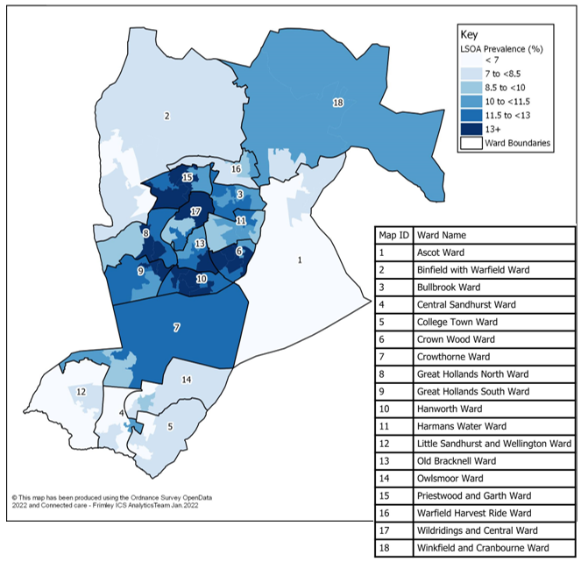
Figure 7 shows the prevalence of recorded obesity by Lower Super Output Area (LSOA) in Bracknell Forest. This shows higher levels of obesity within central Bracknell, with the highest recorded prevalence found in neighbourhoods in Great Hollands North, Crown Wood and Priestwood and Garth wards. The neighbourhoods with the highest prevalence rates are included below:

Caution should be taken with this data as it is based on crude rates, rather than age-standardised rates. Age is a factor that impacts on recorded obesity prevalence and areas of Bracknell Forest with older populations will therefore have higher obesity prevalence.
Source: Connected Care - Frimley ICB Analytics Team (Jan 2022)

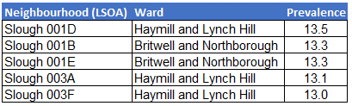
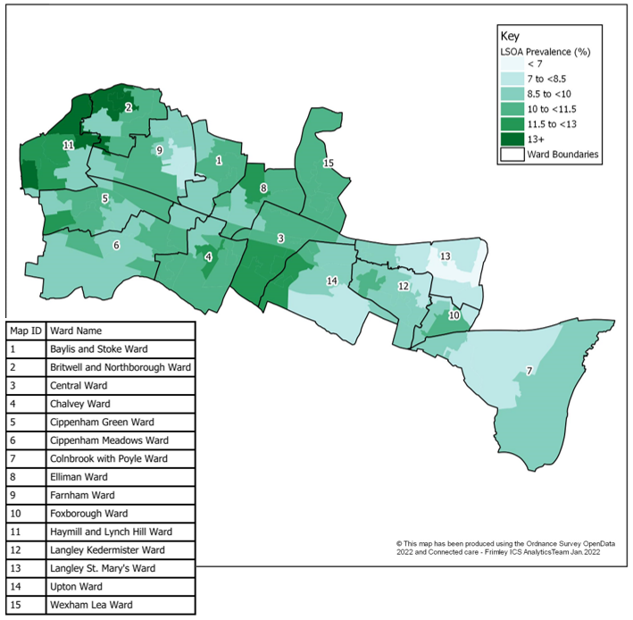
Figure 8 shows the prevalence of recorded obesity by LSOA in Slough. This shows higher levels of obesity to the left of the Borough in neighbourhoods within Haymill and Lynch Hill ward and Britwell and Northborough ward. The neighbourhoods with the highest prevalence rates are included below:
Figure 8: Prevalence of recorded obesity in adults (18+) by LSOA in Slough

Caution should be taken with this data as it is based on crude rates, rather than age-standardised rates. Age is a factor that impacts on recorded obesity prevalence and areas of Slough with older populations will therefore have higher obesity prevalence.

Source: Connected Care - Frimley ICB Analytics Team (Jan 2022)

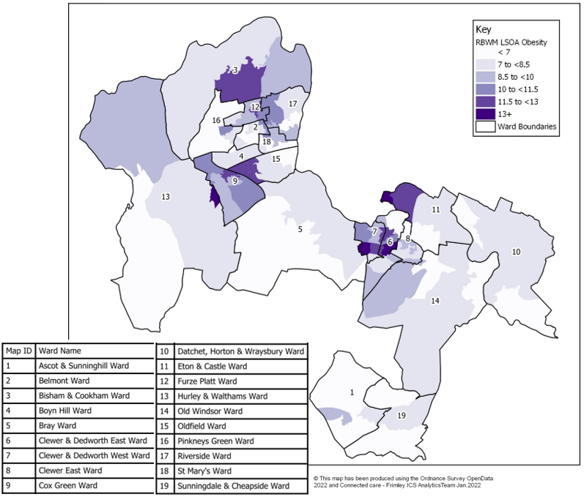
Figure 9 shows the prevalence of recorded obesity by LSOA in RBWM. This shows higher levels of obesity in neighbourhoods within Windsor and Maidenhead’s town centres. The neighbourhoods with the highest prevalence rates are included below.
Figure 9: Prevalence of Obesity in adults (18+) by LSOA in RBWM

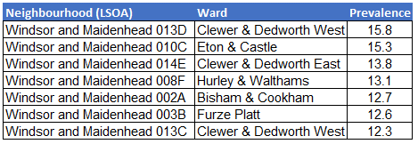

Caution should be taken with this data as it is based on crude rates, rather than age-standardised rates. Age is a factor that impacts on recorded obesity prevalence and areas of RBWM with older populations will therefore have higher obesity prevalence.

Source: Connected Care - Frimley ICB Analytics Team (Jan 2022)
Figure 10: Prevalence of Obesity in adults (18+) by ward (January 2022)
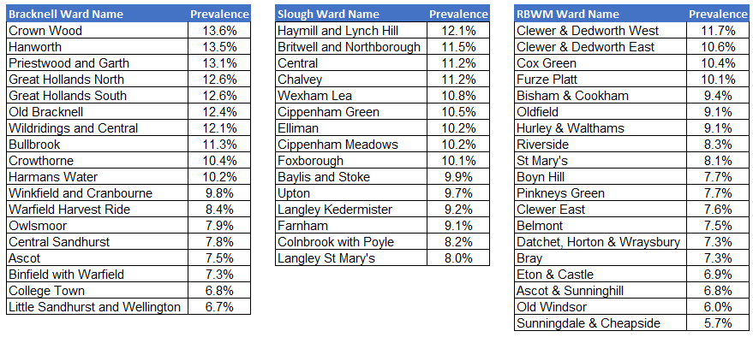

Source: Connected Care - Frimley ICB Analytics Team (Jan 2022)

3.1.3 Prevalence of overweight recorded on GP practice records (Connected Care)
Please note: data for overweight was pulled at a later date to that of other Connected Care data as this was a request put in after first review of the data.

Unlike obesity, the prevalence of overweight is not monitored through the Quality and Outcomes Framework (QOF). However, for this analysis the same approach has been taken to measure the proportion of adults who have a BMI from 25<30kg/m² recorded on their GP Record in the previous 12 months in June 2022. These are also regarded as an underestimation of the true level of overweight in the GP practice population, as they will only include people who have required support from their GP and have subsequently had a BMI measurement recorded.

Across Frimley ICS, there are over 150,000 people aged 18 or over with a BMI recorded at this point in time, making up approximately 24% of the population.
Of those where BMI is recorded, 54,500 people are overweight – 37% of all those with a BMI recorded.

The Quality and Outcomes Framework’s methodology for obesity has been used in this analysis to calculate the prevalence of recorded overweight against the whole adult population. The overweight prevalence for the whole of Frimley ICS’s adult population was 8.7% in June 2022, with a slightly higher prevalence in Berkshire East at 9.0%.

Sex
The proportion of males and females who are overweight in Frimley ICS are the same.

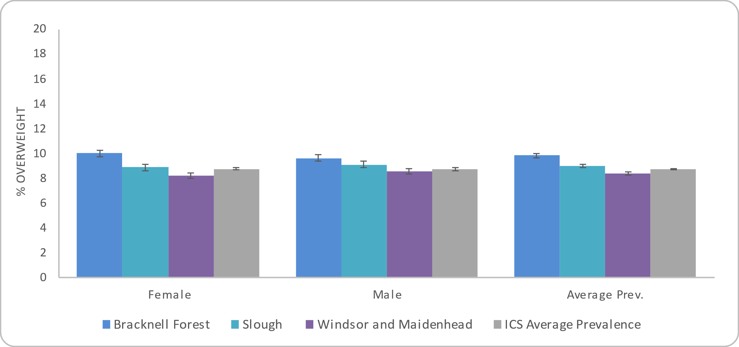
Figure 11: Prevalence of overweight adults (18+) by sex in Frimley ICS and Berkshire East local authorities

Source: Connected Care - Frimley ICB Analytics Team (June 2022)

Age
Across Frimley ICS, the highest prevalence of overweight adults is people aged 70 to 79 (14.7%), followed by adults aged 80 to 89.

Figure 12: Prevalence of overweight adults (18+) by age group in Frimley ICS and Berkshire East local authorities
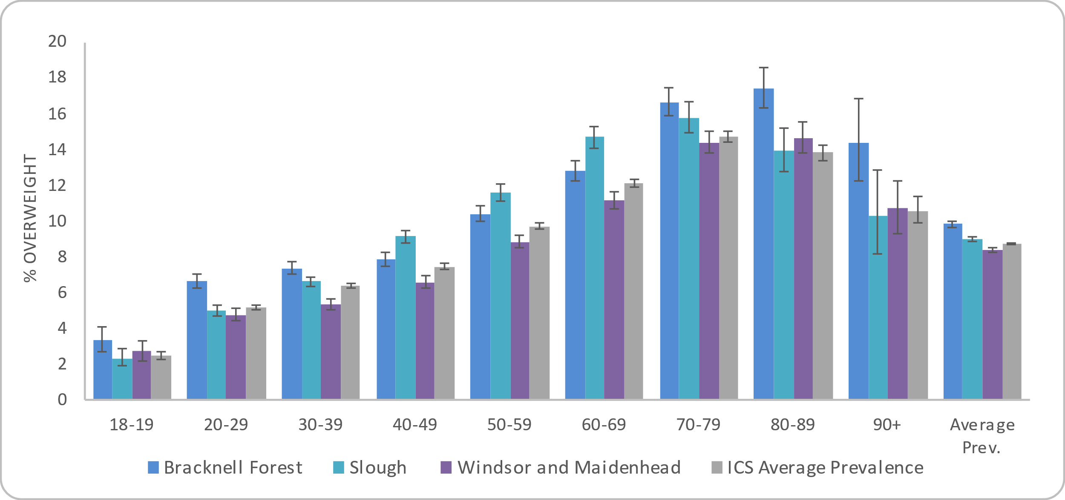
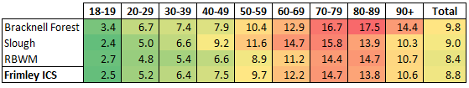
The colour-coding used above indicates higher (red) and lower (green) levels of obesity. This does not infer significance and is only for information.

Source: Connected Care - Frimley ICB Analytics Team (June 2022)

Ethnicity
People from Asian or Asian British groups have the highest recorded prevalence of overweight (10.6%) in Frimley ICS, followed by those from a black of black British group (9.4%). The lowest prevalence is seen in people from ‘other ethnic groups’.

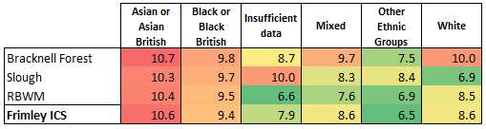
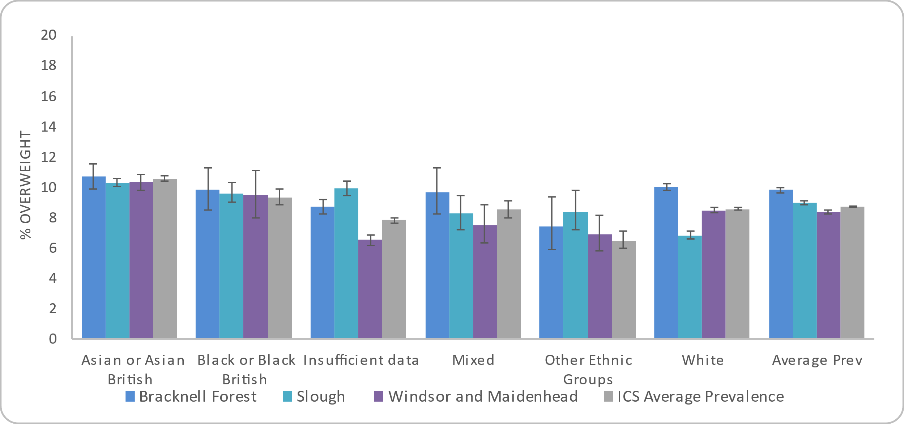
Figure 13: Prevalence of overweight adults (18+) by ethnicity in Frimley ICS and Berkshire East local authorities
The colour-coding used above indicates higher (red) and lower (green) levels of obesity. This does not infer significance and is only for information.

Source: Connected Care - Frimley ICB Analytics Team (June 2022)

Deprivation
Each neighbourhood in England, or Lower Super Output Area (LSOA), has a deprivation score that indicates how deprived that area is compared to the rest of England. Frimley ICS and Berkshire East do not have any LSOAs in the 10% most deprived neighbourhoods nationally and this group is therefore not included in the analysis below.

The most deprived areas in Frimley ICS (2nd and 3rd most deprived deciles nationally) have the highest recorded prevalence of overweight at 9.5% each. The least deprived decile has the lowest recorded prevalence of obesity at 8.4%. However, any association between deprivation and being overweight is not as clear as the association between deprivation and obesity.

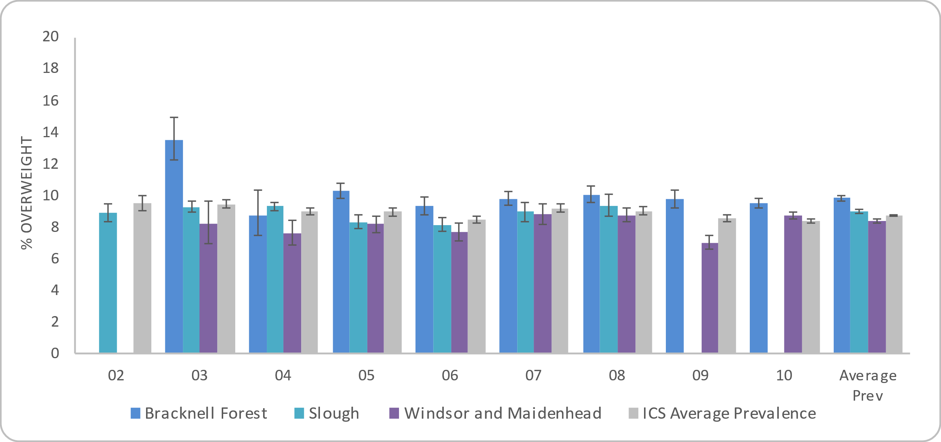
Figure 14: Prevalence of overweight adults (18+) by deprivation decile in Frimley ICS and Berkshire East local authorities

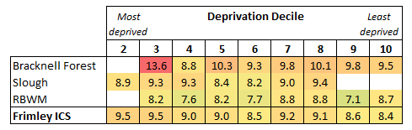
The colour-coding used above indicates higher (red) and lower (green) levels of obesity. This does not infer significance and is only for information.

Source: Connected Care - Frimley ICB Analytics Team (June 2022)

Bracknell Forest | Slough | Windsor and Maidenhead
9.9% of people aged 18 or over are overweight (BMI from 25<30kg/m² recorded on their GP Record in the previous 12 months) | 9.0% of people aged 18 or over are overweight (BMI from 25<30kg/m² recorded on their GP Record in the previous 12 months) | 8.4% of people aged 18 or over are overweight (BMI from 25<30kg/m² recorded on their GP Record in the previous 12 months)
Sex: 10.0% of females and 9.6% of males aged 18 or over are recorded as overweight in Bracknell Forest. | Sex: 9.1% of males and 8.9% of females aged 18 or over are recorded as overweight in Slough. | Sex: 8.5% of males and 8.3% of females are recorded as overweight in RBWM.
Age: The highest prevalence of overweight adults is in adults aged 80 to 89 (17.5%), followed by adults aged 70 to 79 (16.7%). | Age: The highest prevalence of overweight adults is in adults aged 70 to 79 (15.8%), followed by adults aged 60 to 69 (14.7%). | Age: The highest prevalence of overweight adults is in adults aged 80 to 89 (14.7%), followed by adults aged 70 to 79 (14.4%).
Ethnicity: The highest prevalence of overweight people aged 18 or over were people from an Asian or Asian British ethnic group at 10.7%, followed by 10.0% of those from a white ethnic group. This reflects the ICS’s picture.  The lowest prevalence is recorded in the other ethnic group at 7.5%. | Ethnicity: The highest prevalence of overweight people aged 18 or over were people from an Asian or Asian British ethnic group at 10.3%, followed by 9.7% of those from a black or black British ethnic group. This reflects this ICS’s picture.  The lowest prevalence is recorded in the white ethnic category at 6.9%. | Ethnicity: The highest prevalence of overweight people aged 18 or over were people from an Asian or Asian British ethnic group at 10.4%, followed by 9.5% of those from a black or black British ethnic group. This reflects the ICS’s picture.  The lowest prevalence is recorded in the other ethnic group category with a prevalence rate of 6.9%.
Deprivation: Bracknell Forest has LSOAs in deprivation deciles 3 to 10.  The highest prevalence of overweight is 13.6% for the 3rd most deprived decile, followed by the 5th most deprived decile (10.3%).  People living in the 5th least deprived neighbourhood areas have the lowest prevalence with a rate of 8.3%. | Deprivation: Slough has LSOAs in deprivation deciles 2 to 8.  The highest prevalence is 9.4% for the 3rd least deprived decile, followed by the 3rd and 4th most deprived deciles with a rate of 9.3% each.  People living in the 5th least deprived area have the lowest prevalence with a rate of 8.2%. | Deprivation: RBWM has LSOAs in deprivation deciles 3 to 10.  The highest prevalence is 8.8% for the third and fourth least deprived deciles, followed by the least deprived decile with 8.7%.  People living in the 2nd least deprived areas have the lowest prevalence with a rate of 7.1%.

Location
Figure 15: Prevalence of overweight adults (18+) by LSOA in Bracknell Forest

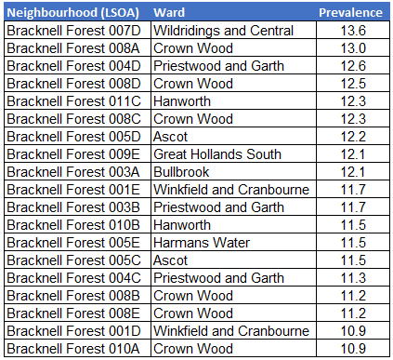
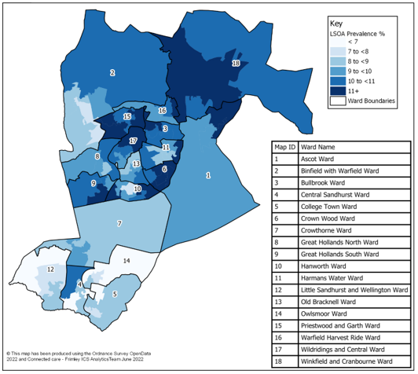
Figure 15 shows the prevalence of people recorded as overweight by LSOA in Bracknell Forest. This shows the highest levels of overweight people in neighbourhoods (LSOAs) within Wildridings and Central, Crown Wood and Priestwood and Garth wards. The neighbourhoods with the highest prevalence rates are included below.

Caution should be taken with this data as it is based on crude rates, rather than age-standardised rates. Age is a factor that impacts on recorded prevalence of overweight and areas of Bracknell Forest with older populations will therefore have a higher prevalence.

Source: Connected Care - Frimley ICB Analytics Team (June 2022)

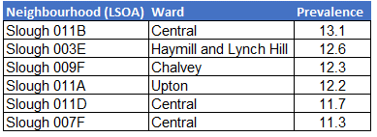
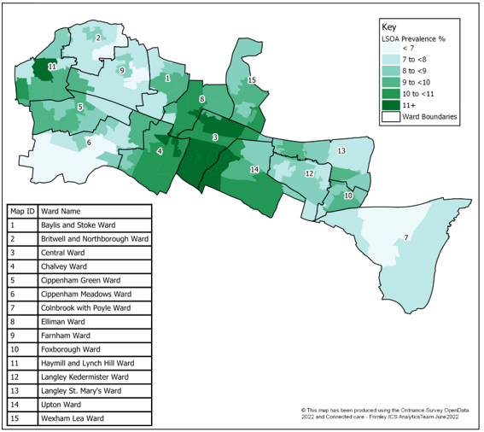
Figure 16 shows the prevalence of people recorded as overweight by LSOA in Slough. This shows the highest levels of overweight people in neighbourhoods (LSOAs) within Central, Haymill and Lynch Hill and Chalvey wards, The neighbourhoods with the highest prevalence rates are included below.
Figure 16: Prevalence of overweight adults (18+) by LSOA in Slough

Caution should be taken with this data as it is based on crude rates, rather than age-standardised rates. Age is a factor that impacts on recorded prevalence of overweight and areas of Slough with older populations will therefore have a higher prevalence.

Source: Connected Care - Frimley ICB Analytics Team (June 2022)

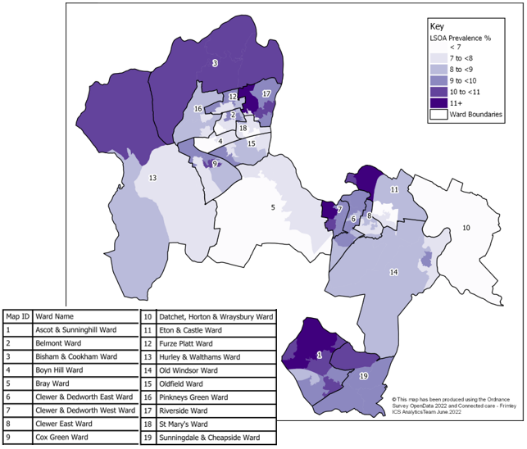
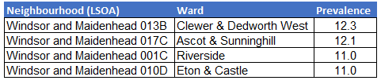
Figure 17 shows the prevalence of people recorded as
Figure 17: Prevalence of overweight adults (18+) by LSOA in RBWM

overweight by LSOA in RBWM. This shows the highest levels of overweight people in neighbourhoods (LSOAs) within Clewer & Dedworth West, Ascot & Sunninghill, Riverside and Eton & Castle wards.
Caution should be taken with this data as it is based on crude rates, rather than age-standardised rates. Age is a factor that impacts on recorded prevalence of overweight and areas of Slough with older populations will therefore have a higher prevalence.

Source: Connected Care - Frimley ICB Analytics Team (June 2022)

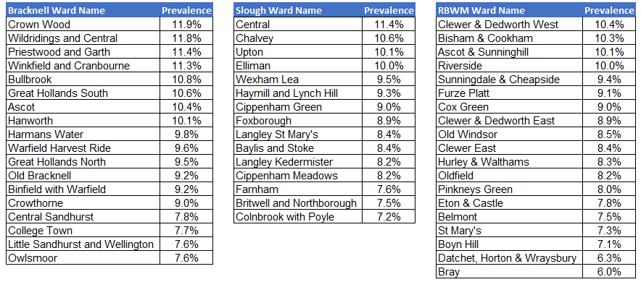
Figure 18: Prevalence of overweight in adults (18+) by ward (June 2022)

Source: Connected Care - Frimley ICB Analytics Team (June 2022)

3.1.4 Children’s data
Studies tracking child obesity into adulthood have found that the probability of overweight and obese children becoming overweight or obese adults increases with age. There is concern about the rise of childhood obesity and the implications of such obesity persisting into adulthood. The risk of obesity in adulthood and risk of future obesity-related ill health are greater as children get older. For this reason, there is data for children to help understand the current picture of excess weight and obesity in children (Office for Health Improvement and Disparities 2022).

The health consequences of childhood obesity include increased blood lipids, glucose intolerance, Type 2 diabetes, hypertension, increases in liver enzymes associated with fatty liver, exacerbation of conditions such as asthma and psychological problems such as social isolation and low self-esteem.

The National Child Measurement Programme (NCMP) measures the height and weight of 4 to 5-year-olds (Reception) and 10 to 11-year-olds (Year 6) in primary schools. This surveillance data helps to identify patterns in obesity and excess weight in the child population, as well as those that are underweight. Figure 19 provides a summary of 2019/20 NCMP results for Berkshire East, compared to England.

Figure 19: Number and proportions of children in each weight group for Berkshire East and England (2019/20)

 | Reception (aged 4-5) |  |  |  | Year 6 (aged 10-11)
Weight group | Berkshire East |  | England |  | Berkshire East |  | England
 | Number of children | Percentage of children | Percentage of children |  | Number of children | Percentage of children | Percentage of children
Healthy weight | 2,500 | 76% | 76% |  | 3,275 | 63% | 63%
Under weight | 70 | 2% | 1% |  | 85 | 3% | 1%
Overweight | 355 | 11% | 13% |  | 790 | 15% | 14%
Obese | 355 | 11% | 10% |  | 1,060 | 20% | 21%
Excess weight (obese and overweight) | 700 | 21% | 23% |  | 1,845 | 35% | 35%
Source: Office for Health Improvement and Disparities (2022); Obesity Profile

Although Berkshire East’s levels of excess weight (being overweight or obese) are similar to the national average for both age groups, there is variation across the three local authorities and also within them. Figure 20 shows the proportion of children who have excess weight by ward and highlights the association between excess weight and deprivation, which is apparent for the older age group. The link between excess weight and deprivation is recognised nationally and children from non-white ethnic groups also have a higher prevalence of excess weight compared to their peers from white ethnic groups (Office for Health Improvement and Disparities 2022).
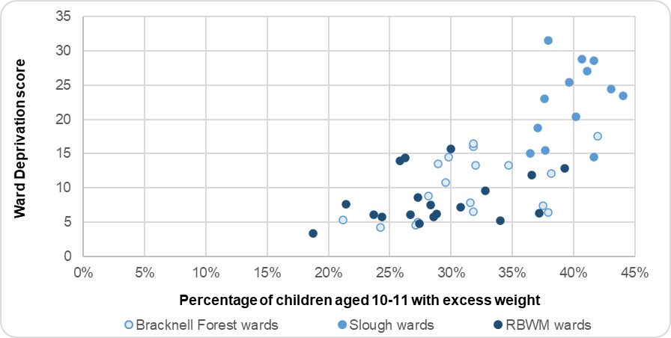
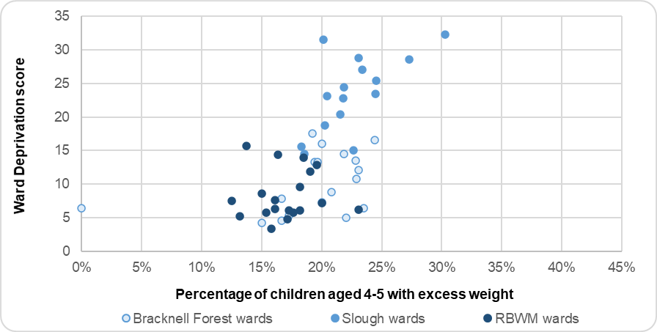
Figure 20: Proportion of children with excess weight (overweight or obese) by ward and deprivation score (2017/18 to 2019/20)
In 2019/20, 21% of 4 to 5 years olds in Berkshire East had excess weight (overweight or obese). RBWM had a significantly lower prevalence of excess weight compared to England, while Bracknell Forest and Slough’s rates were similar. The prevalence of obesity in Slough’s 4 to 5 year-olds is the highest in the South East at 11.9% and is significantly worse than England’s.

10 to 11 year-olds have higher levels of obesity and excess weight compared to the younger age group, both nationally and locally. In 2019/20, 35% of 10 to 11 year-olds in Berkshire East were overweight and obese. This prevalence rate also varied across Berkshire East, with significantly higher levels of excess weight in Slough (41%) and significantly lower levels in RBWM (29%).

The proportion of Berkshire East’s children aged 4 to 5 who were underweight in 2019/20 was significantly higher than the national figures. This is due to a much higher prevalence rate of 2.7% in Slough. Children who are underweight may not be consuming the calories and nutrients that come from a varied and balanced diet, which could impact on their development and energy levels.

Source: Office for Health Improvement and Disparities (2022); Obesity Profile
Bracknell Forest | Slough | Windsor and Maidenhead
Excess weight: NCMP findings from 2019/20 show that 20% of Reception Children and 33% of Year 6 children had excess weight in Bracknell Forest. This was similar to the national and regional figures for both age groups. | Excess weight: NCMP findings from 2019/20 show that 23% of Reception Children and 41% of Year 6 children had excess weight in Slough. While Slough’s prevalence in Reception Year children is similar to the national average, the prevalence in Year 6 is significantly worse than the national picture and currently the highest rate in the South East. | Excess weight: NCMP findings from 2019/20 show that 16% of Reception Children and 29% of Year 6 children had excess weight in RBWM. This was significantly better than the national and regional figures for both age groups.
Obesity: NCMP findings from 2019/20 show that 10% of Reception Children and 18% of Year 6 children were obese in Bracknell Forest. Bracknell Forest’s prevalence for Reception aged children was similar to the national and regional picture, while prevalence for the Year 6 age group was significantly better.  Data from 2015/16 to 2019/20 shows that children living in the most deprived areas of Bracknell Forest (2nd most deprived quintile) had a significantly higher prevalence of obesity, compared to those from the least deprived quintile.  Children from non-white ethnic groups have a higher prevalence of obesity compared to children from white ethnic groups. This is significantly higher for children in Year 6 and reflects the national picture. | Obesity: NCMP findings from 2019/20 show that 12% of Reception Children and 25% of Year 6 children were obese in Slough. Both of these were significantly worse than England and the highest rates in the South East.  Data from 2015/16 to 2019/20 shows that children living in the most deprived areas of Slough (most deprived quintile) had a significantly higher prevalence of obesity, compared to those from the least deprived quintal.  The difference in obesity prevalence between ethnic groups in Slough is not as great as the national picture or across the rest of Berkshire East. | Obesity: NCMP findings from 2019/20 show that 7% of Reception Children and 15% of Year 6 children were obese in RBWM. This was significantly better than the national and regional figures for both age groups.  Data from 2015/16 to 2019/20 does not show a clear association between deprivation and obesity in RBWM for Reception aged children, unlike other areas of Berkshire East. For children in Year 6 those from the most deprived areas (2nd most deprived quintile) had a significantly higher prevalence of obesity, compared to those from the least deprived quintile.  For Reception children, those from a black ethnic group have a higher prevalence of obesity compared to children from white and Asian ethnic groups.

3.1.5 Diet
Poor diet is currently the 4th largest risk factor for ill health, disability and premature death in England. Nationally, this contributes to over 7% of all healthy life years lost (Global Burden of Disease 2019). A poor diet includes having an excessive of certain foods (for example processed meats, red meats, salt and high-sugar drinks) and/or not consuming enough foods or nutrients (such as fruit and vegetables, fibre and omega 3 fatty acids). Average intakes of saturated fat, sugar, and salt are above recommendations while intakes of fruit and vegetables, oily fish, fibre and some vitamins and minerals in some groups are below recommendations.

The NHS (2022) recommends eating at least five portions of a variety of fruit and vegetables every day as an excellent source of vitamins, minerals, and fibre. The 2019/20 Active Lives Adult Survey reported 55.4% of England’s population met the recommended ‘5-a-day’ on a ‘usual day’ for fruit and vegetable consumption. This is significantly better in the South East region with 58.3% of adults meeting the recommended level (Office for Health Improvement and Disparities 2022). There is variation across Berkshire East’s local authorities, ranging from 49.7% in Slough to 60.6% in RBWM.

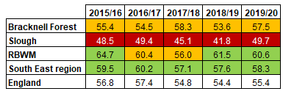
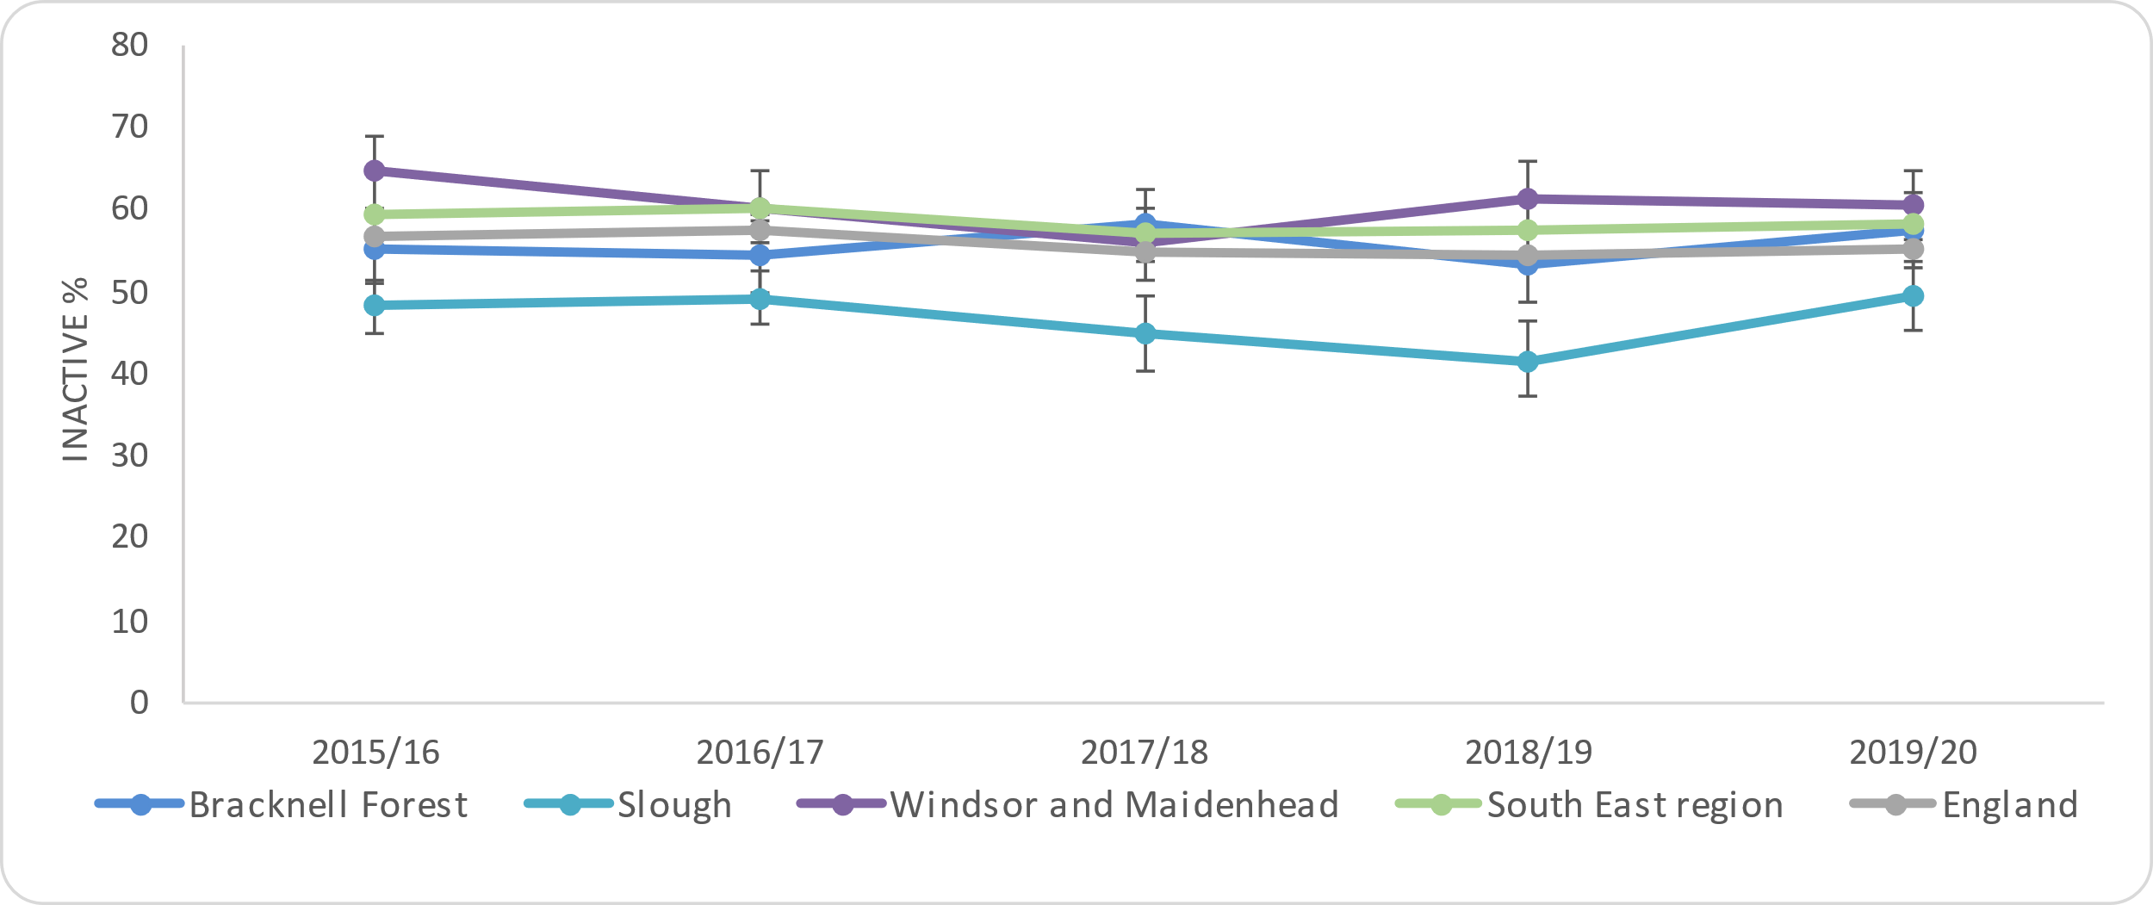
Figure 21: Percentage of adults meeting the recommended ‘5-a-day’ in Berkshire East

Source: Office for Health Improvement and Disparities (2022); Obesity Profile

Additional analysis from the latest Active Lives Survey highlights a number of different groups within the population that have significantly lower levels of people who meet the recommended levels of fruit and vegetables. These are based on national figures and are not available at a local level:
- Males (51%), compared to females (60%)
- People aged 16 to 54, compared to those aged 55 to 84
- People from Chinese (52%), Asian (47%) and black (46%) groups, compared to white-British group (57%)
- People with disabilities (52%), compared to those who are not disabled (56%)
- People from more deprived areas (most deprived to 3rd most deprived decile), compared to other less deprived areas

Bracknell Forest | Slough | Windsor and Maidenhead
Bracknell Forest had similar proportions of adults meeting the recommended 5-a-day to both England and the South East region in 2019/20. This has consistently been similar to the national figure | Slough had significantly worse proportions of adults meeting the recommended 5-a-day to both England and the South East region in 2019/20. This has consistently been significantly below the national figure. | RBWM had similar proportions of adults meeting the recommended 5-a-day to the South East region and significantly better proportions compared to England in 2019/20.

3.1.6 Disordered Eating
Disordered eating is the development of (typically restrictive) eating habits that are potentially harmful to wellbeing that may otherwise be recommended as part of a ‘healthy behaviour’ (Musolino et al. 2015), or due to food insecurity (Jenkins et al. 2021). This should be distinguished from eating disorders that are formally defined and require a specific complement of treatments, which are not within the scope of healthy behaviours interventions.

Long-term disordered eating can cause extensive physical and psychiatric consequences. Behaviours related to disordered eating may see people self-regulate and monitor their diet and weight by skipping meals, dietary restriction or exercising to “burn off” calories. Academic literature has recorded associations with disordered eating and self-harm (Warne et al. 2020), poor mental health, management of other gastrointestinal disorders (Satherley et al. 2014). However, there are no formal guidelines or a clinical definition of ‘disordered eating’, during which people may present as being ‘health conscious’, and as a result, there are no data to estimate the number of people who engage in disordered eating. Information regarding specific nutrient deficiencies or reasons for restriction can also be found in National Diet and Nutrition Survey. These are out of scope for the HNA.

3.2 Understanding Physical Activity and Sedentary Behaviours
People who have a physically active lifestyle have a 20-35% lower risk of cardiovascular disease, coronary heart disease and stroke compared to those who have a sedentary lifestyle. Regular physical activity is also associated with a reduced risk of diabetes, obesity, osteoporosis and colon/breast cancer and with improved mental health. In older adults physical activity is associated with increased functional capacities (Public Health England, 2014).

Key Findings
66% of people aged 19 and over in England state that they are physically active (at least 150 moderate intensity equivalent minutes of physical activity per week in bouts of 10 minutes or more) and 23% state that they are physically inactive (engaging in less than 30 minutes of physical activity per week). Levels of physical activity and inactivity vary across Berkshire East with Slough having significantly worse levels of physical activity/inactivity compared to England and the rest of Berkshire East.

Population groups that have higher levels of physical inactivity nationally include:
- Females
- People aged 75 and over
- People from black, Asian and minority ethnic groups (apart from mixed ethnic groups),
- People with disabilities
- People from more deprived areas
- People who are long term unemployed or never employed, those in semi-routine or routine occupations and lower supervisory roles

Available information about local inequalities in Berkshire East show that levels of physical inactivity are higher in the older population (65 and over, compared to 16 to 64 year olds) and that there is little difference between males and females. However, the proportion of females that are inactive in Slough is much higher than other Berkshire East local authorities, England and the South East region.

Creating an environment where people actively choose to walk and cycle as part of everyday life can have a significant impact on public health and can reduce inequalities in health. Approximately 15% of people aged 16 and over in England report that they walk for travel at least three days per week and 2% cycle for travel. Berkshire East local authorities have similar levels of active travel compared to England, apart from the proportion of people who walk in RBWM which is significantly lower at 10%.

People who are sedentary - spend long periods of time sitting - have been found to have higher rates of diabetes, cardiovascular disease and death from all causes. Approximately 40% of women and 35% of men aged 16 to 75 spend more than six hours a day desk-bound or sitting still. This equates to nearly 160,000 people in Berkshire East.

3.2.1 Physical activity and inactivity
The Chief Medical Officer (2019) recommends that adults undertake a minimum of 150 minutes (2.5 hours) of moderate physical activity per week, or 75 minutes of vigorous physical activity per week. Sport England’s Active Lives Survey monitors the levels of physical activity for adults aged 19 and over against the Chief Medical Officer recommendations.
In the latest reported survey from 2020/21, 65.9% of respondents in England said they were doing at least 150 moderate intensity equivalent minutes of physical activity per week in bouts of 10 minutes or more. The South East region was significantly better with 69.2% of physically active adults. Figure 22 shows the levels of physical activity for adults across Berkshire East local authorities, with Slough having a significantly lower level of physical activity compared to the rest of Berkshire East.
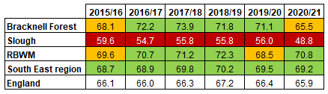
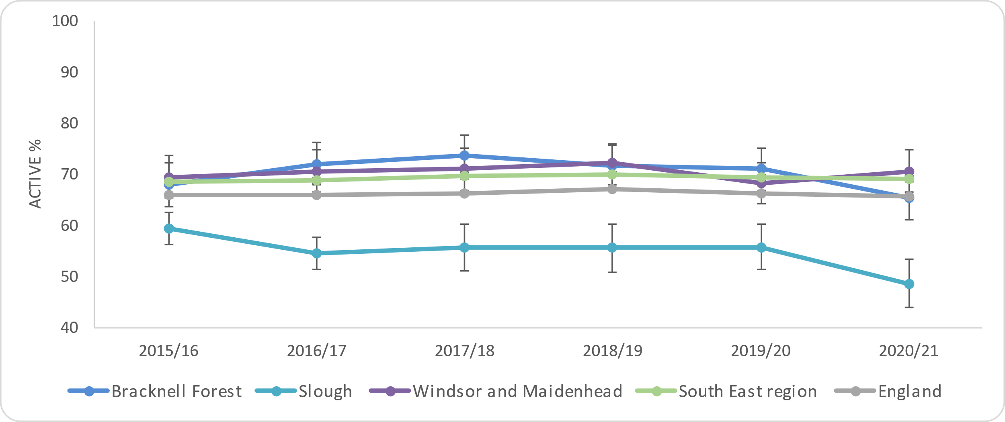
Figure 22: Percentage of physically active adults (19+)

Source: Office for Health Improvement and Disparities (2022); Physical Activity Profile

Physical inactivity is defined as engaging in less than 30 minutes of physical activity per week. In 2020/21, 23.4% of adults (aged 19 or over) stated they were physically inactive in England. The South East region was significantly better than England with 20.2% of adults physically inactive. Figure 23 shows the levels of physical inactivity for adults across Berkshire East local authorities, with Slough having a significantly worse level of physical inactivity compared to the rest of Berkshire East.

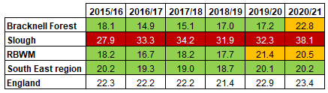
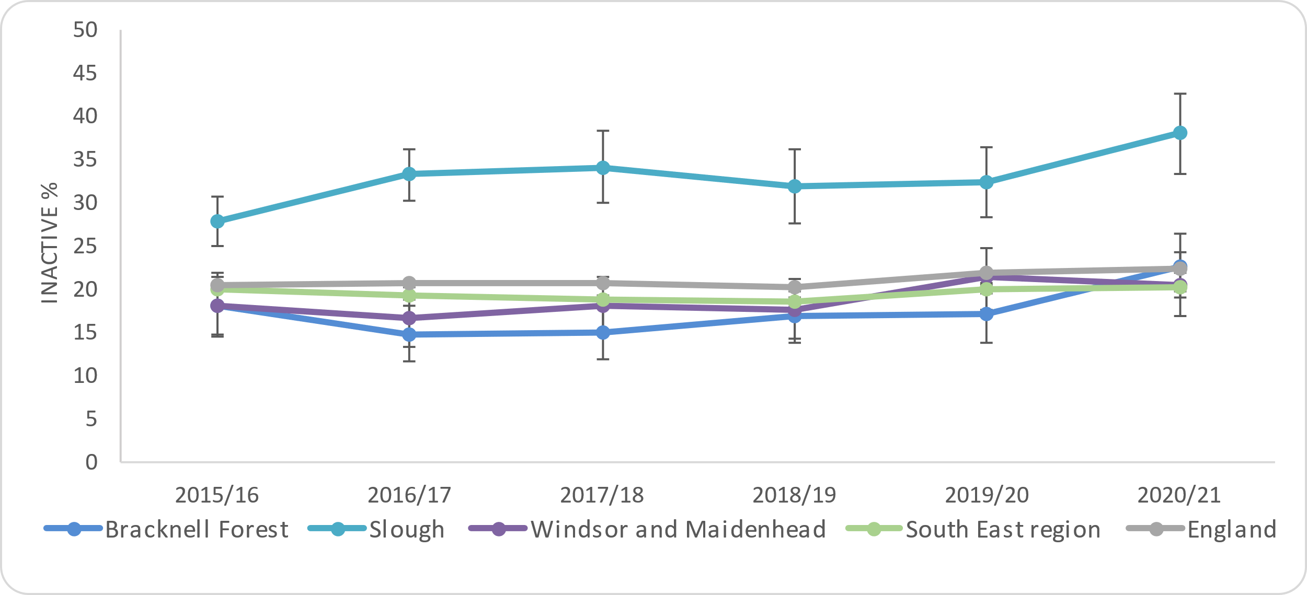
Figure 23: Percentage of physically inactive adults (19+)

Source: Office for Health Improvement and Disparities (2022); Physical Activity Profile

Additional analysis from the latest Active Lives Survey highlights a number of different groups within the population that are physically inactive. These are based on national figures. Some local level inequalities are shown in the following section of the report:
- Females (24%), compared to males (23%)
- People aged 75 and over, compared to those aged 19 to 64
- People from black, Asian and minority ethnic groups (apart from mixed groups), compared to those from white ethnic groups
- People with disabilities (36%), compared to those who are not disabled (20%)
- People from more deprived areas (most deprived to 4th most deprived decile), compared to other less deprivation areas
- Long term unemployed or never employed (39%), those in semi-routine or routine occupations (30%) and lower supervisory roles (26%), compared to higher occupation classes and students

Bracknell Forest | Slough | Windsor and Maidenhead
The proportion of physically active adults in Bracknell Forest is similar to England and the South East region for 2020/21.  The proportion of physically inactive adults in Bracknell Forest is also similar to England and the South East region for 2020/21. | The proportion of physically active adults in Slough is significantly worse than England and the South East region for 2020/21.  The proportion of physically inactive adults in Slough is also significantly worse than England and the South East region for 2020/21. | The proportion of physically active adults in RBWM is significantly better than England and similar to the South East region for 2020/21.  The proportion of physically inactive adults in RBWM similar to England and the South East region for 2020/21.

Detailed reports from the latest Active Lives Survey (November 2020 to November 2021) show inequalities in activity levels at a national and local level. Figures 24 and 25 show that people aged 16 to 64 have a higher level of activity than those aged 65 and older. This is the case across all local geographies.
There is not a significant difference in activity levels between males and females in England and the South East region. However, Slough’s proportion of females that are inactive is much higher than other Berkshire East local authorities, England and the South East region.

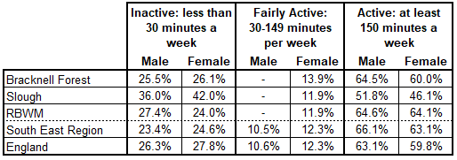
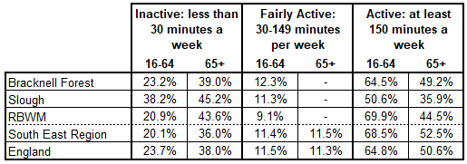
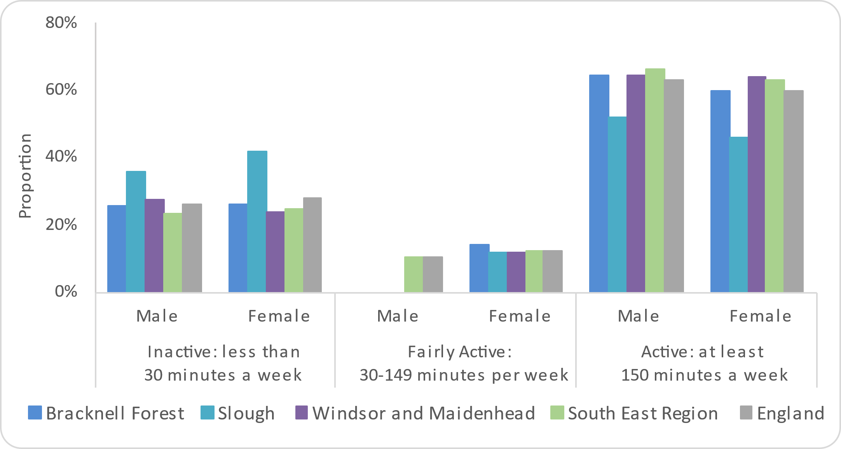
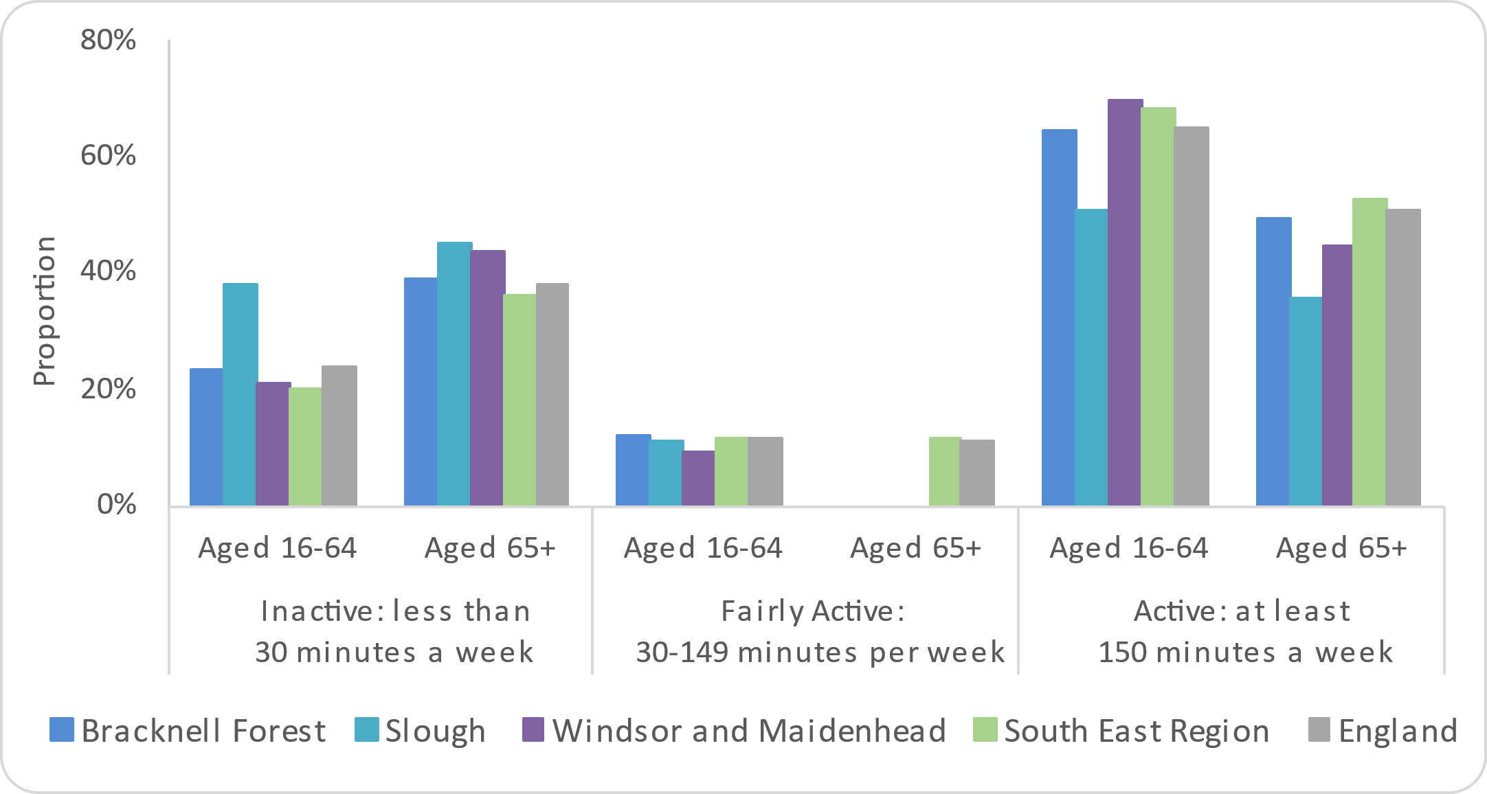
Figure 24: Levels of activity by age Figure 25: Levels of activity by gender
Source: Sport England (2021); Active Lives Survey

Data for work status groups is not available at a local authority. However, nationally it is possible to see that there are higher levels of retired people who are inactive, compared to people in employment. People with a disability or long-term condition (LTC) have higher levels of inactivity and lower levels of activity compared to those who reported no disability or long-term condition (LTC). In England, activity levels decreased with the number of impairments that people had – from 54.4% for people with one impairment, 47.3% for people with two impairments and 38.0% for people with three or more impairments.

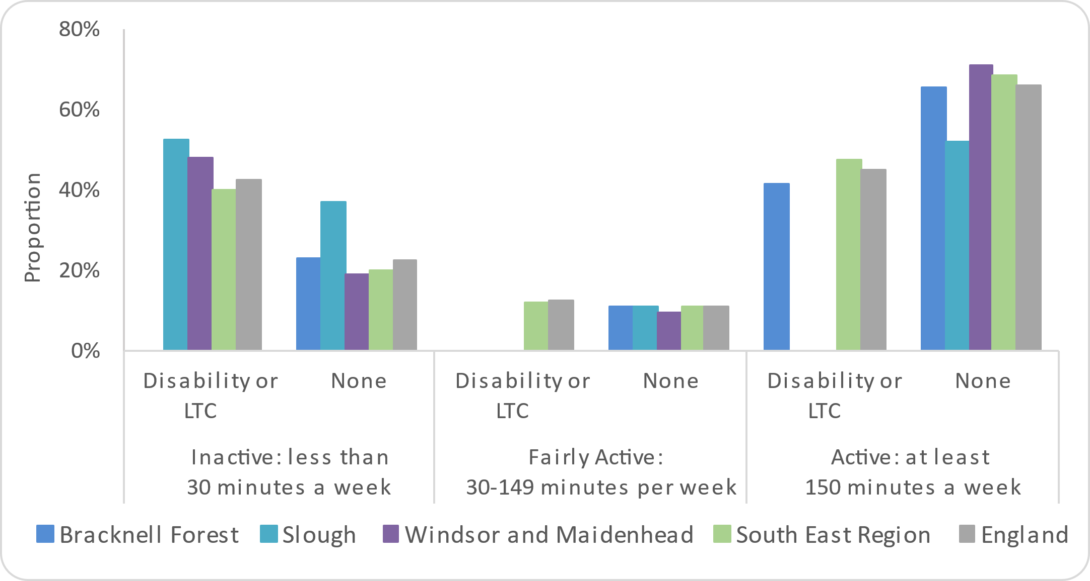
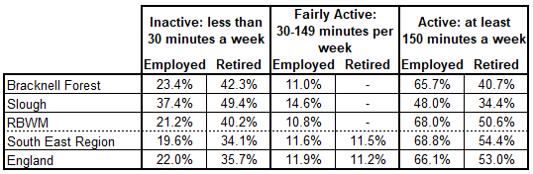
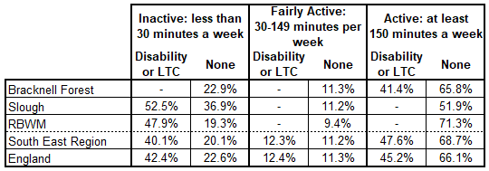
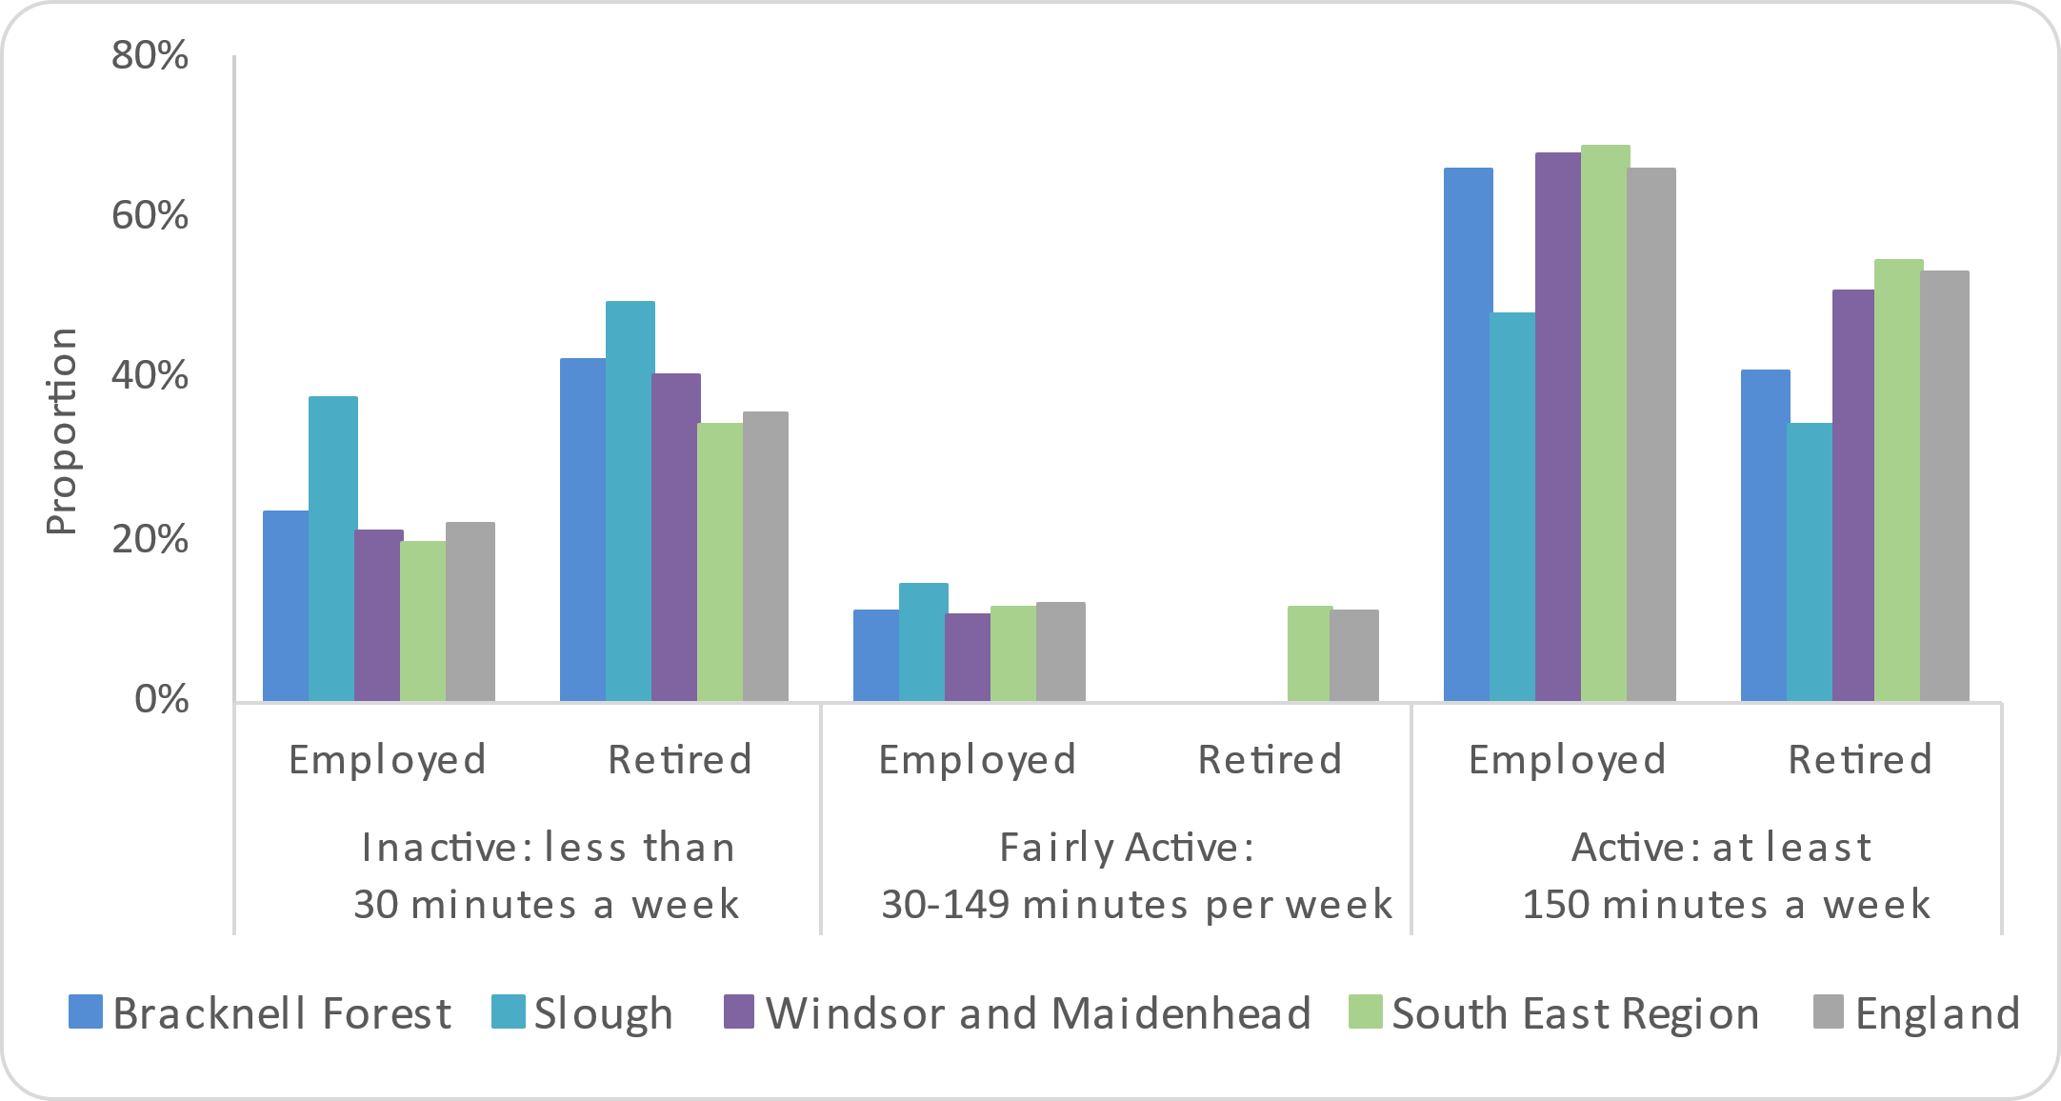
Figure 26: Levels of activity by work status Figure 27: Levels of activity by disability

Source: Sport England (2021); Active Lives Survey
The data provided in the survey are limited at a lower geographical level for ethnicity, education and social status. However, the national picture shows that there are no significant differences across ethnic groups. There is a relationship between education and physical activity, with more educated people having higher level of physical activity and those with lower levels of qualification having higher levels of inactivity.

Data broken down by National Statistics Socio-economic Classification (NS SEC) indicates that there is a general relationship between occupation class and activity with activity levels decreasing as occupation classification decreases. There is one anomaly with this, as people from the lowest occupation group (Never worked and long-term unemployed) have the 2nd highest levels of activity behind the highest occupation group (Higher managerial, administrative and professional occupations).

Bracknell Forest | Slough | Windsor and Maidenhead
61.5% of adults aged 19 and over in Bracknell Forest are physically active and achieve the recommended 150 minutes of exercise per week.  12% state they are fairly active, doing between 30 and 149 minutes of exercise per week and over a quarter (26%) of Bracknell residents are inactive. | 48% of adults aged 19 and over in Slough are physically active and achieve the recommended 150 minutes of exercise per week.  12% state they are fairly active, doing between 30 and 149 minutes of exercise per week and 39% who are inactive. | 64% of adults aged 19 and over in RBWM’s are physically active and achieve the recommended 150 minutes of exercise per week.  10% state they are fairly active, doing between 30 and 149 minutes of exercise per week with over a quarter (26%) being inactive.
There is no significant difference between male and female activity levels in Bracknell Forest (64% of males active, compared to 60% of females; 25% of males inactive, compared to 26% of females).  This is reflective of the South East and England trends. | Slough has a higher proportion of females who are inactive (42%), compared to other Berkshire East local authorities and the national and regional figures.  The level of inactivity in Slough males is lower 36%, however this is still worse than their Berkshire East, national and regional counterparts. | There is no significant difference between men and women’s activity levels in RBWM with (65% of males active, compared to 64% of females; 27% of males inactive, compared to 24% of females).  This is reflective of the South East and England trends.
Activity by age group in Bracknell Forest also reflects the national and regional trend.  The working age population (16 to 64 year-olds) sees 64% of people being active, 12% fairly active and 23% inactive.  For the older population, activity drops slightly to 49% for people aged 65 or over who are active and increases to 39% stating they are inactive. | Activity by age group in Slough reflects the national and regional trend.  There is a higher proportion of people aged 16 to 64 (51%) who are active compared to the older age group of 65 and over (36%).  Activity drops with age with 45% of people aged 65 and over saying they are inactive and 38% of people aged 16 to 64. | Activity by age group in RBWM also reflects the national and regional trend.  The working age population (16- to 64-year-olds) sees 70% of people being active, 9% fairly active and 21% inactive.  For the older population, activity drops slightly to 44% for people aged 65 or over who are active and increases to 44% stating they are inactive.

Bracknell Forest | Slough | Windsor and Maidenhead
41% of people who say they have a disability or long-term health condition are active.  There is no data for fairly active or inactive levels for Bracknell Forest, but the data suggests it follows the national trends. | 52% of people who say they have a disability or long-term health condition are inactive.  There is no data for fairly active or active for Slough, but the data suggests it is lower than the national and regional trends for active people. | 48% of people who say they have a disability or long-term health condition are inactive.  There is no data for fairly active or active for RBWM, but the data shows that there is a high proportion of people with no disability who are active at 71%, compared to England’s 66%
There is a lower proportion of active retired people in Bracknell compared to the national figure (41% compared to 53%). In contrast, there is a higher level of inactivity in Bracknell Forest at 42%, compared to 36% in England. | There is a lower proportion of active retired people in Slough compared to the national figure (34% compared to 53%). In contrast, there is a higher level of inactivity in Slough at 49%, compared to 36% in England. | There is a similar proportion of active retired people in RBWM compared to the national figure of (53% compared to 51%). However, RBWM does have higher levels of inactive retired people compared to the national figure (40% compared to 36% in England).

Creating an environment where people actively choose to walk and cycle as part of everyday life can have a significant impact on public health and can reduce inequalities in health. It is an essential component of a strategic approach to increase physical activity and may be more cost-effective than other initiatives that promote exercise, sport and active leisure pursuits. For most people, the easiest and most acceptable forms of physical activity are those that can be built into everyday life. Examples include walking or cycling instead of travelling by car and using stairs instead of lifts.

In 2019/20, 15.1% of people aged 16 and over in England reported that they walked for travel at least three days per week. The South East region is similar to England with 14.9%. 2.3% of people cycled for travel at least three days per week in England and 2.4% in the South East region. Figures 28 and 29 show this information at a Berkshire East local authority level (Office for Health Improvement and Disparities 2022).
Figure 29: Percentage of adults cycling for travel at least three days per week

Figure 28: Percentage of adults walking for travel at least three days per week

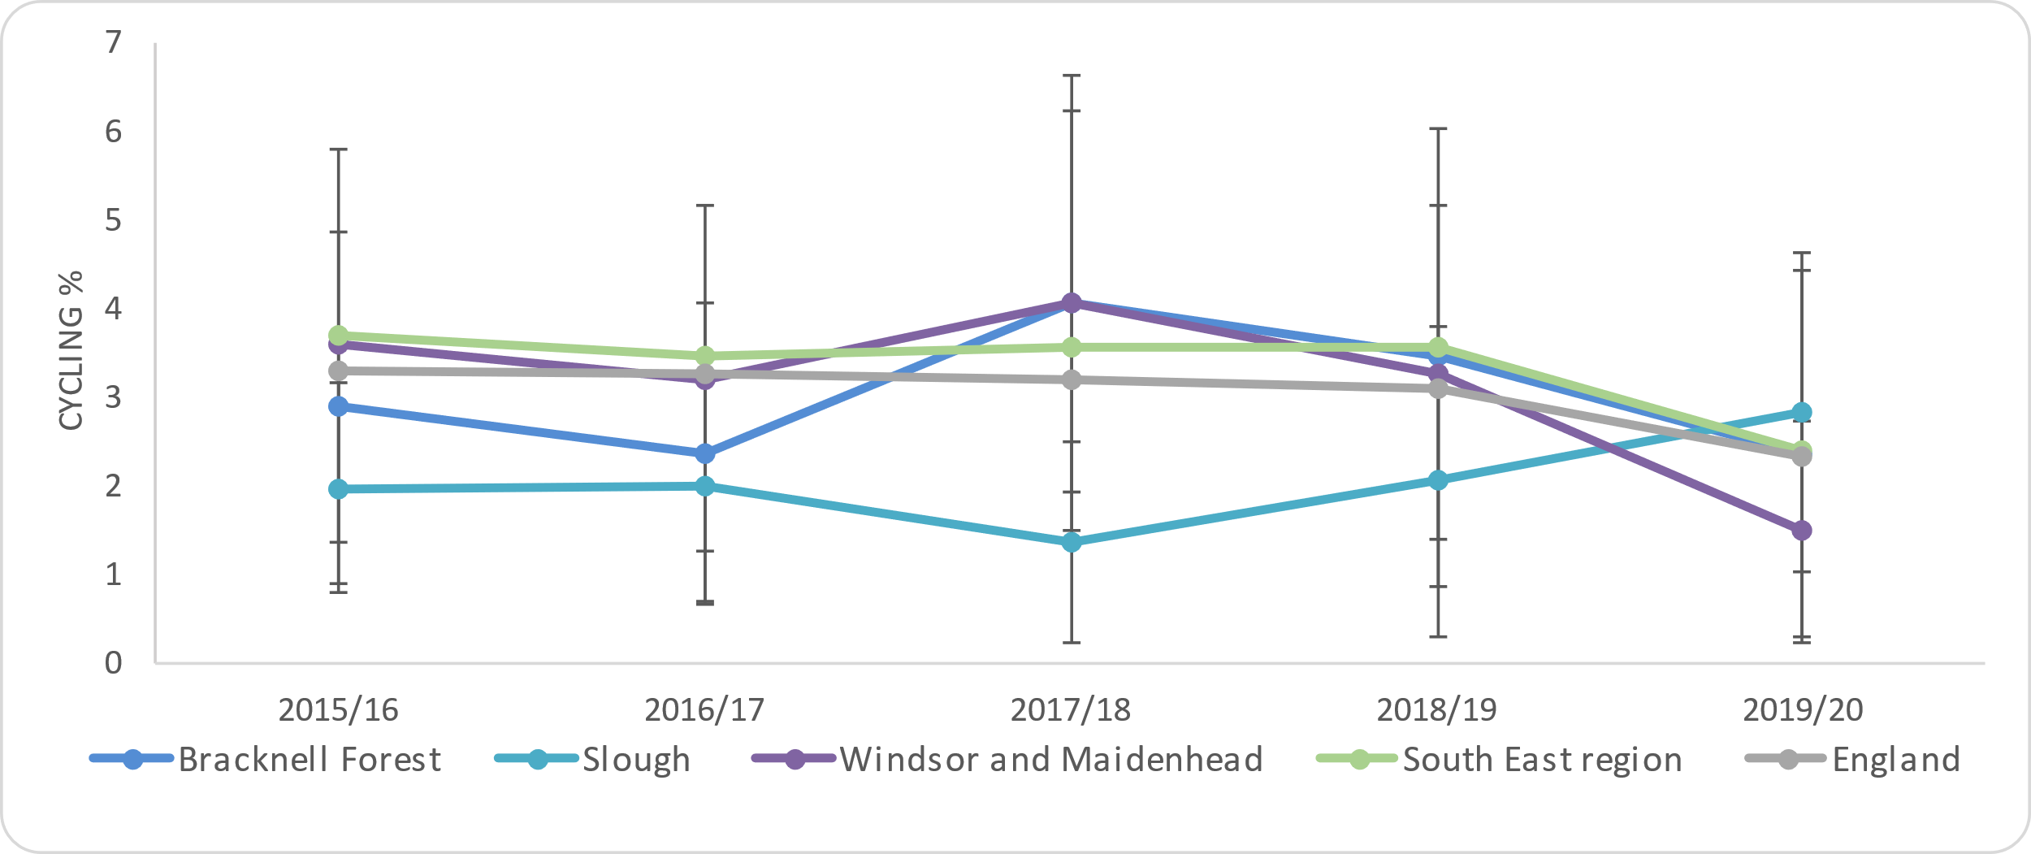
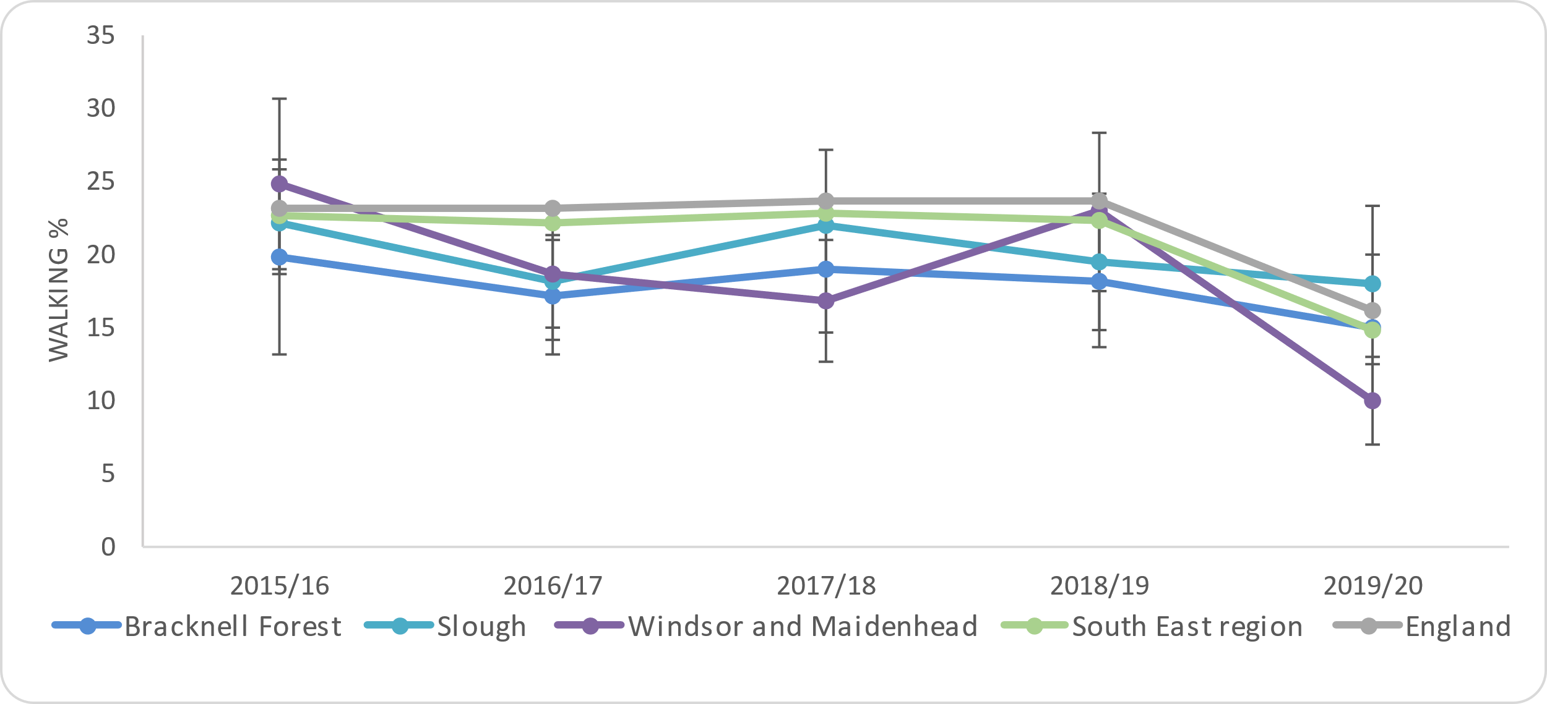
Source: Office for Health Improvement and Disparities (2022); Physical Activity Profile

Bracknell Forest | Slough | Windsor and Maidenhead
The percentage of people walking for travel decreased from 18.3% to 15.1% between 2018/19 and 2019/20. This is similar to the South East Region and England.  The percentage of people cycling for travel has remained constant over time and is similar to the South East region and England. | The percentage of people walking for travel decreased from 19.6% to 18.0% between 2018/19 and 2019/20. This is similar to the South East Region and England.  The percentage of people cycling for travel has remained constant over time and is similar to the South East region and England. | The percentage of people walking for travel decreased from 23.0% to 10.1% between 2018/19 and 2019/20. This is significantly worse than the South East Region and England.  The percentage of people cycling for travel has remained constant over time and is similar to the South East region and England.

3.2.2 Sedentary Behaviour
The Chief Medical Officer’s guidelines on physical activity recommends that everyone should minimise the amount of time spent being sedentary for extended periods (Public Health England 2014). Sitting for long periods of time damages health because of the way it affects circulation and fails to fully use muscles and bones, which is why it is also a risk even to those who regularly exercise. People who spend long periods of time sitting have been found to have higher rates of diabetes, cardiovascular disease and death from all causes. The report suggests that more than 40% of women and 35% of men aged 16 to 75 spend more than six hours a day desk-bound or sitting still. Whilst there is a growing body of evidence pointing to the risks of sedentary behaviour, it is still unknown the exact level of harm it causes and data is minimal.

Figure 30 takes the national estimates of sedentary behaviour and uses local population figures to create modelled estimates.

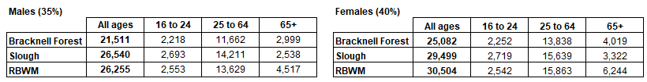
Figure 30: Estimated number of people sedentary for more than six hours by age groups and local authority in Berkshire East

Source: Prevalence estimates from Public Health England (2014); Everybody active, every day. Population estimates from Office for National Statistics (2021) Mid-year population estimates for 2020

3.3 Understanding Smoking Behaviours
Smoking is the biggest cause of preventable ill health and premature mortality in the UK. It is a major risk factor for many diseases, such as lung cancer, chronic obstructive pulmonary disease (COPD) and heart disease and contributes to 14% of all healthy life years lost nationally (Global Burden of Disease 2019). This not only affects people who smoke, but also impacts on the health of others through second-hand smoke. Smoking is a modifiable behavioural risk factor and effective tobacco control measures can reduce the prevalence of smoking in the population. The Government’s Tobacco Control Plan, published in July 2017 sets out the strategy to reduce smoking prevalence among adults and young people.

Smoking is also the main cause of health inequalities in England with the harm concentrated in disadvantaged communities and groups (Office for Health Improvement & Disparities 2021). Demographic factors and social determinants of health, such as where someone lives, their employment status, income and support networks, will impact on the likelihood of someone smoking.

This section of the report includes information from the Local Tobacco Control Profiles that provide self-reported information on smoking status, as well as local data from GP Practice records (Connected Care). It is important to note that the GP recorded prevalence rates of smoking will be an underestimation of the true level of smoking in the GP practice population, as they will only include people who have required support from their GP and have subsequently had a smoking status recorded. This will be skewed towards the older population and those that have ongoing health needs and conditions. However, this information can still provide a useful tool to monitor trends and inequalities in local hypertension prevalence.

Key Findings

12.1% of adults smoke nationally, based on the findings of the 2020 Annual Population Survey. Berkshire East local authorities all have similar prevalence rates to England, ranging from 10.3% in RBWM to 12.1% in Slough.

Population groups that have higher smoking prevalence rates nationally include:
- Males
- People aged 25 to 54
- People from white and mixed ethnic groups,
- People from more deprived areas (most deprived to 3rd most deprived decile)
- People who rent their home

Routine and manual occupations also have a significantly higher smoking prevalence rates, compared to other occupation groups, at 21.4% nationally. Locally, people in these occupations are 1.4 to 2.5 times more likely to smoke than people from other occupation groups.

People with long-term mental health conditions are also identified as a population group with significantly higher smoking prevalence rates at 26% nationally. Locally, people with mental health conditions are 2.0 to 5.2 times more likely to smoke that than those without mental health conditions.
The prevalence of smoking is also recorded on GP Practice Registers and this includes people aged 18 and over who have had their smoking status recorded over the last year. In January 2022, nearly 87,000 of Frimley ICS’s registered population were recorded as current smokers at 13.5% of the total adult population. Over 51,000 of these people were Berkshire East residents with a smoking prevalence of 14.5%.

In Frimley ICS, recorded smoking prevalence is highest in:
- Males
- Adults aged 30 to 39, followed by adults aged 40 to 49
- People from white ethnic groups, followed by mixed ethnic groups
- People from more deprived neighbourhoods

The prevalence of smoking in Slough particularly stands out as an outlier when broken down by ethnic group. People from white ethnic groups (27.9%) and mixed ethnic groups (17.7%) have significantly higher smoking prevalence rates compared to the other local authorities and other ethnic groups within Slough.

(This will only include people who have contacted their GP Practice and had their smoking status recorded in the previous 12 months, which will skew figures to older populations and those with long-term health conditions).

3.3.1 Self-reported prevalence of smoking in the general population
Figure 31: Proportion of smoking prevalence by gender and smoking status (APS 2020)

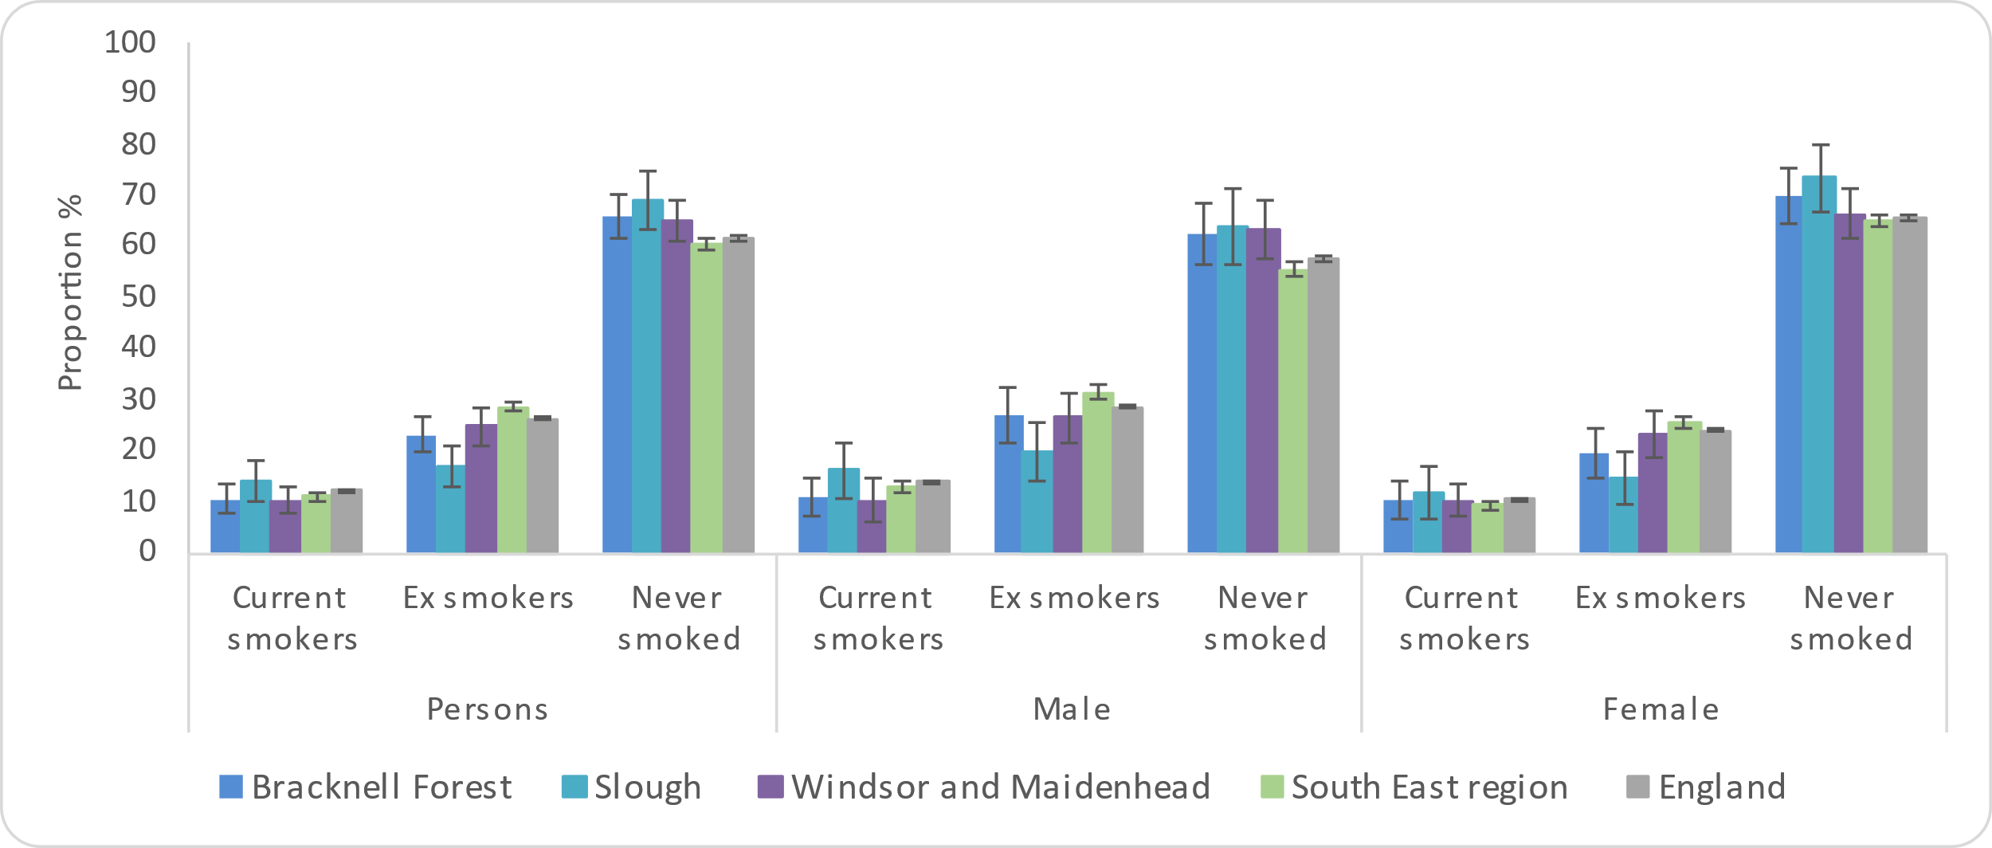
The Annual Population Survey monitors the self-reported smoking status of people aged 18 and over. The methodology for this survey changed in 2020, due to the Covid-19 pandemic restrictions, and meant that surveys had to be completed through telephone interviews rather than face-to-face. This means that 2020 data cannot be directly compared with previous years. In 2020, 12.1% of people stated that they were a current smoker in England. The prevalence of smoking in Berkshire East local authorities is similar to England, ranging from 10.3% in RBWM to 13.9% in Slough.

Additional analysis from the survey highlights a number of different groups within the population that have higher levels of smoking prevalence. These are based on national figures.
- Males (14%), compared to females (10%)
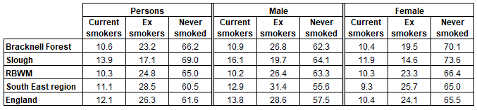
- People aged 25 to 54, compared to those aged 65 and over
- People from white and mixed ethnic groups, compared to those from other ethnic groups
- People from more deprived areas (most deprived to 3rd most deprived decile), compared to other less deprivation areas
- People who rent their home, compared to those who have a mortgage or own outright
Source: Office for Health Improvement and Disparities (2022); Local Tobacco Control Profiles

Source: Office for Health Improvement and Disparities (2022); Physical Activity Profile

People from Routine and Manual (R&M) occupations have significantly higher smoking prevalence rates compared to people in other occupations. In England, 21% of R&M workers smoke, which is 2.1 times higher than in other occupations. Locally, R&M worker’s smoking prevalence is also significantly higher, ranging from 1.4 times higher in Slough to 2.5 times higher in RBWM (Office for Health Improvement and Disparities 2022).

The 2020/21 annual GP Patient Survey shows that people with long-term mental health conditions also have significantly higher smoking prevalence rates than the rest of the adult population at 26% nationally. This is 2.4 times higher than the adult population that do not have long-term mental health conditions. Locally, the prevalence of smoking for people with long-term mental health conditions varies significantly from 20.4% in Bracknell Forest to 47.3% in Slough. This means that people with mental health conditions are between 2.0 to 5.2 times more likely to smoke than those without mental health conditions in Berkshire East (Office for Health Improvement and Disparities 2022).

Successful quitters are those smokers who successfully quit at the four week follow up from the designated quit date, if they declare they have not smoked, in the past two weeks. This is a self-reported indicator, so there is a possibility of over reporting, however carbon monoxide validation is used where possible. In 2019/20, there were 1,808 quitters per 100,000 smokers in England. Rates across Berkshire East vary significantly, with Slough having significantly better quitting rates compared to England, whilst RBWM has significantly worse rates. Data for Bracknell Forest is not available (Office for Health Improvement and Disparities 2022).

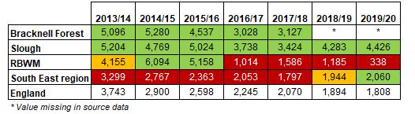
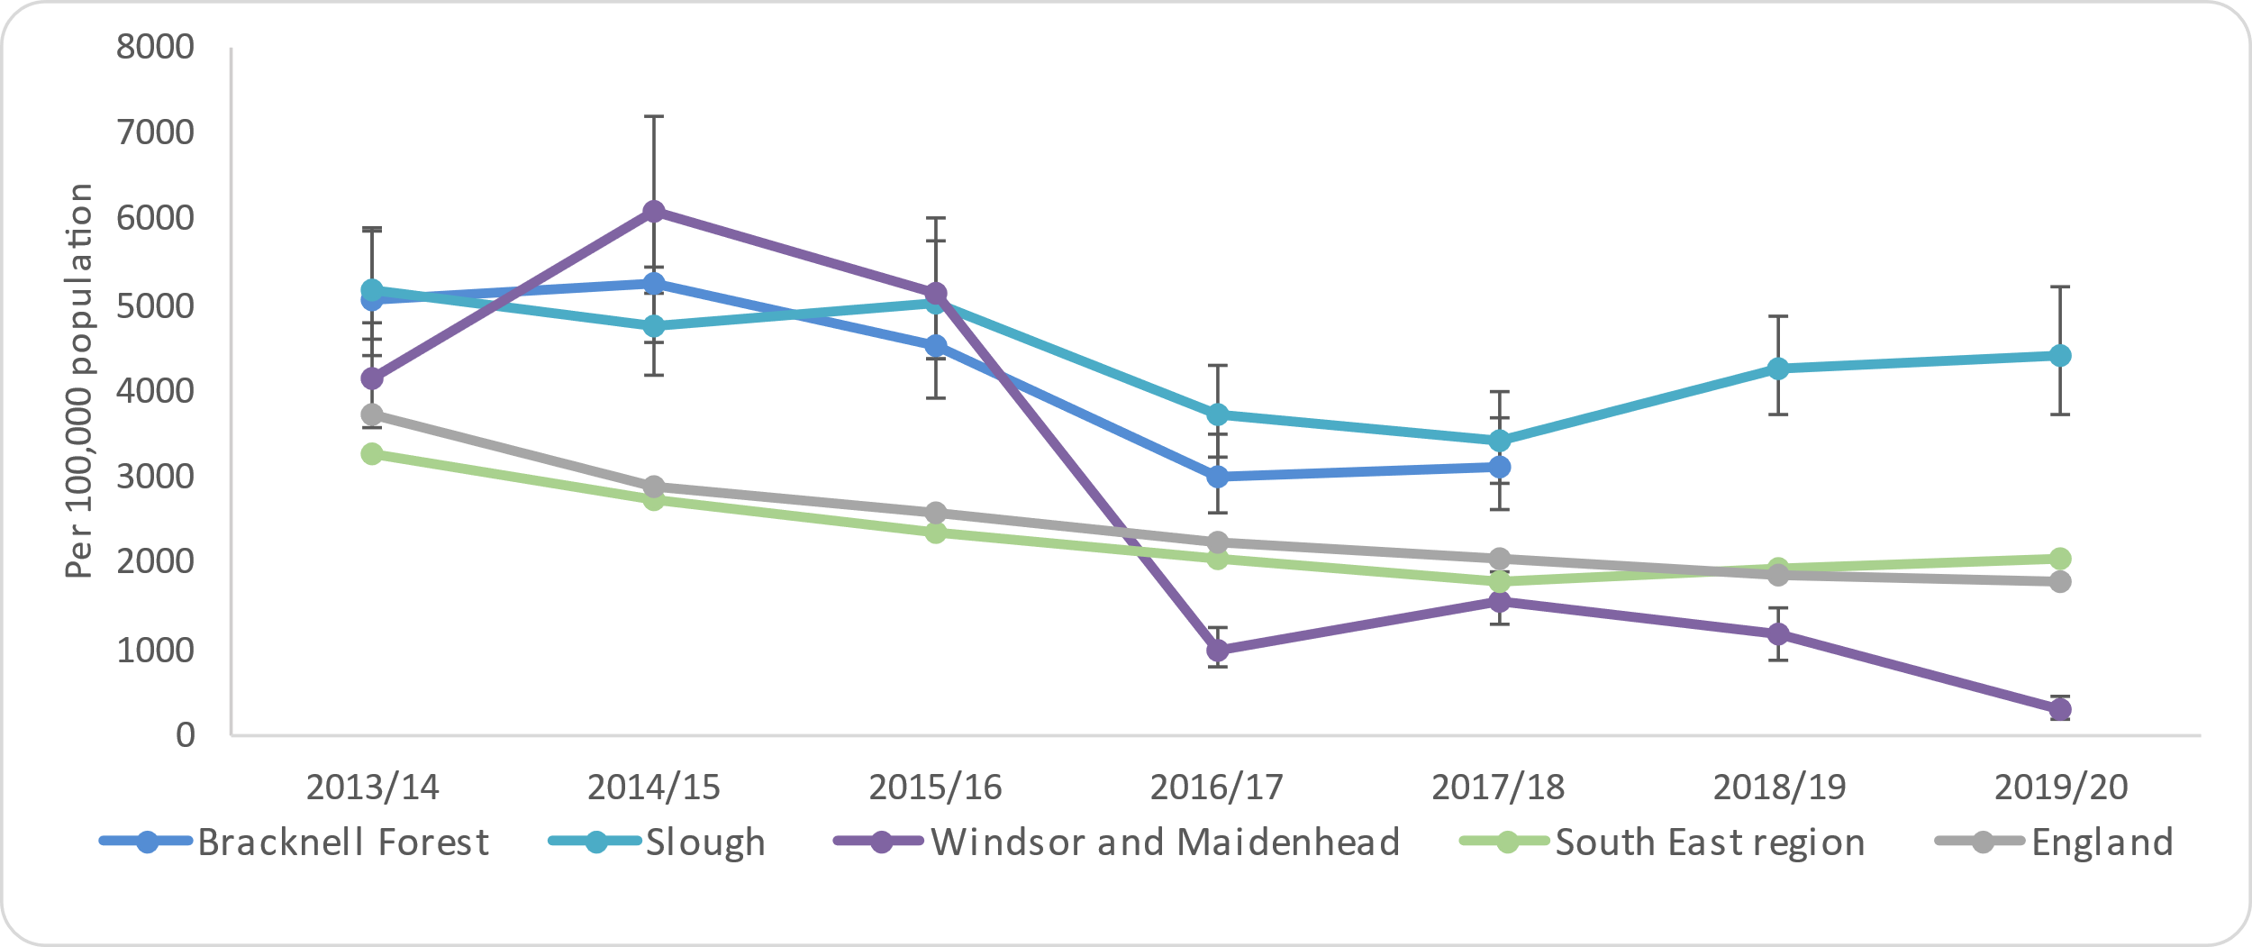
Figure 32: Smokers that have successfully quit at 4 weeks, crude rate per 100,000 smokers

Source: Office for Health Improvement and Disparities (2022); Local Tobacco Control Profiles

Bracknell Forest | Slough | Windsor and Maidenhead
10.6% of adults aged 18+ are current smokers in Bracknell Forest. This is similar to England and the South East region.  23.2% of adults are ex-smokers, which is similar to England’s figure but significantly better than the South East.  The proportion of adults who have never smoked is significantly worse than England with 66.2%, compared to 61.6%. | 13.9% of adults aged 18+ are current smokers in Slough. This is similar to England and the South East region.  17.1% of adults are ex-smokers, which is significantly better than England and the South East region.  The proportion of adults who have never smoked is significantly worse than England with 69.0%, compared to 61.6%. | 10.3% of adults aged 18+ are current smokers in RBWM. This is similar to England and the South East region.  24.8% of adults are ex-smokers, which is similar to England’s figure but significantly better than the South East.  The proportion of adults who have never smoked is similar to England with 65.0%, compared to 61.6%.
Smoking prevalence in routine and manual workers aged 18 to 64 is 19.4%, which is similar to both England and the South East region.  This is 2.1 times higher than the smoking prevalence of other occupation groups in Bracknell Forest. | Smoking prevalence in routine and manual workers aged 18 to 64 has a rate of 18.7% which is similar to both England and the South East region.  This is 1.4 times higher than the smoking prevalence of other occupation groups in Slough. | Smoking prevalence in routine and manual workers aged 18 to 64 has a rate of 22.1% which is similar to both England and the South East region.  This is 2.5 times higher than the smoking prevalence of other occupation groups in RBWM.
Smoking prevalence in people with long-term mental health conditions aged 18 and over is 20.4%, which is similar to both England and the South East region.  This is 2.1 times higher than the smoking prevalence of other adults in Bracknell Forest. | Smoking prevalence in people with long-term mental health conditions aged 18 and over is 47.3%, which is significantly worse than both England and the South East region. This is 5.4 times higher than the smoking prevalence of other adults in Slough. | Smoking prevalence in people with long-term mental health conditions aged 18 and over is 25.1%, which is similar to both England and the South East region.  This is 3.3 times higher than the smoking prevalence of other adults in RBWM.
Data about successful quitters is not available for Bracknell Forest. | 787 people quit smoking in Slough in 2019/10. This was 4,426 quitters per 100,000 smoking population, which was significantly better than England. | 40 people quit smoking in RBWM in 2019/10. This was 338 quitters per 100,000 smoking population, which was significantly worse than England.

3.3.2 Prevalence of recorded Smoking on GP Practice Records (Connected Care)
The prevalence of smoking is also monitored through the Quality and Outcomes Framework (QOF) and measures the proportion of adults who have a current smoking status recorded on their GP Record in the previous 12 months. This is regarded as an underestimation of the true level of smoking in the GP practice population, as it will only include people who have required support from their GP and have subsequently had their smoking status discussed and recorded. Recorded prevalence data will therefore be skewed towards the older population and those that have ongoing health needs and conditions. However, this information can still provide a useful tool to monitor trends and inequalities in local obesity prevalence.

The information included in this section of the report focuses on the local population aged 18 and over that had a current smoking status recorded on their GP Practice record in January 2022.

Across Frimley ICS, nearly 87,000 people are recorded as being current smokers at 13.6% of the total adult population. Over 51,000 people are recorded as current smokers across Berkshire East at 14.5% of the total adult population.

Sex
The prevalence of smoking in Frimley ICS is higher in males than females with rates of 16.5% and 10.7% respectively. This trend is consistent across all Berkshire East local authorities.

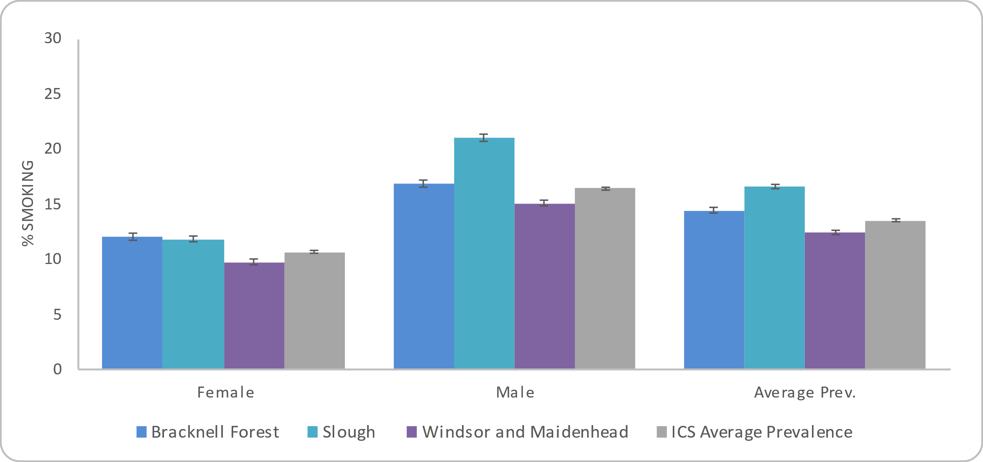
Figure 33: Prevalence of smoking by sex in Frimley ICS and Berkshire East local authorities (18+)

Source: Connected Care - Frimley ICB Analytics Team (Jan 2022)

Age
The highest smoking prevalence in Frimley ICS is seen in people aged 30 to 39 (17.7%), followed by people aged 40 to 49 (15.8%). The lowest prevalence is in the older age groups at 2.0% in people aged 90 and over and 3.7% in people aged 80 to 89.

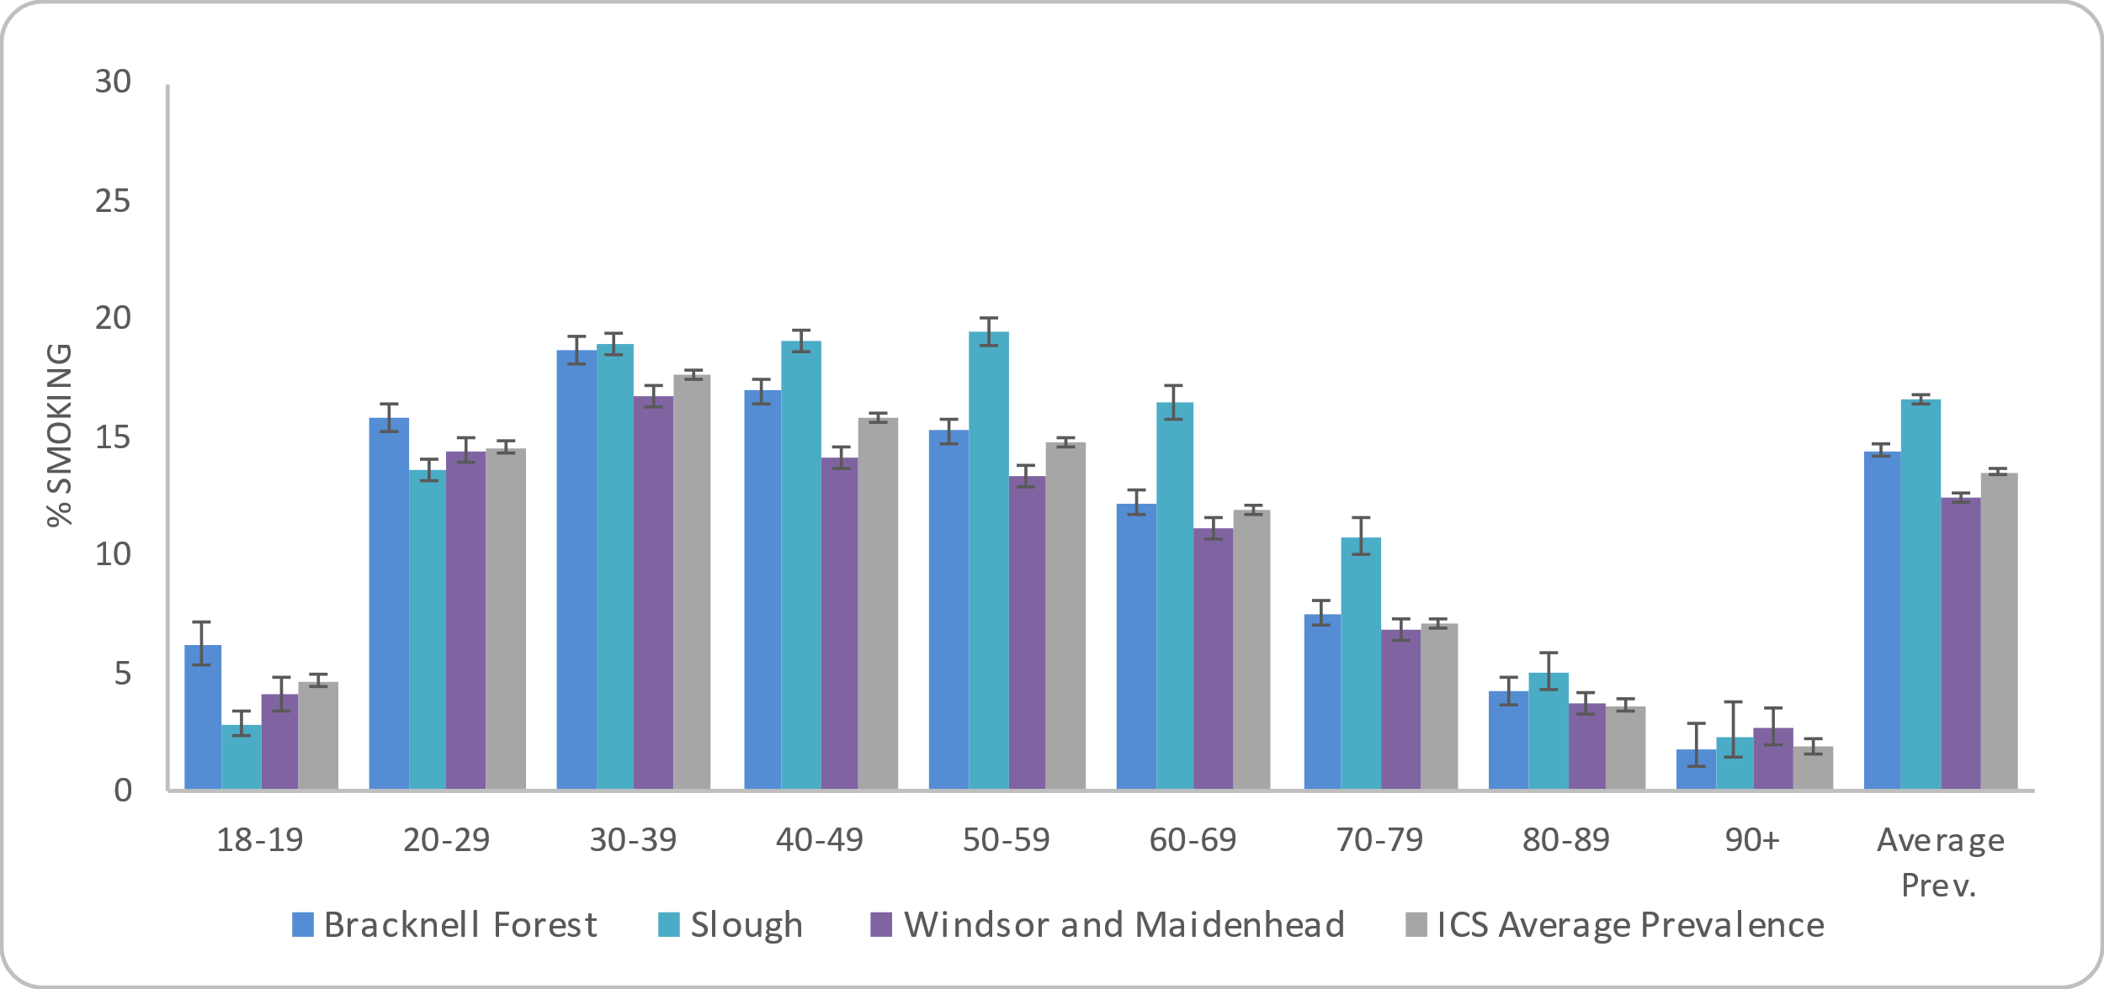
Figure 34: Prevalence of smoking by age group in Frimley ICS and Berkshire East local authorities (18+)
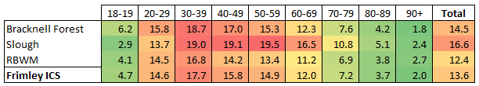

The colour-coding used above indicates higher (red) and lower (green) levels of obesity. This does not infer significance and is only for information.

Source: Connected Care - Frimley ICB Analytics Team (Jan 2022)

Ethnicity
People from white ethnic groups have the highest recorded smoking prevalence (15.4%) in Frimley ICS, followed by those from a mixed ethnic group (13.3%). The lowest prevalence is seen in people from Asian or Asian British ethnic groups at 9.2%.

The prevalence of smoking in Slough particularly stands out as an outlier when broken down by ethnic group. People from white ethnic groups (27.9%) and mixed ethnic groups (17.7%) have significantly higher smoking prevalence rates compared to the other local authorities and other ethnic groups within Slough.

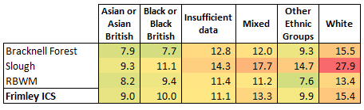
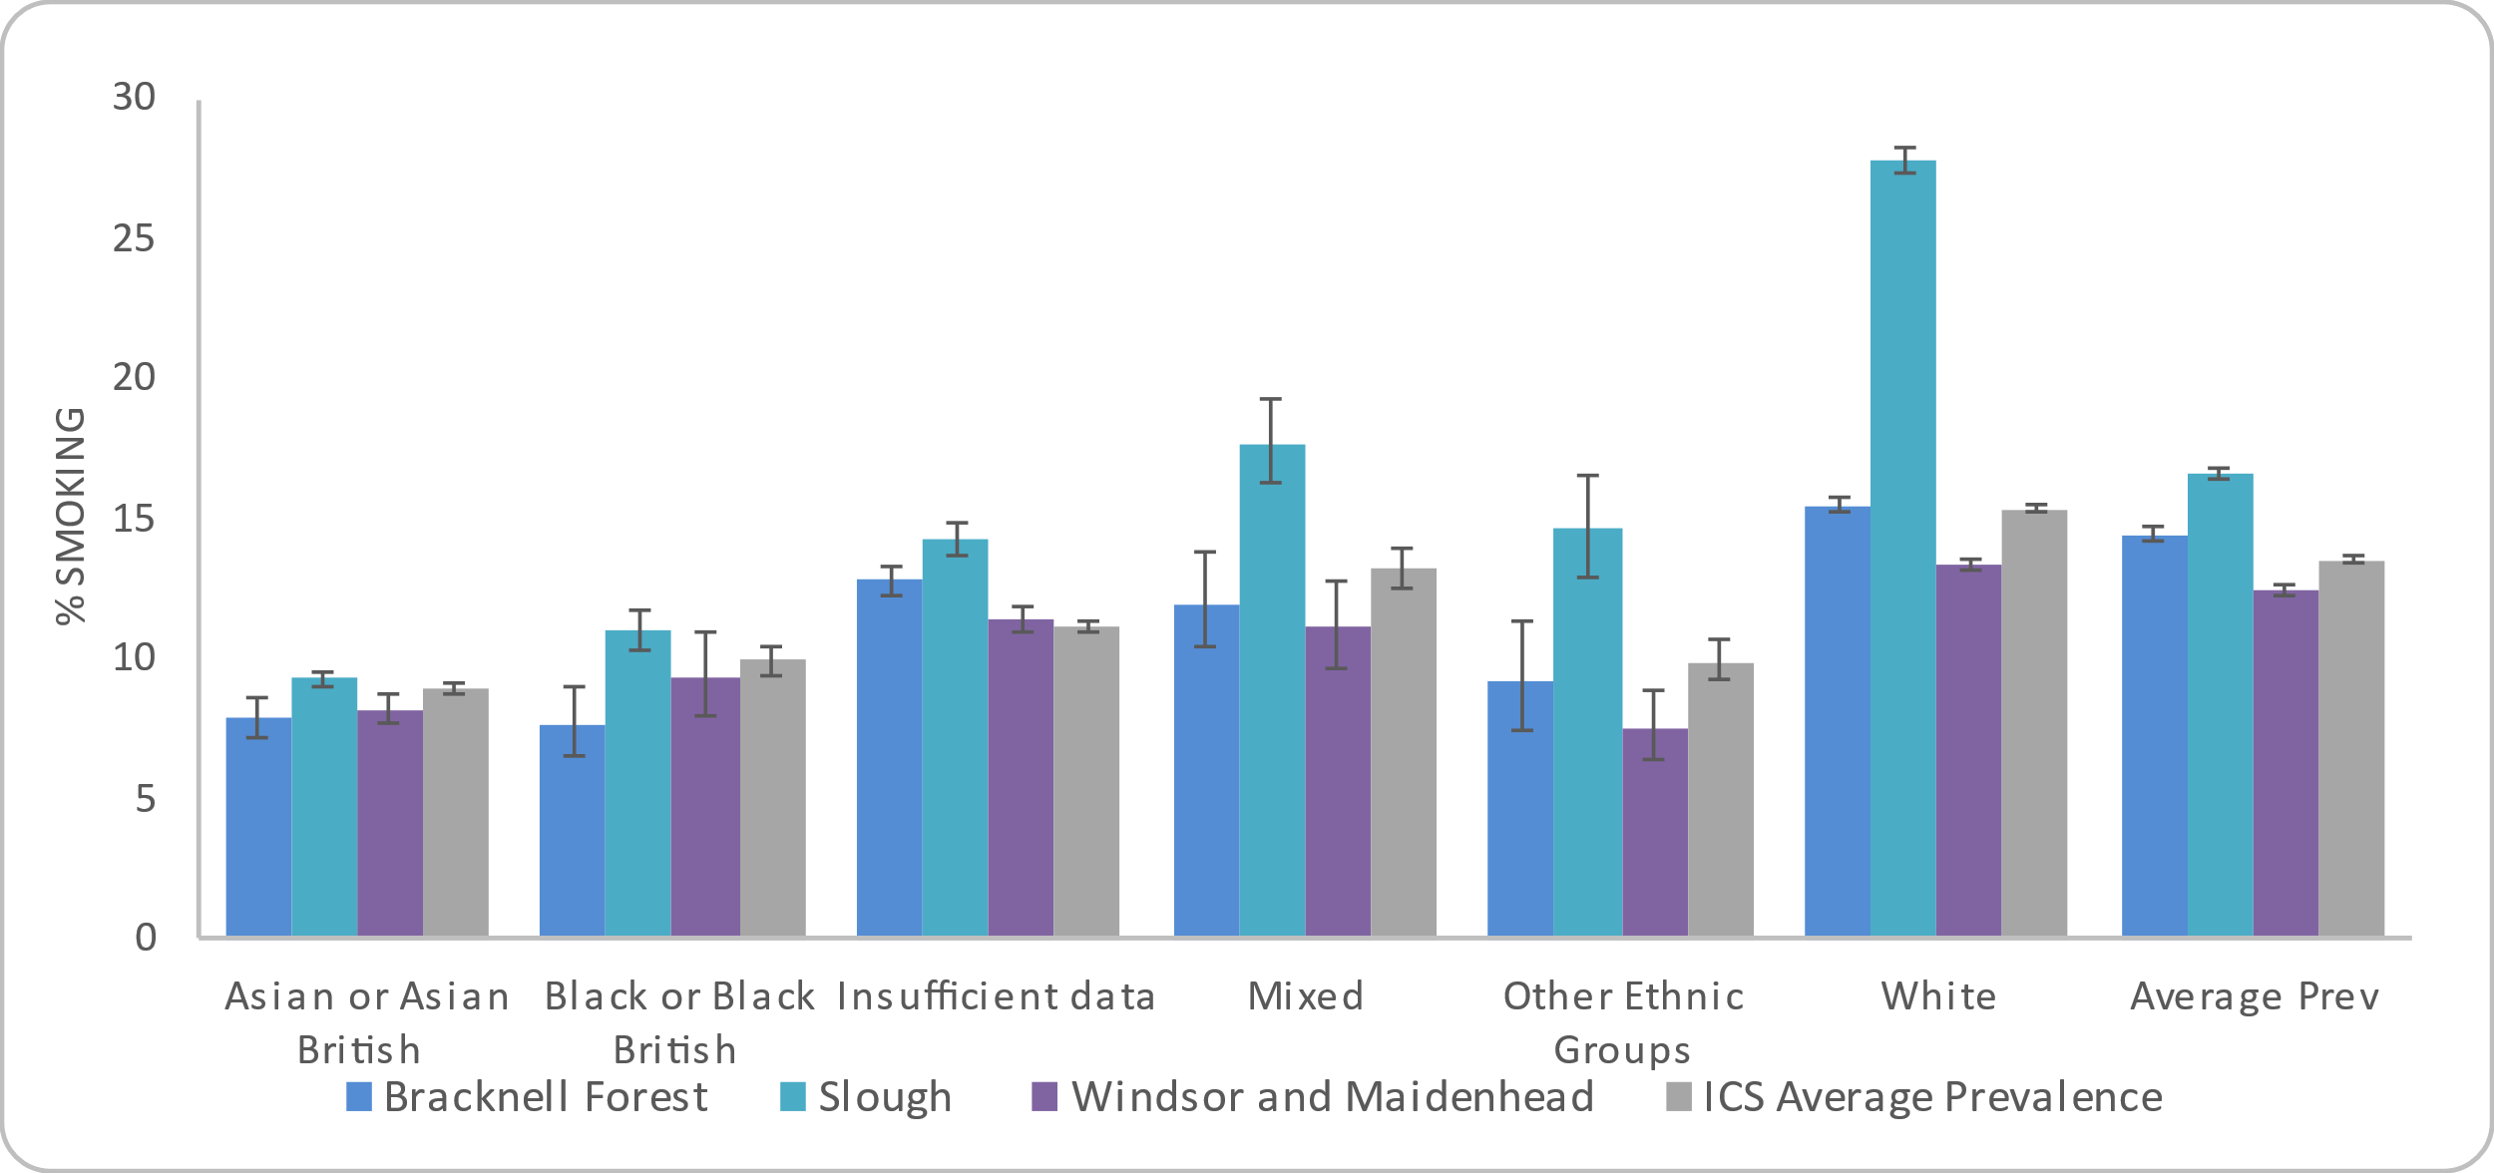
Figure 35: Prevalence of smoking by ethnicity in Frimley ICS and Berkshire East local authorities (18+)
The colour-coding used above indicates higher (red) and lower (green) levels of obesity. This does not infer significance and is only for information.

Source: Connected Care - Frimley ICB Analytics Team (Jan 2022)

Deprivation
Each neighbourhood in England, or Lower Super Output Area (LSOA), has a deprivation score that indicates how deprived that area is compared to the rest of England. Frimley ICS and Berkshire East do not have any LSOAs in the 10% most deprived neighbourhoods nationally and this group is therefore not included in the analysis below.

There is a clear association between deprivation and recorded smoking prevalence in Frimley ICS, People from the most deprived areas in Frimley ICS (2nd most deprived decile nationally) have the highest recorded smoking prevalence at 20.3%, compared to 9% of people in the least deprived decile.

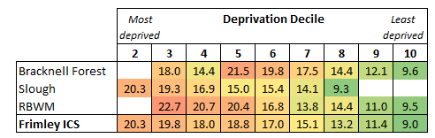
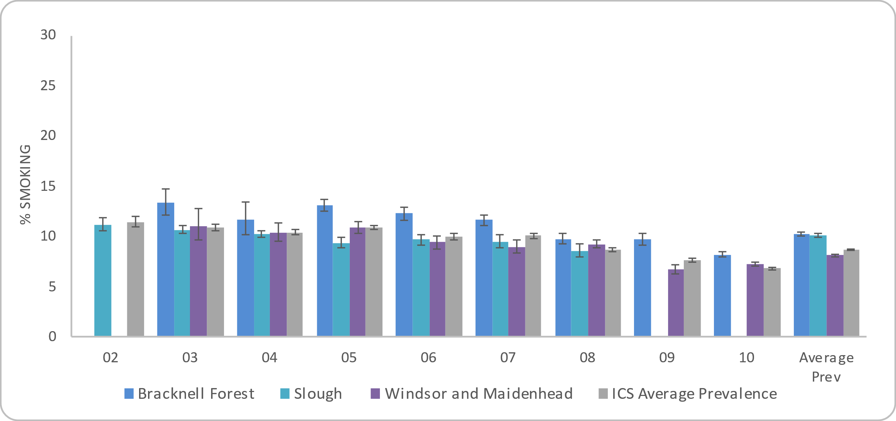
Figure 36: Prevalence of smoking by deprivation decile in Frimley ICS and Berkshire East local authorities (18+)
The colour-coding used above indicates higher (red) and lower (green) levels of obesity. This does not infer significance and is only for information.

Source: Connected Care - Frimley ICB Analytics Team (Jan 2022)

Bracknell Forest | Slough | Windsor and Maidenhead
14.5% of Bracknell Forest residents aged 18 and over are recorded as current smokers on their GP Practice Register. | 16.4% of Slough residents aged 18 and over are recorded as current smokers on their GP Practice Register. | 12.4% of RBWM residents aged 18 and over are recorded as current smokers on their GP Practice Register.
Sex: 16.9% of males aged 18 or over are recorded as current smokers on the GP register.  12.1% of females aged 18 or over are recorded as current smokers on the GP register. | Sex: 21.0% of males aged 18 or over are recorded as current smokers on the GP register. This is the highest prevalence by sex and local authority across Frimley ICS.  11.9% of females aged 18 or over are recorded as current smokers on the GP register. | Sex: 15.1% of males aged 18 or over are recorded as current smokers on the GP register.  9.8% of females aged 18 or over are recorded as current smokers on the GP register.
Age: 14.5% of people aged 18 or over are registered as current smokers on the GP register.  The highest prevalence is in adults aged 30 to 39 (18.7%), followed by adults aged 40 to 49 (17%).  The lowest is in people aged 90+ (1.8%). | Age: 16.6% of people aged 18 or over are registered as current smokers on the GP register.  The highest prevalence is in adults aged 50 to 59 (19.5%), followed by adults aged 40 to 49 (19.1%).  The lowest is in people aged 90+ (2.4%). | Age: 12.4% of people aged 18 or over are registered as current smokers on the GP register.  The highest prevalence is in adults aged 30 to 39 (16.8%), followed by adults aged 20 to 29 (14.5%).  The lowest is in people aged 90+ (2.0%).
Ethnicity: The highest prevalence of smokers by ethnicity is 15.3% for those with a recorded white ethnicity.  12.3% have no ethnicity recorded, followed by 10.5% of smokers with mixed ethnicity recorded.  The lowest prevalence is recorded in the black or black British ethnic group with a prevalence rate of 6.5%. | Ethnicity: The highest prevalence of smokers by ethnicity is 27.4% for those with a recorded white ethnicity. The highest prevalence across Frimley ICS local authorities.  16.3% have mixed ethnicity recorded, followed by 13.7% with no ethnicity recorded.  The lowest prevalence is recorded in the Asian or Asian British ethnic group with a prevalence rate of 9.1%. | Ethnicity: The highest prevalence of smokers by ethnicity is 13.2% for those with a recorded white ethnicity.  12.6% have mixed ethnicity recorded, followed by 11.0% with no ethnicity recorded.  The lowest prevalence is recorded in the Asian or Asian British ethnic group with a prevalence rate of 8.8%
Deprivation: Bracknell Forest has LSOAs in deprivation deciles 3 to 10.  The highest prevalence of smoking is 21.5% for the 5th most deprived decile, followed by the 5th least decile (19.8%) and the 4th most deprived decile (18.0%).  People living in the least deprived areas have the lowest smoking prevalence at 9.6%. | Deprivation: Slough has LSOAs in deprivation deciles 2 to 8.  The highest prevalence of smoking is 20.3% for the most deprived decile, People living in the 3rd least deprived decile have the lowest prevalence of smoking with a rate of 9.3%. | Deprivation: RBWM has LSOAs in deprivation deciles 3 to 10.  The highest prevalence of smoking is 22.7% for the 3rd most deprived decile, followed by the 4th most (20.7%) and 5th most deprived decile (20.4%).  People living in the least deprived area have the lowest smoking prevalence at 9.5%.

Location
Figure 37: Prevalence of Smoking in adults (18+) by LSOA in Bracknell Forest

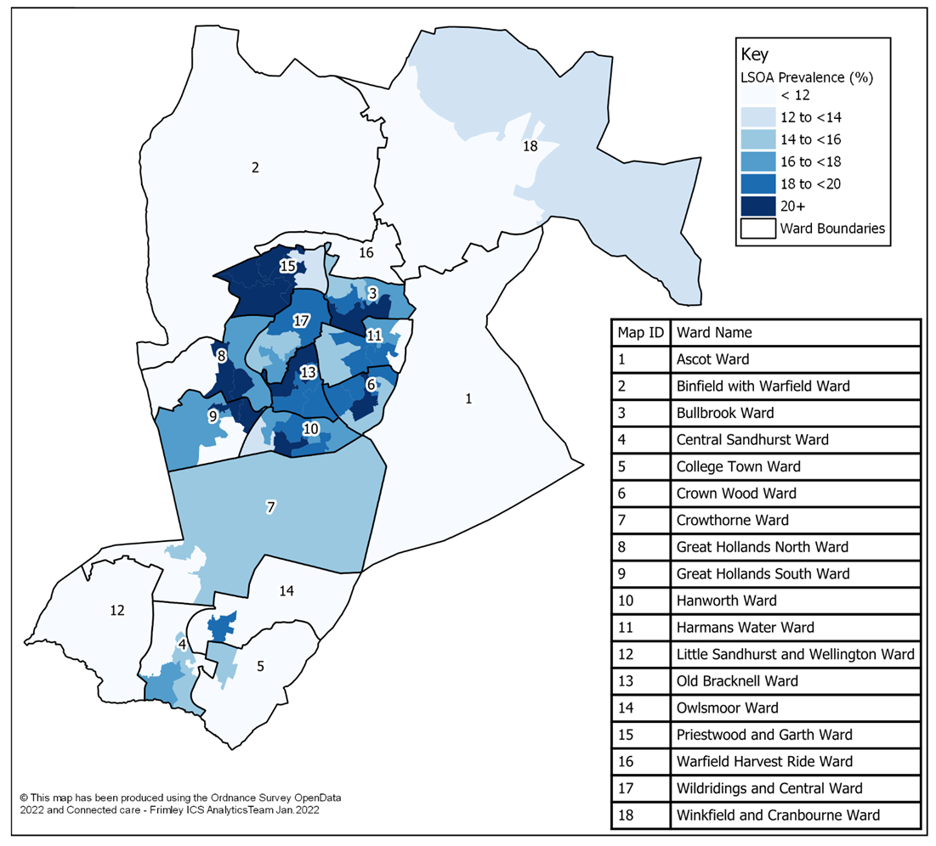
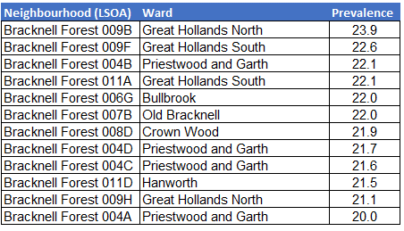
Figure 37 shows the prevalence of people recorded as current smokers by LSOA in Bracknell Forest. This shows the highest levels of smoking in central Bracknell with the highest recorded prevalence found in neighbourhoods in Great Hollands North, Great Hollands South and Priestwood and Garth wards. The neighbourhoods with the highest prevalence rates are included below:
Caution should be taken with this data as it is based on crude rates, rather than age-standardised rates.

Source: Connected Care - Frimley ICB Analytics Team (Jan 2022)

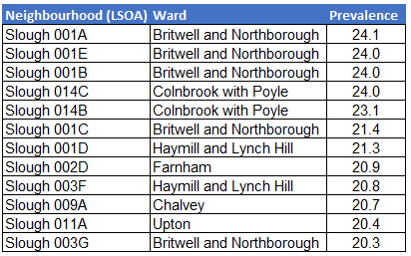
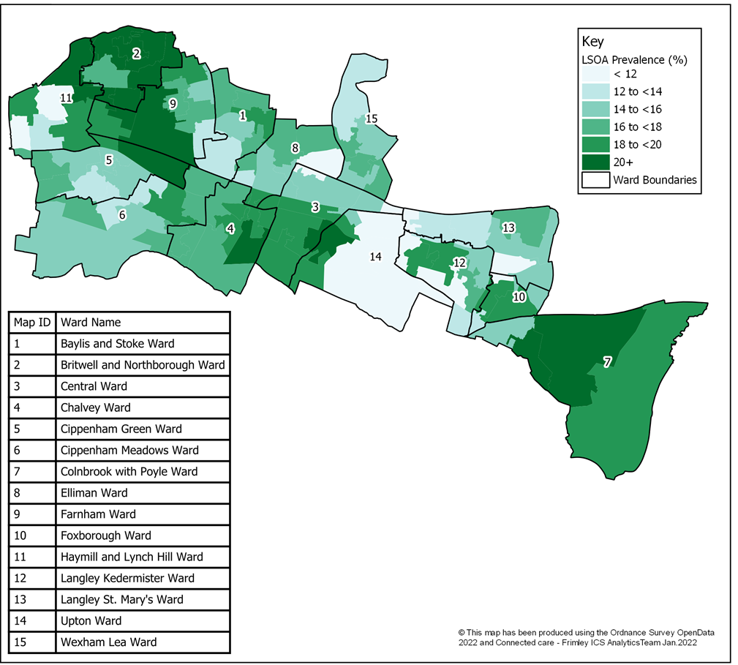
Figure 38 shows the prevalence of people recorded as current smokers by LSOA in Slough. The highest levels of smoking are in neighbourhoods within Britwell and Northborough and Colnbrook with Poyle wards. The neighbourhoods with the highest prevalence rates are included below:
Figure 38: Prevalence of Smoking in adults (18+) by LSOA in Slough

Source: Connected Care - Frimley ICB Analytics Team (Jan 2022)

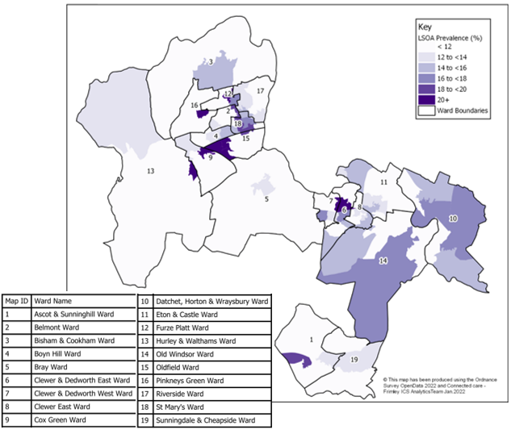
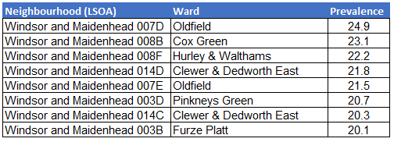
Figure 39 shows the prevalence of people recorded as current smokers by LSOA in RBWM. The highest levels of smoking are in neighbourhoods within Oldfield, Cox Green and Hurley & Walthams wards. Neighbourhoods with the highest prevalence rates are included below
Figure 39: Prevalence of Smoking in adults (18+) by LSOA in RBWM

Source: Connected Care - Frimley ICB Analytics Team (Jan 2022)

Figure 40: Prevalence of smoking in adults (18+) by ward (January 2022)
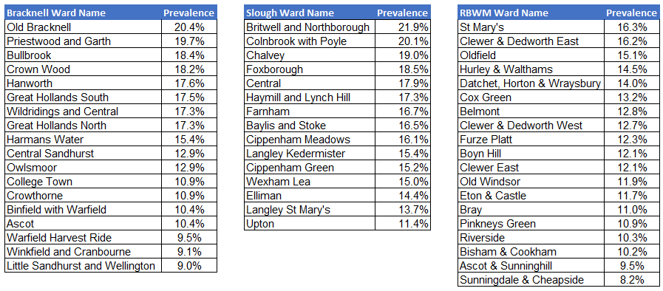

Source: Connected Care - Frimley ICB Analytics Team (Jan 2022)

3.4 Understanding alcohol use
Alcohol use is the biggest risk factor for death, ill-health and disability among 15 to 49 year olds in England and the sixth biggest risk factor across all ages (Institute for Health Metrics and Evaluation 2019). Approximately 30% of men and 15% of women consistently exceed the recommended weekly limit of alcohol (14 units) and this increases their risk of ill health over their lifetime (Health Survey for England 2019).

Alcohol is a causal factor in more than 60 medical conditions, including cancers, high blood pressure, cirrhosis of the liver and depression. Alcohol misuse is also a major cause of A&E attendances and admission to hospitals. NHS England estimate that up to 15% of all A&E attendances are alcohol-related and approximately 2% of admissions are for conditions solely-attributable to alcohol (House of Commons Library 2021).

This HNA focuses on the prevalence of alcohol usage that could be supported through a brief intervention of lifestyle service, rather than for those that are alcohol dependent and require higher levels of support. Levels of alcohol usage are not collated at a local authority level, so adverse effects of increased alcohol intake – such as hospital admissions and mortality - have been used as a proxy for increased alcohol use.

Local GP data is also not currently available for analysis, however a project to improve data quality and availability within the Connected Care data is underway in the Frimley ICB Analytics Team.

Key Findings

Approximately 19% of England’s adult population are drinking alcohol at a level which puts them at increasing risk and 4% at a level which is higher risk. The Health Survey shows that men drink at higher levels than women and that alcohol consumption also increases with age peaking in the 55 to 64 age group. The proportions of men and women who drink at increasing risk levels also increases with household income.

Using the national prevalence as a model, it is estimated that there are over 62,500 people aged 16 and over in Berkshire East that are drinking at increasing levels of risk and over 13,000 at a higher risk level.

Hospital admissions reduced during the first national lockdown (March 2020 to June 2020) for all causes and this is also the case for alcohol-specific and alcohol-related conditions. In 2020/21, there were nearly 4,500 admissions for alcohol-related conditions (broad) for Berkshire East residents. 1,650 of these were alcohol-specific conditions. The latest admission rates show a variation across Berkshire East, with Bracknell Forest and RBWM having significantly better admission rates than England. Slough’s admissions are significantly worse than England’s for alcohol-related (broad) conditions.
Alcohol-specific deaths increased by 19% in England between 2019 and 2020. Over 75% of these deaths were attributed to alcoholic liver disease. Alcohol-related deaths increased by 4% during this time period and accounted for nearly 20,500 deaths in total. Deaths from alcohol are relatively small at a local authority level with 123 alcohol-specific deaths across Berkshire East in 2020. 35 of these were alcohol-specific deaths. Due to these small numbers, the majority of Berkshire East local authorities’ rates are similar to the national picture. However, Bracknell Forest’s alcohol-specific mortality rates do stand out as the lowest in the South East region in 2017-19 and significantly lower than England’s.
While the level of hospital admissions and mortality from alcohol do not quantity the level of alcohol consumption within a population, they do help to evidence where this may be higher and also the groups that are more likely to drink at higher-risk levels. The population groups that have higher admission and mortality rates from alcohol include:
- males – this is the case both nationally and locally, with males having double or triple the levels of admissions and mortality compared to females
- people from more deprived areas (most deprived to 3rd most deprived decile)

An analysis of age-standardised deaths in England from 2017-19 also showed some difference between ethnic groups, with people from Indian, white and mixed/multiple ethnic groups having higher alcohol-specific mortality rates compared to other ethnicities.

3.4.1 Modelled estimates of alcohol usage
The Health Survey for England (2019) provides an estimate of alcohol consumption levels in line with the current guidelines for sensible drinking:
- ‘lower risk (up to 14 units a week for men and women)
- ‘increasing risk’ (15 to 50 units a week for men, 15 to 35 units for women)
- ‘higher risk’ (above 50 units a week for men, above 35 units for women)

Approximately 19% of England’s adult population are drinking alcohol at a level which puts them at increasing risk and 4% at a level which is higher risk. The Health Survey shows that men drink at higher levels than women and that alcohol consumption also increases with age peaking in the 55 to 64 age group. The proportions of men and women who drink at increasing risk levels also increases with household income.

Using the national prevalence as a model, it is estimated that there are over 62,500 people aged 16 and over in Berkshire East that are drinking at increasing levels of risk and over 13,000 at a higher risk level. This estimate does not take age or household income factors into account and is included as a guide only. Figure 41 gives this breakdown for Berkshire East local authorities.

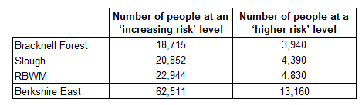
Figure 41: Modelled estimates of alcohol consumption risk levels for people aged 16 and over based (2020)

Source: Prevalence estimates from NHS Digital (2020) Health Survey for England 2019 ;Population estimates from Office for National Statistics (2021) Mid-year population estimates for 2020

3.4.2 Hospital admissions from alcohol
Definition of hospital admissions for alcohol
Alcohol-specific admissions: Admissions to hospital where the primary diagnosis or any of the secondary diagnoses are an alcohol-specific (wholly attributable) condition.
Alcohol-related admissions (Broad): A measure of hospital admissions where either the primary diagnosis (main reason for admission) or one of the secondary (contributory) diagnoses is an alcohol-related condition. This represents a Broad measure of alcohol-related admissions but is sensitive to changes in coding practice over time.
Alcohol-related admissions (Narrow): A measure of hospital admissions where the primary diagnosis (main reason for admission) is an alcohol-related condition. This represents a Narrower measure - since every hospital admission must have a primary diagnosis it is less sensitive to coding practices but may also understate the part alcohol plays in the admission.
In 2020/21 there were approximately 815,000 alcohol-related hospital admissions and 318,500 alcohol-specific hospital admissions in England. These figures were both lower than previous years and will have been impacted by the Covid-19 pandemic, which saw a reduction in admissions from March to June 2020 during the first national lockdown (Office for Health Improvement & Disparities 2022).
Figure 42 shows the rate of hospital admissions for different conditions in 2020/21. During this time-period, there were nearly 4,500 admissions for alcohol-related conditions (broad) for Berkshire East residents. 1,650 of these were alcohol-specific conditions. The latest admission rates show a variation across Berkshire East, with Bracknell Forest and RBWM having significantly better admission rates than England in all conditions and sexes. Slough’s admissions are significantly worse than England’s for alcohol-related (broad) conditions for all people and males.
Although admission rates fell in 2020/21, the inequality in admission rates between different population groups was still clear and followed pre-pandemic patterns. Groups with significantly worse admission rates nationally included:
- Males have more than double the admission rate of females for alcohol related and alcohol-specific conditions. Males also account for 87% of all admissions due to unintentional alcohol-related injuries
- More deprived areas (most to 3rd most deprived local authorities) have a significantly worse admission rate for all four alcohol conditions included here, compared to less deprived areas.
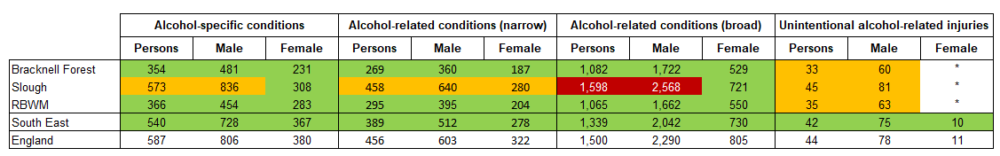
Figure 42: Hospital admissions per 100,000 population by cause and sex in 2020/21 (directly standardised rates)
* Data has been suppressed, due to small numbers
Source: Office for Health Improvement and Disparities (2022); Local Alcohol Profiles for England

3.4.3 Alcohol-specific and related mortality
Definition of mortality from alcohol use
Alcohol-specific deaths: These include health conditions where each death is a direct consequence and wholly contributable to alcohol misuse, such as alcoholic liver disease.
Alcohol-related deaths: These include conditions that are a direct consequence of alcohol consumption, such as alcohol poisoning, as well as conditions that are partly related to alcohol, such as liver cancer.
In 2020 there were approximately 6,980 alcohol-specific deaths in England, which was a 19% increase on 2019. Over 75% of these deaths were attributed to alcoholic liver disease (Office for National Statistics 2021). Alcohol-related deaths increased by 4% between 2019 and 2020 and accounted for nearly 20,500 deaths in total (Office for Health Improvement & Disparities 2022).
Figure 43 shows the mortality rate for different conditions. Numbers are relatively small at a local authority level with 123 alcohol-specific deaths across Berkshire East in 2020. 35 of these were alcohol-specific deaths, which means that they were wholly attributable to alcohol consumption. Due to these small numbers, the majority of Berkshire East local authorities’ rates are similar to the national picture. However, Bracknell Forest’s alcohol-specific mortality rates do stand out as the lowest in the South East region in 2017-19 and significantly lower than England’s.
Groups with significantly worse mortality rates from alcohol include:
- Males have more than double the alcohol-specific mortality rate of females and nearly triple the alcohol-related mortality rate.
- More deprived areas (most to 3rd most deprived local authorities) have a significantly worse mortality rate for both conditions included here, compared to less deprived areas.

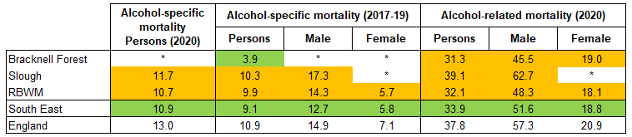
Figure 43: Mortality per 100,000 population by cause and sex (directly standardised rates)

* Data has been suppressed, due to small numbers
Source: Office for Health Improvement and Disparities (2022); Local Alcohol Profiles for England
An analysis of age-standardised deaths in England from 2017-19 shows that people from Indian, white and mixed/multiple ethnic groups have higher alcohol-specific mortality rates, compared to other ethnicities (Office of National Statistics 2022).
Bracknell Forest | Slough | Windsor and Maidenhead
Approximately 22,655 people aged 16 and over are drinking above at increasing or higher risk levels in Bracknell Forest. | Approximately 25,240 people aged 16 and over are drinking above at increasing or higher risk levels in Slough. | Approximately 27,770 people aged 16 and over are drinking above at increasing or higher risk levels in RBWM
In Bracknell Forest, there were 1,176 hospital admissions for alcohol-related conditions (broad definiton) in 2020/21. This was a rate of 1,082 per 100,000 population and significantly better than the national figure. The male rate of admissions was triple that of females, although there has been a signifincat decrease in the male admissions overall.  There were 308 hospital admissions for alcohol-related conditions (narrow definiton) in 2020/21. This was a rate of 269 per 100,000 population and significantly better than the national figure. The male rate of admissions was nearly double that of females, although there has ben a significant decrease in the male admissions overall.  There were 405 hospital admissions for alcohol-specific conditions in 2020/21. This was a rate of 354 per 100,000 population and significantly better than the national figure. The male rate of admissions was double that of females. | In Slough, there were 1,722 hospital admissions for alcohol-related conditions (broad definiton) in 2020/21. This was a rate of 1,598 per 100,000 population and significantly worse than the national figure. The male rate of admissions was more than triple that of females. The female rate was significantly better than England’s.  There were 557 hospital admissions for alcohol-related conditions (narrow definiton) in 2020/21. This was a rate of 458 per 100,000 population and similar to the national figure. The male rate of admissions was more than double that of females.  There were 705 hospital admissions for alcohol-specific conditions in 2020/21. This was a rate of 573 per 100,000 population and similar to the national figure. The male rate of admissions was more than double that of females. The female rate was significantly better than England’s. | In RBWM, there were 1,591 hospital admissions for alcohol-related conditions (broad definiton) in 2020/21. This was a rate of 1,065 per 100,000 population and significantly better than the national figure. The male rate of admissions was triple that of females.  There were 433 hospital admissions for alcohol-related conditions (narrow definiton) in 2020/21. This was a rate of 295 per 100,000 population and significantly better than the national figure. The male rate of admissions was nearly double that of females.  There were 540 hospital admissions for alcohol-specific conditions in 2020/21. This was a rate of 366 per 100,000 population and significantly better than the national figure. The male rate of admissions was signifiicantly higher than that of females.
In Bracknell Forest, there were 13 alcohol-specific deaths in 2017-19 at a rate of 3.9 per 100,000 population. This was the lowest rate in the South East region and significantly better than the national rate. The male mortality rate was more than double that of females.  There were 33 alcohol-related deaths in 2020 at a rate of 31.3 per 100,000 population. This was similar to England. The male mortality rate was more than double that of females. | In Slough, there were 37 alcohol-specific deaths in 2017-19 at a rate of 10.3 per 100,000 population. This was similar to England. Due to small numbers, the rate for females cannot be calculated – however, males made up 86% of all deaths.  There were 41 alcohol-related deaths in 2020 at a rate of 39.1 per 100,000 population. This was similar to England. Due to small numbers, the rate for females cannot be calculated – however, males made up 78% of all deaths. | In RBWM, there were 43 alcohol-specific deaths in 2017-19 at a rate of 9.9 per 100,000 population. This was similar to England. The male mortality rate was more than double that of females.  There were 49 alcohol-related deaths in 2020 at a rate of 32.1 per 100,000 population. This was similar to England. The male mortality rate was more than double that of females.

3.5 Understanding Type 2 Diabetes
Diabetes is a non-communicable disease where the amount of glucose in the blood is too high. Type 1 diabetes is an autoimmune disease where the body is unable to produce any insulin and is not impacted by modifiable lifestyle factors. Type 2 diabetes is different and develops when the body stops producing enough insulin or the body’s cells stop reacting to insulin produced (Public Health England 2018). While Type 2 diabetes is affected by non-modifiable factors, such as a person’s age, family history and ethnicity, it is also closely associated with modifiable lifestyle factors, such as being overweight or obese, alcohol consumption, diet and physical inactivity. Research shows that living with obesity is the single greatest risk factor for type 2 diabetes, accounting for 80-85% of someone’s risk of developing the condition (Diabetes UK 2021). The onset of Type 2 diabetes can therefore be delayed or prevented through support to change behaviour around lifestyle choices and is the focus of this section of the report.
The prevalence of diabetes is monitored through the Quality and Outcomes Framework (QOF) and measures the proportion of the population aged 17 and over who have a recorded diagnosis of diabetes at a specific point in time. This covers diabetes as a whole, rather than splitting it by type, but still provides a useful measure of the level of diagnosed diabetes in the population as 90% of diabetes diagnoses are for those with Type 2 (Diabetes UK 2021). This section of the report also includes additional local data from GP Records (Connected Care) that focuses on people aged 18 and over who had a Type 2 diabetes diagnosis recorded in January 2022.

People with undiagnosed diabetes have not been included in this analysis. It is important to note that approximately 14% of people with diabetes are unaware that they have the condition (Diabetes.co.uk 2019) and these will mainly be those with Type 2 diabetes.

Key Findings

Diabetes (diagnosed)
The prevalence of diabetes is recorded on GP Practice Registers for people aged 17 and over. In 2020/21, Berkshire East had the same prevalence of recorded diabetes as England at 7.1%. This prevalence has continued to increase at a national and local level, with approximately 26,000 Berkshire East residents people diagnosed with diabetes in March 2021.

The prevalence of diabetes varies significantly across Berkshire East. Slough has the 3rd highest prevalence rate in England at 9.7%, while Bracknell Forest and RBWM have prevalence rates below the national figure.

Type 2 diabetes (diagnosed)
The prevalence of Type 2 diabetes is recorded on local GP Practice Registers (Connected Care) and has been analysed for people aged 18 and over. In January 2022, 6.4% of Frimley ICS’s registered population had a Type 2 diabetes diagnosis and 7.0% of Berkshire East’s population.
In Frimley ICS, recorded Type 2 diabetes prevalence is highest in:
- males
- adults aged 80 to 89, followed by adults aged 70 to 79
- people from Asian or Asian British groups, followed by black or black British ethnic groups
- people from more deprived neighbourhoods *

* Slough has the highest recorded prevalence of Type 2 diabetes across Frimley ICS in all sex, age, ethnic groups and deprivation groups. This will have impacted on the overall analysis of the ICS, as Slough’s figures account for 30% of all people diagnosed with Type 2 diabetes while only making up 19% of the total Frimley ICS registered adult population. Analysis at an individual local authority level does not show clear links between diabetes diagnoses and deprivation, however as Slough is one of the more deprived areas in Frimley ICS and Berkshire East it would have skewed this analysis.

Slough has an ethnically diverse population, with 54% of people coming from an ethnic minority (excluding white ethnic minorities) group. People from black African, black Caribbean or South Asian descent are more likely to be diagnosed with diabetes, compared to people from white ethnic groups. This will therefore impact on the overall prevalence of diabetes in Slough.

Undiagnosed diabetes
Approximately 14% of people with diabetes are unaware that they have the condition (Diabetes.co.uk 2019) and these will mainly be those with Type 2 diabetes. This represents an additional 4,090 people in Berkshire East.

3.5.1 Prevalence of recorded diabetes in the general population
In 2020/21, the recorded prevalence of diabetes in Berkshire East was 7.1% for those aged 17 and over, which was approximately 26,000 people. This was the same as the national recorded prevalence rate. All Berkshire East local authorities have seen an increase in diabetes diagnosis, in line with the national picture, and there is significant variation across the area. Slough has the 3rd highest prevalence rate in England at 9.7%, while Bracknell Forest and RBWM have prevalence rates below the national figure (Office for Health Improvement and Disparities 2022).

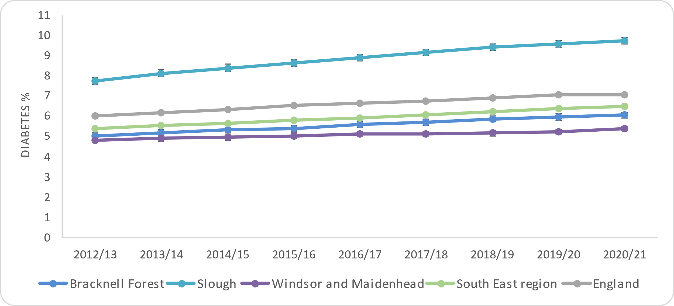
Figure 44: Prevalence of Diabetes (aged 17+) over time in Berkshire East
QOF prevalence rates for diabetes include all types of diabetes.
Diabetes UK (2021) states that 90% of people with diabetes have Type 2, which would equate to nearly 23,500 people.

Source: Office for Health Improvement and Disparities (2022); Fingertips Public Health Profiles
Source: OHID Fingertips Profiles 2022
Bracknell Forest | Slough | Windsor and Maidenhead
6.1% of patients aged 17 years and over are recorded on GP practice disease registers as having diabetes in 2020/21, equating to 6,134 people in Bracknell Forest. It is estimated that 5,521 of these would have Type 2 diabetes.  Diabetes recorded prevalence is continuing to increase. | 9.7% of patients aged 17 years and over are recorded on GP practice disease registers as having diabetes in 2020/21, equating to 12,319 people in Slough. This is the 3rd highest rate in English local authorities. It is estimated that 11,087 of Slough’s cases would have Type 2 diabetes.  Diabetes recorded prevalence is continuing to increase. | 7.1% of patients aged 17 years and over are recorded on GP practice disease registers as having diabetes in 2020/21, equating to 7,577 people in RBWM. It is estimated that 6,819 of these would have Type 2 diabetes.  Diabetes recorded prevalence is continuing to increase.

3.5.2 Prevalence of recorded Type 2 Diabetes on GP Practice Records (Connected Care)
The prevalence of Type 2 diabetes in the Frimley ICS and Berkshire East population can be analysed using the data held in local GP Practice Records (Connected Care). The information included in this section of the report focuses on the local population aged 18 and over that had a Type 2 diabetes diagnosis on their record in January 2022.

Across Frimley ICS, over 41,000 people aged 18 and over had a Type 2 diabetes diagnosis, which was 6.4% of the total adult population. Nearly 24,800 people are recorded as having Type 2 diabetes across Berkshire East at 7.0% of the total adult population.

Sex
The prevalence of recorded Type 2 diabetes in Frimley ICS is higher in males than females with rates of 7.3% and 5.6% respectively. This trend is consistent across all Berkshire East local authorities.

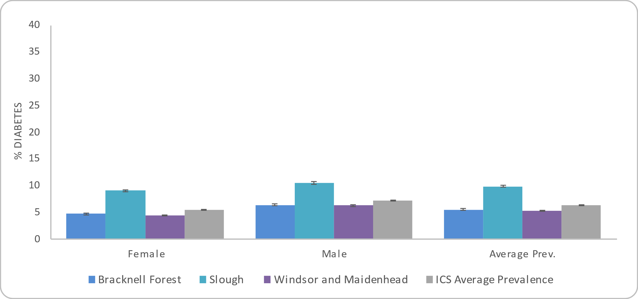
Figure 45: Prevalence of adult (18+) Type 2 Diabetes by sex in Frimley ICS and Berkshire East local authorities

Source: Connected Care - Frimley ICB Analytics Team (Jan 2022)

Age
The highest prevalence of Type 2 Diabetes is in adults aged 80 to 89 (19.1%), followed by adults aged 70 to 79 (16.9%). The lowest prevalence rates are in the younger age groups.

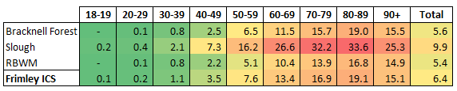
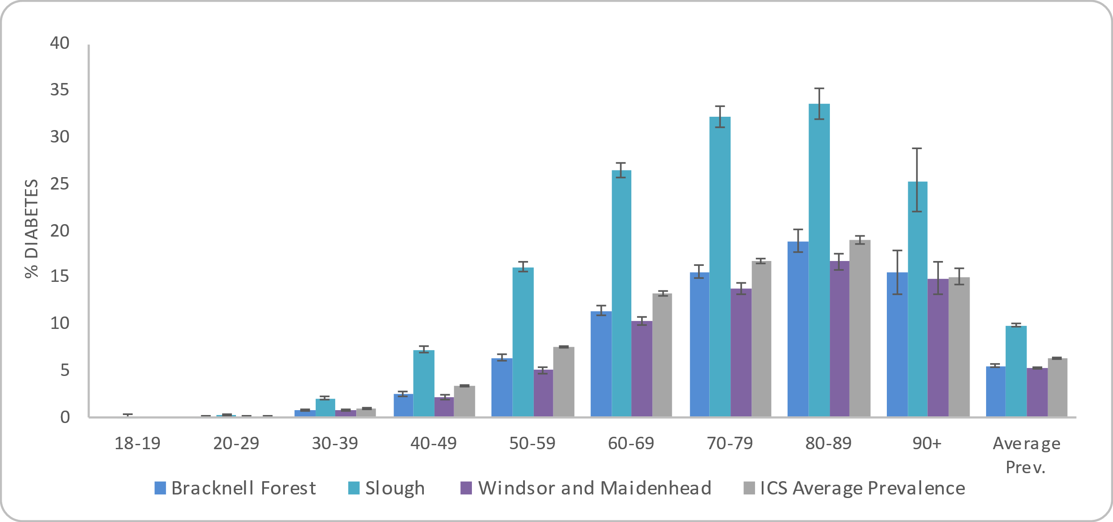
Figure 46: Prevalence of adult (18+) Type 2 Diabetes by age group in Frimley ICS and Berkshire East local authorities
The colour-coding used above indicates higher (red) and lower (green) levels of obesity. This does not infer significance and is only for information.

Source: Connected Care - Frimley ICB Analytics Team (Jan 2022)

Ethnicity
The highest prevalence of people aged 18 or over with Type 2 Diabetes recorded are people from an Asian or Asian British ethnic group (12.8%), followed by black or black British groups at 9.3%. This is the case across all Berkshire East local authorities. The lowest prevalence is for people with no ethnic group recorded at 2.9%, followed by 5.2% categorised as other ethnic group.

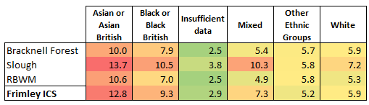
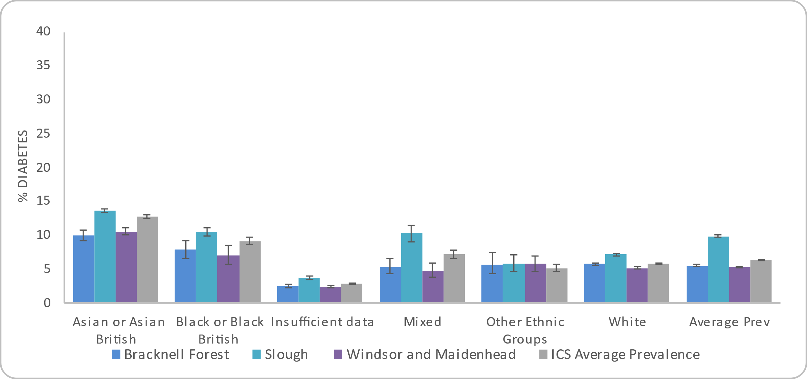
Figure 47: Prevalence of adult (18+) Type 2 Diabetes by ethnicity in Frimley ICS and Berkshire East local authorities
The colour-coding used above indicates higher (red) and lower (green) levels of obesity. This does not infer significance and is only for information.

Source: Connected Care - Frimley ICB Analytics Team (Jan 2022)

Source: Connected care - Frimley ICS Analytics Team (Jan 2022)

Deprivation
Each neighbourhood in England, or Lower Super Output Area (LSOA), has a deprivation score that indicates how deprived that area is compared to the rest of England. Frimley ICS and Berkshire East do not have any LSOAs in the 10% most deprived neighbourhoods nationally and this group is therefore not included in the analysis below.

There is an association between deprivation and recorded Type 2 diabetes prevalence in Frimley ICS. People from the most deprived areas in Frimley ICS (2nd most deprived decile nationally) have the highest recorded prevalence at 10.3%, compared to 4.8% of people in the least deprived decile. This may be partly explained by the significantly higher prevalence of diabetes across Slough, which does have more areas of deprivation. Links between deprivation and diabetes diagnoses are not as clear within individual local authorities.

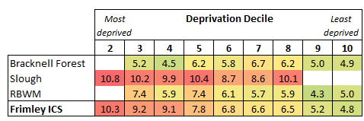
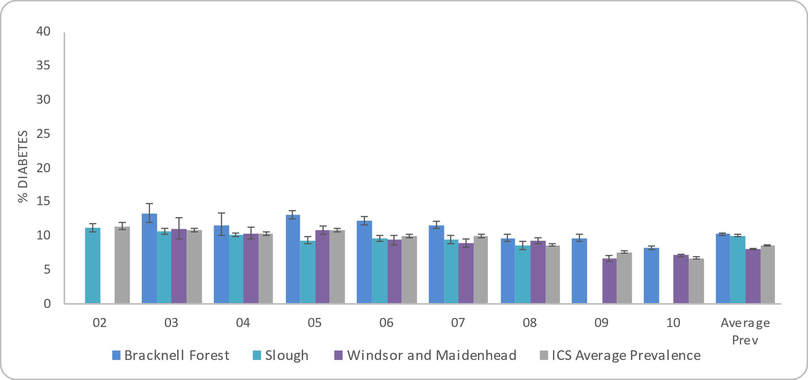
Figure 48: Prevalence of adult (18+) Type 2 Diabetes by deprivation decile in Frimley ICS and Berkshire East local authorities
The colour-coding used above indicates higher (red) and lower (green) levels of obesity. This does not infer significance and is only for information.

Source: Connected Care - Frimley ICB Analytics Team (Jan 2022)

Bracknell Forest | Slough | Windsor and Maidenhead
5.6% of people aged 18 or over are recorded as having Type 2 diabetes. | 9.9% of people aged 18 or over are recorded as having Type 2 diabetes. This is significantly higher than any other local authority area in Frimley ICS. | 5.4% of people aged 18 or over are recorded as having Type 2 diabetes.
Sex: 6.5% of males and 4.8% of females aged 18 or over are recorded as having Type 2 diabetes. | Sex: 10.6% of males and 9.1% of females aged 18 or over are recorded as having Type 2 diabetes. Both prevalence rates are significantly higher than any other local authority area in Frimley ICS. | Sex: 6.3% of males and 4.5% of females aged 18 or over are recorded as having Type 2 diabetes.
Age: The highest prevalence is in adults aged 80 to 89 (19.0%), followed by adults aged 70 to 79 (15.7%). | Age: The highest prevalence is in adults aged 80 to 89 (33.6%), followed by adults aged 70 to 79 (32.2%). | Age: The highest prevalence is in adults aged 80 to 89 (16.8%), followed by adults aged 90 or over (14.9%).
Ethnicity: The highest prevalence is in adults from an Asian or Asian British ethnic group at 10.0%, followed by those from a black or black British ethnic group at 7.9%.  The lowest prevalence is in adults with no ethnicity recorded at 2.5% and those with a mixed ethnicity recorded at 5.4%. | Ethnicity: The highest prevalence is in adults from an Asian or Asian British ethnic group at 13.7%, followed by those from a black or black British ethnic group at 10.5%.  The lowest prevalence is in adults with no ethnicity recorded at 3.8% and those with ‘other ethnic group’ recorded at 5.8%. | Ethnicity: The highest prevalence is in adults from an Asian or Asian British ethnic group at 10.6%, followed by those from a black or black British ethnic group at 7.0%.  The lowest prevalence is in adults with no ethnicity recorded at 2.5% and those with a mixed ethnicity recorded at 4.9%.
Deprivation: Bracknell Forest has LSOAs in deprivation deciles 3 to 10.  An association between deprivation and type 2 diabetes is unclear within Bracknell Forest.  The highest prevalence is 6.7% for the 4th least deprived decile, followed by the 5th most and 3rd least deprived deciles (6.2%).  People living in the 4th most deprived area have the lowest prevalence rate at 4.5%. | Deprivation: Slough has LSOAs in deprivation deciles 2 to 8.  An association between deprivation and type 2 diabetes is unclear within Slough.  The highest prevalence is 10.8% for the 2nd most deprived decile, followed by the 5th most deprived decile (10.4%) and the 3rd most (10.2%).  People living in the 4th least deprived area have the lowest prevalence rate at 8.6%.  . | Deprivation: RBWM has LSOAs in deprivation deciles 3 to 10.  An association between deprivation and type 2 diabetes is unclear within RBWM.  The highest prevalence is 7.4% for the 3rd most and 5th most deprived deciles, followed by the 5th least deprived decile (6.1%).  People living in the 2nd least deprived area have the lowest prevalence rate at 4.3%.

Location
Figure 49: Prevalence of Type 2 Diabetes in adults (18+) by LSOA in Bracknell Forest

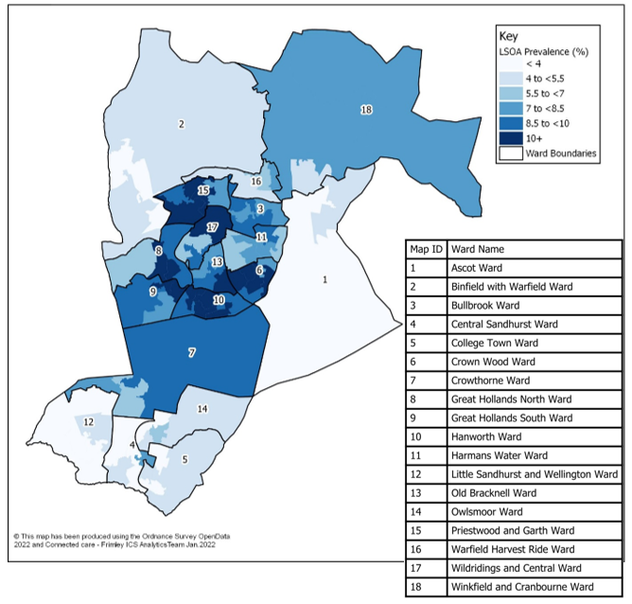
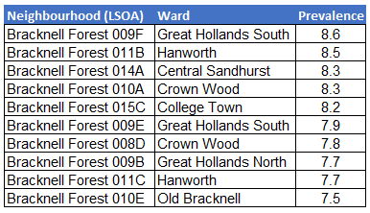
Figure 49 shows the prevalence of people recorded as having Type 2 diabetes by LSOA in Bracknell Forest. This shows the highest levels of Type 2 diabetes in central Bracknell with the highest recorded prevalence found in neighbourhoods in Great Hollands South, Hanworth, Central Sandhurst and Crown Wood wards. The neighbourhoods with the highest prevalence rates are included below:

Caution should be taken with this data as it is based on crude rates, rather than age-standardised rates. Age is a factor that impacts on diabetes prevalence and areas of Bracknell Forest with older populations will therefore have higher obesity prevalence. Some ethnic groups also have higher rates of diabetes, including those from black African, black Caribbean or South Asian descent. Neighbourhoods with higher proportions of people from these groups will also have higher diabetes prevalence overall.

Source: Connected Care - Frimley ICB Analytics Team (Jan 2022)

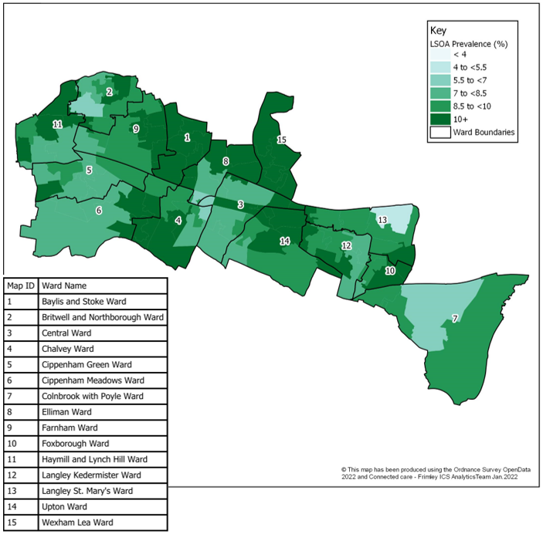
Figure 50 shows the prevalence of people recorded as having Type 2 diabetes by LSOA in Slough. Prevalence rates are high across the whole Borough. Neighbourhoods with the highest prevalence rates are included below:
Figure 50: Prevalence of Type 2 Diabetes in adults (18+) by LSOA in Slough

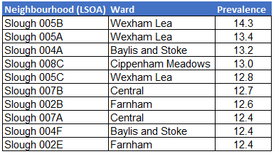

Caution should be taken with this data as it is based on crude rates, rather than age-standardised rates. Age is a factor that impacts on diabetes prevalence and areas of Bracknell Forest with older populations will therefore have higher obesity prevalence. Some ethnic groups also have higher rates of diabetes, including those from black African, black Caribbean or South Asian descent. Neighbourhoods with higher proportions of people from these groups will also have higher diabetes prevalence overall.

Source: Connected Care - Frimley ICB Analytics Team (Jan 2022)

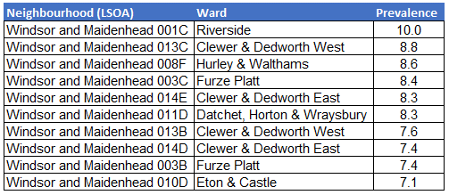
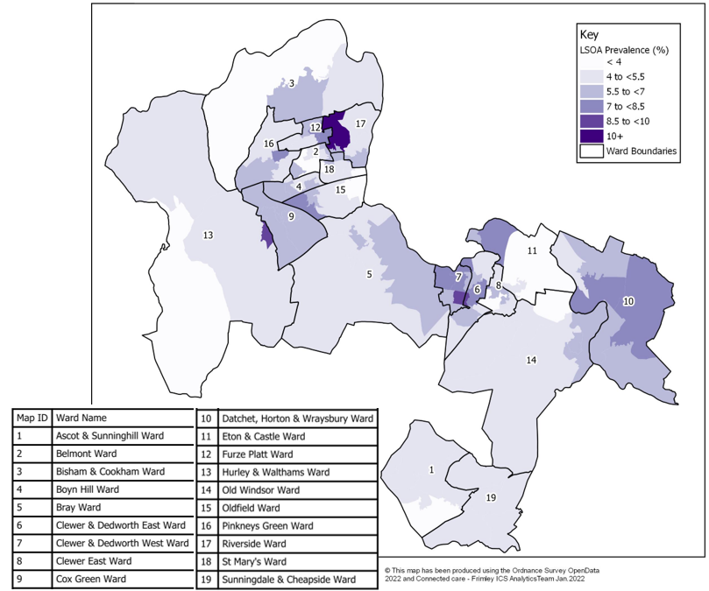
Figure 51 shows the prevalence of people recorded ss having Type 2 diabetes by LSOA in RBWM. The neighbourhoods with the highest prevalence rates are included below
Figure 51: Prevalence of Type 2 Diabetes in adults (18+) by LSOA in RBWM

Source: Connected Care - Frimley ICB Analytics Team (Jan 2022)

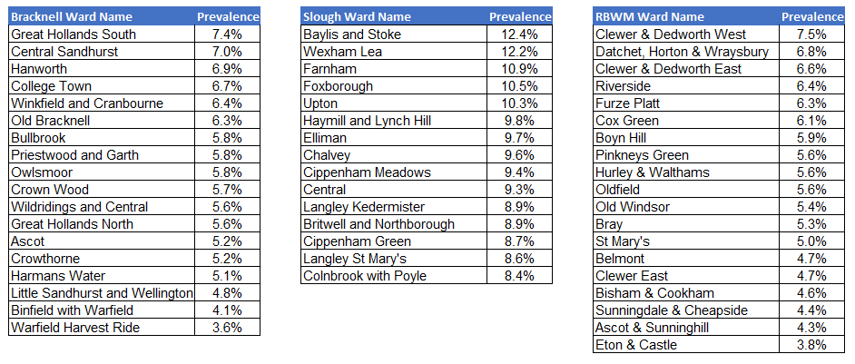
Figure 52: Prevalence of recorded Type 2 diabetes in adults (18+) by ward (January 2022)

Source: Connected Care - Frimley ICB Analytics Team (Jan 2022)

3.6 Understanding Hypertension
Hypertension, or high blood pressure, is the biggest risk factor for cardiovascular disease and contributes to half of all strokes and heart attacks. It is also associated with an increase in risk of developing dementia, heart failure and kidney disease (UK Health Security Agency 2017). Hypertension is a preventable condition that is affected by modifiable risk factors, such as poor diet and obesity, lack of physical activity and excess alcohol consumption.

The prevalence of hypertension is monitored through the Quality and Outcomes Framework (QOF), which measures the proportion of the total population who have a recorded diagnosis of hypertension at a specific point in time. These are an underestimation of the true level of hypertension in the population, as approximately 41% of people with hypertension are undiagnosed and not recorded on GP Practice registers (UK Health Security Agency 2017). However, this information can still provide a useful tool to monitor trends and inequalities in hypertension prevalence. This section of the report also includes additional local data from GP Records (Connected Care) that focuses on people aged 18 and over who had a hypertension diagnosis in January 2022.

Adults who have hypertension recorded in Frimley ICS also had a number of other health conditions and co-morbidities recorded. Diabetes, Chronic Kidney Disease (CKD) and non-Diabetic Hyperglycaemia are the conditions with the highest prevalence in this population.

Key Findings

Hypertension (diagnosed)
The prevalence of hypertension is recorded on GP Practice Registers for people of all ages. In 2020/21, 12.8% of people in Berkshire East had a hypertension diagnosis, which is approximately 60,400 people. This is significantly lower than the national prevalence of 13.8%.

The prevalence of hypertension is recorded on local GP Practice Registers (Connected Care) and has also been analysed for people aged 18 and over. In January 2022, 16.0% of Frimley ICS’s registered population had a hypertension diagnosis and 16.2% of Berkshire East’s population.

In Frimley ICS, recorded hypertension prevalence is highest in:
- the older population – there is a clear linear relationship between hypertension and age, with the highest rates in adults aged 90 and over followed by those aged 80 to 89
- people from black or black British ethnic groups, followed by those from white ethnic groups (Bracknell Forest and RBWM had slightly higher prevalence rates in their white ethnic groups)

There is no clear link between deprivation and hypertension prevalence across Frimley ICS or within individual local authorities. The differences in prevalence rates between males and females is also minimal.

Undiagnosed hypertension
Approximately 41% of people with hypertension are unaware that they have the condition and have not been diagnosed (UK Health Security Agency 2017). This represents an additional 42,000 people in Berkshire East.

3.6.1 Prevalence of recorded hypertension in the general population
In 2020/21, the recorded prevalence of hypertension in Berkshire East was 12.8% for the total population, which was approximately 60,400 people. This was significantly lower than the national recorded prevalence of 13.9%. Bracknell Forest and RBWM have seen increasing recorded prevalence rates since 2015/16, whilst Slough’s rates have remained more static. It is important to note that the increase in hypertension prevalence could show an improvement in detection and diagnosis, rather than an actual increased level of the condition in the population (Office for Health Improvement and Disparities 2022).

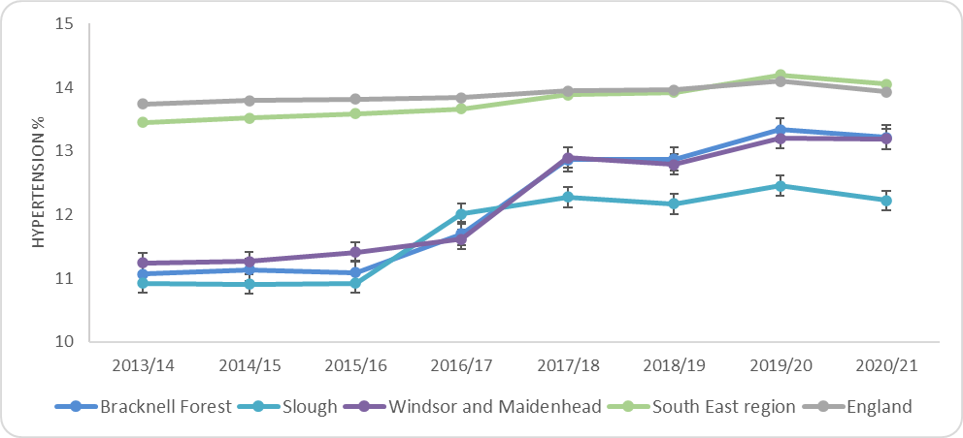
Figure 53: Prevalence of Hypertension (all ages) over time in Berkshire East

Source: Office for Health Improvement and Disparities (2022); Physical Activity Profile
Bracknell Forest | Slough | Windsor and Maidenhead
13.2% of people in Bracknell Forest had a hypertension diagnosis recorded in 2020/21. This equates to 16,907 people. This prevalence has been increasing since 2015/16. | 12.2% of people in Slough had a hypertension diagnosis recorded in 2020/21. This equates to 20,606 people. | 13.2% of people in RBWM had a hypertension diagnosis recorded in 2020/21. This equates to  22,843 people. This prevalence has been increasing since 2015/16.

3.6.2 Prevalence of recorded hypertension on GP Practice Records (Connected Care)
The recorded prevalence of hypertension in the Frimley ICS and Berkshire East population can be analysed using the data held in local GP Practice Records (Connected Care). The information included in this section of the report focuses on the local population aged 18 and over that had a hypertension diagnosis on their record in January 2022. This will be an underestimation of the true level of hypertension, as it is estimated that 41% of cases are undiagnosed (UK Health Security Agency 2017).

Across Frimley ICS, over 102,000 people aged 18 and over had a hypertension diagnosis, which was 16.0% of the total adult population. Over 57,100 people are recorded as having a hypertension diagnosis across Berkshire East at 16.2% of the total adult population.

Sex
The prevalence of recorded hypertension in Frimley ICS is slightly higher in males than females with rates of 16.4% and 15.6% respectively. Slough has slightly higher rates in females, rather than males, however this is not significant.

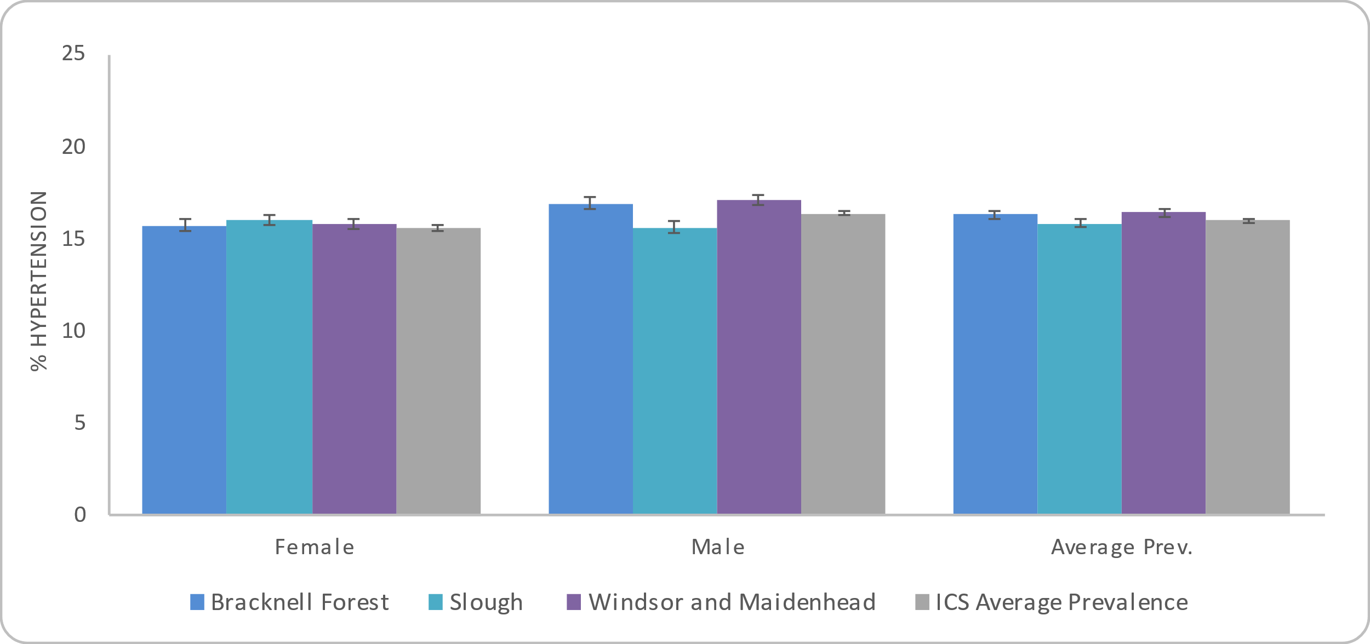
Figure 54: Prevalence of Hypertension in adults (18+) by sex in Frimley ICS and Berkshire East local authorities

.

Source: Connected Care - Frimley ICB Analytics Team (Jan 2022)

Age
The prevalence of hypertension increases by age group in Frimley ICS, with the highest prevalence in people aged 90 or over (63.2%) followed by those aged 80 to 89 (60.3%).

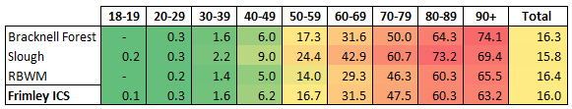
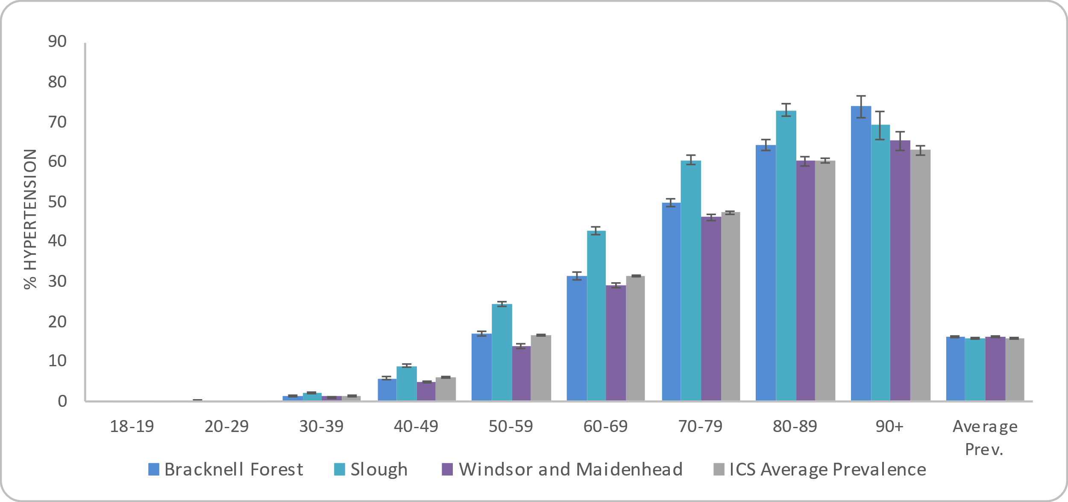
Figure 55: Prevalence of recorded Hypertension in adults (18+) by age group in Frimley ICS and Berkshire East local authorities
The colour-coding used above indicates higher (red) and lower (green) levels of obesity. This does not infer significance and is only for information.

Source: Connected Care - Frimley ICB Analytics Team (Jan 2022)

Ethnicity
The highest prevalence of hypertension in Frimley ICS is for people from black or black British ethnic groups (18.7%), followed by those with a white ethnicity recorded (18.3%). This does differ across Berkshire East local authorities, as Bracknell Forest and RBWM both have their highest rates in people from a white ethnic group.

The lowest prevalence is found in those without an ethnicity recorded (7.6%), followed by those from any other ethnic group (9.9%).

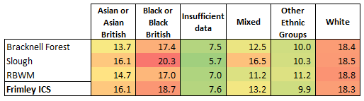
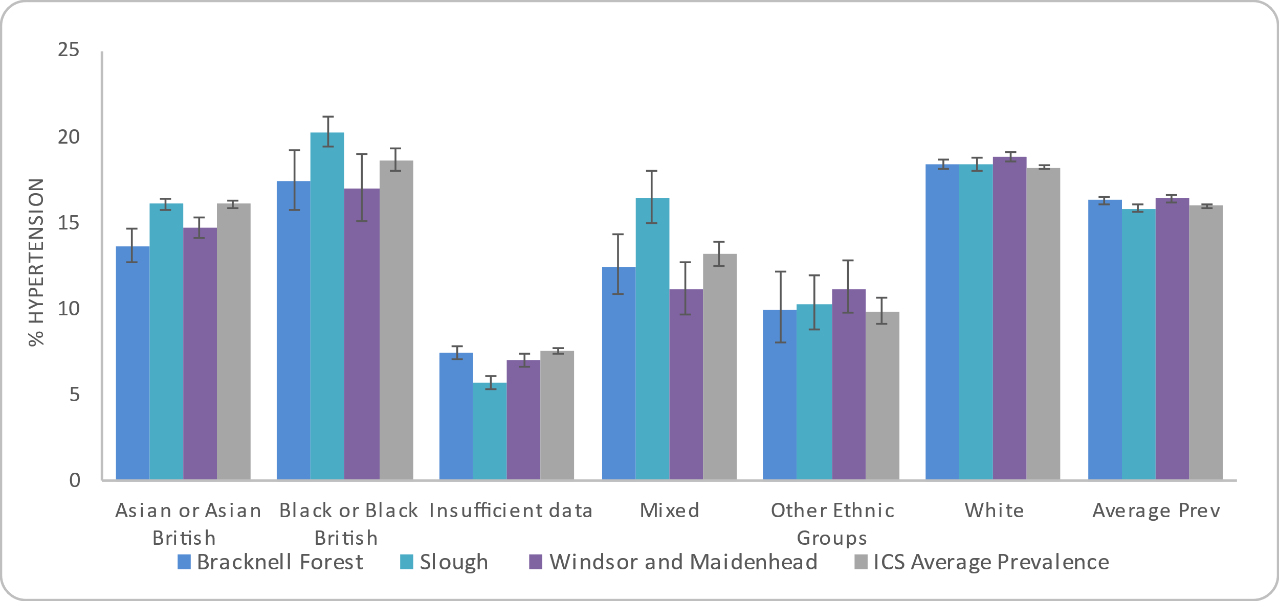
Figure 56: Prevalence of Hypertension in adults (18+) by ethnicity in Frimley ICS and Berkshire East local authorities
The colour-coding used above indicates higher (red) and lower (green) levels of obesity. This does not infer significance and is only for information.

Source: Connected Care - Frimley ICB Analytics Team (Jan 2022)

Deprivation
Each neighbourhood in England, or Lower Super Output Area (LSOA), has a deprivation score that indicates how deprived that area is compared to the rest of England. Frimley ICS and Berkshire East do not have any LSOAs in the 10% most deprived neighbourhoods nationally and this group is therefore not included in the analysis below.

There does not appear to be a link between deprivation and recorded hypertension prevalence in Frimley ICS or within the local authorities. No deprivation decile has a significantly different prevalence to the ICS’s total prevalence rate.

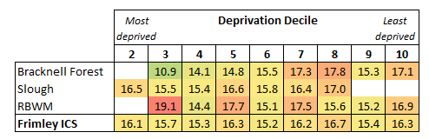
Figure 57: Prevalence of Hypertension in adults (18+) by deprivation decile in Frimley ICS and Berkshire East local authorities
The colour-coding used above indicates higher (red) and lower (green) levels of obesity. This does not infer significance and is only for information.

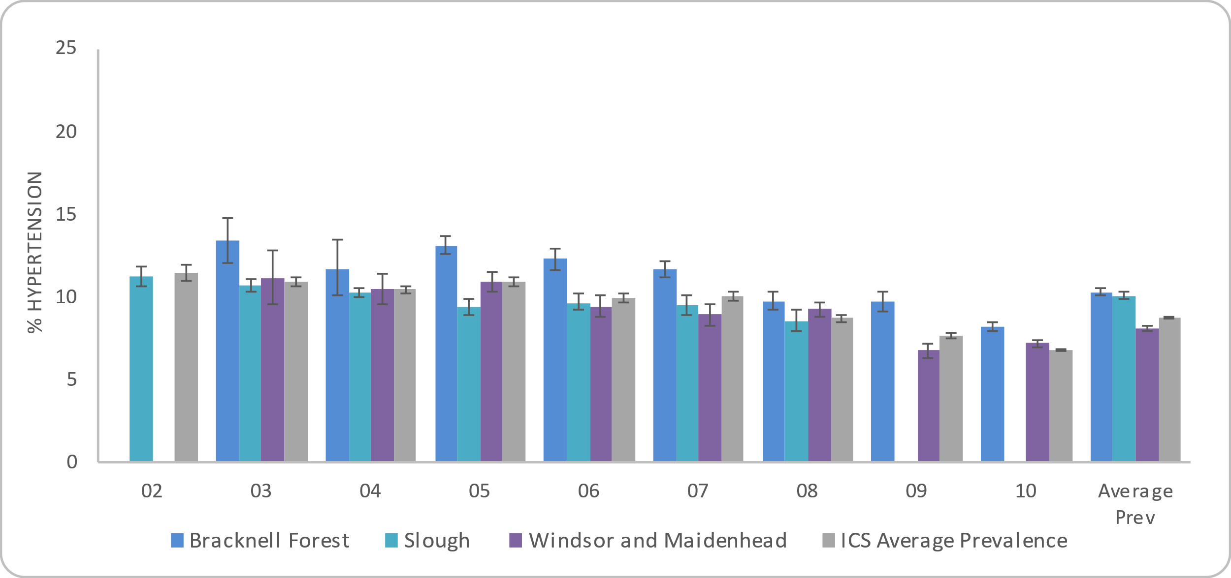

Source: Connected Care - Frimley ICB Analytics Team (Jan 2022)

Bracknell Forest | Slough | Windsor and Maidenhead
16.3% of people aged 18 or over are recorded on the QOF register as having Hypertension. | 15.8% of people aged 18 or over are recorded on the QOF register as having Hypertension. | 16.4% of people aged 18 or over are recorded on the QOF register as having Hypertension.
Sex: 17.0% of males and 15.8% of females aged 18 or over are recorded as having hypertension. | Sex: 15.7% of males and 16.0% of females aged 18 or over are recorded as having hypertension. | Sex: 17.1% of males and 15.8% of females aged 18 or over are recorded as having hypertension.
Age: The highest prevalence is in adults aged 90 or over (74.1%), followed by adults aged 80 to 89 (64.3%).  The prevalence in the 90 and over is the highest rate recorded across all Frimley ICS local authorities by age group. | Age: The highest prevalence is in adults aged 80 to 89 (73.2%), followed by adults aged 90 or over (69.4%). | Age: The highest prevalence is in adults aged 90 or over (65.5%), followed by adults aged 80 to 89 (60.3%).
Ethnicity: People from a white ethnic group have the highest prevalence rates of hypertension at 18.4%, followed by those from a black or black British group at 17.4%.  The lowest prevalence is for people where no ethnicity has been recorded at 7.5%, followed by those from any other ethnic group at (10.0%). | Ethnicity: People from a black or black British ethnic group have the highest prevalence rates of hypertension at 20.3%, followed by those from a white ethnic group at 18.5%.  The lowest prevalence is for people where no ethnicity has been recorded at 5.7%, followed by those from any other ethnic group at (10.3%). | Ethnicity: People from a white ethnic group have the highest prevalence rates of hypertension at 18.8%, followed by those from a black or black British group at 17.0%.  The lowest prevalence is for people where no ethnicity has been recorded at 7.0%, followed by those from any other ethnic group at (11.2%).
Deprivation: Bracknell Forest has LSOAs in deprivation deciles 3 to 10.  There is no clear link between recorded hypertension prevalence and deprivation in Bracknell Forest. | Deprivation: Slough has LSOAs in deprivation deciles 2 to 8. There is no data for the first and second least deprived areas.  There is no clear link between recorded hypertension prevalence and deprivation in Slough. | Deprivation: RBWM has LSOAs in deprivation deciles 3 to 10.  There is no clear link between recorded hypertension prevalence and deprivation in RBWM.

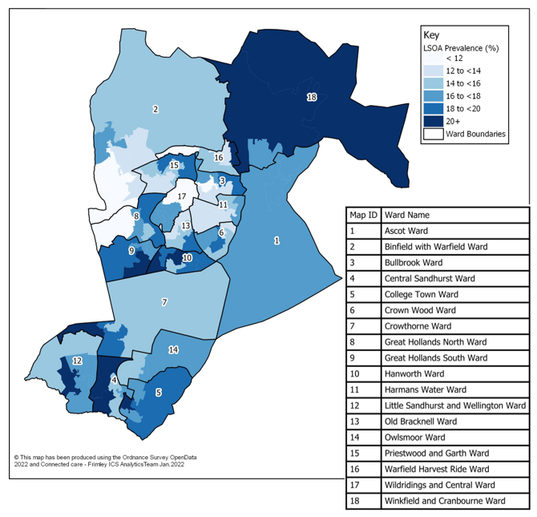
Location
Figure 58: Prevalence of Hypertension in adults (18+) by LSOA in Bracknell Forest

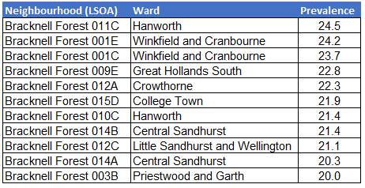
Figure 58 shows the prevalence of people recorded as having a hypertension diagnosis by LSOA in Bracknell Forest. The neighbourhoods with the highest prevalence rates are included below:
Caution should be taken with this data as it is based on crude rates, rather than age-standardised rates. Age is a factor that impacts on hypertension prevalence and areas of Bracknell Forest with older populations will therefore have higher obesity prevalence. Some ethnic groups also have higher rates of hypertension, including those from black and black British backgrounds. Neighbourhoods with higher proportions of people from these groups will also have higher diabetes prevalence overall.

Source: Connected Care - Frimley ICB Analytics Team (Jan 2022)

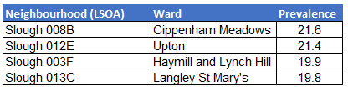
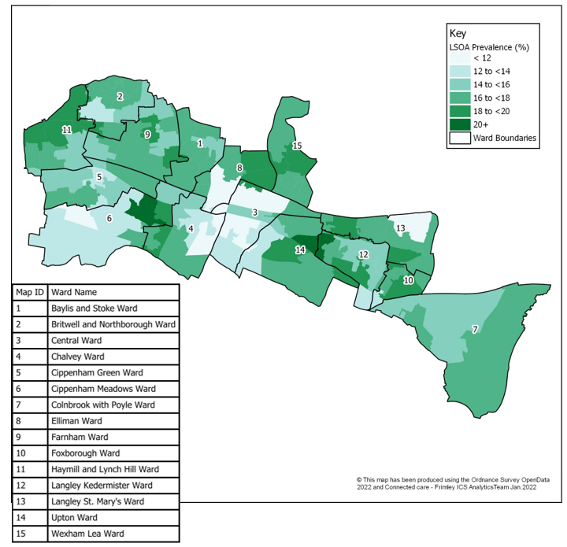
Figure 59 shows the prevalence of people recorded as having a hypertension diagnosis by LSOA in Slough. The neighbourhoods with the highest prevalence rates are included below:
Figure 59: Prevalence of Hypertension in adults (18+) by LSOA in Slough

Caution should be taken with this data as it is based on crude rates, rather than age-standardised rates. Age is a factor that impacts on hypertension prevalence and areas of Bracknell Forest with older populations will therefore have higher obesity prevalence. Some ethnic groups also have higher rates of hypertension, including those from black and black British backgrounds. Neighbourhoods with higher proportions of people from these groups will also have higher diabetes prevalence overall.

Source: Connected Care - Frimley ICB Analytics Team (Jan 2022)

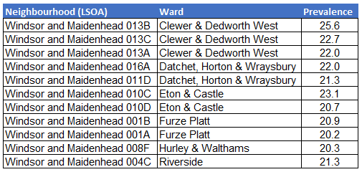
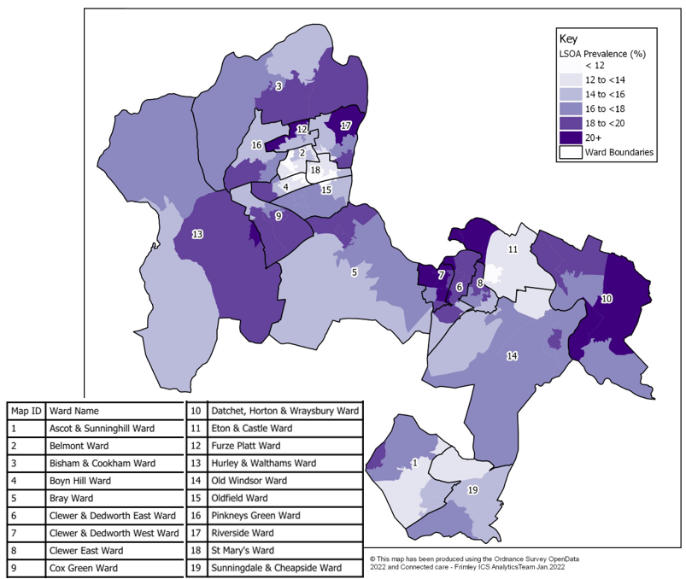
Figure 60 shows the prevalence of people recorded as having a hypertension diagnosis by LSOA in RBWM. The neighbourhoods with the highest prevalence rates are included below:
Figure 60: Prevalence of Hypertension in adults (18+) by LSOA in RBWM

Caution should be taken with this data as it is based on crude rates, rather than age-standardised rates. Age is a factor that impacts on hypertension prevalence and areas of Bracknell Forest with older populations will therefore have higher obesity prevalence. Some ethnic groups also have higher rates of hypertension, including those from black and black British backgrounds. Neighbourhoods with higher proportions of people from these groups will also have higher diabetes prevalence overall.

Source: Connected Care - Frimley ICB Analytics Team (Jan 2022)

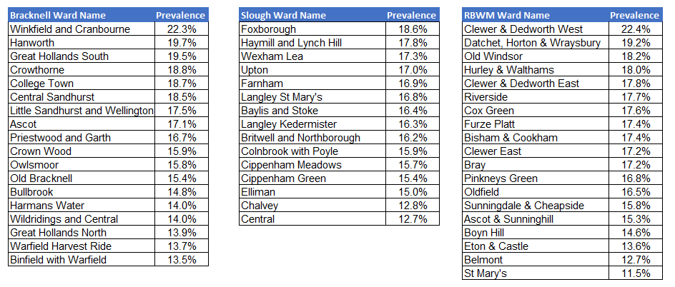
Figure 61: Prevalence of recorded hypertension in adults (18+) by ward (January 2022)

Source: Connected Care - Frimley ICB Analytics Team (Jan 2022)

4 Specific population groups
The HNA Steering Group recognised the importance of looking at specific population groups to see how health behaviours differed compared to the general population. The aim of this analysis was to highlight and quantify inequalities, where possible. Information about these groups are summarised in this section.

4.1 Pregnancy

4.1.1 Obesity
Modifiable risk factors in pregnancy can have health impacts on both mother and child. Mothers who are overweight or obese have increased risk of complications during pregnancy and birth including diabetes, thromboembolism, miscarriage and maternal death. Babies born to obese women have a higher risk of foetal death, stillbirth, congenital abnormality, shoulder dystocia, macrosomia and subsequent obesity. Midwives will ask questions and perform tests to ascertain these risks at the maternity booking appointment and will advise on recommended actions (Office for Health Improvement and Disparities 2022).

The levels of obesity (BMI of 30kg/m² or over) in pregnant women ranged from 15.6% in RBWM to 21.3% in Bracknell Forest in 2018/19. These compare to 22.1% in England.

Nationally, the prevalence of maternal obesity by ethnicity is highest in people from a black ethnic background (32.6%) and lowest in people from an Asian ethnic background (18.5%). White (22.4%) and mixed ethnic groups (23.1%) fall between these.

Obesity is also higher in subsequent pregnancies (24.1%) than in first pregnancies (18.3%) and follows the pattern by deprivation that the most deprived see the highest rates decreasing to the lowest in the least deprived areas.

Figure 62: Percentage of pregnant women who were obese at the time of booking appointment (2018/19)
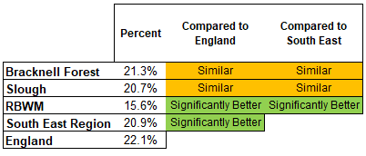
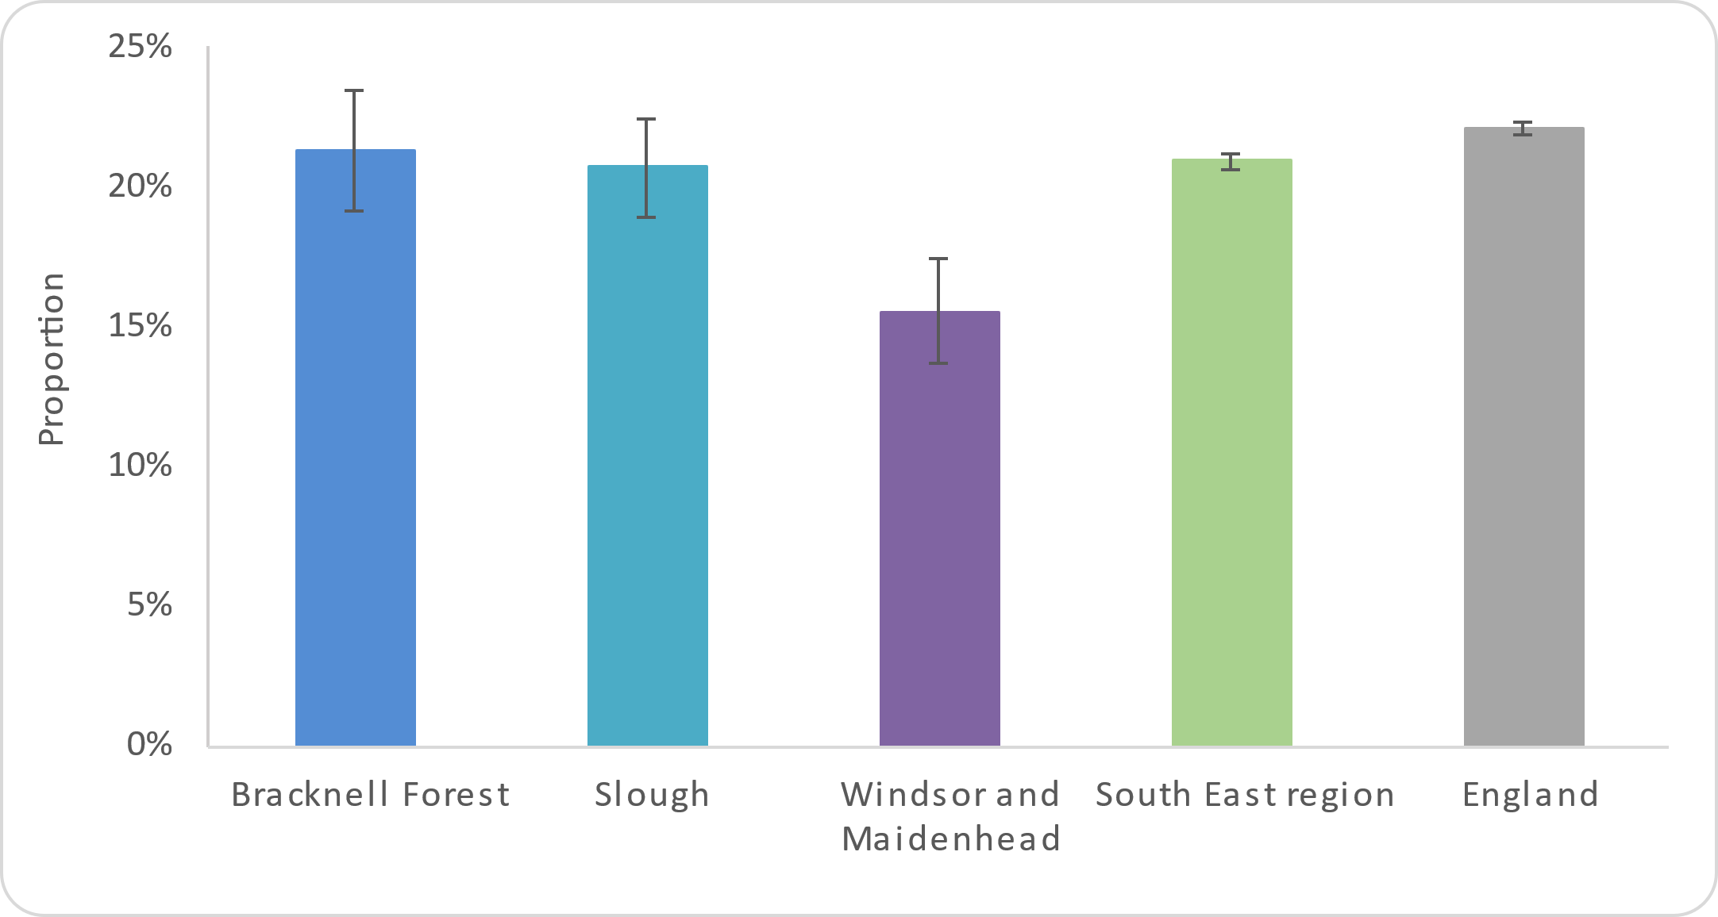

Source: Office for Health Improvement and Disparities (2022); Child and Maternal Health Profile

4.1.2 Smoking
Smoking during pregnancy causes premature births, miscarriage, and perinatal deaths. It also increases the risk of stillbirth, complications in pregnancy, low birthweight, and of the child developing other conditions in later life.

In 2018/19, the smoking prevalence of pregnant women ranged from 6.4% in RBWM to 8.8% in Slough. All Berkshire East local authorities had significantly better smoking prevalence rates compared to the England figure of 12.8% (Office for Health Improvement and Disparities 2022).

Nationally, the prevalence of smoking in pregnant women is highest in people in the most deprived areas. This decreases through deprivation decile to the lowest rate in the least deprived areas. There were also a lower proportion of women who smoked at the time of booking for first pregnancies (9.8%) over subsequent pregnancies (14.5%).

The younger the mother, the more likely they were to be still smoking at time of booking with the age groups under 18, 18 to 19 and 20 to 24 seeing the highest proportions with 31.8%, 31.2% and 22.7% respectively.

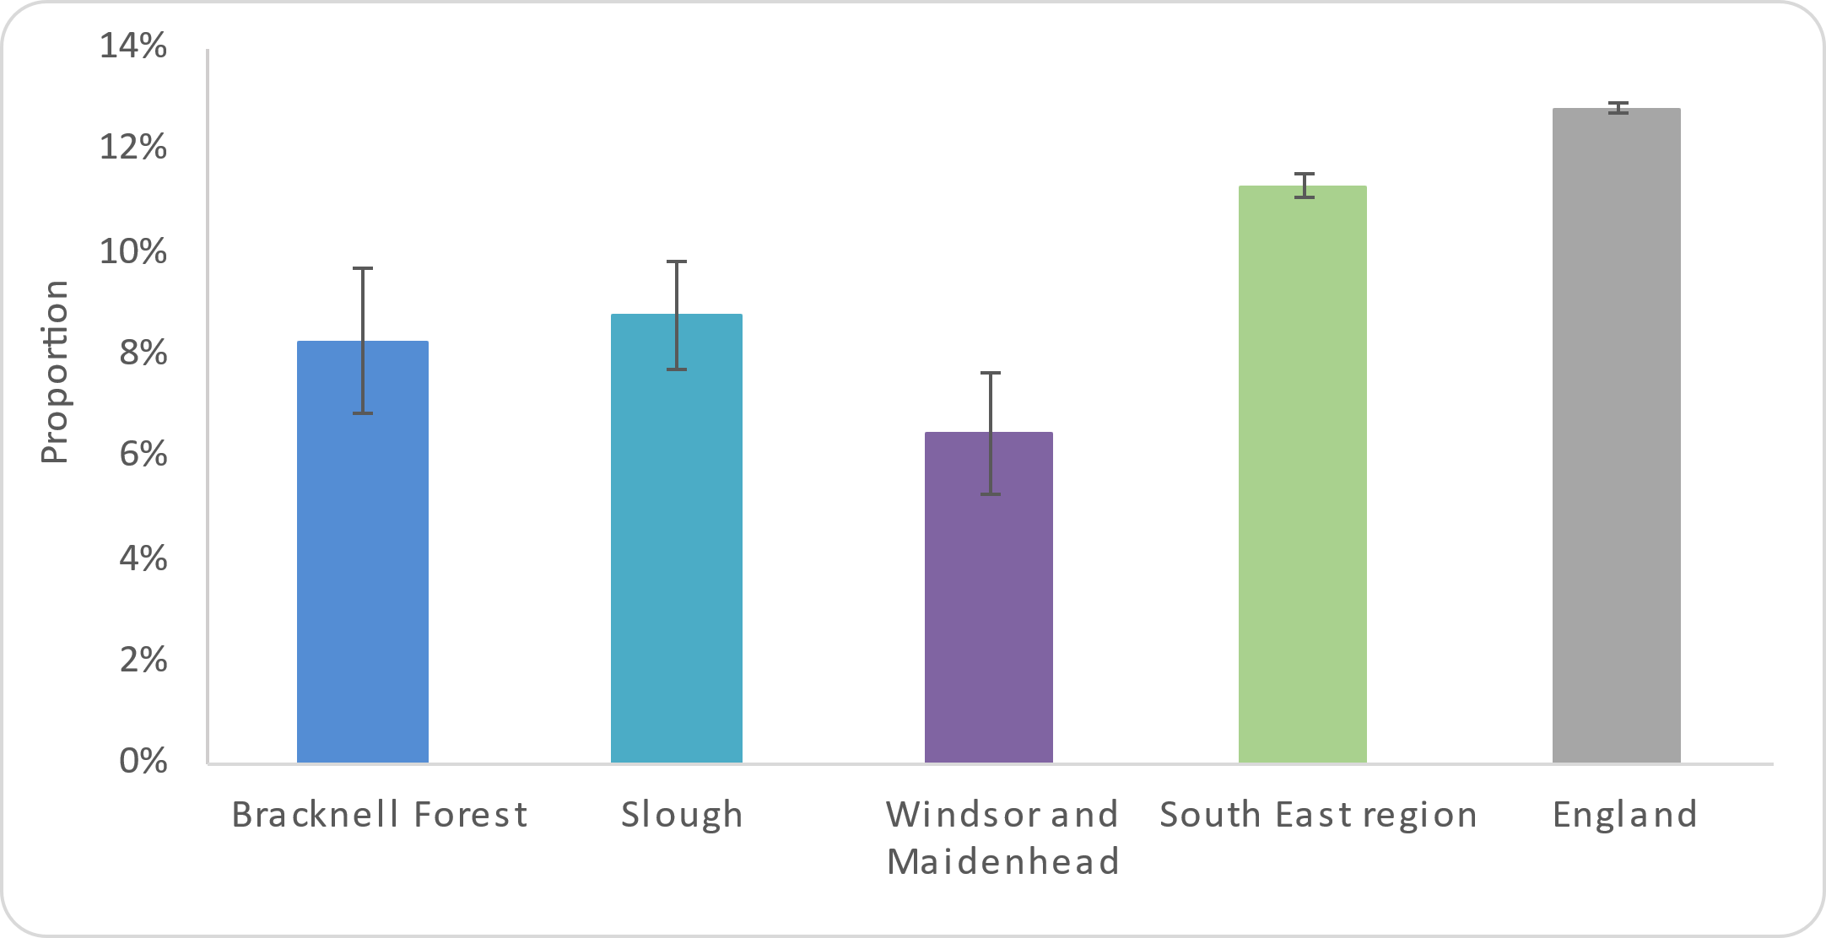
Figure 63: Percentage of pregnant women who smoke at the time of booking appointment (2018/19)
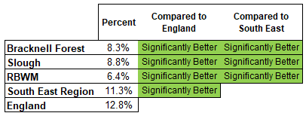

Source: Office for Health Improvement and Disparities (2022); Child and Maternal Health Profile

4.2 People with a disability
People with a disability are defined in many national surveys as those who self-report any physical or mental health conditions or illnesses that have lasted or are expected to last 12 months or more, that have a substantial effect on their ability to carry out normal daily activities (Office for Health Improvement and Disparities 2022).
Approximately 8.5 million people in England recorded limitations in their day to day activities, due to illness and disability during the 2011 census and this made up over 20% of the population aged 16 and over (Office for National Statistics 2013). 9.4% of people aged 16 and over stated that their activities were ‘limited a lot’ and 11.0% stated that they were ‘limited a little’. Figure 64 shows that the proportion of people reporting limitations in Berkshire East’s local authorities was significantly lower than the national prevalence at 15%. This is approximately 55,545 of the current population aged 16 and over.
Figure 64: Proportion of people who reported that they had limitations in their day to day activities due to illness or disability and an estimation of current population affected
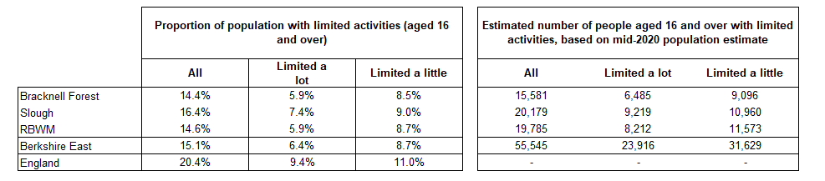

Source: Prevalence estimates from Office for National Statistics (2012); Census 2011 - DC3302EW - Long term health problem or disability by health by sex by age; Population estimates from Office for National Statistics (2021) Mid-year population estimates for 2020

The 2011 census highlights specific groups that are more likely to have limitations, due to illness and disability. These include:
- Older age groups - the prevalence of disability increases with age with fewer than 20% of disabled people born with a disability and over 80% acquiring disability later in life. There is a clear linear link between age and disability with much higher prevalence levels in those aged 65 and over.
- Females have a higher prevalence of illness and disability in all age groups, compared to males.
- People from more deprived areas – there is an association between deprivation and disability, with higher prevalence rates in more deprived areas.

Some of the sources included in this HNA have identified disability as a factor which impacts on people’s health and also their health behaviours. These have highlighted the increased prevalence of obesity and overweight in people who are disabled, as well as lower levels of physical activity and more sedentary behaviour (Sport England 2022). People with a long-term mental health condition are also 2.4 times more likely to smoke than the rest of the adult population (Office for Health Improvement and Disparities 2022).

4.2.1 People with a learning disability
People with a learning disability will have been included in the analysis of data for disabilities as a whole, however there are health and lifestyle factors that specifically impact on those with learning disabilities.

In 2020/21, 0.5% of patients registered with a GP Practice in England were recorded as having a learning disability. 75% of these people had received a Learning Disability Health Check within the year (NHS Digital 2022). The most common conditions identified through these health checks included Attention Deficit and Hyperactivity Disorder (ADHD), autism, epilepsy and conditions that require treatment with prescription of antipsychotics. Additionally, people with learning disabilities are also have increased risk of being overweight or obese.

In Berkshire East, there are 1,507 people with a learning disability recorded on their GP Practice record (June 2022). Figure 65 shows the prevalence of different lifestyle factors in the local population with learning disabilities, compared to those without learning disabilities. This indicates that the learning disabled population has a significantly higher prevalence of obesity and overweight, as well as an increased prevalence of Type 2 diabetes. The only condition that had a lower prevalence in the learning disabled population was hypertension. This can partly be explained by the difference in age profiles between these groups, as the learning disabled population is notably younger.

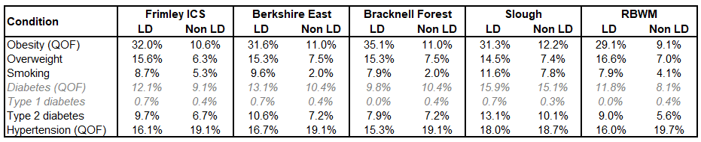
Figure 65: Prevalence of lifestyle factors and conditions for people with learning disabilities, compared to those without learning disabilities in the Frimley ICS population

Source: Connected Care - Frimley ICS Analytics Team (June 2022)
4.3 Carers
The 2011 Census stated that 23,400 people across Berkshire East provided unpaid care for a friend of family member who needs help because of illness, frailty, disability, mental health problem or addiction (Office for National Statistics 2012). Unpaid carers are more than twice as likely to suffer from poor health, compared with people without caring responsibilities. In Berkshire East, 18% of people proving unpaid care reported that their own health was “fair”, “bad” or “very bad”.

A Carers UK (2015) survey showed that people who provide unpaid care have considerably lower health and wellbeing scores when compared to the general population. 84% of the carers surveys nationally said that their caring responsibilities impacted on their health and 64% attributed health risks to lack of support. Carers UK (2015) also identifies that carers may not be aware of who and where to get health and wellbeing support from.

A report on physical activity among carers aged 55 and over showed that carers were less active than people without caring responsibilities (14% of carers were active compared with 54% of all adults), with 76% of carers acknowledging that they do less physical activity than they would like to (Carers UK 2021). Survey respondents list lack of time (88%), not being motivated (71%), financial restrictions (67%), and not having anyone to go with (59%) as key barriers to physical activity.

Insight from these data may be applicable for developing interventions relevant for a Berkshire East population, however, there are no apparent data specifically related to the population.

4.4 Asylum seekers / refugees
People seeking asylum in the UK are not a homogenous group and their health needs are likely to be diverse. The British Medical Association (2022) notes that there are common challenges for refugees and asylum seekers including untreated communicable disease, poorly controlled chronic conditions, maternity care and mental health or specialist support needs.

Detailed information about the health of asylum seeks and refugees is not held nationally or locally and can therefore not be included in this report. There is ongoing academic research regarding health seeking behaviour in asylum seeker populations, such as structural barriers to healthcare access, maternity care, physical activity, or mental health care perception, and the findings from this research will help to identify specific health needs in time.

5 The Impact COVID-19 has had on Healthy Behaviours
The majority of data sources and literature used for this HNA have focussed on time periods prior to the Covid-19 pandemic. This section provides a summary of the data and evidence available that highlight how health behaviours may have changed during and after the pandemic restrictions. The Office for Health Improvement and Disparities will continue to publish more information, as they become available, on the Wider Impacts of Covid-19 on Health Profile, Wider Impacts of Covid-19 on Health monitoring tool (WICH) and the Covid-19 Health Inequalities Monitoring for England tool (CHIME).

5.1 Healthy Eating
There are minimal high-quality studies into the impact of the COVID-19 pandemic on people’s eating behaviours nationally and these do not include data at a local authority. There has been some evidence through literature that the limitations on social mixing and national closures of hospitality venues, such as restaurants and cafes, increased the number of people cooking their own meals. In a national YouGov (2022) survey, 24% of people said that the quality of their diet had improved and approximately 73% of respondents claimed to have enjoyed cooking in a year-long period between 2020 and 2021. 91% wanted to cook as much or more than during the lockdown periods. Increased cooking has been linked with healthier food choices being made.

In a survey commissioned by the Food Safety Authority (2022), all measures of food insecurity were seen to increase nationally from May 2020 to October 2021. This included the proportion of people skipping or reducing the size of their meals because of income insecurity, as well as more people using food banks. Larger households (with 4+ residents), younger households (aged 16 to 24) and those with a child present were more likely to be food insecure. Food insecurity influences eating habits and also the levels of nutrition that people consume. In a survey completed by the Office for National Statistics (2021), 34% of respondents said that they were ordering takeaway food more regularly, as opposed to their activity pre-pandemic. This was highest in the 16 to 29 age group at 51%. 13% of people said that they would continue to order takeaway food more regularly once the pandemic had ended. Males and those living in single households were less likely to eat healthy meals and 16 to 44 year olds, those living with a child and larger households were more likely to eat processed snacks.

5.2 Physical Activity
Gyms, sports clubs and programmes to increase physical activity were restricted during the national lockdowns and this is likely to have influenced how and whether people engaged in physical activity. Data shows that during 1st lockdown (23rd March to 4th July 2020) there was an overall 4% increase in the proportion of people who were physically active nationally. However, this was not sustained and returned to pre-pandemic levels in March 2021. This pattern was generally seen across all sex, age, disability, ethnicity and occupation groups. The only groups that did not follow this trend were those aged 85 and over, which slightly decreased physical activity levels during lockdown 1, and people who were long-term sick or disabled (Office for Health Improvement and Disparities 2022).

These data are not available at a Berkshire East or local authority level, however it can be assumed that similar trends occurred locally.

5.3 Smoking
A number of national surveys have been completed to quantify the impact of the COVID-19 pandemic on smoking prevalence rates, however there is no data available at a Berkshire East level. The Opinion and Lifestyle Survey and YouGov surveys have both monitored smoking prevalence at different stages of the pandemic and do not show any significant changes in peoples’ reported smoking habits overall (Office for Health Improvement and Disparities 2022). Approximately 47% of smokers stated that the number of cigarettes they smoked was the same as pre-pandemic levels, while slightly more smokers said that their usage had increased compared to those who said they had reduced the number of cigarettes.

The national Annual Population Survey had to change the methodology for collecting this information during the pandemic restrictions and this means that estimated prevalence rates for 2020 cannot be directly compared with previous years (Office for Health Improvement and Disparities 2022).

5.4 Alcohol
There are no data specifically monitoring alcohol consumption across Berkshire East during the pandemic. Nationally, duty-paid wine and spirits consumption increased by 9% and 7% respectively in 2020/21, when compared with 2019/20. Meanwhile, cider and beer decreased by 17% and 14% respectively for the same time period. This may be attributable to beer and cider more commonly being bought in trade settings, such as pubs and restaurants, which were impacted by restrictions on social mixing (Public Health England 2021). In a Public Health England (2021) survey, 59% of respondents reported drinking more alcohol between March 2020 and March 2021.

There were 3% fewer unplanned hospital admissions for alcohol-specific conditions during the pandemic, when compared to 2019. There was also a rapid decrease in alcohol-related conditions from February 2020. The trend in decreased alcohol-related admissions coincided with reductions in hospital admissions generally. However, in 2020 there was a 20% increase in alcohol specific deaths and an 11% increase in deaths from mental and behavioural disorders due to alcohol (Public Health England 2021). The true impact of increased alcohol consumption is likely to take many years to be seen in longer-term alcohol-related conditions.

