Findings from the Healthy Behaviours Surveys
07.06.22 – 19.07.22
Full report

INTRODUCTION
Between 07 June and 19 July 2022 Slough Borough Council conducted a survey to gain information to inform a Healthy Behaviours Health Needs Analysis. The aim was to ascertain the type of support residents need with improving their health.
The survey focused on asking about support needed in relation to four key behaviours that are recognised to have the greatest impact on health:
- Smoking
- Drinking alcohol
- Diet
- Physical activity
The survey sought views from Slough residents and from professionals working in health and other frontline services.

SURVEY METHODOLOGY AND NUMBER OF RESPONSES
The survey questions were developed by a Healthy Behaviours steering group comprising of colleagues from Public Health, Communications, Community Engagement, and Primary Care, across East Berkshire. Additionally, advice on the design of the survey was received from Dr Margaret Glogowska, Senior Researcher in the Nuffield Department of Primary Health Care Sciences at University of Oxford.
The survey was produced in two versions; a survey for the public and a survey for professionals. Both surveys were launched digitally on Survey Monkey (E.g survey monkey or engagement site)
The surveys were widely promoted to stakeholders through different communication channels, including:
- SBC Social Media channels (Twitter, Facebook, etc.)
- The SBC Members’ newsletter
- The GP newsletter
- Adult Social Care
- Children’s First
- Directly to commissioned services
- With our Voluntary Sector organisation
In total 133 survey responses were received from:
- Residents: 114 responses (86%).
- Professionals: 19 responses (14%).

Of the 19 responses from Professionals, these were received from:
- Social workers – 4 (21%)
- Allied Health Professional – 3 (16%)
- Care co-ordinator – 1 (5%)
- Public health professional – 2 (11%)
*9 (47%) Skipped the question
FINDINGS FROM PUBLIC SURVEY
Who responded?
Location
Responses were received from residents living across a variety of wards in Slough. A handful of responses were received from residents outside of Slough.

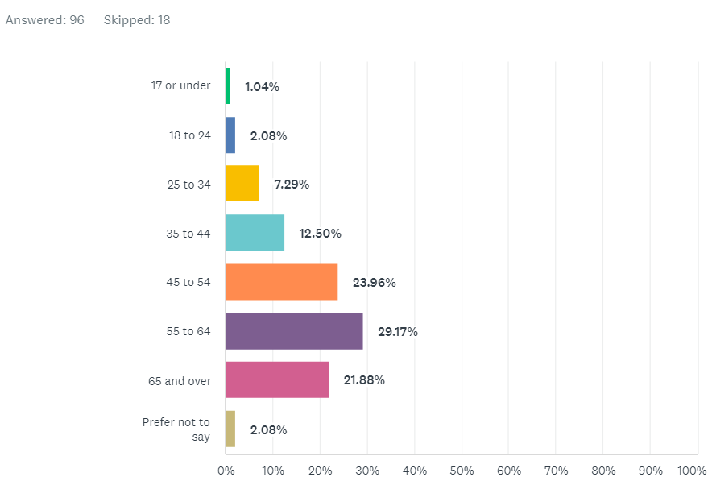
Age

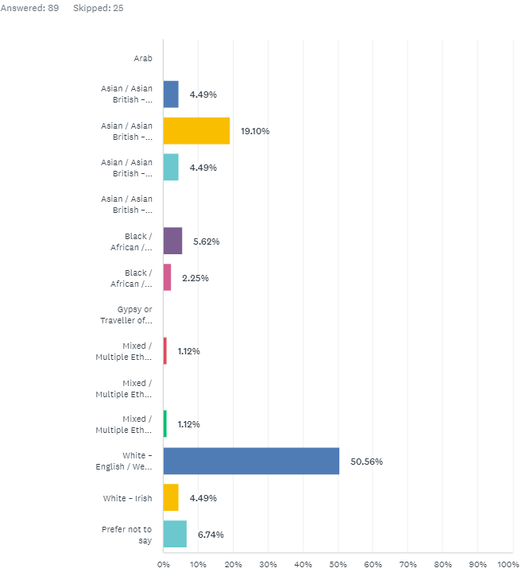
Ethnicity

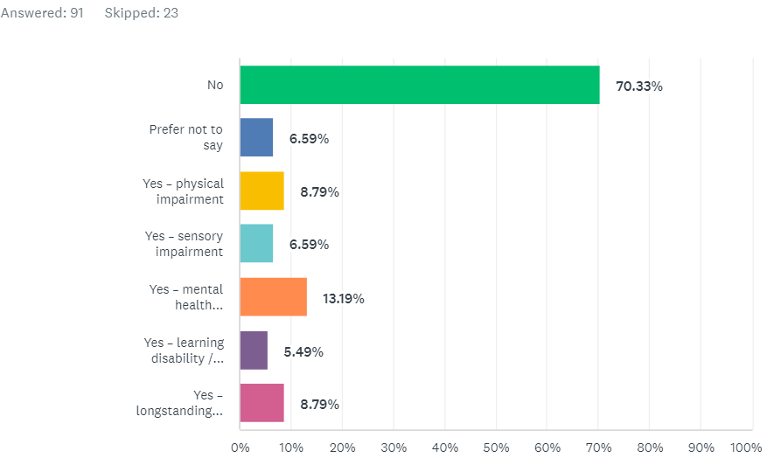
Impairment or Disability?

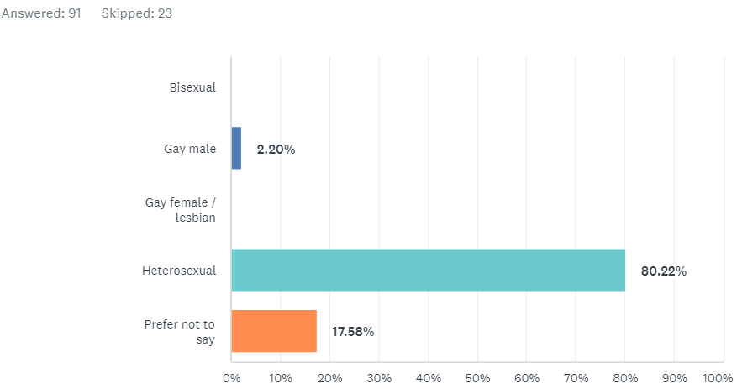
Sexual Orientation & Gender
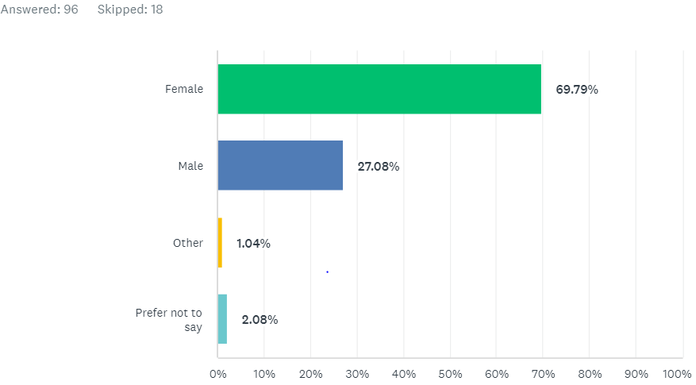
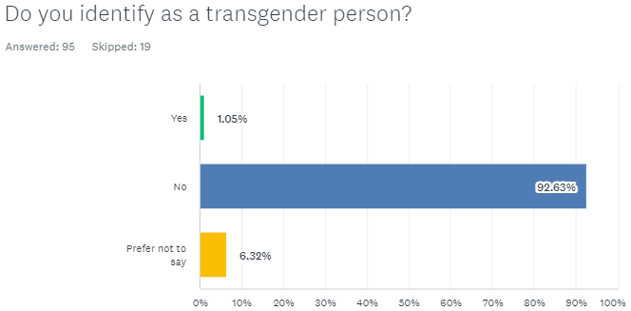

Employment and Economic Status
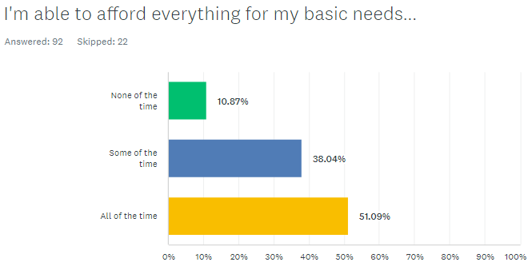
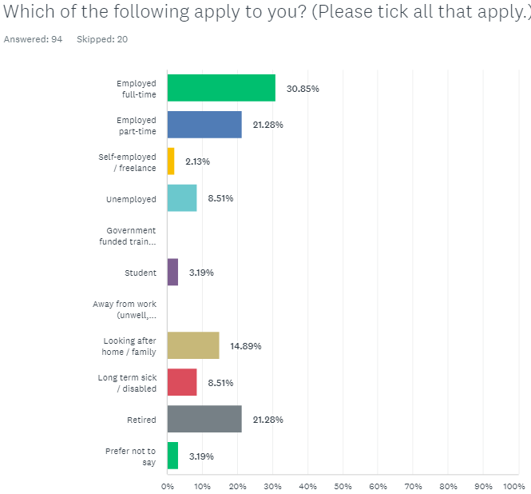

Dependents
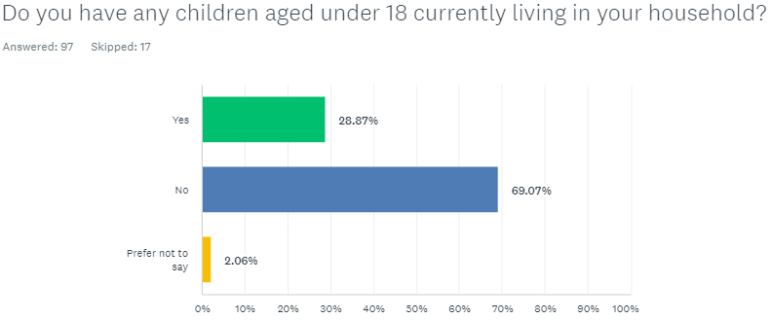
What did responses (114 No.) to the Public Survey tell us?
Healthy Behaviours (Q1-4)
- 12.5% (14) respondents reported they were currently smokers (112 responses, 2 skipped) – 1 free-text comment “Vape”
- 5.7% (6) respondents reported concerns about how much alcohol they drink (112 responses, 2 skipped) -
- 67.3% (74) respondents reported concerns about their weight (112 responses, 2 skipped).
- 65.8% (73) respondents reported concerns about their activity levels (112 responses, 2 skipped). – 8 free-text comments “Slimming World”; “Self”; “Absolutely Fitness”; “I go to my gym and joined classes. I walk 10000 steps every day”

When asked if they were looking to make healthy changes (Q5):
- 84 (77.8%) respondents wanted to get active.
- 13 (16.3%) respondents wanted to quit smoking
- 13 (15.7%) respondents wanted to drink less alcohol
- 82 (77.4%) respondents wanted to lose weight
*113 responses, 1 skipped this question.

Current services
When asked if they had used any of our current services (Q6):
- 77.14% (81) respondents stated they had used none of the above services
- 7.62% (8) respondents stated they had used the Shapeup4life app
- 7.62% (8) respondents stated they had used the 12 week weight management service
- 5.71% (6) respondents stated they had used Health and Wellbeing Slough – Stop Smoking
- 0.95% (1) respondents stated they had used the Slough Treatment, Advice & Recovery Team (START) / Turning Point (support service for drug and alcohol use)
- 10.48% (11) respondents stated they got support via their GP practice
* Answered: 105 Skipped: 9

When respondents were asked how helpful they found the services they had used (Q7):
Service | NOT HELPFUL– | SOMEWHAT HELPFUL– | VERY HELPFUL– | N/A– | TOTAL–
–  Shapeup4life app | 3.37%  3 | 6.74%  6 | 3.37%  3 | 86.52%  77 | 89
–  12 week weight management service | 3.45%  3 | 1.15%  1 | 3.45%  3 | 91.95%  80 | 87
–  Health and Wellbeing Slough – Stop Smoking | 6.74%  6 | 0.00%  0 | 2.25%  2 | 91.01%  81 | 89
–  Slough Treatment, Advice & Recovery Team (START) / Turning Point | 1.12%  1 | 0.00%  0 | 2.25%  2 | 96.63%  86 | 89
–  Support through your GP practice | 8.89%  8 | 5.56%  5 | 3.33%  3 | 82.22%  74 | 90

Future services
When respondents were asked how they would like to access services in the future (Q8):
SERVICE ACCESS | RESPONSES
–  Separate services for smoking, alcohol, diet and exercise. | 31.25%  30
–  A single service that offers support for smoking, alcohol, diet and exercise together. | 11.46%  11
–  I don't mind either way. | 57.29%  55
TOTAL | 96

When asked how respondents would prefer to receive support (Q9):
ANSWER CHOICES– | RESPONSES–
–  In person | 61.54%  64
–  By telephone | 12.50%  13
–  Online via Apps or a website. | 45.19%  47
–  I don’t mind | 17.31%  18
Total Respondents: 104

Comments alongside ‘Other’ responses included:

Theme | Sub theme | Example comment
Mental health | Children’s MH | “Lots of kids I think need mental health therapy as well as mentoring programs”
 | MH Support | “It's difficult to get a GP appt. There is no mental health support for generalised anxiety.”
 | MH Support | “It is very important that this support also includes mental support because it's a very important part to reach success.”
Access to healthcare | GP Services | “Improving access to doctors when you need them”
 | GP Services | “It's difficult to get a GP appt. There is no mental health support for generalised anxiety.”
Leisure and physical activity access | Availability | “More classes are needed for people to be able to access. Willing to pay a reasonable amount for them
 | Carers | “Unfortunately as a full-time carer for my husband it's very difficult to attend activities I would like or need to due to lack of spare time.”
 | Information | “Its difficult to access the services as nobody tells you about them”
 | Carers | “Would be great if carers that also go to work could get a discount at local gyms. The only ones who currently get discounts are those claiming benefits.”
 | Information | “Never heard of any of these services”
 | Prices | “would like more offers at the council leisure centre to become a member”
 | Information | “I didn’t know about any of these services, would be nice to know more”
 | Information and support services | “I am new in UK, I want to have support to strength my muscles and reshape my body without stressing on my knees because of hyper mobility and arthritis, fibromyalgia as well .”
 | Outdoor equipment | “I really like the Outdoor Gym Equipment available in Slough parks and recreational fields. Would like to see a wider range of equipment so people can use it more”
General | Council | “No support from the council. Bunch of looters”
 | Fitness classes | “Like to have classes in person”
 | Health | “I do have also a hip condition which I'm about to have my 4th surgery so I believe it could help having exercise classes that are not great at running etc.”
Healthy choices support | Additional cessation support | “I really need help to quit smoking, I've tried everything but am really struggling”

FINDINGS FROM PROFESSIONALS’ SURVEY
Who responded?
Of the 19 responses from Professionals, these were received from:
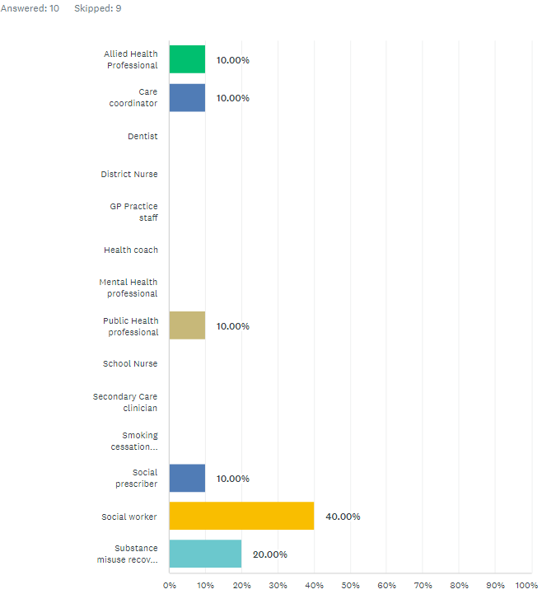
‘Other’ responses were:
- “Unemployed”
- “Carer”
- “Public Health”
- “Older persons Group leader”
- “Health Visitor”
- “Social Care”
- “Transport Planner - saw nothing at start of the questionnaire that specified professional in health care etc. I am a professional but not in the field you want”
What did responses (No. 19) to the Professionals’ Survey tell us?
When asked to select which SBC support services professionals currently refer or signpost people to (Q1), responses showed:

SERVICE | RESPONSES
SBC | 42.11%  8
–  Shapeup4life app | 5.26%  1
–  12 week weight management service | 10.53%  2
–  Health & Wellbeing Slough - Stop Smoking | 15.79%  3
–  Slough Treatment, Advice & Recovery Team (START) / Turning Point (support service for drug and alcohol use) | 36.84%  7
–  Support through your GP practice | 42.11%  8
Total Respondents: 19

‘Other’ responses to Q1 were:

- “Mental Health Team”
- “Public Health Professional”
- “Number 22 counselling service, CMHT, CRISIS, anxiety helpline, Hestia, Adult safeguarding, Social services”

When asked how helpful professionals think the public find the SBC support services listed (Q3), responses showed:
– | VERY HELPFUL | AVERAGE/ SOMEWHAT HELPFUL | NOT HELPFUL– | NOT SURE/UNABLE TO SAY | TOTAL–
–  Shapeup4life app | 5.88%  1 | 17.65%  3 | 5.88%  1 | 70.59%  12 | 17
–  12 week weight management service | 11.76%  2 | 29.41%  5 | 5.88%  1 | 52.94%  9 | 17
–  Health and Wellbeing Slough – Stop Smoking | 5.88%  1 | 29.41%  5 | 5.88%  1 | 58.82%  10 | 17
–  Slough Treatment, Advice & Recovery Team (START) / Turning Point (support service for drug and alcohol use) | 23.53%  4 | 47.06%  8 | 5.88%  1 | 23.53%  4 | 17
–  Support through GP practice | 0.00%  0 | 55.56%  10 | 22.22%  4 | 22.22%  4 | 18
–  Others (as stated in Q2) | 14.29%  2 | 21.43%  3 | 7.14%  1 | 57.14%  8 | 14

‘Other’ responses to Q3 were:
- “Depends on the commitment made by those providing the service”
- “There are more services that should be stated here to get a more in depth understanding of the health services most used”

When asked which other support services professionals routinely refer to signpost people to for support with losing weight, getting active, quitting smoking or drinking less (Q2), responses included:
- “Everyone Active sports activities suitable for older age.”
- “Yes to Solutions for Health but they are so crap and just copy other services which means repetitive”
- “n/a”
- “see above”
- “Quit smoking and weight loss.”
- “No”
- “Active Slough, Slough Exercise Referral Scheme, Quit with Bella app”

When professionals were asked about the design of health improvement support services in the future (Q4):
ANSWER CHOICES– | RESPONSES–
Separate services for smoking, alcohol, diet and exercise | 16.67%  3
A single service that offers support for smoking, alcohol, diet and exercise together | 55.56%  10
I don’t have a strong opinion | 27.78%  5
TOTAL | 18

When professionals were asked how they thought support should be made available in the future (Q5):
ANSWER CHOICES– | RESPONSES–
–  In person | 94.44%  17
–  By telephone | 61.11%  11
–  Online via Apps or a website. | 55.56%  10
–  No strong preference | 5.56%  1

When professionals were asked to give their views on the reasons people don’t benefit from support services (Q6):
ANSWER CHOICES– | RESPONSES–
–  Not enough time | 58.82%  10
–  Location of services | 64.71%  11
–  Not engaged | 41.18%  7
–  Existing service isn’t right for them | 52.94%  9
–  They’re not yet ready to change | 76.47%  13
–  They’re struggling to maintain change | 64.71%  11

‘Other’ responses to Q1 were:

- “I haven't referred anyone because I've not been aware of services available except through my GP”
- “Follow-up is also an important part of a service. Non-engaged clients could be for various commitment issues, but we need to keep trying with clients.”
- “Timing of services”
- “Transport”

Professionals were asked: ‘Of the groups/communities you work with – not currently engaged with support services – who could benefit most with health help to lose weight, get active, quit smoking, or drink less? (Q7). Responses are summarised here:

- All residents
- Young people
- Retired/not economically active
- Lower income residents
- Marginalised groups

Professionals were asked whether overall they thought the right support services were in place to help people make healthy behaviour changes (Q8).

ANSWER CHOICES– | RESPONSES–
–  Yes | 22.22%  4
–  No | 77.78%  14
TOTAL | 18

Professionals were asked to give their views on what else they thought was needed if they had answered No to the previous question. Responses to Q9 are summarised here by theme:

Theme | Comment
Information/comms | “It may be more the marketing. So much and not easily known what is available, what the criteria is and how to get referred. For families who have the red book a flyer to have a list of what is available and for whom and how to access the group”
Accessibility | “Need to have hubs in different locations around Slough where people can access both am and pm activity and weekends plus Slough Community Transport Team should offer free bus for people to access these”
 | “Services need to be easily accessible”
Service design | “Services need to be tailored to the individuals needs and the length of time needed for changes to behaviour shorten or lengthened depends on 'need”
 | “No/Yes - There is room for improvement on the way services are delivered, managed, monitoring of services. Services must be better contracted from the start to ensure they are providing evidence based models and service specifications should not be tailored to the capacity/ability of the providers”
 | “I think that, rather than just focusing on changing behaviours there needs to be more education around answering the question - why should I change my behaviours.”
Pressure on services | “More time to consult with people”
 | “More of it. The services are there but there is such pressure on all services that it is too easy for people to slip through the net”
Younger residents | “I think that services for young people to be active and healthy and that are inclusive for all should be available”
 | “Smoking/ alcohol service for younger residents”
Service Quality | “Better substance misuse support and more supportive loss of weight services”

Professionals were asked if they had any other comments to add (Q10). Findings showed:

Theme | Comment
Service design | “We need to keep in mind the needs of the Slough residents when providing services. How can residents co-design services?”
N/A | No (x6)
Accessibility | “As above More provision at more convenient times/ days etc. The services are there but there is such pressure on all services that it is too easy for people to slip through the net”
 | “Some people would need support to attend. If we referred having a place to say they would benefit from a call before the group and identified person to meet them at their first session for support.”

CONCLUSIONS FROM THE PUBLIC AND PROFESSIONALS’ SURVEYS

Representation

There was a reasonable number of responses to the public survey in Slough. Responses tended to come from older members of the community when compared to the age profile of residents; with most responses coming from those in the 55-64 cohort whereas the largest age cohort in Slough residents is 30-44. In terms of the ethnicity of respondents the Asian/Asian British cohort in particular is underrepresented compared to Slough as a whole. There was also a disparity with regards to the proportion of female responses – with 70% of those completing the survey identifying as female in comparison to 51% of the population of Slough as a whole.

Employment and economic status representation amongst respondents was again skewed towards those who are not economically active with 54% of respondents reporting being either fully employed, part time employed or self-employed as opposed to 82% of Slough residents generally.However, the number of Slough residents reporting fuel poverty in 2018 (9%) roughly correlates with the 10% of survey responses reporting an inability to afford to cover basic needs.

A significant number of respondents also reported having a disability – this tallies with data from the Slough population generally. However, it is difficult to compare like for like data.

The number of responses to the professionals’ survey was low overall, meaning that findings could not be assumed to represent the views of a wide cohort of Slough professionals working in frontline services. Despite this, a range of professional groups responded, and the findings provided valuable insight into the ways in which health improvement support could best be provided.

Support with health improvement

It’s clear from responses to the survey that Slough residents are keen on making changes to their lifestyle to improve their health. 77% of respondents stated that they were interested in getting active and losing weight. A lesser proportion wanted to give up smoking or drink less alcohol, with just 16% and 15% of respondents agreeing respectively.

Despite the number of respondents to the survey that reported wanting to make healthy lifestyle changes, 77% of respondents stated that they had never used any of SBCs support services – the answers to ‘Is there anything else you would like to say?’ would appear to indicate that a lack of information regarding what is available is amongst the causes of this. These findings indicate that there is an opportunity to improve knowledge, and uptake, of effective health improvement services offered by SBC.

Professionals that responded to the survey showed that they were aware of a significant proportion of the services offered by SBC, however there were reservations regarding the quality/viability of these – 77% of professional respondents stated that they did not think SBC has the right support services in place to support healthy lifestyle changes for its residents. This is echoed by the fact that the majority of respondents felt that the current suite of services are only averagely/somewhat helpful for residents.

Barriers to health improvement

The public survey highlighted a number of barriers that residents felt were inhibiting their ability to access services to support them make healthy choices. These included:

- Lack of classes
- Poor promotion of available services resulting in lack of knowledge of offering
- Other duties such as caring for family members
- Cost
- Lack of council support
- Inability to attend mainstream classes due to medical conditions

The professional survey indicated that the majority of respondents do not think the right support services are in place at present. In addition to this, a majority of respondents thought that lack of time; location of services being inaccessible and existing services not being the right fit all contribute to the barriers residents face. However 76% and 65% of respondents thought that residents were ‘Not ready to change’ or ‘Struggling to maintain change’ respectively. This suggests that education and communication campaigns need to be strengthened alongside core services such as exercise classes.

Future services

In terms of the shape of future services and the optimum route for the delivery of these, the public and professional survey revealed a split of opinion. 56% of professionals felt that the most appropriate way of delivering these services would be via a single service model, whereas the public felt that individual services are preferable (31% vs. 11%).

Taken together, these findings do not clearly point to a preferred option for integrated versus individual support services. However, the numbers of respondents to the public survey looking for support with losing weight and getting active indicates that many respondents selected both of these answers. As such, future services for weight management should include dedicated support for exercise and movement.

Data from the professional survey regarding method of delivery of services showed that almost 95% were in favour of the availability of in-person appointments, however a majority also thought that telephone and online services were valuable tools, demonstrating the belief that a range of entry points to services is preferable. The public survey’s results were slightly more mixed, however, with only 13% of residents that responded stating that services should be telephone based; perhaps suggesting poor experiences with this method of delivery in the past.

SUMMARY OF RECOMMENDATIONS

Based on the conclusions drawn from the public and professionals’ surveys, this report makes the following recommendations:

- Knowledge of services offered amongst the Slough population needs to be improved – an enhanced communications and promotion strategy would increase utilisation and therefore healthy lifestyle changes
- More tailored classes for disabled and marginalised groups to ensure appropriate services are available for everyone making healthy lifestyle changes
- Mental health support should be an integral element of services
- Services need to be accessible via a range of routes, including both in person and online to maximise uptake
- Where potential digital exclusion exists (e.g. within older population) support needs to be offered in order to allow these residents to best utilise the resources on offer
- More dialogue with gyms/service providers required to best target pricing discounts where they are needed; particularly in light on the ongoing cost of living crisis and the potential impact this will have on resident’s ability to make healthy behavioural choices
- Improved service design and specification to strengthen the offering to Slough’s residents is required
- Contract management for SBC health and wellbeing services needs to ensure that KPIs and service innovation targets are consistently being met or exceeded – preventing stagnation of delivery

APPENDICES

Full list of responses to Q10 from residents

Theme | Sub theme | Resident Comment
Mental Health | Children’s | Lots of kids I think need mental health therapy as well as mentoring programs
N/A | N/A | no
N/A | N/A | Mo
N/A | N/A | No
N/A | N/A | No
N/A | N/A | No
N/A | N/A | No
Access to healthcare | GPs | Improving access to doctors when you need them
N/A | N/A | None
Access to healthcare |  | It's difficult to get a GP appt. There is no mental health support for generalised anxiety.
N/A | N/A | I am only slightly worried.
Leisure and physical activity access |  | More classes are needed for people to be able to access. Willing to pay a reasonable amount for them
Access to healthcare |  | The GP was no good at all - unsympathetic and rude
Leisure and physical activity access | Information | It’s difficult to access the services as nobody tells you about them.
Leisure and physical activity access |  | Unfortunately as a full-time carer for my husband it's very difficult to attend activities I would like or need to due to lack of spare time.
N/A | N/A | Mo
Leisure and physical activity access | Format | Like to have classes in person
N/A | N/A | No
N/A | N/A | No support from council. Bunch of looters.
Access to healthcare | Services | I really need help to quit smoking, I've tried everything but am really struggling
N/A | N/A | No thanks
Leisure and physical activity access | Cost | Would be great if carers that also go to work could get a discount at local gyms. The only ones who currently get discounts are those claiming benefits.
Leisure and physical activity access | Information | Never heard of any of these services
Leisure and physical activity access | Cost | Would like more offers at the Council Leisure Centre to become a member
Access to healthcare | Services | It is very important that this support also includes mental support because it's a very important part to reach success.
Leisure and physical activity access | Information | I didn't know about any of these services, would be nice to know more
N/A | N/A | No
Leisure and physical activity access | Information | I am new in UK, I want to have support to strength my muscles and reshape my body without stressing on my knees because of hyper mobility and arthritis, fibromyalgia as well .
Leisure and physical activity access | Equipment available | I really like the Outdoor Gym Equipment available in Slough parks and recreational fields. Would like to see a wider range of equipment so people can use it more.
Leisure and physical activity access | Appropriate classes for all levels | I do also have a hip condition which I'm about to have my 4th surgery so I believe it could help having exercise classes that are not great at running etc
N/A | N/A | no

Bershire Observatory: Slough, https://slough.berkshireobservatory.co.uk/population/#/view-report/63aeddf1d7fc44b8b4dffcd868e84eac/___iaFirstFeature/G3
Ibid
Ibid
Ibid

