Findings from the RBWM Healthy Behaviours Surveys
19 April – 31 May 2022
Full report

INTRODUCTION
Between 19 April and 31 May 2022 RBWM conducted a survey to gain information to inform a Healthy Behaviours Health Needs Analysis and to support the development of a Healthy Behaviours Strategy. The aim was to ascertain the type of support residents need with improving their health.
The survey focused on asking about support needed in relation to four key behaviours that are recognised to have the greatest effect on health:
- Smoking
- Drinking alcohol
- Diet
- Physical activity
The survey sought views from residents and from professionals working in health and other frontline services.

SURVEY METHODOLOGY AND NUMBER OF RESPONSES
The survey questions were developed by a Healthy Behaviours working group comprising colleagues working in Public Health, Communications, Community Engagement, and Primary Care, across East Berkshire. Additionally, advice on the design of the survey was received from Dr Margaret Glogowska, Senior Researcher in the Nuffield Department of Primary Health Care Sciences at University of Oxford.
The survey was produced in two versions; a survey for the public and a survey for professionals. Both surveys were launched digitally on the RBWM Together community engagement portal.
The surveys were widely promoted to stakeholders through different communication channels, including:
- RBWM Social Media channels (Twitter, Facebook, Next Door app).
- The RBWM Members’ newsletter.
- The GP newsletter
Additionally, stakeholders in attendance at local meetings and forums were given information and encouraged to complete the surveys.
In total 340 survey responses were received from:
- Residents: 327 responses (96%).
- Professionals: 13 responses (4%).

FINDINGS FROM PUBLIC SURVEY
Who responded?
Responses were received from residents living across different wards in RBWM. A small number of responses were received from people who stated a home postcode outside of RBWM.
Location
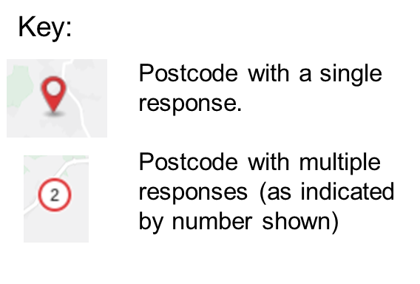
What is your home postcode?
*319 responses, 17 skipped.
(produced using: https://maps.espatial.com/esWebApp/pages/map.jsp?geoMapId=1182076).
Age
Responses were received in greater numbers from residents of an older age. 42% responses were from residents aged 65 years and over; 22% responses were from residents aged 55 to 64 years; 18% were from residents aged 45 to 54 years and 12% were from residents aged 35 to 44 years. Only 4% responses were from residents aged 34 years or younger.
Of all adults in RBWM, the highest proportion are in the 35 – 59 years age group. Therefore, to some extent, the results of this survey reflected the age structure of the population¹. However, the proportion of responses from residents 65 years and over were disproportionately high and those from residents aged 18 to 34 were disproportionately low, relative to the total population in these age groups¹.

Ethnicity
In general responses were representative of the ethnic groups within the RBWM population, with the exception of a lower response rate from people from an Asian/Asian British background¹.*
- Responses were predominantly received from residents of white British ethnicity (80%). This is representative of the total RBWM population, of whom 86% are white British¹.
- 10% responses were from residents with a white Other ethnicity. This is broadly representative of the total RBWM population, of whom approximately 8.6% describe their ethnicity as white Other¹.
- Certain Asian/Asian British ethnic groups were underrepresented compared to the local demographic: 2% responses were from Asian/Asian British – Indian residents, lower than the estimated 4.1% residents from this ethnic background living in RBWM; and 0% (n=1) Asian/Asian British – Pakistani residents responded, lower than the estimated 2.9% residents from this ethnic background living in RBWM¹.
- 1% residents from an Asian/Asian British – Chinese ethnicity responded which reflects the local population estimate of 0.7% residents from this ethnic background¹.
- 1% residents from a Black/ African / Caribbean / Black British – Caribbean ethnic background responded which again is broadly representative of the local population estimate of 1.2% from this ethnic background¹.
*Total population estimates are based on data from the 2011 Census and may not reflect the current proportion of RBWM residents from each ethnic background¹.

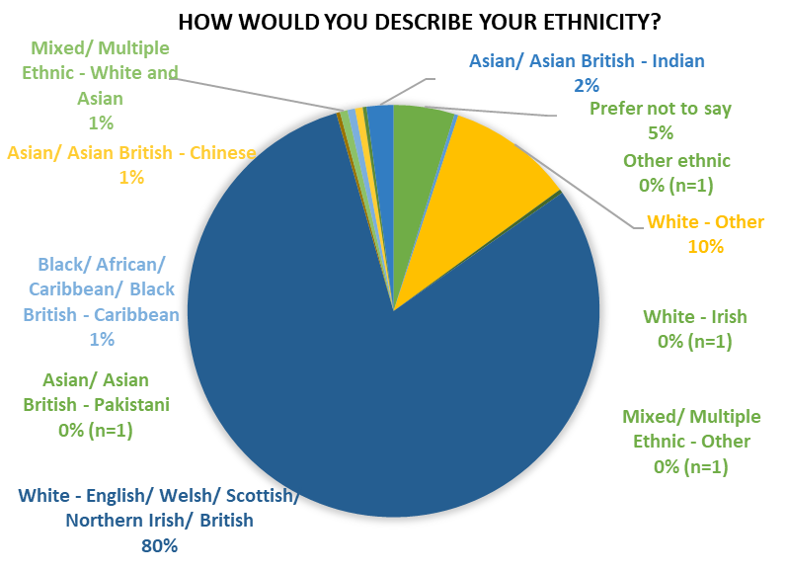

Employment and economic status
In answer to the question ‘I am able to afford everything to meet my basic needs and those of my family,’ a high proportion of residents selected the response ‘all of the time’ (78%).
20% respondents selected the response ‘some of the time’ and 2% respondents selected ‘none of the time.’
Although RBWM is generally an affluent borough, there are known to be a proportion of residents living in relative deprivation¹. Responses to this question in the survey indicate that we have received responses from some of the less affluent residents in RBWM.

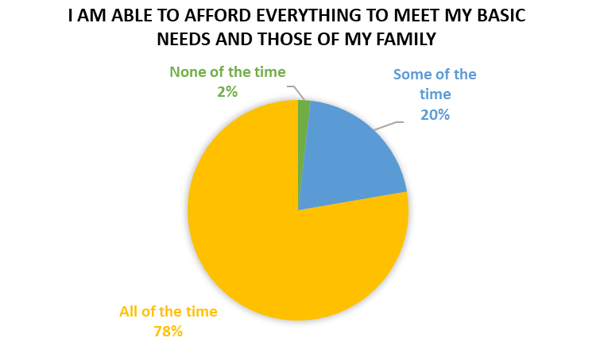

A high proportion of respondents were retired (41%), in line with the older age of respondents. 45% respondents were employed (either full-time, part-time or self-employed). 5% respondents described their employment status as ‘looking after home/family’ indicating they are not in employment in order fulfil caring responsibilities.
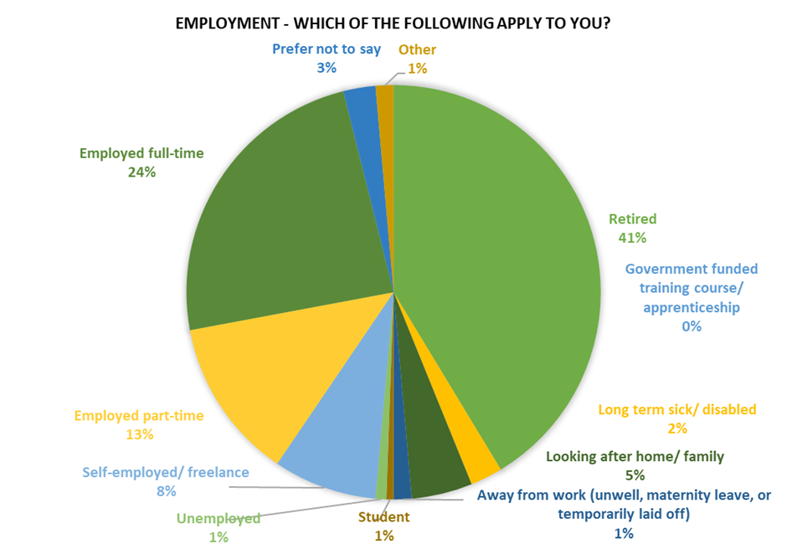

78% respondents did not live in a household with children or young people aged under 18 years. This is in line with the older age of respondents. 21% respondents did live with children or young people. This is informative since we know that the health behaviours of adults’ influence those of children and young people around them.

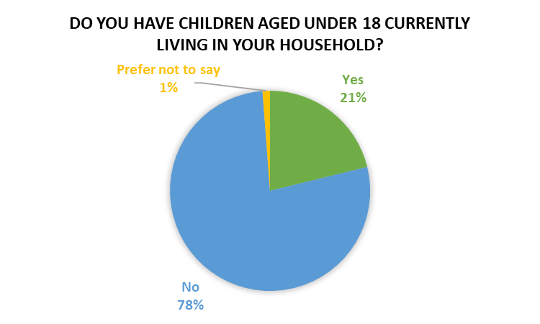
Impairment or Disability
60% respondents were people living without impairments or disabilities. 13% respondents indicated longstanding illness or health conditions such as cancer, diabetes, chronic heart disease or epilepsy. A further 10% respondents selected that they had a physical impairment. These findings may be reflective of the older age of respondents. Additionally, the nature of this health-focused survey, may attract responses from people who have particular health challenges.
6% respondents selected that they had a mental health condition, 3% a sensory impairment, and 1% a learning disability or difficulty.

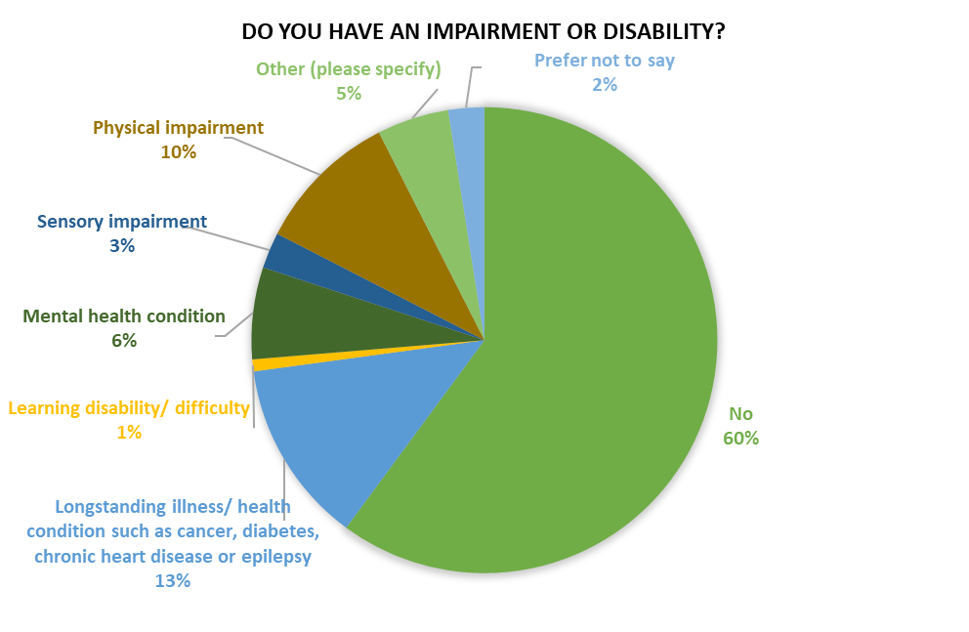

Gender identity and sexual orientation
Whilst the gender identity split across RBWM is approximately 50:50¹, this survey attracted a disproportionately high number of responses from people identifying as female (78%) compared to people identifying as male (21%). However, it is recognised in general that people identifying as female tend to be more concerned with their health, which may be a factor influencing the responses received to this Health Behaviours survey. Additionally, 1% responses were received from people identifying as transgender.

85% respondents described their sexual orientation as heterosexual; 11% preferred not to say; 2% answered bisexual; 1% answered gay male and 1% answered Other.

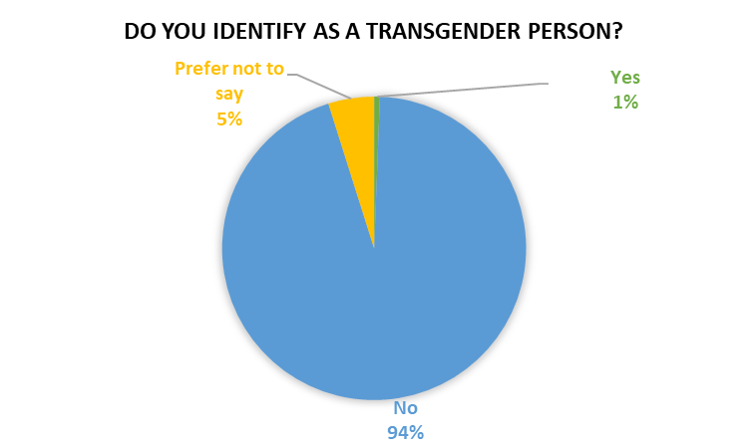
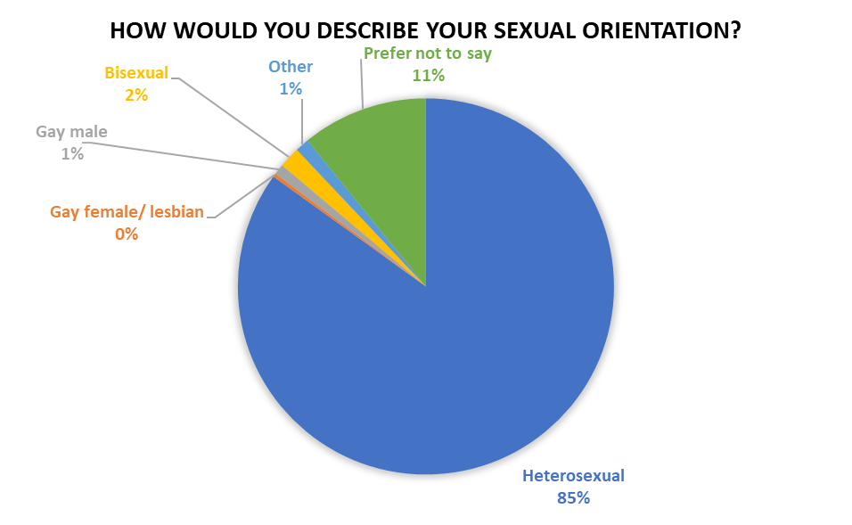
What did responses to the Public Survey tell us?
Healthy Behaviours (Q1-4)
- 4.2% (14) respondents reported they were currently smokers (334 responses, 2 skipped).
- 9.8% (33) respondents reported concerns about how much alcohol they drink (336 responses, 0 skipped).
- 61.6% (204) respondents reported concerns about their weight (331 responses, 5 skipped).
- 51.2% (166) respondents reported concerns about their activity levels (324 responses, 12 skipped).

When asked if they were looking to make healthy changes (Q5):
- 212 (64%) respondents wanted to lose weight.
- 168 (50%) respondents wanted to get active.
- 6 (2%) respondents wanted to quit smoking (43% of smokers who responded).
- 39 (12%) respondents wanted to drink less alcohol.
- 74 (22%) people were not looking to make healthy changes.
*333 responses, 3 skipped this question.

Current services
When asked if they had used any of our current services (Q6):
- 5 (1.6%) respondents had used Glowji.
- 4 (1.2%) respondents had used the Lower My Drinking App.
- 1 (0.3%) respondent had used the Man V Fat weight loss support group.
- 2 (0.6%) respondents had used smoking cessation services.
- 1 (0.3%) respondent had used Resilience Drug and Alcohol service.
- 27 (8.3%) respondents had used support from their GP Practice.
- 268 (82%) had used none of the above services.
- 38 (11.7%) had used other services.

Other services used included: MyFitnessPal (x3), Talking Therapies through NHS (x2), Slimming World (x8), Slimming clubs, Weight Watchers (x4), Short term help from hospital, Al-Anon, Physiotherapist (x3) Google, NHS Active 10, Pilates classes, Used to use SMILE sessions ( Still walk with Group) 3 Community Art Group ( Maidenhead, Cookham and Windsor), Achieva exercise classes, Achieva weight loss group, joined a gym, Moveability and Get Berkshire Active, Diabetic monitoring via the Freestyle Libre, Noom, my health app, Genesis gym and well-being Part of recovery programme for cancer, Couch to 5k (x2), Nutracheck, Flexercise, Drinkaware app, Braywick Leisure Centre, going for a walk in my lunch break, salsa classes, Beaut Camp in Imperial Park,
*325 responses, 11 skipped this question.

When respondents were asked how helpful they found the services they had used (Q7):
Glowji: 5 very helpful, 7 somewhat helpful, 10 not helpful (NB: this data cannot be relied on given only 5 respondents reported having used Glowji).
Lower My Drinking app: 3 somewhat helpful, 7 not helpful (NB: this data cannot be relied on given only 4 respondents reported having used Lower My Drinking).
Man v Fat weight loss support group: 1 very helpful, 3 somewhat helpful, 6 not helpful (NB: this data cannot be relied on given only 1 respondent reported using the Man v Fat service).
Smoking cessations service: 2 somewhat helpful, 6 not helpful (NB: this data cannot be relied on given only 2 respondents reported using the smoking cessation service).
Resilience Drug and Alcohol service: 1 very helpful, 2 somewhat helpful, 4 not helpful (NB: this data cannot be relied on given only 1 respondent reported using the Resilience service).
Support through GP Practice: 5 very helpful, 19 somewhat helpful, 20 not helpful (NB: this data cannot be relied on given 27 respondents reported accessing support from their GP Practice but 44 have responded to this question).
*81 responses, 255 skipped this question.

Future services
When respondents were asked how they would like to access services in the future (Q8):
- 111/283 (39%) respondents preferred to access separate services for smoking, alcohol, diet and exercise.
- 23/283 (8%) respondents preferred to access a single service that offers support for smoking, alcohol, diet and exercise together.
- 149/283 (53%) respondents did not mind either way.
*283 responses, 53 skipped this question.

When asked how respondents would prefer to receive support (Q9):
- 124/301 (41%) respondents would prefer to receive support in person.
- 18/301 (6%) respondents would prefer to receive support by telephone.
- 131/301 (44%) respondents would prefer to receive support digitally by apps or a website.
- 74/301 (25%) respondents did not mind.
- 16/301 (5%) respondents stated ‘Other’ as their response.
*301 responses, 35 skipped this question.

Comments alongside ‘Other’ responses included:
Hybrid or in person; Slimming World; Joined up Community Hub where Retired Citizens can meet and discuss a range of Community Health & Wellbeing Issues; I don't need or want support. I am doing fine by myself (6 x similar responses); The option to choose a variety of ways that suit; Via zoom or teams so you can actually see someone but remotely; Email.

When asked ‘Is there anything else you would like to say?’ (Q10):
75 responses written comments were provided (full list in appendices). These comments have been split into key themes as part of the analysis of findings. However, there is often overlap between the themes and as such, some comments have been included in two different sections where relevant.

A summary of the key themes from responses is set out here:

Theme | Sub theme | Example comment
General barriers to improving health | Long term conditions | I used to be very energetic and still belong to the Leisure Centre – but am effectively paying for nothing as advanced knees arthritis prevents me doing practically anything. I can drive but not stand or walk for very long at all. I'd welcome face-to-face help with diet and exercise.
 | Cost | The cost of gym referral support from the gp was too much for my husband and I at nearly £50 a month.
 | Caring responsibilities | Full time carer so very hard to attend anything.
 | Time | Finding the time to be active between work and family needs is difficult for me.
 | Safety | Would love to walk more if it was safe around Maidenhead – need much much more pedestrian crossings please!
 | Digital exclusion | I don’t know what the Gloji app is and can’t find it on my phone?
Mental health support | General | I think support in terms of managing depression should be mentioned.
 | Alcohol | The Gov response to the pandemic has negatively impacted my mental health - particularly my feelings of wellbeing and stress / anxiety. In addition, as well as drinking more alcohol during lockdown due to boredom and depression, I am now still drinking more by going out more often to make the most of establishments being open for fear of any restrictions being re-imposed.
Weight management | Access to leisure facilities | I need to lose 5kgs because I'm needing a gastric banding but because of health issues and mental health issues I can’t go to the gym and I can’t stand very long but to me weight loss is very important to me.
 | Mental health
 | Long term condition
Leisure and physical activity opportunities | Travel | There are no fitness (gym, etc) facilities close to me in Sunningdale. It rather defeats the purpose to drive to Windsor or Maidenhead.
 | Cost | The cost of gym referral support from the gp was too much for my husband and I at nearly £50 a month.
 | Online classes | Something accessible for housebound people.
Access to healthcare | High demand on GP Practices | Doctors are so busy at the moment they cannot give help and advice for chronic issues. A separate service with a medical lead would be helpful.
Access to digital support | Digital exclusion | I don’t use any apps.
 | Unaware of Glowji | I don’t know what the Gloji app is and can’t find it on my phone?
Other |  | Main thing is personal, human support. Not pre-filled not responses or articles/exercises. Human required for encouragement and accountability.
 |  | Earlier education to school age children about active travel (cycling/walking) and cooking/healthy diet would significantly improve the health of many for generations.
 |  | I don't think I need any help. I try to take care of my own health (total 6 similar responses).

FINDINGS FROM PROFESSIONALS’ SURVEY
Who responded?
Of the 13 responses from Professionals, these were received from:
- Allied Health Professional: 2 (15%)
- Care Coordinator: 2 (15%)
- GP: 3 (23%)
- Practice Nurse: 1 (8%)
- Social Prescriber: 3 (23%)
- Social Worker: 1 (8%)
- Unknown: 1 (8%)
What did responses to the Professionals’ Survey tell us?
When asked to select which RBWM support services professionals currently refer or signpost people to (Q1), responses showed:
- 6 (50%) respondents had referred or signposted to the Glowji app.
- 6 (50%) respondents had referred or signposted to Man v Fat (weight loss support group).
- 7 (58%) respondents had referred or signposted to smoking cessation services.
- 7 (58%) respondents had referred or signposted to Resilience Drug & Alcohol service.
- 10 (83%) respondents had referred to Primary Care services, including GP support, social prescribers, or health coaches.
* 12 responses, 1 skipped.

When asked how helpful professionals think the public find the RBWM support services listed (Q3), responses showed:
Glowji: 3 very helpful, 3 somewhat helpful, 5 not sure/unable to say.
Man v Fat weight loss support group: 1 very helpful, 2 somewhat helpful, 8 not sure/unable to say.
Smoking cessation services: 2 very helpful, 4 somewhat helpful, 1 not helpful, 4 not sure/unable to say.
Resilience Drug & Alcohol services: 2 very helpful, 3 somewhat helpful, 2 not helpful, 5 not sure/unable to say.
Primary Care services, including GP support, social prescribers, or health coaches: 6 very helpful, 5 somewhat helpful.
Lower My Drinking app: 1 somewhat helpful, 8 not sure/unable to say.
*12 responses, 1 skipped.

When asked which other support services professionals routinely refer to signpost people to for support with losing weight, getting active, quitting smoking or drinking less (Q2), responses included:
BHFT dieticians; Public Health Collaboration TLC groups; Rangan Chatterjee Feel Better Live More podcast; Calm app; Diet doctor website, Wellbeing referrals to local gym (unfortunately thought they have been overwhelmed recently and can’t manage demand), walking groups, local activities, Slimming World (x 3), National Diabetes Prevention Programme, Weight Watchers, NHS websites.

When professionals were asked about the design of health improvement support services in the future (Q4):
- 3 (25%) respondents thought people would benefit from separate services for smoking, alcohol, diet and exercise.
- 7 (58%) respondents thought people would benefit from a single service that offers support for smoking, alcohol, diet and exercise.
- 2 (17%) respondents did not have a strong opinion.
*12 responses, 1 skipped.

When professionals were asked how they thought support should be made available in the future (Q5):
- 12 (100%) respondents thought support should be provided in person.
- 10 (83%) respondents thought support should be provided digitally via apps or a website.
- 8 (67%) respondents thought support should be provided by telephone.
- 1 respondent (8%) commented that all of these options should be available to people, due to differing preferences and support needs.
The high proportion of responses indicating support should be provided in person, digitally and by telephone, show that most respondents selected more than one option. As such, responses indicate that professionals think that support should be accessible in several ways.
* 12 responses, 1 skipped.

When professionals were asked to give their views on the reasons people don’t benefit from support services (Q6):
- 6 (50%) respondents selected ‘Not enough time.’
- 3 (25%) respondents selected ‘Location of services.’
- 6 (50%) respondents selected ‘Not engaged.’
- 7 (58%) respondents selected ‘Existing service isn’t right for them.’
- 8 (67%) respondents selected ‘They’re not yet ready for change.’
- 7 (58%) respondents selected ‘They’re struggling to maintain change.’
Additionally, 1 respondent commented: ‘Again all of the above, time for those working, child care, criteria (SMI can't access Gloji even if their Mental Health is managed) Do not see it as important, not motivated to change.
Again, the high proportion of responses to each option indicates that respondents tended to selected multiple responses to this question.
* 12 responses, 1 skipped.

Professionals were asked: ‘Of the groups/communities you work with – not currently engaged with support services – who could benefit most with health help to lose weight, get active, quit smoking, or drink less? (Q7). Responses are summarised here:

- People who Slimming World / Weight Watchers have not helped.
- People wanting to detox from alcohol.
- Broader offer of free/means tested services to those who are living in deprivation, this cohort are really in need of these services and yet aren't able to afford to engage even with a gym referral at £26 a month for 1 year then it would go up to £50-£60.
- There is no fixed answer, there are many ages/demographics that have these issues.
- Those that show an interest in wanting to make these changes (x 2 responses).
- Single mothers.
- People with learning disabilities (x2 responses).
- People living with mental illness.
- People living with Type 2 diabetes.
- People living with Chronic obstructive pulmonary disease (COPD).

Professionals were asked whether overall they thought the right support services were in place to help people make healthy behaviour changes (Q8).
- 5 (42%) respondents answered Yes.
- 7 (58%) respondents answered No.

Professionals were asked to give their views on what else they thought was needed if they had answered No to the previous question. Responses to Q9 are summarised here by theme:

Theme | Comment
Education | More focus on nutrition - avoidance of ultra-processed food, cooking from scratch, cooking real food on a budget, teaching children how to make healthy choices.
 | Weight loss education sessions for weight loss.
Green space /  Healthy communities | Healthy communities, what is on our high street - less fast food outlets! More green spaces.
Person centred support | Person-centred support, tailored to different groups.
 | More face to face as well as online offer, more peer support to cover the generations.
Substance misuse support | Advocates for those disengaged from families and friends due to addictions.
 | Supported alcohol detox tier 3.
Access for underserved communities | Consistent affordable or means tested programmes for those living in deprivation (beat the street, reward scheme).
 | More availability for low income.
Increased capacity of local services | Shorter waiting times, so more services to deal with the numbers.
 | Not enough patient choice, available at local places, at times people are able to engage.
Address digital exclusion | More availability for less tech savvy people.
Information / promotion from Public Health. | Not advertised sufficiently. Practice staff unaware of services to recommend to Patients. Email from Public Health approx. quarterly to update staff with what's available currently and how patients can access would be useful.

Professionals were asked if they had any other comments to add (Q10). 4 responses were received for this question. Due to the varied and insightful comments, responses are included here in full:

Response 1: Take the Eatwell plate off all Frimley ICS/CCG websites!

Response 2: Can we engage not just local leisure centres with a wellbeing referral for example there is the gym at Maidenhead ruby club for £25 a month with PT's in place. More free groups for all ages as part of a programme to encourage the peer support. Build in a reward scheme with local supermarkets for those deprived as part of their corporate responsibility. Means test for residents using schemes exercise groups.

Response 3: There are a lot of people being missed because they do not fit into certain criteria. Would it not be wise to look at prevention rather than waiting until the patient is obese or from a result of not taking care of themselves they have health issues? A lot of these people have issues that are to do with their mental state. Also, the state of the economy is affecting the way they can eat sorry to say junk food is cheaper. There are so many environmental issues that have to factored into the times we are living in and how best we can help.

Response 4: Local green spaces should have free parking to encourage free walking, e.g. car parks around Windsor Great Park. This may help to reduce obesity and encouraged family exercise.

CONCLUSIONS FROM THE PUBLIC AND PROFESSIONALS’ SURVEYS

Representation

The number of responses to the public survey was reasonable. Findings were skewed towards representing views of older, white British, retired residents in RBWM who identify as female, can afford the cost of meeting their basic needs all of the time, and who do not have children and young people living in their household.

Findings also reflect views of the significant proportion of respondents who reported living with impairments or disabilities due to long term conditions.

Alongside these population groups, the survey findings also reflected the views of a moderate proportion of respondents who are in employment, people who identify as male, and people who sometimes cannot afford to meet basic needs for themselves and their family. In addition, there were a small number of responses from people from ethnic minority backgrounds, in proportions generally relative to the local population estimates.

The number of responses to the professionals’ survey was low overall, meaning that findings could not be assumed to represent the views of a wide cohort of RBWM professionals working in frontline services. Despite this, a range of professional groups responded, and the findings provided valuable insight into the ways in which health improvement support could best be provided.

Support with health improvement

Responses to the public survey told us that 78% respondents were looking to make healthy changes. Respondents were particularly wanting to lose weight and get active, and to a lesser extent reduce alcohol intake. Support with smoking cessation did not emerge as a strong finding since only 14 of the 327 respondents were current smokers. However, 40% of the current smokers who responded said that they wanted to quit.

Despite the high proportion of respondents wanting to make healthy changes, low numbers of respondents had used existing RBWM support services. The most used support service was GP Practices, which we know to be in extremely high demand, as reflected in multiple responses to question 10 (‘Is there anything else you would like to say?’)

A wide range of other support services had been used by respondents. However, given the number of respondents who answered that they need support, there is a question about the effectiveness of these different support offers.

These findings together indicate that there is an opportunity to improve uptake of evidence based, effective health improvement services offered by RBWM.

Responses to the professionals’ survey showed respondents were aware of RBWM health improvement services and had referred into or signposted more than one of these services previously. Professionals also refer and/or signpost a range of other support services run by the NHS and independent providers.

Professionals’ views on how helpful they think residents find RBWM health improvement services were mixed; responses for each service were generally split between very helpful, somewhat helpful and not sure/unable to say. This finding suggests that the RBWM Public Health team should ensure commissioned health improvement services are regularly evaluated and findings are shared widely with stakeholders. This would support improved understanding of how helpful services are for different population groups and potentially increase referrals/ signposting to services.

Barriers to health improvement

Response to the public survey provided valuable insight on the barriers people experience in improving their health. The key themes should help to inform service design with a view to removing barriers and improving participation in local services. This survey found that:

- Respondents with long term conditions report difficulties with accessing leisure services and do not mention whether they use more local opportunities for exercise (e.g. local parks).
- There are unique challenges around health improvement for people with caring responsibilities.
- The cost of leisure services (including car parking) and the location of the leisure centres are viewed as barriers to participation by respondents to this survey - likely a high proportion of older people.
- Digital resources do not suit everyone, but some respondents reported not knowing about them or not being able to access them. Promotion of these resources (such as the Glowji app) should continue. Consideration should be given to how to enable uptake in people who feel digitally excluded.
- GP services are under high demand; alternative sources of support for health improvement should aim to support GP Practices by lessening unnecessary demand.
- Mental health and wellbeing are likely to underpin the readiness of respondents to improve their own health. Support for mental wellbeing should be a consideration within all future services.

Responses to the professionals’ survey provided additional useful information on the perceived barriers to people accessing health improvement support. There were a range of views on why people may not utilise current support. The most common reasons were ‘they’re not yet ready for change,’ ‘they’re struggling to maintain change’ and ‘existing service isn’t right for them.’ Half of respondents also selected the reasons ‘not enough time,’ and ‘not engaged.’ A quarter of respondents selected ‘location of services.’ Taken together, these findings suggest that health improvement services should utilise effective behaviour change approaches for improving readiness to change and supporting people to maintain change. Additionally, findings indicate that it is important individuals feel the service is right for them. Ongoing service user consultation is important for developing services that people feel are relevant and appropriate to their own needs.

Responses from professionals provided valuable insight into specific population groups who are not currently engaged with support services and could benefit most from health improvement support. The breadth of responses highlights that there are numerous underserved populations within RBWM. Findings indicate the importance of designing health improvement services that give particular consideration to the needs of less affluent residents, single parents, people with dependence issues, people who have tried but failed to manage their weight themselves, people with learning disabilities, people living with mental illness and people living with long term conditions.

Future services

A key question in the design of health improvement support is whether services should be integrated (support for multiple health behaviours under one service) or separate. Of the responses to the public survey, over half did not mind either way whether future services were integrated or separate, 40% respondents said they would prefer separate support services for different health behaviours and 8% said they would prefer to access support through a single service.

Of the responses from professionals, 58% were in favour of a single integrated service; 25% in favour of separate services and 17% respondents did not have a strong opinion.

Taken together, these findings do not clearly point to a preferred option for integrated versus single support services. However, the numbers of respondents to the public survey looking for support with losing weight (212 responses) and getting active (168 responses) indicates that many respondents selected both of these answers. As such, future services for weight management should include dedicated support for exercise and movement.

Another key question for the design of health improvement services is whether services are provided in-person or remotely. Overall responses were mixed; 41% respondents would prefer support in person and 44% respondents would prefer digital support. Only 6% respondents preferred support by phone. Similarly, responses from professionals were in favour of offering support in different ways. As such, future health improvement services through RBWM should include options for accessing support in person and through digital platforms. This will allow individuals to select a support package that meets their preferences and is proportionate to their level of need.

Responses from professionals indicated that the majority of respondents do not think the right support services are in place at present. Themes emerging from comments about what else is needed reflect many of the themes emerging from responses in the public questionnaire. Key suggestions about support requirements from professionals were:

- Provision of education on diet and weight loss.
- Provide healthy environments and access to green space.
- Ensure support is person-centred.
- Specific support is required for people dependent on substances.
- Improved support for people who cannot afford to participate in current opportunities.
- Increase capacity of local services.
- Address digital exclusion.
- Promote current support services more widely.

SUMMARY OF RECOMMENDATIONS

Based on the conclusions drawn from the public and professionals’ surveys, this report makes the following recommendations:

- Efforts to improve the uptake of evidence based, effective health improvement health improvement services offered by RBWM should be continued. This includes continuing to promote services to the public and to professionals who may refer or signpost this support.

- Ensure that health improvement services commissioned through RBWM are regularly evaluated and findings are shared widely with stakeholders.

- To ensure future health improvement services are appropriate, accessible and affordable, particular consideration should be given to the needs of people living with long term conditions, people with learning disabilities, people living with mental illness, people with caring responsibilities, older people, less affluent residents, single parents, people with dependence issues and people who have tried but failed to manage their weight themselves.

- Support for mental wellbeing should be integrated within all health improvement services in the future.

- Efforts should be made to support more people with accessing digital opportunities where they would like to participate but feel digitally excluded, particularly older and/or housebound residents.

- Health improvement services should utilise effective behaviour change approaches for improving readiness to change and supporting people to maintain change.

- Ongoing service user consultation should be gathered and used to refine services so that that people feel support is relevant and appropriate to their own needs.

- Future services for weight management should include dedicated support for exercise and movement.

- Future health improvement services through RBWM should include options for accessing support both in person and through digital platforms. This will allow individuals to select a support package that meets their preferences and is proportionate to their level of need.

REFERENCES

1. Public Health for Berkshire. Berkshire Observatory; Windsor and Maidenhead; Population and Demographics. Available at: Windsor_and_maidenhead - Population - UTLA | Windsor and Maidenhead | InstantAtlas Reports (berkshireobservatory.co.uk) [Accessed 07 June 2022].
APPENDICES

Theme | Sub theme | Comments
Mental health support |  | Mental Health services seem lacking.
 |  | Art in the Community can provide Mental Wellbeing for All.
 |  | I think support in terms of managing depression should be mentioned
 | Alcohol | The Gov response to the pandemic has negatively impacted my mental health - particularly my feelings of wellbeing and stress / anxiety. In addition, as well as drinking more alcohol during lockdown due to boredom and depression, I am now still drinking more by going out more often to make the most of establishments being open for fear of any restrictions being re-imposed.
 | Alcohol | I would like support as a parent of a drug addict and alcoholic.
Weight management |  | During 2020 I completed my weight loss journey which I had been focusing on since 2019 by reaching my target. I increased my fitness levels during 2020 and 2021.
 | Access to leisure  Mental health  Long term condition | I need to lose 5kgs because I'm needing a gastric banding but because of health issues and mental health issues I can’t go to the gym and I can’t stand very long but to me weight loss is very important to me.
 |  | To live healthy people also need to put weight on and there is no service to help people struggling to keep weight on and eat. There was no option to select this as the focus is always on people losing weight and forgetting the ones that struggle the other way.
 |  | Having a partner who has the same goal such as weight loss can be very motivational.
 |  | A weight loss club for women over 50 in Maidenhead would be so Useful.
 | Long term condition | I hope that a by-product of getting more active will be that I lose a bit of weight, but that is not my principal concern. I had to stop swimming when the pandemic started and never replaced it with an alternative form of exercise. Swimming was my favourite form because it was not 'load bearing' and I have arthritis.
 | Long term condition | My weight problem and low activity level are due to arthritis. I used to enjoy long walks (up to 7 miles) but now am lucky if I can do four miles on a good day and spend the next few days recuperating.
 |  | Weight just about ok at the moment but have to watch it carefully.
 |  | It's the changes in working habits rather than lockdown itself that have had the major impact.
Barriers to improving health | Long term condition | I used to be very energetic and still belong to the Leisure Centre – but am effectively paying for nothing as advanced knees arthritis prevents me doing practically anything. I can drive but not stand or walk for very long at all. I'd welcome face-to-face help with diet and exercise.
 | Cost | Cost is a barrier.
 | Long term condition | I have fibromyalgia and struggle with activity. I asked my GP re weight loss support and was told there wasn’t any.
 | Caring responsibilities | Full time carer so very hard to attend anything.
 | Caring responsibilities | As a carer time is critical and attempting any of the above almost Impossible.
 |  | I didn’t know about this help.
 | Digital exclusion | I don't use any apps
 | Safety  Active travel | Would love to walk more if it was safe around Maidenhead – need much much more pedestrian crossings please! Old /infirm / people with kids struggle to cross road all over Maidenhead!! Look at the fast dual carriage way of bray wick!!!! Between the two roundabouts how many miles is that - and how many crossings are provided???? ONE!!! You supposed to make it appealing to people to go there!!!!!  MORE PEDESTRIAN CROSSINGS ALL OVER MAIDENHEAD PLEASE.
 | Cost | There needs to be more free parking near places to walk. I’d love to  take my kids in different walk but can’t afford the car parks during the  cost of living crisis.
 | Time | Finding the time to be active between work and family needs is difficult for me.
 | Time | Tips in addressing heavy work load versus leisure time would be must welcomed!
 | Time | I have a very busy workload (3 days a week in London, two at home) so access to F2F sessions would need to be around 5.30-7.
 | Long term condition | Something accessible for housebound people.
 | Cost | The cost of gym referral support from the gp was too much for my husband and I at nearly £50 a month.
 |  | The problem is the motivation and enthusiasm to start anything.
Leisure and physical activity opportunities | Travel | There are no fitness (gym, etc) facilities close to me in Sunningdale. It rather defeats the purpose to drive to Windsor or Maidenhead.
 |  | I am still active and go to a gym three or four times a week.
 | Travel  Cost | I was a great fan of the SMILE group at the Magnet although I don't go to it at Braywick (can't walk there, don't want to pay for parking).
 |  | Senior Citizens require access to Health and Exercise opportunities to maintain a holistic approach
 |  | I think the new leisure looks lovely but the sessions I would like to book are always full. Would like more over 50s active sessions maybe later in the day to accommodate those who work.
 | Online classes | A daily or possibly twice daily web chat---nothing complex, first 20 -30 mins a low-key exercise class (standing for some, seated for others).
 |  | Referred by GP to Braywick gym for attendance at the gym for support/assessment/exercise plan back in Dec 2021 (coronary artery calcification identified at Royal Berkshire Hospital). I am still waiting for appointment despite 2 enquiries at reception desk, email to person organising the sessions. Informed they had received a large number, some 800, referrals.
 | Online classes | Something accessible for housebound people.
 | Cost | The cost of gym referral support from the gp was too much for my husband and I at nearly £50 a month.
 |  | I need to lose 5kgs because I'm needing a gastric banding but because of health issues and mental health issues I can’t go to the gym and I can’t stand very long but to me weight loss is very important to me.
Access to healthcare |  | I feel I can't contact the doctor as won't be seen. I buy prescription  needs online through an external pharmacy now.
Have done under my own steam GPs are too busy for us. Female and proud. Alienating women and treating us like we don't matter for 1 percent of the population is pointless. I firmly believe that we are all
equal and treat everyone with respect.
 |  | ensure all GPs see patients.
I am extremely concerned that it has become almost impossible for me to get a GP appointment in less than 3 weeks. The system at Symons Medical Centre has not worked at all well for me over the last
few years. There is no consistency of care, no follow through and very minimal support.
 |  | Access to health care is now very difficult. It is very worrying.
 |  | Doctors are so busy at the moment they cannot give help and advice for chronic issues. A separate service with a medical lead would be helpful.
 |  | GP services poor No time allowed for proper consultation. No confidence at all in getting a diagnosis.
 |  | Due to Covid had to wait over two years for new hip so put on the weight as a result as unable to exercise.
 |  | Unable to work and only leaving the house in a wheelchair for medical appointments I have been waiting for a diagnosis re my increasing pain and difficulty walking since before the pandemic which caused longer waiting lists. The support from my GP practice has not been what I needed and expected. I am close to giving up hope.
Access to digital support |  | Apps don't work, in my experience.
 |  | I bet a lot of people don’t know about these apps. You need to publicise them better, e.g. Facebook ads, rbwm newsletter, emails where they are obvious and not just hidden in a survey that most people won’t to!
 |  | I don’t know what the Gloji app is and can’t find it on my phone?
 |  | I don't use any apps
Other |  | Main thing is personal, human support. Not pre-filled not responses or articles/exercises. Human required for encouragement and accountability.
 |  | More support is required for Menopause and weight loss.
 |  | Real wellbeing is best approached and a whole rather than 'sections of a person' These questions are specific and only addressing a small section of health and wellbeing –
 |  | "Concerns" over the weight and drinking is a bit more nuanced than a simple Yes / No. Do I want to reduce both? Yes. Do I obsess about it or consider that I am not healthy at current intake / BMI? no.
 |  | The lock down... has been the best thing ever. I have got so much healthier. My biggest concern is that ongoing isolation may have a negative effect on children.
 |  | Meaningful feedback and not just ticking boxes.
 |  | Earlier education to school age children about active travel (cycling/walking) and cooking/healthy diet would significantly improve the health of many for generations.
 |  | Still a bit wary of being in groups of people.
 |  | I don't think I need any help. I try to take care of my own health (total 6 similar responses).

