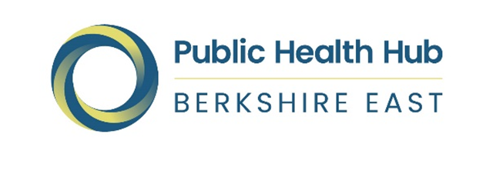

Berkshire East Healthy Behaviours

Health Needs Assessment

SEPTEMBER 2022

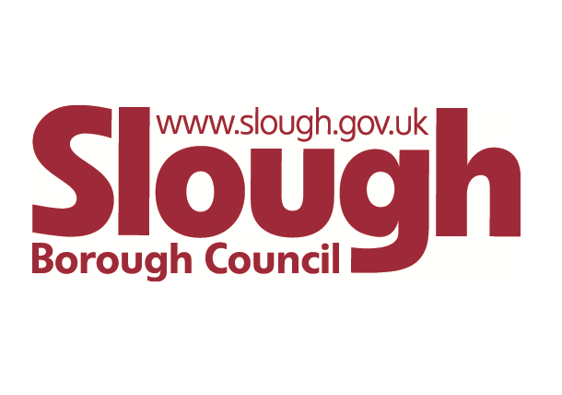
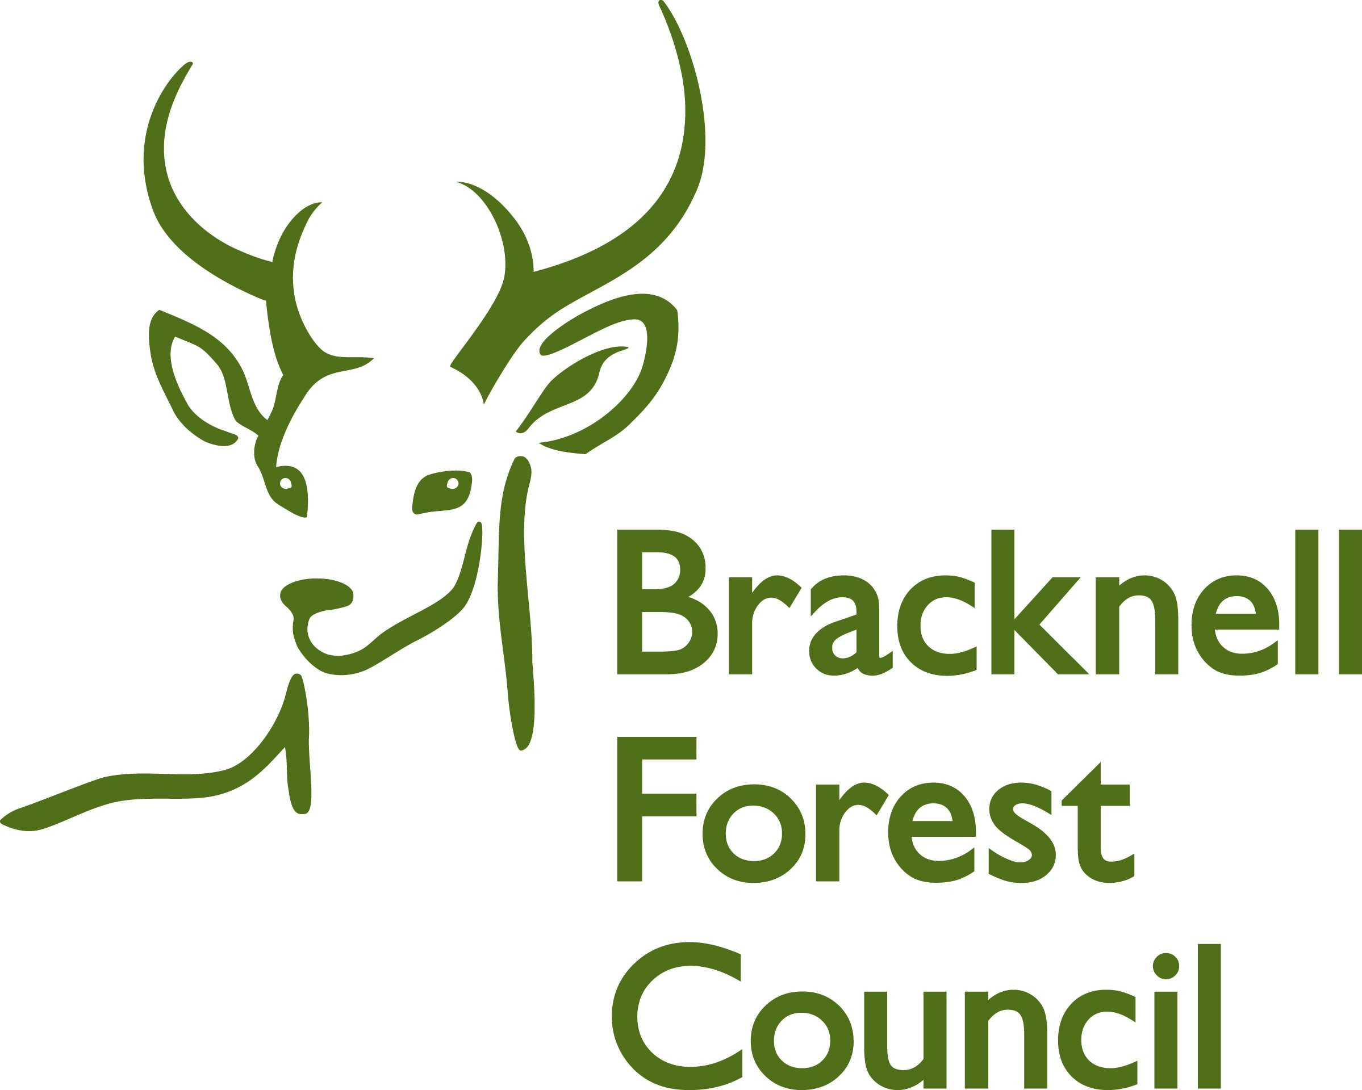
Contents
1. Introduction 4
1.1 Aims and purpose 4
1.2 Scope 5

2. What do we know about the health behaviours of people living in Berkshire East? 6
2.1 Methodology and datasets used 6
2.2 Key demographics 8
2.3 Excess weight and diet 10
2.4 Physical activity 14
2.5 Smoking 16
2.6 Alcohol 19
2.7 Type 2 diabetes 22
2.8 Hypertension 24
2.9 Specific population groups 26
2.10 Impact of Covid-19 on healthy behaviours 28
2.11 Key points to inform HNA recommendations 29

3. Current service provision across Berkshire East 30
3.1 Overview of current service provision in Berkshire East 30
3.2 Overview of current service provision in Berkshire East 32
3.3 Key points to inform HNA recommendations 35

4. Research on integrated health behaviour service models 36
4.1 Evidence on whether separate or integrated health behaviour services are more effective 36
4.2 Learning from existing integrated health behaviour services through discussions with commissioners 37
4.3 Key points to inform HNA recommendations 38
5. Evidence reviews on effective interventions for healthy behaviours 39
5.1 Methodology for healthy behaviour evidence reviews 39
5.2 Key findings from healthy behaviour evidence reviews 39
5.3 Key points to inform HNA recommendations 48

6. Feedback from residents and professionals 49
6.1 Bracknell Forest healthy behaviour surveys 49
6.2 Slough healthy behaviour surveys 53
6.3 RBWM healthy behaviour surveys 57
6.4 Berkshire East healthy behaviours surveys 61

7. Recommendations 63

8. Next steps 65

9. Acknowledgements 66

Appendices 67
Appendix 1: Equality Impact Assessment
Appendix 2: Full Data Pack to describe the population (supports analysis included in section 2 of the overall report)
Appendix 3: Bracknell Forest Council healthy behaviour surveys full report
Appendix 4: Slough Borough Council healthy behaviour surveys full report
Appendix 5: RBWM healthy behaviour surveys full report

Introduction
How do we work in Berkshire East?
The Berkshire East area is made up of three unitary local authorities - Bracknell Forest, Slough, and the Royal Borough of Windsor & Maidenhead (RBWM). Berkshire East is covered by the Frimley Integrated Care Board (ICB), which replaced the Frimley Clinical Commissioning Group (CCG) on 1st July 2022 under the Health and Care Act 2022 changes. These organisations all form part of the wider Frimley Health and Care Integrated Care System (ICS).
The three local authorities and ICB are supported by the Berkshire East Public Health Hub, which includes a jointly appointed Director of Public Health and specialist Hub Team. The Hub Team includes support for commissioning, health protection, public health intelligence, communications, and marketing. The Hub, three local authorities and ICB work collaboratively at a Berkshire East level where appropriate.
This Health Needs Assessment (HNA) has been developed across Berkshire East to understand the health needs and behaviours of the local population in relation to excess weight (being obese or overweight), diet, physical activity, smoking and alcohol use at an increased risk level (people drinking more than 14 units of alcohol but generally fewer than 50 units alcohol a week).
This work has been undertaken collaboratively by the local authorities of Bracknell Forest Council, Slough Borough Council and the Royal Borough of Windsor and Maidenhead (RBWM) with support from the Berkshire East Public Health Hub and colleagues from NHS Frimley Integrated Care Board (ICB). An HNA Steering Group was established to deliver this work, which included representatives from each of these organisations.
An Executive Summary slide deck has been developed to accompany this HNA and can be found on the Berkshire East Joint Strategic Needs Assessment (JSNA) website.

Aims and purpose
Public Health England (PHE) (2018) stated that in order to prevent diseases and reduce inequalities, people needed to be supported to make manageable and sustained behaviour changes. This includes stopping smoking, drinking less alcohol, moving more, and eating more healthily. While unhealthy behaviours often cluster together in the population (The King’s Fund 2018), many of the behaviour change services across Berkshire East are currently addressing these behaviours separately.
This aims of this HNA are:
- to understand health behaviours of adults across Berkshire East in relation to excess weight, diet, physical activity, smoking and alcohol use
- to identify health inequalities within the three local authorities and how these affect healthy behaviours
- to review the evidence on effective interventions for healthy behaviours and integrated health behaviour services.
The purpose of this HNA is to inform the commissioning process for adult focused health behaviour services in Berkshire East, so that the most effective support for those in greatest need can be planned and delivered.

Scope
In this HNA, healthy behaviours will be defined as ‘actions taken by an individual that affect health or mortality, they can be both intentional or unintentional, positive and negative’ (Short and Mollborn 2015). These will include:
- Excess weight, diet, physical activity, and sedentary behaviour (healthy weight)
- Smoking
- Alcohol use at increased risk levels.
The impact of not adopting healthy behaviours will also be examined by including the prevalence of Type 2 diabetes and hypertension, which are largely preventable through uptake of healthier behaviours.

Populations included
The HNA primarily focuses on the adult age group (aged 18 and over), as it is the commissioning of services for this population group that is being addressed. Data that are only available for other age groups, such as all ages or 16 and over, are included where required. An analysis of the prevalence of excess weight in children has also been included in the HNA, as developing a healthy weight starts early in life; Childhood obesity is a risk factor for being overweight or obese in adulthood and therefore provides information about the future prevalence of these conditions in Berkshire East’s adults. A separate HNA outlining the health and wellbeing needs of Berkshire East’s children and young people is available on the Berkshire East Joint Strategic Needs Assessment (JSNA) website.
The focus of this HNA will also be on adults who live in Berkshire East (residents), as opposed to those that are registered to GP Practices within the area, as it is the resident population that services are currently being commissioned for. Information is presented at a local authority and geographical level only and do not include analyses at a GP Practice or Primary Care Network (PCN) level. Section 2.1 of the HNA provides additional information about how local healthcare datasets were used and the caveats that need to be considered.
The HNA Steering Group recognised the importance of looking at specific population groups to see how health behaviours differed compared to the general population.

Populations and factors out of scope
The scope of the HNA does not include:
- a focus on mental health as this was considered too large a scope for the HNA. However, mental health can heavily influence a person’s ability to change their behaviour and, where relevant, this is acknowledged in the report
- eating disorders – it was recognised that support and treatment for eating disorders was provided by mental health services, rather than general health behaviour services and should be excluded from this analysis
- the NHS Health Check programme, as a separate review is currently underway for this specific programme.

What do we know about the health behaviours of people living in Berkshire East?
A detailed analysis of health behaviours in Berkshire East was undertaken to support the HNA, based on the outlined scope. This section provides a summary of this analysis and includes:
- a summary of Berkshire East’s population and demography
- the key findings about local health behaviours, including significant differences or variation between the Berkshire East local authorities
- population groups that have higher levels of risky health behaviours or associated conditions
- a summary of how Covid-19 restrictions may have impacted on healthy behaviours.
The full analysis has been attached as Appendix 2: Data Pack to describe the population and includes information at a local authority and sub-local authority level where available.

Methodology and datasets used
The data analysed for this HNA have come from a range of sources, including national surveys, audits, and local health care information systems. These will all have restrictions and caveats associated with the data collection and will not always be comparable, due to the different methodologies used. An explanation of these sources and caveats are outlined below.

Self-reported surveys
Information about healthy behaviours is often collected through surveys, where respondents state how often they smoke, drink alcohol and exercise. The advantage of these surveys is that they can cover a large number of the population and that the information gathered can be used to identify difference and inequalities across the general public. However, self-reporting may not reflect a true picture with people more likely to over-state their healthy behaviours (such as physical activity) and under-state those that are seen as higher risk (such as smoking).

Information gathered through healthcare information systems, such as GP Practice records and registers
Data collected through healthcare information systems, such as GP Practice registers, provide detailed information about health behaviours, conditions, and the prevalence of recorded disease within a registered population group. However, this will only include data about people who are registered with a GP Practice and who have contacted their GP for support. This will therefore skew some analysis towards population groups that are more likely to be in contact with their GP, such as the older population and those with long-term conditions. This particularly impacts on the analysis of health behaviours, like smoking and excess weight, as there will be sections of the population that are not captured in this analysis.
The prevalence of disease is captured through the national Quality and Outcomes Framework (QOF), which identifies how many people are on disease registers at a snapshot in time. These can provide a useful picture of the health of the population and also how disease trends change over time. It is important to note that these show recorded prevalence of disease and will not indicate the proportion of the population that have an undiagnosed condition, such as diabetes and hypertension.
This HNA includes an analysis of data that comes from the NHS Frimley Integrated Care Board’s (ICB) local healthcare information system – Connected Care. This dataset has enabled the HNA to include a detailed analysis of the current health of the local population of Berkshire East. This will be impacted by the same caveats described above and will only include Berkshire East residents who are registered with a GP Practice.

Modelled estimates based on national data
Some health behaviour datasets are only available at a national level. In some instances, these national figures have been used to create modelled estimates for Berkshire East and the local authorities. These are only used as a guide to quantify the populations that may be impacted locally and will not always take age, sex, ethnicity, and other demographic factors into account. Mid-year 2020 population estimates have been used to calculate these modelled estimates (Office for National Statistics (ONS) 2021).

Comparator groups
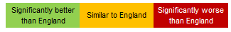
National and regional benchmarks have been provided as comparators to the datasets included in this HNA, where available. The majority of these data are taken from the Office for Health Improvement and Disparities (OHID) Fingertips Profiles. The Red-Amber-Green (RAG) approach used in the Fingertips Profiles has been adopted in this HNA to show how individual local authority and regional areas compare to the national (England) benchmark. It is important to note that an indicator that is RAG-rated “green” may still indicate relatively high levels of poor health (if the national average itself is high) and/or may hide significant variation between communities within the Local Authority.

Data that have been taken from local healthcare systems includes Frimley Integrated Care System (ICS) as a benchmark, as this is the highest geography available in the local GP Record System (Connected Care). The ICS includes the Berkshire East local authorities, as well as people living within the local authority districts of Guildford, Hart, Runnymede, Rushmoor, Surrey Heath and Waverley. National and regional data are not available for Connected Care datasets.

Key demographics
Figure 1: Population of Berkshire East compared with England (mid-2020)

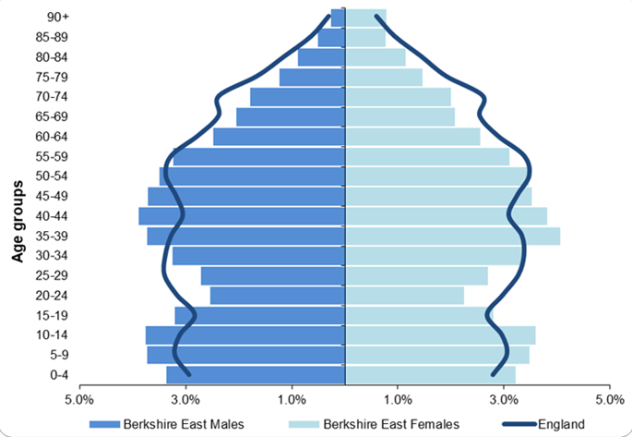
To fully understand health behaviours in Berkshire East it is important to provide some context about the local population. An overarching summary of Berkshire East’s demographics is included below. Further information can be found in Appendix 2 and also on the Berkshire East Joint Strategic Needs Assessment (JSNA) website, which includes individual People and Place Summaries for Bracknell Forest, Slough and RBWM.

2.2.1 Age and sex
The population of Berkshire East was estimated to be 425,015 in mid-2020, with 75% of the population aged 18 and over (ONS 2021). Figure 1 compares the Berkshire East population to England and shows:
- Berkshire East has a younger population than England with higher proportion of young people (aged 0 to 19) and adults aged 35 to 49
- Berkshire East has lower proportions of people aged 20 to 29 and 60 and over compared to England.

Although all three local authorities have a higher proportion of the population aged under 18 compared to England, there are significant differences across Berkshire East. Slough’s population is much younger than Bracknell Forest and RBWM’s, while RBWM has a significantly higher proportion of people aged 65 compared to the other two local authorities.
Source: ONS (2021); Estimates of the population for the UK mid-2020

2.2.2 Ethnicity
The 2011 census showed that 27% of people in Berkshire East came from a black, Asian or other minority ethnic group, compared to 15% in England (ONS 2012). A further 9% of the Berkshire East population came from a white non-British background, compared to 6% nationally.
Ethnic diversity varies significantly across Berkshire East:
- Bracknell Forest has a significantly lower proportion of people from a black, Asian, or other minority ethnic group compared to England at 9%
- RBWM has similar proportion to England at 14%
- Slough has one of the highest proportions in England at 54%.
People from an Asian background are the largest minority ethnic group in all three local authority areas and make-up 19% of the Berkshire East population overall (ONS 2012). The 2021 census is expected to show an increase in diversity across England and all of our local authority areas.

2.2.3 Deprivation
People living in more deprived areas have a shorter life expectancy and live more years in ill-health (The Health Foundation 2022), which makes deprivation one of the key measures of health inequality. Each neighbourhood in England, or Lower Super Output Area (LSOA), has a deprivation score that indicates how deprived that area is compared to the rest of England. Neighbourhoods are split into 10 different groups, called deciles, which help to analyse how deprivation impacts on different health and life outcomes. Deciles go from the 10% most deprived areas to the 10% least deprived areas. Frimley ICS and Berkshire East do not have any LSOAs in the 10% most deprived neighbourhoods nationally.
Levels of deprivation vary significantly across Berkshire East (Ministry of Housing, Communities and Local Government 2019).
- Slough is a more deprived area than the rest of Berkshire East with approximately 8% of the population living in neighbourhoods (LSOAs) that are in the 20% most deprived neighbourhoods nationally
- Bracknell Forest and RBWM are both in the 10% least deprived local authorities in England. However, they also have pockets of deprivation and neighbourhoods that are noticeably more deprived than the local authority area as a whole.

Excess weight and diet
This section summarises the analysis about excess weight and diet in Berkshire East. The full analysis of these data are included at section 3.1 in Appendix 2.

2.3.1 Obese and overweight adults
Obese: Body Mass Index (BMI) of 30kg/m² or over
Overweight: BMI of 25 to 30kg/m²
Excess weight (overweight or obese): BMI of 25kg/m² or over
Obesity is a major public health problem both nationally and globally (OHID) 2022). Obesity and being overweight are leading causes of premature death and are associated with reduced life expectancy and life-limiting conditions such as type 2 diabetes, cardiovascular disease, and some cancers. They can also have a significant impact on mental health and wellbeing. High Body Mass Index (BMI) is currently the 3rd largest risk factor for ill health, disability and premature death in England and contributes to 9% of all healthy life years lost (Global Burden of Disease 2019).

Prevalence of obesity and overweight in the adult population
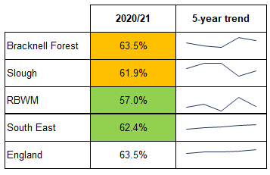
Sport England’s national Active Lives Survey monitors the proportion of adults who are overweight or obese, based on a self-reported survey. Findings from the latest survey in 2020/21 showed that:
Figure 2: Proportion of adults who are obese or overweight
- There is an increasing rate of obesity and overweight in the adult population nationally and regionally
- There has been some fluctuation in local figures, which can be partly attributed to small numbers, however it is expected that Berkshire East’s local authority’s trends are following the overall national picture
- While Bracknell Forest and Slough’s prevalence of obesity and overweight has generally remained similar to England, RBWM has significantly better rates (Figure 2).
Population groups that have higher levels of obesity and overweight nationally include:
- Males (69%), compared to females (58%)
- People aged 45 and over, compared to those aged 18 to 34
Source: OHID (2022); Obesity Profile

- People from black (72%) and white-British (65%) groups, compared to all other ethnic groups
- People with disabilities (73%), compared to those who are not disabled (61%)
- People from more deprived areas (most deprived to 5th most deprived decile), compared to other less deprived areas.

Prevalence of obesity and overweight recorded on local GP Practice Registers
This analysis is taken from Frimley ICB’s Connected Care system and includes adults (aged 18 and over) who had had their BMI recorded by their GP Practice within the previous 12 months. Section 2.2 of the HNA explains the caveats that need to be considered with these data, as they will be skewed towards population groups that contact their GP more frequently (older populations and those with long-term conditions).
In January 2022, 24% of Frimley ICS’s registered population had their BMI recorded. 37% of these were obese. A follow-up analysis in June 2022 identified an additional 37% of the population as overweight. This means approximately 74% of Frimley ICS’s adult population with a recent BMI recorded are overweight or obese.
The QOF methodology for obesity has been used in this analysis to calculate the prevalence of recorded obesity and overweight against the whole adult population. The recorded obesity prevalence for the whole of Frimley ICS’s adult population was 8.7% in January 2022, with a higher prevalence in Berkshire East at 9.5%. The prevalence of recorded overweight in June 2022 was 8.7% in Frimley ICS and 9.0% in Berkshire East.
In Frimley ICS, recorded obesity prevalence is highest in:
- Females (10.0%)
- Adults aged 60 to 69 (13.2%), followed by those aged 70 to 79 (12.9%)
- People from black or black British ethnic groups (12.5%), followed by white ethnic groups (9.4%)
- People from more deprived neighbourhoods.
In Frimley ICS, recorded overweight prevalence is highest in:
- Adults aged 70 to 79 (14.7%), followed by those aged 80 to 89 (13.8%)
- People from Asian or Asian British ethnic groups (10.6%), followed by black British ethnic groups (9.4%).
The profile of obesity and overweight differs between males and females in Frimley ICS. A significantly higher proportion of females with excess weight are recorded as obese, as opposed to being overweight. In contrast, a significantly higher proportion of males with excess weight are recorded as overweight, as opposed to being obese.

2.3.2 Obese and overweight children
The National Child Measurement Programme (NCMP) monitors the height and weight of primary school children in Reception Year (aged 4 to 5) and Year 6 (aged 10 to 11). This allows the prevalence of obesity and overweight to be calculated for these age groups and gives an indication of the levels and trends in childhood obesity.
In 2019/20, 21% of 4- to 5-year-olds and 35% of 10- to 11-year-olds in Berkshire East had excess weight (overweight or obese). Although Berkshire East’s levels of excess weight are broadly similar to the national average, Figure 3 does show significant variation across the three local authorities. Slough has one of the highest rates of childhood obesity in the South East, while RBWM’s rates are significantly lower than the national average.
Nationally, children from the following groups are more likely to be obese or have excess weight:
- From more deprived areas, compared to those in least deprived decile. This association is also visible in Bracknell Forest and Slough, although RBWM’s figures do not clearly show this (perhaps due to relatively small numbers).
- Non-white ethnic groups, compared to white ethnic groups. There is also local evidence to show significant differences in some parts of Berkshire East, including Bracknell Forest (both age groups) and RBWM (Reception Year). Slough has less difference between white and non-white ethnic groups, although those from a black group do have a higher prevalence of obesity compared to those from white and Asian ethnic groups.
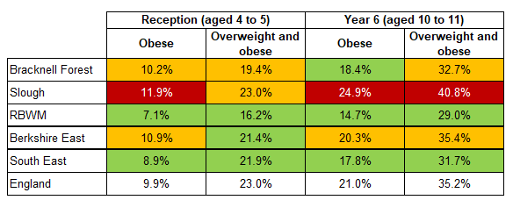
Figure 3: Proportion of children with excess weight (2019/20)

Source: OHID (2022); Obesity Profile

2.3.3 Diet
The 2019/20 Active Lives Survey reported that 55.4% of England’s population met the recommended ‘5-a-day’ fruit and vegetable portions with considerable variation across Berkshire East’s local authorities. Slough consistently has a significantly worse proportion of people meeting this recommendation compared to England, while RBWM’s levels are significantly better. Bracknell Forest’s levels are similar to England’s.
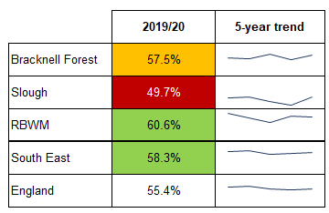
Figure 4: Proportion of adults who meet the ‘5-a-day’ fruit and vegetable portion recommendation

Source: OHID (2022); Obesity Profile
Population groups that have lower levels of people who meet the recommended levels of fruit and vegetables nationally include:
- Males (51%), compared to females (60%)
- People aged 16 to 54, compared to those aged 55 to 84
- People from Chinese (52%), Asian (47%) and black (46%) groups, compared to white-British group (57%)
- People with disabilities (52%), compared to those who are not disabled (56%)
- People from more deprived areas (most deprived to 3rd most deprived decile), compared to other less deprived areas.

2.3.4 Disordered eating
Disordered eating is the development of (typically restrictive) eating habits that are potentially harmful to wellbeing that may otherwise be recommended as part of a ‘healthy behaviour’ or be due to food insecurity. No data were available to quantify the level of disordered eating in Berkshire East or the population groups that may be more impacted by this.

Physical activity
This section summarises the levels of physical activity, inactivity, and sedentary behaviour in Berkshire East. The full analysis of these data are included at section 3.2 in Appendix 2.

2.4.1 Physical activity and inactivity
People who have a physically active lifestyle have a 20-35% lower risk of cardiovascular disease, coronary heart disease and stroke compared to those who have a sedentary lifestyle. Regular physical activity is also associated with a reduced risk of diabetes, obesity, osteoporosis, and colon/breast cancer and with improved mental health. In older adults physical activity is associated with increased functional capacities (PHE 2014).
The Chief Medical Officer (2019) has made recommendations for the minimum level of physical activity that adults should have per week. These recommendations are monitored through Sport England’s Active Lives Survey, based on self-reported information. Findings from the 2020/21 survey (Figure 5) show how levels of physical activity and inactivity vary locally, with Slough having significantly worse levels compared to England and the rest of Berkshire East.
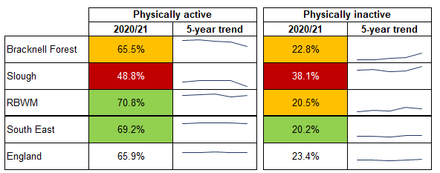
Figure 5: Proportion of adults who are physically active and physically inactive
Physical activity: at least 150 moderate intensity minutes of physical activity per week in bouts of 10 minutes or more
Physical inactivity: less than 30 minutes of physical activity per week

Source: OHID (2022); Physical Activity Profile

Population groups that have higher levels of physical inactivity nationally include:
- Females (24%), compared to males (23%)
- People aged 75 and over, compared to those aged 19 to 64
- People from black, Asian and minority ethnic groups (apart from mixed groups), compared to those from white ethnic groups
- People with disabilities (36%), compared to those who are not disabled (20%)
- People from more deprived areas (most deprived to 4th most deprived decile), compared to other less deprived areas
- Long term unemployed or never employed (39%), those in semi-routine or routine occupations (30%) and lower supervisory roles (26%), compared to higher occupation classes and students.

Available information about local inequalities in Berkshire East show that levels of physical inactivity are higher in the older population (65 and over, compared to 16- to 64-year-olds) and that there is little difference between males and females. However, the proportion of females that are inactive in Slough is much higher than other Berkshire East local authorities, England and the South East region.
Creating an environment where people actively choose to walk and cycle as part of everyday life can have a significant impact on public health and can reduce inequalities in health. Approximately 15% of people aged 16 and over in England report that they walk for travel at least three days per week and 2% cycle for travel. Berkshire East local authorities have similar levels of active travel compared to England, apart from the proportion of people who walk in RBWM which is significantly lower at 10%.

2.4.2 Sedentary behaviour
People who are sedentary - spend long periods of time sitting - have been found to have higher rates of diabetes, cardiovascular disease and death from all causes. Approximately 40% of women and 35% of men aged 16 to 75 spend more than six hours a day desk-bound or sitting still. This equates to nearly 160,000 people in Berkshire East. Whilst there is a growing body of evidence pointing to the risks of sedentary behaviour, it is still unknown the exact level of harm it causes, and data are not available at a Berkshire East or Local Authority level.

Smoking
This section summarises smoking prevalence rates in Berkshire East. The full analysis of these data are included at section 3.3 in Appendix 2.
Smoking is the biggest cause of preventable ill health and premature mortality in the UK. It is a major risk factor for many diseases, such as lung cancer, chronic obstructive pulmonary disease (COPD) and heart disease and contributes to 14% of all healthy life years lost nationally (Global Burden of Disease 2019). Smoking is also the main cause of health inequalities in England with the harm concentrated in disadvantaged communities and groups (OHID 2021). Demographic factors and social determinants of health, such as where someone lives, their employment status, income, and support networks, will impact on the likelihood of someone smoking.

Prevalence of smoking in the adult population
The Annual Population Survey monitors the smoking status of adults through self-reported information. The methodology used to collect the latest data in 2020 was different to previous years, due to Covid-19 restrictions, so cannot be directly compared to previous trends. Data for key population groups are included at Figure 6.
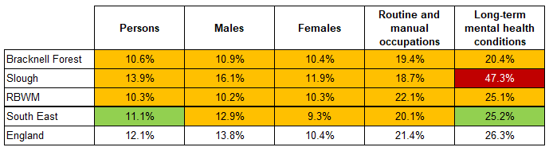
Figure 6: Prevalence of smoking in key population groups (2020)

Source: OHID (2022); Local Tobacco Control Profiles
Population groups that have higher smoking prevalence rates nationally include:
- Males (14%), compared to females (10%)
- Adults aged 25 to 54, compared to those aged 65 and over
- People from white and mixed ethnic groups, compared to those from other ethnic groups
- People from more deprived areas (most deprived to 3rd most deprived decile), compared to other less deprived areas
- People who rent their home, compared to those who have a mortgage or own outright.
Routine and manual (R&M) occupations also have a significantly higher smoking prevalence, compared to other occupation groups. Locally, people with R&M occupations have between 1.4 to 2.5 times higher smoking rates than other occupations.
People with long-term mental health conditions are also identified as a population group with significantly higher smoking prevalence rates at 26% nationally. Locally, people with mental health conditions are 2.0 to 5.2 times more likely to smoke that than those without mental health conditions.

Smoking quitters
Figure 7: Smokers that have successfully quit at 4 weeks per 100,000 smoker population
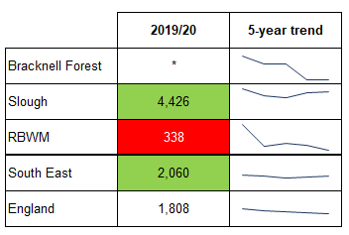
Successful quitters are those smokers who successfully quit at the four week follow up from the designated quit date if they declare they have not smoked in the past two weeks. This is a self-reported indicator, so there is a possibility of over reporting. Quitting rates vary across Berkshire East, with Slough having significantly better quitting rates compared to England and RBWM having significantly worse rates. Data for Bracknell Forest are not available (OHID 2022).

Prevalence of smoking recorded on local GP Practice Registers
This analysis is taken from Frimley ICB’s Connected Care system and includes adults (aged 18 and over) who had a smoking status recorded by their GP Practice within the previous 12 months. Section 2.2 of the HNA explains the caveats that need to be considered with this data, as they will be skewed towards population groups that contact their GP more frequently (older populations and those with long-term conditions).
In January 2022, nearly 87,000 of Frimley ICS’s registered population were recorded as current smokers at 13.5% of the total adult population. Over 51,000 of these people were Berkshire East residents with a smoking prevalence of 14.5%.
Source: OHID (2022); Local Tobacco Control Profiles

In Frimley ICS, recorded smoking prevalence is highest in:
- Males (16.5%), compared to females (10.7%)
- Adults aged 30 to 39 (17.7%), followed by adults aged 40 to 49 (15.8%)
- People from white ethnic groups (15.4%), followed by mixed ethnic groups (13.3%)
- People from more deprived neighbourhoods, with a largely linear decline in prevalence rates from the most deprived area (20.3%) to least deprived areas (9.0%) in Frimley ICS.
The prevalence of smoking in Slough particularly stands out as an outlier when broken down by ethnic group, as shown in Figures 8 and 9. People from white ethnic groups (27.9%) and mixed ethnic groups (17.7%) have significantly higher smoking prevalence rates compared to the other local authorities and other ethnic groups within Slough. People from white ethnic groups in Slough have 2.5 times higher smoking prevalence rates than people from other ethnic groups. This compares to 1.3 times higher rates in Bracknell Forest and RBWM.

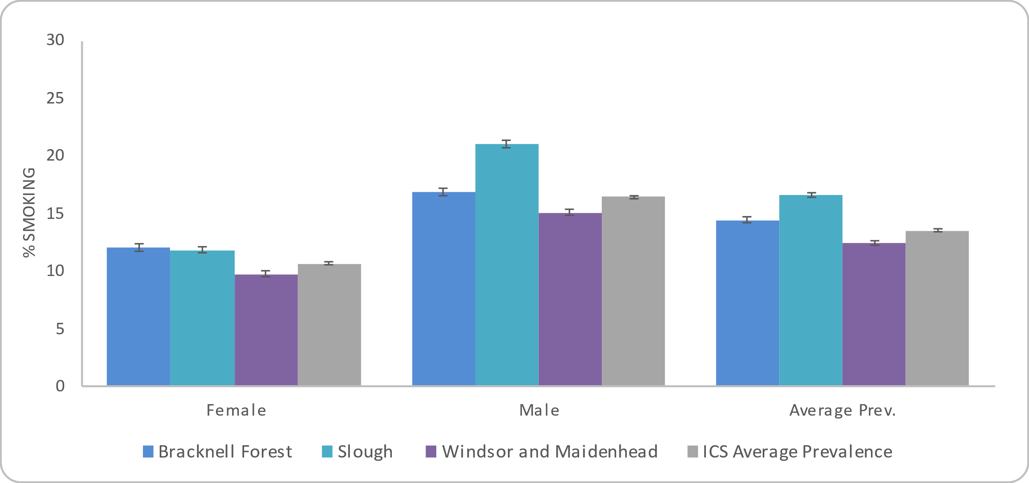
Figure 8: Prevalence of smoking by sex in Frimley ICS and Berkshire East local authorities (18+)
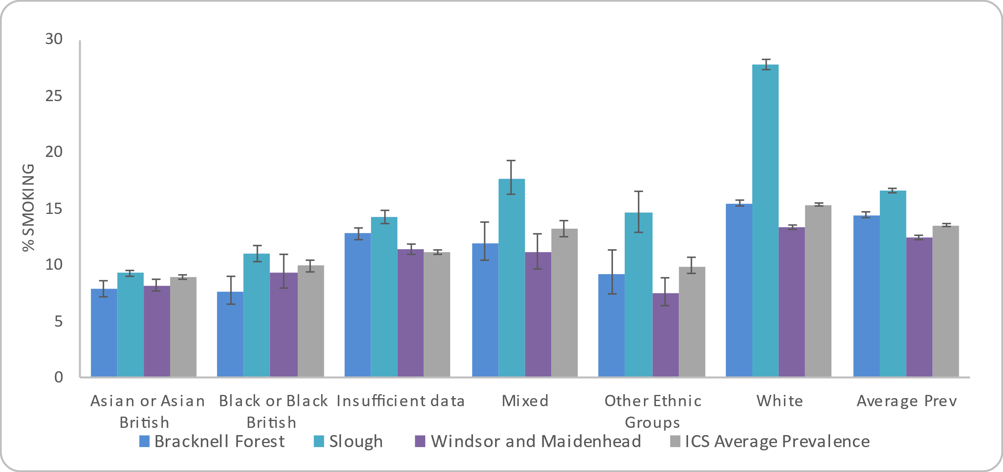
Figure 9: Prevalence of smoking by ethnicity in Frimley ICS and Berkshire East local authorities (18+)

Source: Connected Care - Frimley ICS Analytics Team (Jan 2022)

Alcohol
This HNA focuses on the prevalence of alcohol usage that could be supported through a brief intervention or lifestyle service (consuming 15 to 50 units of alcohol per week on a regular basis), rather than for those that are alcohol dependent and require higher levels of support. Levels of alcohol usage are not collated at a local authority level, so adverse effects of increased alcohol intake – such as hospital admissions and mortality - have been used as a proxy for increased alcohol use. The full analysis of these data are included at section 3.4 in Appendix 2.
Alcohol use is the biggest risk factor for death, ill-health and disability among 15- to 49-year-olds in England and the sixth biggest risk factor across all ages (Institute for Health Metrics and Evaluation 2019). Approximately 30% of men and 15% of women consistently exceed the recommended weekly limit of alcohol (14 units) and this increases their risk of ill health over their lifetime (Health Survey for England 2019).

Alcohol is a causal factor in more than 60 medical conditions, including cancers, high blood pressure, cirrhosis of the liver and depression. Alcohol misuse is also a major cause of A&E attendances and admission to hospitals. NHS England estimate that up to 15% of all A&E attendances are alcohol-related and approximately 2% of admissions are for conditions solely-attributable to alcohol (House of Commons Library 2021).

2.6.1 Modelled estimates of alcohol usage
The Health Survey for England (2019) provides an estimate of alcohol consumption levels in line with the current guidelines for sensible drinking:
- ‘lower risk’ (up to 14 units a week for men and women)
- ‘increasing risk’ (15 to 50 units a week for men, 15 to 35 units for women)
- ‘higher risk’ (above 50 units a week for men, above 35 units for women).
Approximately 19% of England’s adult population are drinking alcohol at a level which puts them at increasing risk and 4% at a level which is higher risk. The Health Survey shows that men drink at higher levels than women and that alcohol consumption also increases with age peaking in the 55 to 64 age group. The proportions of men and women who drink at increasing risk levels also increases with household income.
Using the national prevalence, as a model, it is estimated that there are over 62,500 people aged 16 and over in Berkshire East that are drinking at increasing levels of risk and over 13,000 at a higher risk level.
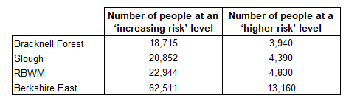
Figure 10: Modelled estimates of alcohol consumption risk levels for people aged 16 and over based (2020)

Source: Prevalence estimates from NHS Digital (2020) Health Survey for England 2019 ;Population estimates from ONS (2021) Mid-year population estimates for 2020

2.6.2 Hospital admissions and mortality from alcohol
Alcohol-specific admissions: Admissions to hospital where the primary diagnosis or any of the secondary diagnoses are an alcohol-specific (wholly attributable) condition.
Alcohol-related admissions (Broad): A measure of hospital admissions where either the primary diagnosis (main reason for admission) or one of the secondary (contributory) diagnoses is an alcohol-related condition. This represents a Broad measure of alcohol-related admissions but is sensitive to changes in coding practice over time.
Alcohol-related admissions (Narrow): A measure of hospital admissions where the primary diagnosis (main reason for admission) is an alcohol-related condition. This represents a narrower measure - since every hospital admission must have a primary diagnosis it is less sensitive to coding practices but may also understate the part alcohol plays in the admission.
Alcohol-specific deaths: These include health conditions where each death is a direct consequence and wholly contributable to alcohol misuse, such as alcoholic liver disease.
Alcohol-related deaths: These include conditions that are a direct consequence of alcohol consumption, such as alcohol poisoning, as well as conditions that are partly related to alcohol, such as liver cancer.

The level of hospital admissions and mortality from alcohol do not quantify the level of alcohol consumption within a population, however they do help to evidence where this may be higher and also the groups that are more likely to drink at increasing risk levels.
Hospital admissions reduced during the first national lockdown (March 2020 to June 2020) for all causes and this is also the case for alcohol-specific and alcohol-related conditions (OHID 2022).
In 2020/21, there were nearly 4,500 admissions for alcohol-related conditions (broad) for Berkshire East residents. 1,650 of these were alcohol-specific conditions. The latest admission rates (Figure 11) show a variation across Berkshire East, with Bracknell Forest and RBWM having significantly better admission rates than England. Slough’s admissions are significantly worse than England’s for alcohol-related (broad) conditions (OHID 2022)
Alcohol-specific deaths increased by 19% in England between 2019 and 2020. Over 75% of these deaths were attributed to alcoholic liver disease. Alcohol-related deaths increased by 4% during this time period and accounted for nearly 20,500 deaths in total (ONS 2021).
Figure 12 shows the latest mortality rates from alcohol across Berkshire East. Deaths from alcohol are relatively small at a local authority level with 123 alcohol-related deaths across Berkshire East in 2020. 35 of these were alcohol-specific deaths. Due to these small numbers, the majority of Berkshire East local authorities’ rates are similar to the national picture. However, Bracknell Forest’s alcohol-specific mortality rates do stand out as the lowest in the South East region in 2017-19 and significantly lower than England’s (OHID 2022).
The population groups that have higher admission and mortality rates from alcohol include:
- Males – this is the case both nationally and locally, with males often having double or triple the levels of admissions and mortality compared to females
- People from more deprived areas (most deprived to 3rd most deprived decile), compared to those from less deprived areas.
An analysis of age-standardised deaths in England from 2017-19 also showed some difference between ethnic groups, with people from Indian, white and mixed/multiple ethnic groups having higher alcohol-specific mortality rates compared to other ethnicities (ONS 2022).
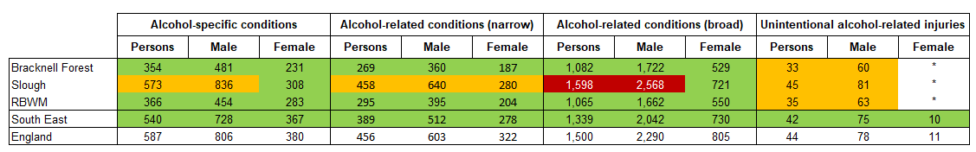
Figure 11: Hospital admissions per 100,000 population by cause and sex in 2020/21 (directly standardised rates)
* Data has been suppressed, due to small numbers
Source: OHID (2022); Local Alcohol Profiles for England

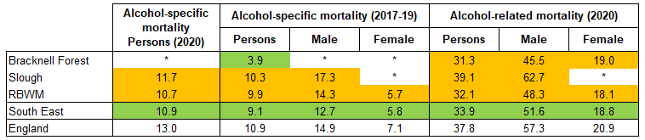
Figure 12: Mortality per 100,000 population by cause and sex (directly standardised rates)

* Data has been suppressed, due to small numbers
Source: OHID (2022); Local Alcohol Profiles for England

Type 2 diabetes
Diabetes is a non-communicable disease where the amount of glucose in the blood is too high. Type 1 diabetes is an autoimmune disease where the body is unable to produce any insulin and is not impacted by modifiable lifestyle factors. Type 2 diabetes is different and develops when the body stops producing enough insulin or the body’s cells stop reacting to insulin produced (PHE 2018). While Type 2 diabetes is affected by non-modifiable factors, such as a person’s age, family history and ethnicity, it is also closely associated with modifiable lifestyle factors, such as being overweight or obese, alcohol consumption, diet, and physical inactivity. The onset of Type 2 diabetes can therefore be delayed or prevented through support to change behaviour around lifestyle choices and is the focus of this section. The full analysis of these data are included at section 3.5 in Appendix 2.

2.7.1 Prevalence of recorded diabetes (all types)
The prevalence of diabetes is recorded on GP Practice Registers for people aged 17 and over, as part of the QOF. This covers diabetes as a whole, rather than splitting it by type, but still provides a useful measure of the level of diagnosed diabetes in the population as 90% of diabetes diagnoses are for those with Type 2 (Diabetes UK 2021). In 2020/21, Berkshire East had the same prevalence of recorded diabetes as England at 7.1%. This prevalence has continued to increase at a national and local level, with approximately 26,000 Berkshire East residents diagnosed with diabetes in March 2021 (OHID 2022). Figure 13 shows how the prevalence of diabetes varies significantly across Berkshire East. Slough has the 3rd highest prevalence rate in England at 9.7%, while Bracknell Forest and RBWM have prevalence rates below the national figure.
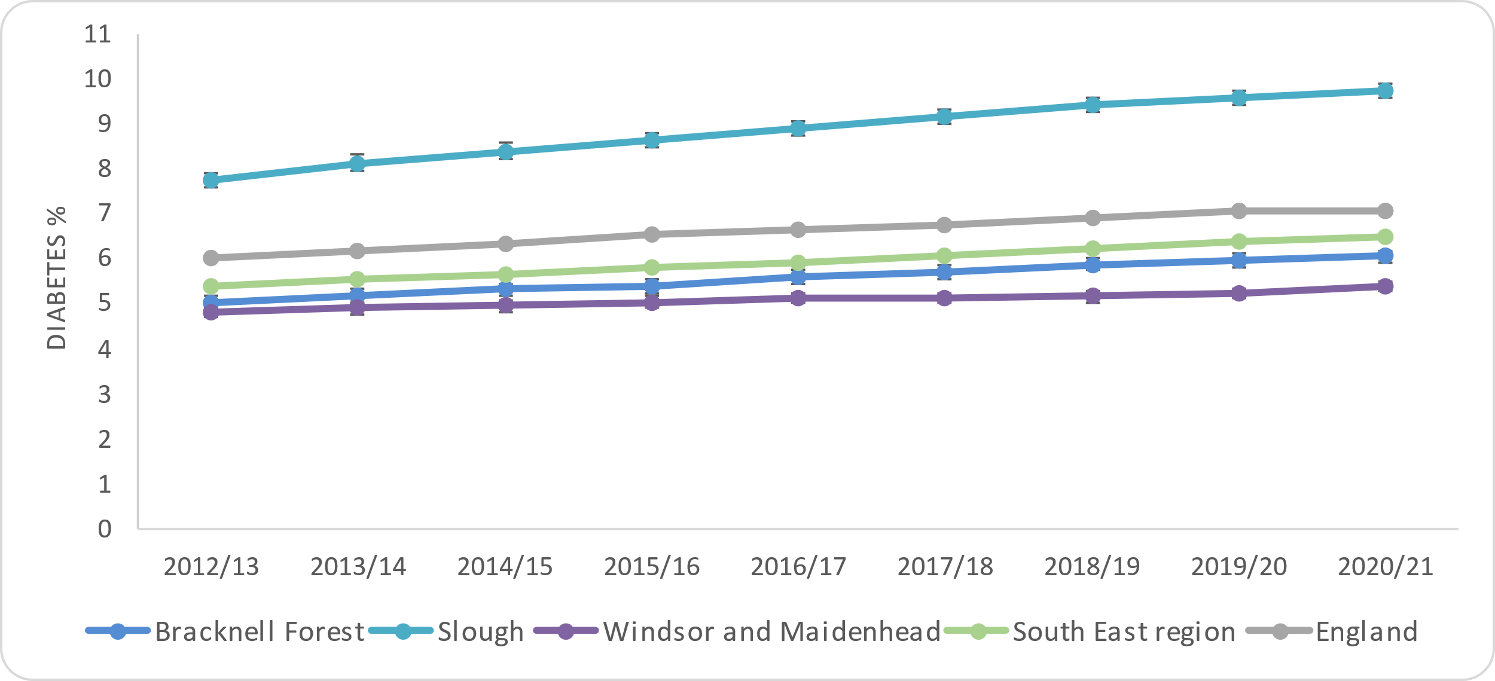
Figure 13: Prevalence of recorded diabetes (aged 17+)

Source: OHID (2022); Fingertips Public Health Profiles

2.7.2 Prevalence of recorded Type 2 diabetes
The prevalence of Type 2 diabetes is recorded on local GP Practice Registers (Connected Care) and has been analysed for people aged 18 and over. In January 2022, 6.4% of Frimley ICS’s registered population had a Type 2 diabetes diagnosis recorded and 7.0% of Berkshire East’s population.
In Frimley ICS, recorded Type 2 diabetes prevalence is highest in:
- Males (7.3%), compared to females (5.6%)
- Adults aged 80 to 89 (19.1%), followed by adults aged 70 to 79 (16.9%)
- People from Asian or Asian British groups (12.8%), followed by black or black British ethnic groups (9.3%)
- People from more deprived neighbourhoods (* see note below).
* Slough has the highest recorded prevalence of Type 2 diabetes across Frimley ICS in all sex, age, ethnic groups, and deprivation groups. This will have impacted on the overall analysis of the ICS, as Slough’s figures account for 30% of all people diagnosed with Type 2 diabetes, while only making up 19% of the total Frimley ICS registered adult population. Analysis at an individual local authority level does not show clear links between diabetes diagnoses and deprivation. However, as Slough is one of the more deprived areas in Frimley ICS and Berkshire East it would have skewed this analysis due to the higher figures of people diagnosed with Type 2 diabetes.
Slough has an ethnically diverse population, with 54% of people coming from an ethnic minority (excluding white ethnic minorities) group. People from black African, black Caribbean or South Asian descent are more likely to be diagnosed with diabetes, compared to people from white ethnic groups (Diabetes UK 2021). This will therefore impact on the overall prevalence of diabetes in Slough.

2.7.3 Prevalence of undiagnosed Type 2 diabetes
Approximately 14% of people with diabetes are unaware that they have the condition (Diabetes.co.uk 2019) and these will mainly be those with Type 2 diabetes. This represents an additional 4,090 people in Berkshire East.

Hypertension
Hypertension, or high blood pressure, is the biggest risk factor for cardiovascular disease and contributes to half of all strokes and heart attacks. It is also associated with an increase in risk of developing dementia, heart failure and kidney disease (UK Health Security Agency (UKHSA) 2017). Hypertension is a preventable condition that is affected by modifiable risk factors, such as poor diet and obesity, lack of physical activity and excess alcohol consumption.
The full analysis of these data are included at section 3.6 in Appendix 2.

2.8.1 Prevalence of recorded hypertension
The prevalence of hypertension is recorded on GP Practice Registers for people of all ages, as part of the QOF. In 2020/21, the recorded prevalence of hypertension in Berkshire East was 12.8% for the total population, which was approximately 60,400 people. This was significantly lower than the national recorded prevalence of 13.9%. Bracknell Forest and RBWM have seen increasing recorded prevalence rates since 2015/16, whilst Slough’s rates have remained more static. It is important to note that the increase in hypertension prevalence could show an improvement in detection and diagnosis, rather than an actual increased level of the condition in the population (OHID 2022).
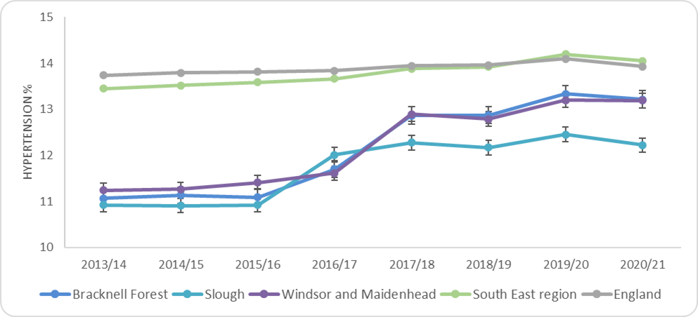
Figure 14: Prevalence of recorded hypertension (all ages)

Source: OHID (2022); Physical Activity Profile

The prevalence of hypertension recorded on local GP Practice Registers (Connected Care) has also been analysed for people aged 18 and over. In January 2022, 16.0% of Frimley ICS’s registered population had a hypertension diagnosis and 16.2% of Berkshire East’s population.
In Frimley ICS, recorded hypertension prevalence is highest in:
- Older population – there is a clear linear relationship between hypertension and age, with the highest rates in adults aged 90 and over followed by those aged 80 to 89
- People from black or black British ethnic groups, followed by those from white ethnic groups (Bracknell Forest and RBWM had slightly higher prevalence rates in their white ethnic groups).

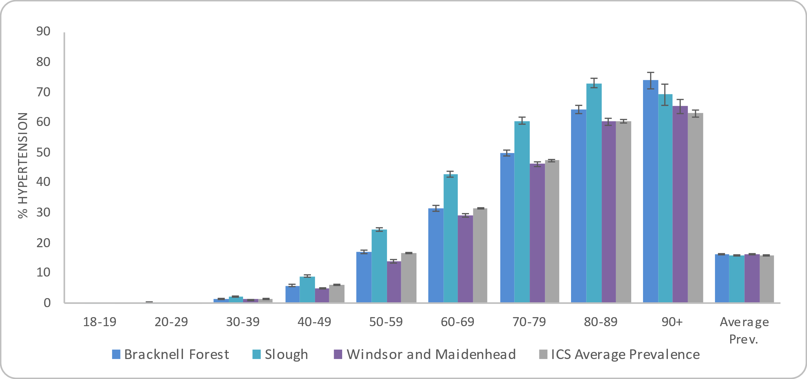
Figure 15: Prevalence of recorded hypertension in adults (18+) by age group in Frimley ICS and Berkshire East local authorities
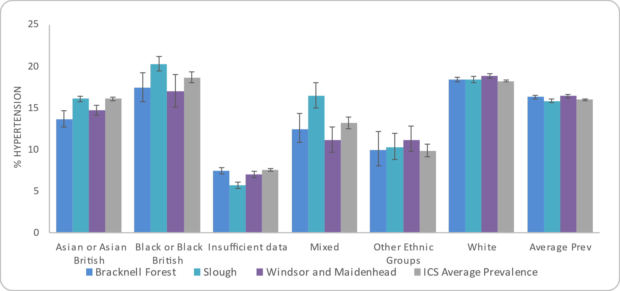
Figure 16: Prevalence of hypertension in adults (18+) by ethnicity in Frimley ICS and Berkshire East local authorities

Source: Connected Care - Frimley ICS Analytics Team (Jan 2022)
There is no clear link between deprivation and hypertension prevalence across Frimley ICS or within individual local authorities. The differences in prevalence rates between males and females is also minimal.

2.8.2 Prevalence of undiagnosed hypertension
Approximately 41% of people with hypertension are unaware that they have the condition and have not been diagnosed (UKHSA 2017). This represents an additional 42,000 people in Berkshire East. It is important to note that populations with higher hypertension prevalence recorded could show better detection and diagnosis rates, rather than an actual increased level of the condition in that population group. PHE’s (2021) analysis of hypertension prevalence suggested that the detection rate for hypertension varied significantly across Berkshire East’s GP Practices, ranging from 54% to 100%.

Specific population groups
In addition to the data presented by age, sex, ethnicity, and deprivation, the HNA Steering Group recognised the importance of looking at specific population groups to see how health behaviours differed compared to the general population. The aim of this analysis was to highlight and quantify inequalities, where possible. Information about these groups is summarised below, with the full analysis of this data included at section 4 in Appendix 2.

2.9.1 Pregnant women
Pregnant women are an identified target group as modifiable risk factors, such as smoking, alcohol and obesity, can have health impacts on both mother and child.
- Mothers who are overweight or obese have increased risk of complications during pregnancy and birth and babies born to obese women have higher risks including foetal death, stillbirth, and congenital abnormality
- Smoking during pregnancy causes premature births, miscarriage, and perinatal deaths. It also increases the risk of stillbirth, complications in pregnancy, low birthweight, and of the child developing other conditions in later life.
Figure 17: Prevalence of smoking and obesity in early pregnancy (2018/19)
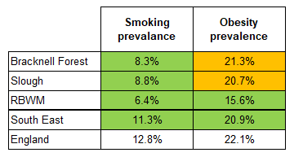
At the maternity booking appointment, midwives ask questions about the mother’s weight and smoking status to ascertain the risks to the pregnancy and advise on recommended actions where necessary (OHID 2022). Figure 17 shows the prevalence of smoking and obesity in early pregnancy for 2018/19.
The prevalence of smoking in Berkshire East is significantly lower than the national and regional rates. Nationally, the population groups that have higher smoking rates in early pregnancy are:
- People from more deprived areas – the prevalence rate decreases through the deprivation deciles and is lowest in the least deprived areas
- Younger people – the younger the mother the more likely they will smoke
- People who have been pregnant before (14.5%), compared to first pregnancies (9.8%).
Source: OHID (2022); Child and Maternal Health Profile
The prevalence of obesity in early pregnancy ranges from 15.6% to 21.3% in Berkshire East. Nationally, the population groups that have a higher prevalence of maternal obesity include:
- People from more deprived areas – the prevalence rate decreases through the deprivation deciles and is lowest in the least deprived areas
- People from black ethnic groups (32.6%), followed by those from mixed ethnic groups (23.1%)
- People who have been pregnant before (24.1%), compared to first pregnancies (18.3%).

2.9.2 People with a disability
People with a disability are defined in many national surveys as those who self-report any physical or mental health conditions or illnesses that have lasted or are expected to last 12 months or more, that have a substantial effect on their ability to carry out normal daily activities (OHID 2022).
Some of the sources included in this HNA have identified disability as a factor which impacts on people’s health and also their health behaviours. These have highlighted the increased prevalence of obesity and overweight in people who are disabled, as well as lower levels of physical activity and more sedentary behaviour (Sport England 2022). People with a long-term mental health condition are also 2.4 times more likely to smoke than the rest of the adult population (OHID 2022).

2.9.3 People with a learning disability
People with a learning disability will have been included in the analysis of data for disabilities as a whole, however there are health and lifestyle factors that specifically impact on those with learning disabilities.
In Berkshire East, there are 1,507 people with a learning disability recorded on their GP Practice record (Connected Care - Frimley ICS Analytics Team, June 2022). There is a significantly higher prevalence of obesity (32.0%), overweight (15.6%) and Type 2 diabetes (9.7%) in adults with a learning disability when compared with the adult population that do not have a learning disability. The prevalence of hypertension is lower (16.1%); however, this could partly be explained by the difference in age profiles as people with a learning disability are notably younger than the adult population as a whole.

2.9.4 Carers
There are no datasets that specifically look at the health behaviours of carers in Berkshire East, so the needs of this population group are unknown. However, information from the 2011 Census and Carers UK surveys do help to identify some key points about carers’ health.
In 2011, 23,400 people across Berkshire East provided unpaid care for a friend of family member who needed help because of illness, frailty, disability, mental health problem or addiction (Office for National Statistics 2012). Unpaid carers are more than twice as likely to suffer from poor health, compared with people without caring responsibilities. In Berkshire East, 18% of people providing unpaid care reported that their own health was fair, bad, or very bad.
84% of carers surveyed nationally said that their caring responsibilities impacted on their health and 64% attributed health risks to lack of support (Carers UK 2015). A report on carers aged 55 and over also showed that carers were less active than people without caring responsibilities (14% of carers were active compared with 54% of all adults), with 76% of carers acknowledging that they do less physical activity than they would like to (Carers UK 2021).

2.9.5 Asylum seekers / refugees
People seeking asylum in the UK are not a homogenous group and their health needs are likely to be diverse. Detailed information about the health of asylum seeks and refugees is not held nationally or locally and can therefore not be included in this report. There is ongoing academic research regarding health seeking behaviour in asylum seeker populations, such as structural barriers to healthcare access, maternity care, physical activity, or mental health care perception, and the findings from this research will help to identify specific health needs in time.

Impact of Covid-19 on healthy behaviours
The majority of data sources and literature used for this HNA have focussed on time periods prior to the Covid-19 pandemic. This section provides a summary of the data and evidence available that highlight how health behaviours may have changed during and after the pandemic restrictions. Additional information can be found in section 5 of Appendix 2. The OHID will also continue to publish more data, as they become available, on the Wider Impacts of Covid-19 on Health Profile, Wider Impacts of Covid-19 on Health monitoring tool (WICH) and the Covid-19 Health Inequalities Monitoring for England tool (CHIME).

2.10.1 Healthy Eating
Key aspects from different national surveys state that:
- Increased cooking during the pandemic restrictions may be linked to healthier food choices being made: 24% of survey respondents stated that the quality of their diet had improved and approximately 73% claimed to have enjoyed cooking in a year-long period between 2020 and 2021 (YouGov 2022)
- Increase in food insecurity between May 2020 to October 2021 may have negatively influenced eating habits and levels of nutrition intake (Food Safety Authority 2022). Larger households (with 4+ residents), younger households (aged 16 to 24) and those with a child present were more likely to be food insecure. The cost-of-living crisis may have further exacerbated inequalities in food insecurity
- Restrictions increased the amount of take away food being consumed and could lead to permanent change in behaviours: 34% of people stated that they were ordering takeaway food more regularly, as opposed to their activity pre-pandemic, with 13% saying they would continue to order takeaways more regularly once the pandemic ended. This was highest in the 16 to 29 year old group (51%) (ONS 2021).

2.10.2 Physical Activity
Data shows that during 1st lockdown (23rd March to 4th July 2020) there was an overall 4% increase in the proportion of people who were physically active nationally. However, this was not sustained and returned to pre-pandemic levels in March 2021. This pattern was generally seen across all sex, age, disability, ethnicity, and occupation groups. The only groups that did not follow this trend were those aged 85 and over, which slightly decreased physical activity levels during lockdown 1, and people who were long-term sick or disabled (OHID 2022).

2.10.3 Smoking
The Opinion and Lifestyle Survey and YouGov surveys have both monitored smoking prevalence at different stages of the pandemic and do not show any significant changes in peoples reported smoking habits overall (OHID 2022). Approximately 47% of smokers stated that the number of cigarettes they smoked was the same as pre-pandemic levels, while slightly more smokers said that their usage had increased compared to those who said they had reduced the number of cigarettes.

2.10.4 Alcohol
In a PHE (2021) survey, 59% of respondents reported drinking more alcohol between March 2020 and March 2021.
There were 3% fewer unplanned hospital admissions for alcohol-specific conditions during the pandemic, when compared to 2019. There was also a rapid decrease in alcohol-related conditions from February 2020. The trend in decreased alcohol-related admissions coincided with reductions in hospital admissions generally. However, in 2020 there was a 20% increase in alcohol specific deaths and an 11% increase in deaths from mental and behavioural disorders due to alcohol (PHE 2021). The true impact of increased alcohol consumption is likely to take many years to be seen in longer-term alcohol-related conditions.

Key points to inform HNA recommendations
- Large numbers of the adult population in Berkshire East are overweight or obese (57% in RBWM, 61.9% in Slough and 63.5% in Bracknell Forest.
- One in five (21.4%) Reception aged children (4-5 years) and one in three (35.4%) Year 6 children (10-11 years) in Berkshire East are overweight or obese. Slough has one of the highest rates of childhood obesity in the South East, while RBWM’s rates are significantly lower than the national average.
- Large numbers of the adult population are physically inactive (undertaking less than 30 minutes of physical activity per week): roughly one in five (20.2%) of the adult population in RBWM and Bracknell Forest (22.8%) and over one in three adults in Slough (38.1%). Levels of physical inactivity are high in the older population (65 and over, compared to 16- to 64-year-olds). The proportion of females that are inactive in Slough is much higher than RBWM and Bracknell Forest.
- One in 10 adults smoke in RBWM (10.3%) and Bracknell Forest (10.6%) and one in seven in Slough (13.9%). The prevalence of smoking in Slough particularly stands out as an outlier when broken down by ethnic group – for example, which ethnic groups in Slough have 2.5 times higher smoking prevalence rates than people from other ethnic groups.
- Using the national prevalence, as a model, it is estimated that there are over 62,500 people aged 16 and over in Berkshire East that are drinking at increasing levels of risk and over 13,000 at a higher risk level and could benefit from reducing their alcohol consumption.
- Approximately 41% of people with hypertension are undiagnosed which represents 42,000 people in Berkshire East.
- Healthy behaviours differ across Berkshire East and between population groups. National and local data indicate that people from more deprived areas are more likely to have higher rates of obesity and overweight, poor diet, higher levels of physical inactivity and smoke. There are also clear relationships between age, gender and ethnicity and the uptake of healthy behaviours - but these relationships differ depending on which healthy behaviour is being looked at.

Current service provision across Berkshire East

Overview of current service provision in Berkshire East
Health behaviour services are commissioned both nationally and locally. In Berkshire East, local services are commissioned through the local authority public health teams and NHS providers (previously Frimley CCG and now Frimley ICB).
Information about Berkshire East’s health behaviour services and commissioning timelines were collated from Bracknell Forest, Slough, RBWM, Frimley ICS and Frimley CCG and covered the period between December 2021 and February 2022. This section provides a summary of the key findings of this analysis.
The types of health behaviour services commissioned in Berkshire East vary. Bracknell Forest and RBWM commission behaviour-specific programmes, while Slough has commissioned an Integrated Wellbeing Service since April 2020. Slough’s service includes the following health behaviour support packages:
- Children and adult Weight Management Programmes (WMPs)
- Stop Smoking services
- Alcohol identification and brief advice (IBA)
- NHS Health Checks
- Falls prevention
- Sedentary behaviour change
- Advice on oral health.

3.1.1 Weight management services
Bracknell, Slough and RBWM all currently commission a tier 2 adult weight management programme (WMP) with each service delivered by a different provider. Slough is the only local authority in Berkshire East to commission a Child WMP.
‘Weight Off Your Mind’ is available across Berkshire East. This is a course of six sessions and a final masterclass that aims to help participants lose 5% of body weight and maintain this weight loss long term.

3.1.2 Stop Smoking services
Three separate stop smoking services are commissioned across Berkshire East:
- Stop smoking services in Bracknell Forest and Slough are provided by Solutions 4 Health and include Nicotine Replacement Therapy (NRT)
- RBWM’s service, provided by Cranstoun, involves a four-week programme, and does not currently offer NRT. Quit rate data are not biochemically validated with a carbon monoxide reading.
With the funding through the NHS Long Term Plan, Frimley Health Foundation Trust (FHFT) has committed to the development of an in-house stop smoking service.

3.1.3 Alcohol services
Berkshire East does not have a common approach to support people with alcohol consumption levels that create an increased risk to their health.
- Bracknell Forest currently commissions a service for low level alcohol needs
- RBWM commissioned Lower My Drinking up until 31st March 2022, which consisted of an app and a digital platform to address tier 2 alcohol needs
- The Slough Wellbeing Cloud (part of Slough’s Integrated Wellbeing service) has been commissioned until 31st March 2023 and provides Intervention & Brief Advice (IBA) and basic intervention.
There are more generic services nationally, such as Drinkline and Alcoholics Anonymous. However, it is not possible to monitor the uptake and success of these programmes at a local level

3.1.4 Type 2 diabetes
Berkshire Healthcare NHS Foundation Trust’s (BHFT) Low Carb Diet, Diabetes Education and Awareness for Life (DEAL) and DEAL PLUS are available to residents in Berkshire East with type 2 diabetes.
The NHS Digital WMP is commissioned at a national level and is accessible to obese individuals who have Type 2 diabetes, hypertension, or both. The BMI threshold for this service has been lowered to 27.5kg/m² for people from black, Asian, and ethnic minority backgrounds and includes people who are at the higher end of the overweight BMI category. The NHS Diabetes Prevention Programme is also commissioned at a national level to identify people at risk of developing type 2 diabetes, referring them to further support to make lifestyle changes.

3.1.5 Hypertension
Hypertension is screened for as part of the NHS health check programme, which is a 5-yearly check-up for people aged 40 to 74 that do not have a diagnosed long-term condition. The purpose of this health check is to spot early signs of cardiovascular diseases, such as hypertension, and dementia. The nationally commissioned NHS Digital WMP (detailed in section 3.1.4) also includes people with diagnosed hypertension.

Overview of current service provision in Berkshire East
The monitoring of service outcomes is vital to assess whether the needs of the population are being met. It is important to note that data collection methods vary across services, and they are therefore not always comparable.

3.2.1 Healthy weight service outcomes

Bracknell Forest
At the time of writing, Bracknell Forest’s Tier 2 adult WMP had only recently started and therefore data were not yet available to include in this HNA.

RBWM
RBWM’s Tier 2 adult WMP commenced in September 2021, consisting of 3 separate services: Gloji, Man v Fat Football and Man V Fat Challenge at Work. 16% of participants attending the adult WMP are from ethnic minority backgrounds, compared to 13% of the Borough’s population (ONS 2012). As of May 2022, service outcomes were as follows:
- Gloji (12-week duration): 177 participants with a total weight loss of 139kg. 6% (n=11) of participants lost 5% body weight and approximately 11% (n=19) lost 3% bodyweight
- Man v Fat Football (14 week duration): 40 participants with a total weight loss 92.8kg. 73% (n=29) recording weight loss, average weight loss 1.9% bodyweight and 15% (n=6) participants have lost 5% bodyweight
- Man v Fat Challenge at Work: no participants have signed up to this service yet
- Initial outcomes from Gloji and Man v Fat Football appear promising, however it will be important to assess outcomes in the medium term (at 26 weeks and one year) to assess if weight loss is sustained.

Slough
The integrated service in Slough identified 2,383 adults as overweight or obese and offered them support. Of these individuals, 78% (n=1,859) declined intervention, 12% (n=286) started the intervention and 7% (n=167) finished the 12-week programme. Of those that did complete the programme, 100% (n=167) either reduced their BMI or stayed stable and 29% (n=48) demonstrated a 5% body mass loss.
Demographic data are not collected for those participating in the weight management service in Slough, however data were collected for the total Integrated Wellbeing Service showed that in 2020/21, 76% of all participants were from an ethnic minority group (not including white minority groups). This was significantly higher than the proportion of Slough’s total population from these ethnic groups at 55% (ONS 2012). Of the 1,414 assessments completed, 38% of service users were from deprived wards.

3.2.2 Stop Smoking service outcomes

Bracknell Forest
Data from Bracknell Forest covered the period October 2020 to Dec 2021 and saw 701 individuals setting a quit date. There was a 4-week quit rate of 59%, which was above the National Institute for Health and Care Excellence (NICE) recommendation of 35%; this quit rate reduced to 35%.
Data were collected on priority groups who set a quit date:
- 57% (n=400) were routine and manual workers
- 9% (n=63) had a mental health condition
- 10% (n=70) had a long-term health condition
- 3% (n=21) were pregnant women.
4-week and 12-week quit data were also collected for these groups with the data showing similar quit rates to total service users:
- Routine and manual workers had a quit rate of 52% at 4 weeks and 30% at 12 weeks
- Those with a mental health condition had a quit rate of 86% at 4 weeks and 45% at 12 weeks
- Those with a long-term condition had a quit rate of 74% at 4 weeks and 64% at 12 weeks.
Ethnicity data from October 2020 to October 2021 showed that 6% (n=39) of service users were from ethnic minority backgrounds (not including white minorities), lower than the proportion of Bracknell Forest’s total population from these ethnic groups at 10% (ONS 2012).

RBWM
The most recent annual data for RBWM’s service is from 2019/20. 55 smokers accessed the service and were encouraged to set a four-week quit date. The demographic data demonstrated that the service users were more likely to be women, people aged 45-59, and from a white ethnic background. The service achieved a 73% four week quit success rate in 2019/20.
Whilst demographic data with regards to sex, age and ethnicity were recorded, the numbers were too small to draw significant conclusions. The rate of successful 4-week quit service users is double that recommended by NICE at present (35%). However, in 2019/20, less than 0.5% of the smoking population of the RBWM accessed the service, significantly lower than the recommended 5% from NICE (NICE, 2021).
Data available from July to December 2021 already show 89 referrals to the service with 47% (n=42) of these needing support for stopping smoking, a significant increase when compared with data from 2019/20. Of the 89 referrals, 31% (n=28) reported that they did not require support.

Slough
Slough’s integrated service saw 803 self-reported smokers in 2021/22, of which 67% (n=537) set a quit date. Out of those setting a quit date, 65% (n=349) successfully quit at 4 weeks. The service has seen under 3% of the smoking population of Slough, below the 5% recommended by NICE.
Demographic data showed that 42% (n=226) of service users who set a quit date had a co-existing mental health condition; 39% (n=209) were routine and manual workers; 55% (n=295) were from ethnic minority backgrounds; 7% (n=38) were pregnant women; and 4% (n=21) were carers. This shows a high proportion of high-priority groups used the service. In addition, data showed that quit rates in all groups except for pregnant women, were similar to the overall four week quit rate. Pregnant women and those with a co-existing mental health condition were also followed up for a 12-week quit rate which were 20% and 48%, respectively.

3.2.3 Alcohol service outcomes

RBWM
Lower My Drinking consisted of an app and a triage/self-assessment website. Between July 2021 and March 2022 there was a total of 147 app downloads, of which there were 15 cases of reduction of alcohol use to lower risk levels and 11 cases of attainment of personal drinking goals. The younger age group (up to 34 years old) had the highest percentage reduction in alcohol use with those in this age group reducing their alcohol use by 98%. This was followed by the 35-54 age group at 60%. Men had a higher percentage reduction in alcohol use than women, 56% and 37% respectively. 31 individuals completed the website triage to determine the risk of their drinking behaviours to their health. This was mostly completed by women rather than men (22 and 9, respectively). The majority (25) of self-assessments were completed by ‘white British’ individuals. The service was not re-commissioned for 2022/23 due to relatively poor uptake of the service and the availability of the national app.
RBWM promotes use of the national MyDrinkaware app. This is a free app that enables people to track alcohol consumption, calculate units and set goals to help moderate drinking.

Slough
Slough’s integrated service screened nearly 100% of the 726 individuals referred to the service with the audit C questionnaire and gave them brief advice. Of these, 68 individuals drank an unsafe level of alcohol, and all were offered Turning Point contact (drug and alcohol service). However, the majority (54 people) declined this.

Key points to inform HNA recommendations
- Demographic data are not collected in a standardised way across healthy behaviours services in Berkshire East (including for those who decline referral or do not complete interventions)
- The reasons why people do not complete health behaviour service interventions are not clear.
- There is a lack of data to understand whether the impact of health behaviour service interventions (e.g., weight loss, quit rates) are sustained over longer periods.
- Stop Smoking services in Bracknell Forest and Slough include Nicotine Replacement Therapy (NRT). RBWM’s service does not currently offer NRT.
- Whilst the successful quit rates in Berkshire East at 4-weeks are higher than recommend by NICE, data from RBWM and Slough show that the total number of service users is lower than the NICE recommendation that services should treat at least 5% of the estimated population who smoke each year.
- For those stop smoking services collecting 12-week quit data, there is a reduction in successful quits between 4 and 12 weeks.
- Not all quit rate data are biochemically validated with a carbon monoxide reading.

Research on integrated health behaviour service models
In recognition that unhealthy behaviours tend to cluster together, and to avoid duplication of services, work has been done in recent years to better understand the role of integrated health behaviour services versus separate behaviour change services (The King’s Fund 2018).
The aim of this section is to understand whether integrated health behaviour services may be more effective than individual services by looking at the available evidence and gaining insight from discussions with commissioners of services.

Evidence on whether separate or integrated health behaviour services are more effective
There is limited research on whether it is better to address multiple unhealthy behaviours together or separately (The King’s Fund 2018, NICE 2014).The National Centre for Smoking Cessation and Training (NCSCT) (2016) reviewed two analyses which together covered over 200 trials assessing four risk behaviours: tobacco smoking, hazardous alcohol use, poor diet, and physical inactivity. They concluded that:
- Only specific risk factors cluster together. At a population level, the greatest co-occurrence is low fruit and vegetable consumption and physical inactivity. At an individual level, tobacco smoking, and hazardous alcohol use cluster together, as do tobacco smoking and poor diet. In contrast, the evidence shows little clustering for physical inactivity with tobacco smoking or with hazardous alcohol use
- Whilst gender and age were not associated with clustering of unhealthy behaviours, being from an ethnic minority group or having a higher socioeconomic status were associated with reduced likelihood of engaging in multiple risk behaviours. The NCSCT (2016) suggest that given the evidence that a number of behaviours do cluster within individuals, and that this may be related to socio-demographic characteristics, integrating services across health behaviours may thus not only reduce wastage by treating common underlying patterns predicted to cross-fertilise to other health risk behaviours, but may also reduce social disparities.
The study concluded that overall, there is some evidence to support multiple risk behaviour interventions that target poor diet and physical inactivity. However, the evidence indicates that stopping smoking should be targeted in isolation. The study also notes that if integrating health behaviour services, commissioners need to consider the available resources, intervention intensity and delivery, and the target population. All of these factors impact the effectiveness and cost effectiveness of multiple risk behaviour interventions.

Learning from existing integrated health behaviour services through discussions with commissioners

Key features of integrated health behaviour services
Discussions with local authorities who already have an integrated health behaviours service highlighted that the design of integrated health behaviour services should be led by an understanding of the population needs, health inequalities, and environmental factors.
Analysis of services within 15 local authorities showed that all services included stop smoking, healthy weight and get active programmes. 10 of these services (67%) also included a drink less programme, 7 (47%) included dedicated support for improving mental health and wellbeing and 6 (40%) included NHS Health Checks. Additional areas covered in some services included high blood pressure monitoring, diabetes prevention, oral health, sexual health, and general self-management. Additionally, one service included a First Contact Plus provision - an online tool which helps adults find information about a range of services all in one place. Some services had links with Making Every Contact Count (MECC), social prescribers and health trainers.
From discussions with six local authority leads, it was clear that there is not a “one-size fits all” model for integrated health behaviour services. Common themes for delivering a good service that were identified by commissioners included:
- A single point of access – all referrals go to one place requiring only one administration team
- Streamlined process for cross-referrals, making it easier, quicker, and more effective to support people with multiple unhealthy behaviours compared to referring into different services
- A consistent approach to measuring health inequalities to demonstrate impact of service on underserved communities
- A blended approach, offering both face to face and digital/online support. This has improved the accessibility of the service depending on user preferences
- Signposting further support beyond the remit of the integrated service can support people to take further action to continue improving their health (if appropriate)
- Staff who are trained to support health improvement across multiple risk behaviours. This leads to efficiencies in service delivery and also means that service users can receive support with applying behaviour change strategies to multiple risk behaviours
- Consulting with residents to understand the needs of the community and to design services appropriately
- Marketing and advertising the service so the community knows about available support and how to access it. As part of this, utilise community groups and residents’ associations to raise awareness.
From the 15 services contacted, the outcome and success measures show the different measures each local authority is using. A key observation was that the service indicators are often broad in their nature.

4.2.2 Effectiveness of existing integrated health behaviour services
Based on discussions held with 15 local authorities who commission integrated health behaviour services, uptake of services had generally been good. This was partially attributed to the provision of mixed approaches, allowing people to access services online or face-to-face depending on their preference.
Some local authorities reported anecdotally that having integrated health behaviour services in place had improved the effectiveness of the service, since there is greater opportunity for staff to impact multiple unhealthy behaviours, particularly when they observe that a person is ready to change their behaviour. However, no outcome data was yet available to support this insight.
Existing services used multiple methods to engage underserved groups, including providing single gender classes, translators attending sessions, providing sessions in different locations across the community, and utilising the current service infrastructure to improve ease of access.

4.2.3 Cost effectiveness of existing integrated health behaviour services
Health professionals in local authority settings reported that having one administration team for an integrated health behaviour service, and staff with a broad skillset, saved time and money.
There is limited published research on the cost effectiveness of integrated health behaviour services. Cost effectiveness of interventions in the UK is determined by NICE and uses ‘quality adjusted life years’ (QALYs) to compare different interventions for different conditions. NICE typically uses a threshold of £20,000 to £30,000 per QALY gained. Interventions over this threshold are less likely to be recommended for use by NICE (NICE, 2015).
Two economic analyses have evaluated the cost effectiveness of behaviour change interventions (Shahab et al 2012, Shahab et al 2013).
A key finding was that when multiple studies are examined, it appears that a greater proportion of stop smoking services are cost effective compared to integrated services. We noted that the evidence on cost effectiveness was collated 10 years ago which is a limitation. Given the number of recently established integrated health behaviour services, this finding may now be different.

Key points to inform HNA recommendations
There is only limited data (either published or from local service evaluations) from which to assess whether integrated health behaviour services are more effective than individual services. The data that are available suggest:
- That it is effective to combine physical activity and healthy diet interventions – supporting achievement of healthy weight.
- There is some evidence to suggest that stop smoking services are more effective (and more cost-effective) when provided as a single service.
- There are common themes, identified by commissioners, for delivering a good integrated health behaviour service.

Evidence reviews on effective interventions for healthy behaviours
This section summarises the effective interventions for improving healthy behaviours in integrated or individual health behaviour services.

Methodology for healthy behaviour evidence reviews
The interventions reviewed are:
- Improving diet
- Increasing physical activity and reducing sedentary behaviour
- Achieving a healthy weight
- Reducing smoking
- Reducing low-level alcohol use
- Hypertension (an additional evidence review compiled for the Frimley ICS Living Well Advisory Board but outside of scope for this HNA since it is a health outcome rather than a health behaviour).

Key findings from healthy behaviour evidence reviews

5.2.1 Healthy diet
This section highlights the key evidence on effective interventions for improving diet in adults in England. It does not seek to review the evidence on ‘what constitutes a healthy diet,’ and adopts the current government definition of a healthy diet.
PHE (2018) set out the government recommendations on healthy eating. The Eatwell Guide shows the proportions of different types of foods that are needed to have a well-balanced and healthy diet. This is supported by recommendations to:
- Choose foods lower in fat, salt, and sugars (eat less often and in small amounts)
- Eat at least five portions of a variety of fruit and vegetables every day
- Choose wholegrain or higher fibre carbohydrates with less added fat, salt, and sugar
- Drink 6-8 glasses of water a day (lower fat milk and sugar-free drinks including tea and coffee all count)
- Limit fruit juice and/or smoothies to a total of 150ml a day
- Choose unsaturated fats/oils and use in small amounts
- Choose lower fat and sugar dairy and dairy-alternative options
- Eat more beans and pulses, two portions of sustainably sourced fish per week, one of which is oily. Eat less red and processed meat.
Additionally, the guidelines state that, on average, women should consume approximately 2,000kcal a day and men should consume approximately 2,500kcal a day (including all food and drinks).

Dietary interventions for preventing excessive weight gain in pregnancy
Excessive weight gain during pregnancy is associated with poor maternal and neonatal outcomes including gestational diabetes, hypertension, caesarean section, macrosomia, and stillbirth. Muktabhant et al (2015) carried out a systematic review to evaluate the effectiveness of diet or exercise, or both, interventions for preventing excessive weight gain during pregnancy and associated pregnancy complications. Authors found high‐quality evidence that diet or exercise interventions, or both, help to reduce excessive weight gain in pregnancy. Moderate‐intensity exercise appears to be an important part of weight‐control strategies in pregnancy; however, more research is needed on side‐effects to inform safe guidelines.

5.2.2 Physical activity and sedentary behaviour
The most relevant evidence on individual level interventions for reducing physical inactivity and promoting physical activity are summarised within PHE’s (2020) Health Matters: Physical Activity-Prevention and Management of Long-Term Conditions.
Physical activity can be defined as ‘referring to all movement. Popular ways to be active include walking, cycling, wheeling, sports, active recreation and play and can be done at any level of skill and for enjoyment’ (World Health Organisation 2021). In the UK the physical activity levels are split into three categories:
- 3 to 18 year olds: this group should aim to complete 60 minutes of physical activity per day (Department of Health and Social Care (DHSC) 2019)
- adults and older adults who should aim to complete, at a minimum, 150 minutes of moderate physical activity per week (DHSC 2019)
- disabled children and young people should aim to complete 20 minutes of physical activity per day (DHSC 2019).

Effectiveness of digital interventions for physical activity
NICE (2020) recommends the consideration of digital and mobile health interventions as an option for people who would benefit from improving their diet or increase their physical activity levels. However, NICE suggests effectiveness is variable. Apps can be useful to self-monitor and report information, although NICE does refer to the fact that those with an eating disorder should not begin an intervention which includes self-reporting.

5.2.3 Healthy weight
The most relevant evidence on individual level interventions for improving weight management are summarised in:
- Tackling obesity: empowering adults and children to live healthier lives (Local Government Association 2021)
- Weight management: lifestyle services for overweight or obese adults (NICE 2014)
- Weight management lifestyle services for overweight or obese children and young people (NICE 2013).

Defining healthy weight
Body Mass Index (BMI) – an adult’s weight in kilograms by their height in metres squared - is the most commonly used measure to define a healthy weight. BMI is split into four categories (NHS 2022):
- <18.5 kg/m² underweight range
- 18.5 to 24.9 kg/m² healthy weight range
- 25 to 29.9 kg/m² overweight range
- 30 to39.9 kg/m² obese
There is a caveat with the use of BMI that muscle is much denser than fat, so very muscular people may be classified as obese even though they may be metabolically healthy. A further caveat to be aware of is that the BMI cut-offs were determined by research on white European populations; some ethnic groups may have different cut-offs which are not represented by this measure (Caleyachetty et al 2021).

Weight management programmes for children and young people
NICE (2013) recommends that providers ensure a family-based, multi component lifestyle weight management service for children and young people are available as part of a community-wide agency approach to promoting a healthy weight. The services for children and young people should include diet and healthy eating habits, physical activity and reducing time spent being sedentary. NICE also recommends that the following components are input into the programme: behaviour change techniques to increase motivation and confidence to change, positive parenting skills training, emphasis on encouraging all the family to eat healthily and be physically active, tailored plan for the individual and ongoing support.

A scoping review of qualitative evidence from the UK and Europe suggests tailoring programmes to better suit the needs of underserved populations. It also suggests more co-produced research is required to support the government ambition to reduce overweight and obesity (PHE 2020).
A systematic review was carried out to identify the programme characteristics and combinations of characteristics that are associated with successful weight management outcomes. The three key mechanisms perceived by children, parents, and providers to support behaviour change were fostered by the most effective interventions and were not fostered by the least effective interventions. The three key mechanisms were:
- showing families how to change: physical activity sessions for children, practical behaviour change strategies and advice on calorie intake
- getting all the family on board: discussion / education sessions for both parents and children, child friendly sessions, aiming to change the whole family behaviours
- Social supports: group sessions specifically for children and adults (Sutcliffe, Burchett, Rees, Melendez-Torres, Stansfield & Thomas, 2017).

Weight management programmes for adults
NICE (2014) recommends that an integrated approach to preventing and managing obesity is adopted. This suggests working with local communities. Systems should be in place to refer people to receive support from across the service tiers and that all obesity pathways should be made clear to professionals and the public. Local services should be identified, and facilities and groups should be included to identify needs of the group and address the wider determinants. Ensure staff in local health services know where to refer individuals and ensure the lifestyle service meets the needs of the local population.
NICE recommends the planning of behaviour change interventions and programmes. This suggests working together with key stakeholders, considering the local and cultural needs of the community. NICE recommends considering the objectives of the intervention, evaluation plans, target group, whether there is a need for tailoring or not, intervention characteristics, training requirements, quality of support, follow up measures.
NICE also recommends ensuring interventions meet the individual’s needs. It suggests service users are given clear information on behaviour change and the service, that the programme meets service user’s needs, whilst recognising that some people may not be accepting of change. Additionally, it is important to plan when the measurements will be taken pre, during and post the intervention. Tailoring the intervention to the individual’s need is important when assessing people’s behaviours, participants physical and psychological capability and how motivated they are to change.
Evidence-based behaviour change techniques recommended, for tier 2 adult weight management services, suggest that weight management interventions associated with self-regulation or control theory (Carver and Scheier 1998), appear to lead to more weight loss (Michie et al 2009, Dombrowski et al 2014). This includes techniques such as prompt specific goal setting, providing feedback on performance, prompt self-monitoring of behaviour and prompt review and reassessing of behavioural goals (NICE 2014).

Weight management and inequalities
NICE recommends that both integrated and individual services should be tailored to meet the needs of the individuals. This includes people with specific needs including cultural, social, and economic needs. (NICE 2014). The UK government suggests that there is mixed evidence that people with learning disabilities are supported with weight management. People with learning disabilities may benefit from health promotion work to help understand the benefits of effective weight management. Programmes also need to be adapted for people with learning disabilities. This includes the use of abstract images, people with learning disabilities benefit from multi-disciplinary and multi-component approaches, require support to understand the risk of unhealthy weight management and the involvement of peers without disabilities who provide support. (PHE 2020).

Effectiveness of digital interventions for weight management
The evaluation of the NHS Weight Loss Plan app showed most users who reported weight loss found that 17% of starters and 94% completers reported a reduction in weight whilst using the 12-week plan. On average, starters reported 2.4% (2.1kg) reduction in weight and completers reported 6.5% (5.8kg) reduction in weight compared to their starting body weight. 17.1% of starters and 64.2% completers reported weight loss of 5% of more. However, there was a large drop off between those downloading and starting the 12-week plan, and between those who started and those who completed the plan. This highlights a need to understand the barriers to starting, and the high attrition rates once using it (PHE 2021).

5.2.4 Smoking

Interventions for stopping smoking
In 2019, the government set an objective for England to be smokefree by 2030, meaning only 5% of the population would smoke by then. The Khan Review (2022) set out the further action required for this target to be met and made a series of recommendations. The review found that without this further action, England will miss the smokefree target by at least 7 years, and the poorest areas in society will not meet the target until 2044. This HNA does not repeat all of the recommendations, instead those recommendations relevant to the design of stop smoking services are highlighted here:
- Recommendation 8: Offer vaping as a substitute for smoking, alongside accurate information on the benefits of switching, including to healthcare professionals. Provide free Swap to Stop packs in deprived communities
- Recommendation 13: Tackle the issue of smoking and mental health. Disseminate accurate information that smoking does not reduce stress and anxiety, through public health campaigns and staff training.
NICE (2021) recommends that a range of interventions are available to people who smoke, including behavioural interventions, medicinally licensed products, and nicotine-containing e-cigarettes. Holliday et al (2021) found benefit from behavioural interventions combined with nicotine replacement therapy (NRT) or e-cigarettes.
Behavioural interventions are one of the most common interventions for stopping smoking. The success of this intervention is influenced by the characteristics of the behavioural intervention, its intensity, and who delivers it (Rice et al 2017, Livingstone-Banks et al 2019, Hartmann-Boyce et al 2021, Carson-Chahoud et al 2019). The literature indicates that more intensive behavioural support is beneficial for stopping smoking, but this depends on the individual or group receiving the support (Rice et al 2017). Some studies suggest that group counselling is more effective than individual counselling (Fanshawe et al 2017, Stead et al 2017).
A common intervention for stopping smoking is behavioural support combined with a pharmacotherapy offer. Hartmann-Boyce et al (2021) found behavioural support increases quit rates regardless of concurrent use of pharmacotherapy, though the effect of behavioural support for stopping smoking is slightly less pronounced when people are already taking pharmacotherapies. There is a large pool of literature identifying that a combination of behavioural support and pharmacotherapy increased the likelihood of stopping smoking (Holliday et al 2021, Apollonio et al 2016, Stead et al 2016).
Self-help is one of the simplest interventions for stopping smoking. The literature suggests that when no other intervention or support is available, self-help resources help more people to stop smoking than if there was no intervention. However, these resources are more effective when tailored to individuals (Livingstone-Banks et al 2019). These findings show the benefit of self-help, but when compared to more intensive interventions, self-help is not as effective in supporting people to stop smoking (Stead et al 2017).
In terms of monitoring stopping smoking, The Russell Standard (2005) set out an English national standard for measurement criteria that allow meaningful comparison between stop smoking services. The primary measure for stop smoking service success is the carbon monoxide 4-week quit rate. A 4-week quitter is defined as someone who reports abstinence between weeks two and four from the target quit date, verified by an expired air CO concentration of less than 10ppm (parts per million). The only exception to the 10ppm threshold is for pregnant smokers where in order to avoid missing any women who smoke, given the heightened importance of stopping smoking at this time, a lower cut-off point of 4ppm is recommended.

However, some stop smoking services are commissioned to offer extended behavioural support beyond four weeks post-quit date, usually to 12 weeks. Increasing behavioural support has been found to be associated with modestly increased chances of successful quits (Hartmann-Boyce et al 2021)

Smoking and inequalities
Smoking is three or four times as common in some disadvantaged communities compared to the most affluent and accounts for half of the gap in life expectancy in England (The King’s Fund 2022). The Khan Review (2022) highlights that reducing the prevalence of smoking could therefore reduce much of this gap and also make a big contribution to the government’s healthy life expectancy goals as part of the Levelling Up agenda.
Higher smoking prevalence is associated with indicators of deprivation and marginalisation, such as low income and unemployment (Action on Smoking and Health (ASH) 2019). This trend is also present with vaping where higher rates are seen in more disadvantaged groups (PHE 2020, PHE 2021). In a more recent publication, ASH (2022) highlighted how finances should be targeted to populations in which smoking does the most damage and has the largest impact.
The King’s Fund (2022) highlight that some population groups are more dependent than others, such as those experiencing severe mental health problems. In addition, gender and ethnicity have an impact on how people perceive and use stop smoking services. In terms of gender, at a global level, male smoking rates have peaked whereas female rates are set to increase (Greaves et al 2015). Research indicates that ‘woman-centred approaches’ that include harm reduction, motivational interviewing and trauma-informed elements are important elements of stop smoking services for encouraging stopping smoking in women. In terms of ethnicity, in 2019 the percentage of adults in England who smoked was higher than average in the mixed (19.5%) and white (14.4%) ethnic groups (ONS 2021). The percentage of adults who smoked was lower than average in the Chinese (6.7%), Asian (8.3%) and black (9.7%) ethnic groups.

Effectiveness of digital interventions for smoking
There is evidence that mass media interventions (campaigns) can increase stopping smoking, with the intensity and duration of campaigns impacting effectiveness. However, this evidence was derived from a diverse group of studies which differed in their methods (Bala et al, 2017). Stoptober is an annual national campaign run by PHE. The 2020 campaign evaluation highlighted that the campaign generated quit attempts in 12.3% of all smokers and recent ex-smokers; 4% reported that they were not smoking at 4 weeks (PHE 2021).
Whittaker et al (2019) found evidence that interventions based on automated text messaging resulted in greater quit rates compared to minimal stop smoking support but found no evidence that smartphone apps improved the likelihood of stopping smoking.
When looking at internet-based interventions for stopping smoking in adults, Taylor et al (2017) established that interactive and tailored internet-based interventions (with or without additional behavioural support) are moderately effective. However, no evidence was found to support that internet-based interventions are more effective than other stop smoking interventions.

5.2.5 Low level alcohol use

The tiered approach to prevention and treatment
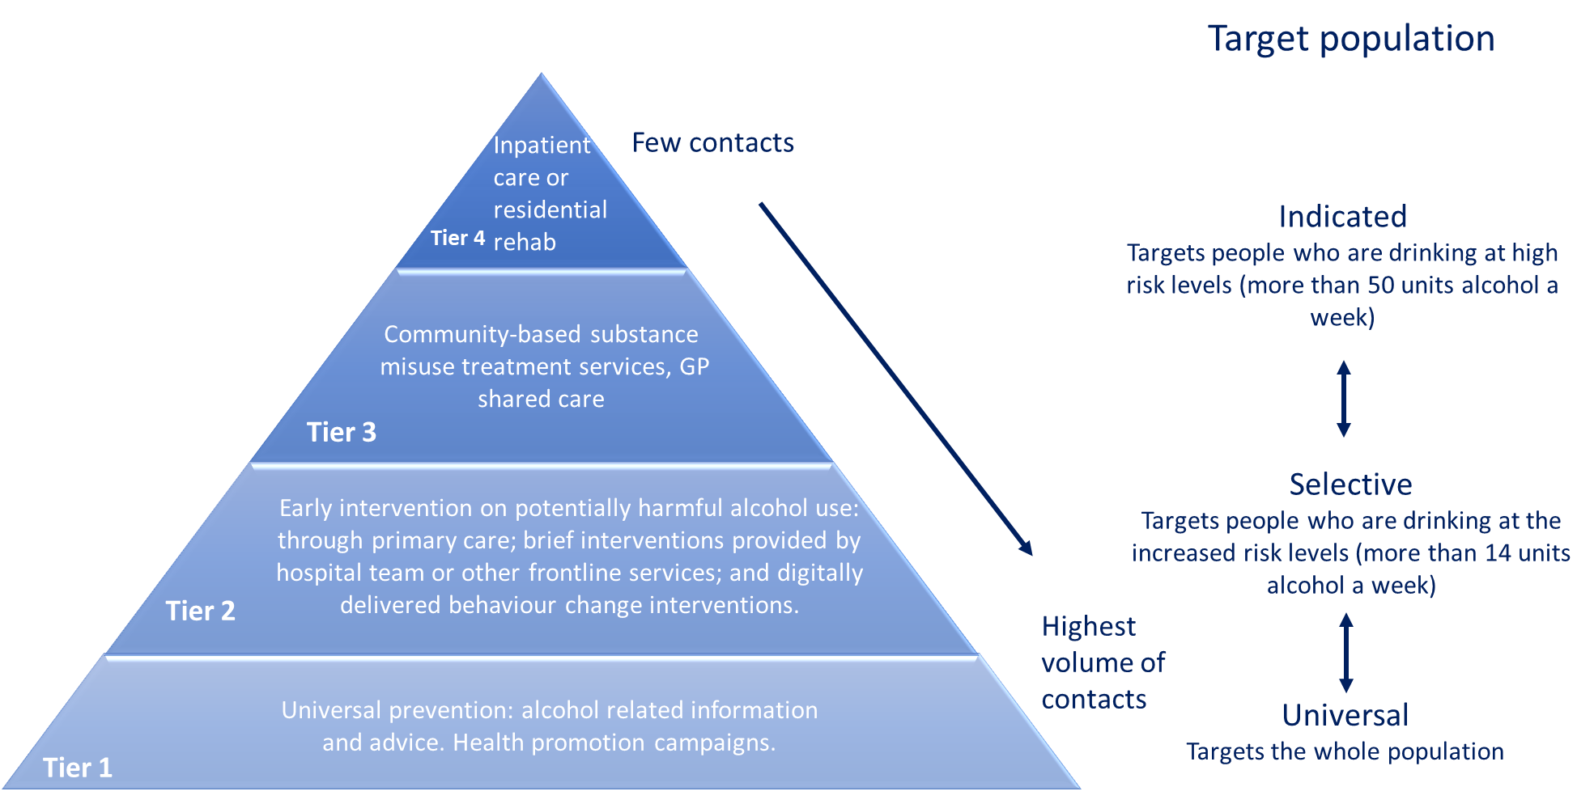
Approaches to the prevention and treatment for alcohol use are generally most effective when proportionate to the level (or tier) of need (PHE 2018). The different levels of need are shown in Figure 18 with Tier 1 referring to the whole population, Tier 2 referring to people drinking above the Chief Medical Officers’ recommendation of 14 units alcohol per week and Tiers 3 and 4 referring to people who are drinking at the most harmful levels – generally those drinking 50 or more units of alcohol a week.
Figure 18: Interventions for the treatment and prevention of harm and alcohol at each Tier of need
Source: RBWM Public Health Team 2022
This HNA considers specifically the support needs for people at the Tier 2 level of need.

Effective interventions for low-level alcohol needs (Tier 2)
Key evidence for effective interventions for reducing alcohol intake have been summarised within the PHE (2018) Guidance: Alcohol commissioning support: principles and indicators (PHE 2018). The key recommendations relevant to the design of local services, are set out here together with evidence from other key papers.
- Brief interventions: These typically comprise a discussion on alcohol use and health-related harms, identification of high- risk situations for heavy drinking, simple advice about how to cut down drinking, strategies that can increase motivation to change drinking behaviour, and the development of a personal plan to reduce drinking. Brief interventions are designed to be delivered in regular primary care consultations, which are often 5 to 15 minutes with doctors and around 20 to 30 minutes with nurses. Although short in duration, brief interventions can be delivered in one to five sessions (Kaner at al 2018). Brief interventions can also be delivered by other frontline professionals who are trained to deliver them (PHE 2018)

A systematic review of 34 studies (15,197 participants) (Kaner at al 2018) found that brief interventions provided by doctors or nurses in primary care settings or emergency care reduced heavy drinking, compared to drinking levels in people who received usual care or brief written information. The study found that longer interventions probably make little or no difference to heavy drinking compared to brief interventions

Targeted interventions and brief advice (IBA) aimed at individuals in at-risk groups can help make people aware of the harm and change their behaviour, preventing extensive damage to health and wellbeing (PHE 2018). NICE (2010) recommends delivering IBA in all adult health, social care, and criminal justice settings

- Quick access to effective and evidence-based alcohol treatment: PHE (2018) highlight that successful treatment and recovery is optimised by providing welcoming, easy to access and flexible services that cater for the needs of a broad range of people and problems. These services should be available for people with both moderate (Tier 2) and higher risk drinking behaviours.
PHE (2018) highlight that mutual aid (such as Alcoholics Anonymous) should be appropriately integrated with all alcohol services including community services, in-patient and residential treatment services. Local services are encouraged to support service users to engage with mutual aid groups through the inclusion of specific requirements in their service specifications.

Low level alcohol use and Inequalities
Within the delivery model for IBA, there are specific interventions to raise awareness of the harms of drinking for at-risk groups, such as pregnant women, older people and those with existing long-term conditions or mental health issues (PHE 2018).

Digital support for low level alcohol needs
Many support services for alcohol and drugs are starting to develop behavioural change programmes through digital media, such as smartphone apps. Digital interventions for alcohol reduction have a number of advantages over face-to-face methods, such as a low cost per user, greater reach, avoidance of stigma associated with receiving help in person and that they are highly convenient to use. Evidence from a systematic review (Kaner et al 2017) found that digital interventions may lower alcohol consumption by an average of up to 3 UK units per week. Although the review did find that the changes are not as large and are of a shorter duration when compared with face-to-face interventions delivered in primary care (which have shown average reductions closer to 5 units per week). However, the reach and accessibility of digital interventions mean that the population impact could potentially be greater.
NICE (2020) produced commissioning guidance for digital and mobile health interventions. These highlight key considerations such as equality of access, cost, expert sources, and impact on and partnerships with existing services.

Key points to inform HNA recommendations
- Health behaviour services should follow the national recommendations as outlined in:
- A Quick Guide to the Government’s Healthy Eating Recommendations, PHE (2018)
- Helping older people maintain a healthy diet: a review of what works, PHE (2017)
- Chief Medical Officer’s Health Matters: Physical Activity – Prevention and Management of Long-Term Conditions, PHE (2020)
- NICE Public Health Guideline 53 (PH53) - Weight management: lifestyle services for overweight or obese adults, NICE (2014)
- NICE Public Health Guideline 47 (PH47) - Weight management lifestyle services for overweight or obese children and young people, NICE (2013)
- NICE Guideline NG209 - Tobacco: preventing uptake, promoting quitting and treating dependence, NICE (2021)
- Alcohol commissioning support: principles and indicators, PHE (2018).
- To consider including digital and mobile interventions within services as an option for people who would benefit from improving their diet, increasing their physical activity levels, or reducing their alcohol consumption.
- Services should be tailored to better suit the needs of underserved populations and individuals. This includes people with specific needs including cultural, social, and economic needs and the needs of people with learning disabilities and those with severe mental health problems.
- To ensure, in line with NICE recommendations, that a family-based, multi component lifestyle weight management service for children and young people is available as part of a community-wide agency approach to promoting a healthy weight. To be effective, this service should ensure that the whole family is on board with the programme, that there are opportunities for parents and children to receive social support and that families are not just told what to change but shown how to change.
- In line with NICE guidance, all healthy weight pathways should be made clear to professionals and the public.
- To offer vaping as a substitute for smoking, alongside accurate information on the benefits of switching, including to healthcare professionals. Provide free Swap to Stop packs in deprived communities.
- To disseminate accurate information that smoking does not reduce stress and anxiety, through public health campaigns and staff training, to help tackle the issue of smoking and mental health.
- Given increasing behavioural support has been found to have modestly increased chance of quitting, certain smoking populations could benefit from behavioural support beyond four weeks post-quit date, alongside stop smoking therapies up to 12 weeks.
- NICE recommends delivering alcohol identification and brief advice (IBA) in all adult health, social care, and criminal justice settings.

Feedback from residents and professionals
Between April and June 2022, Berkshire East’s local authorities each carried out surveys with the public and professionals working in health and other frontline services to ascertain the type of support residents need with improving their health.
The surveys focused on the support needed for four key behaviours that are recognised to have the greatest effect on health:
- Smoking
- Drinking alcohol
- Diet
- Physical activity
The results of these surveys are summarised below for each individual local authority with the full reports attached at Appendices 3 to 5.

Bracknell Forest healthy behaviour surveys

Methodology and number of responses
The survey was produced in two versions (one for the public and one for professionals) and were launched digitally on the BFC Objective Platform. The survey ran from 19th May to 30th June 2022.
The surveys were widely promoted to stakeholders through different communication channels, including:
- Social Media channels (Twitter, Facebook)
- BFC Healthwatch newsletter
- The CCG/Primary care newsletter
- BFC Intranet
- CCG/BFC social prescribers
- And other Voluntary Sectors
- Faith and community groups.
Additionally, stakeholders in attendance at local meetings and forums were given information and encouraged to complete the surveys.
In total 165 survey responses were received from:
- Residents: 133 responses (81%)
- Professionals: 32 responses (19%).

Key findings

Representation
The survey received a good response from both the public and professionals. Response was widely received across the Borough from:
- Middle age group
- Older adults
- Retired residents
- Different ethnic groups (including white British, and a small number of responses from people from ethnic minority backgrounds)
- Individuals who can afford the cost of meeting their basic needs all of the time
- And those who do not have children and young people living in their household.

Findings also reflect views of respondents who reported:
- Living with impairments or disabilities due to long term conditions
- Respondents who are in employment
- People who sometimes cannot afford to meet basic needs for themselves and their family.

Support with health improvement
Responses from the public survey highlighted that:
- 85% (N=113) respondents were looking to make healthy changes e.g., losing weight. 81% (N=108) of the respondents also highlighted they will need support to get active
- In terms of support with smoking cessation, response did not emerge as a strong finding compared to people wanting to lose weight or getting active which is reflective of the prevalence of smoking and obesity in Bracknell Forest
- Only (14%, N=18) respondents indicated wanting to quit smoking and (12%, N=16) respondents wanted to drink less alcohol.

Local services used
Majority of respondents (81%) indicated that they had used different support services in Bracknell to improve their health and wellbeing. This includes:
- Everyone health weight management service
- Smokefreelife Berkshire smoking cessation service
- Primary care services (including GP support)
- Public health social prescribers etc.

The most used support service was Everyone Health Weight Management Service (36%), which we know to be an extremely high demand support service since commissioned due to high overweight and obesity rate in Bracknell Forest (63%). A wide range of other support services had been used by respondents. The majority of respondents that indicated that they would need support also highlighted that they would prefer to continue receiving support either in person, by telephone/ video call or digitally via apps or a website.

Professional
- Responses to the professionals’ survey showed respondents were aware of health improvement services available in Bracknell Forest and had referred into or signposted to more than one of these services previously. However, a few professionals did highlight that they are not aware of some of the new services available, which indicate that more/ regular promotion and awareness of new health improvement services is needed
- When asked Professionals’ views on how helpful they think residents find health improvement services in Bracknell; responses for each service were generally split between very helpful, somewhat helpful, and not sure/unable to say
- Additionally, most of the respondents highlighted a positive experience in the support services available in Bracknell, which shows that things are working
- The findings also provided valuable insight into the ways in which health improvement support could best be provided. For example, making services more accessible (by increasing capacity), sharing of information and support widely and a personalised approach from health professionals is needed.

Barriers to health improvement
Response to the public survey provided valuable insight on the barriers people experience in improving their health. Three key suggestions identified within the answers provided were:
- Cost to leisure centre (such as swimming, gym, physical activity) are viewed as barriers to participation by respondents to this survey.
- Communication – most respondents that have used Everyone Health service, mentioned communication as a key to their health improvement
- Offering more 1.1 sessions in weight management service was also suggested as a barrier to health improvement.
Responses from the professionals survey only highlighted one key barrier to health improvement and reasons people do not benefit from support services below:
- Lack of knowledge of local services available is a key barrier to supporting residents to improve their health.

Specific population groups who are not currently engaged with support services
The survey also provided an insight into specific population groups who are not currently engaged with support services and could benefit most from health improvement support. This includes:
- Homeless people or those placed in unsuitable housing
- Those suffering from mental ill health
- Overweight
- People in deprived and low-income families
- People with learning disabilities
- Rough sleepers
- Elderly and young people.

Future services
A key question in the design of health improvement support is whether services should be integrated (support for multiple health behaviours under one service) or separate.

Public Response
Of the responses to the public survey:
- (41%, N=51) respondents indicated that they don’t mind either having a single service that offers support for smoking, alcohol, diet and exercise or a separate service for smoking, alcohol, diet, and exercise
- (40%, N=49) respondents also indicated that they would like to have a separate service for smoking, alcohol, diet, and exercise
- (19%, N=24) respondents indicated that they would like to have a single service that offers support for smoking, alcohol, diet, and exercise.

Professionals response
Of the responses from professionals:
- (44%, N=14) respondents were in favour of separate services for smoking, alcohol, diet, and exercise
- (38%, N=12) respondents were also in favour of a single service that offers support for smoking, alcohol, diet, and exercise
- (19%, N=6) respondents did not have a strong opinion.
Both the response from professionals and the public indicates that, those that use/refer to health improvement services don’t mind either having a single service that offers support for smoking, alcohol, diet and exercise or a separate service for smoking, alcohol, diet and exercise.
Another key question for the design of health improvement services is whether services are provided in-person or remotely.
- The majority of respondents from the public survey highlighted that; (59%, N=78) respondents would prefer support in person
- (20%, N=27) respondents also stated they would prefer digital support
- (14%, N=18) respondents would prefer to receive support by phone. Similarly, responses from professionals were in favour of offering support through either in person, digitally via apps/website and telephone.
Although Bracknell Forest already have this provision in place, it is important to ensure future health improvement services in Bracknell Forest should continue to include options for accessing support in person, through digital platforms and Telephone to allow residents to select an option that meets their need.
Additionally, when asked professionals in Bracknell Forest if they think we have the right support services in place to help people make healthy behaviour changes; out of the 32 responses received from the professional survey: (81%, N=26) respondents answered Yes and (19%, N=6) respondents answered No. When asked what else is needed, key suggestions about support requirements from professionals were:
- Promote available services widely
- Access to mental health early help support
- Increase capacity of local services as a result of Covid-19 pandemic
- More weight management services
- Reduce cost to health improvement services.

Recommendations
In conclusion:
- Most service users found the services helpful or somewhat helpful
- Service users and professionals were of the view that services for different health behaviours should be separate. This may be due to the fact that majority need was for weight management
- People in employment were not represented in this survey
- Cost of leisure services was highlighted by carer and professionals
- There was a lack of awareness of current services among some residents and professionals.

Current gaps identified that should be considered in recommissioning or service improvement are:
- Include development of an effective marketing strategy/plan to promote health behaviour services available to residents in service specification with a KPI target to increase numbers accessing and completing programmes within the service.
- Explore options with providers, carers and people with sensory, physical disabilities and learning difficulties to make the services accessible to them.
- Educate a wide range of professionals including from voluntary sector on health behaviour services and making referrals to the services through MECC training.

Slough healthy behaviour surveys

Methodology and number of responses
The survey was produced in two versions (one for the public and one for professionals) and were launched digitally via Survey Monkey. The survey ran from 7th June to 19th July 2022.
The surveys were widely promoted to stakeholders through different communication channels, including:
- Social Media channels (Twitter, Facebook)
- The SBC Members newsletter
- The GP newsletter
- Adult Social Care
- Children’s First
- Directly to commissioned services
- With our Voluntary Sector organisation.

In total 133 survey responses were received from:
- Residents: 114 responses (86%)
- Professionals: 19 responses (14%).
A summary of the findings are included below.

Key findings

Representation
There was a reasonable number of responses to the public survey in Slough. Responses tended to come from older members of the community when compared to the age profile of residents; with most responses coming from those in the 55-64 cohort whereas the largest age cohort in Slough residents is 30-44 (Berkshire Observatory 2022). In terms of the ethnicity of respondents the Asian/Asian British cohort in particular is underrepresented compared to Slough as a whole. There was also a disparity with regards to the proportion of female responses – with 70% of those completing the survey identifying as female in comparison to 51% of the population of Slough as a whole.
Employment and economic status representation amongst respondents was again skewed towards those who are not economically active with 54% of respondents reporting being either fully employed, part time employed or self-employed as opposed to 82% of Slough residents generally. However, the number of Slough residents reporting fuel poverty in 2018 (9%) roughly correlates with the 10% of survey responses reporting an inability to afford to cover basic needs.
The number of responses to the public survey was reasonable. Findings were skewed towards representing views of older (53% aged 55 and over), white British (51%), employed (31%) residents in Slough who identify as female (70%), can afford the cost of meeting their basic needs all of the time (51%) and who do not have children or young people living in their home (69%).
The number of responses to the professionals’ survey was low, meaning that findings could not be assumed to represent the views of a wide cohort of Slough professionals working in frontline services. Despite this, a range of professional groups responded, and the findings provided valuable insight into the ways in which health improvement support could best be provided.

Support with health improvement
It is s clear from responses to the survey that Slough residents are keen on making changes to their lifestyle to improve their health. 77% of respondents stated that they were interested in getting active and losing weight. A lesser proportion wanted to give up smoking or drink less alcohol, with just 16% and 15% of respondents agreeing respectively.
Despite the number of respondents to the survey that reported wanting to make healthy lifestyle changes, 77% of respondents stated that they had never used any of Slough’s support services – the answers to ‘Is there anything else you would like to say?’ would appear to indicate that a lack of information regarding what is available is amongst the causes of this. These findings indicate that there is an opportunity to improve knowledge, and uptake, of effective health improvement services offered by Slough.
Professionals that responded to the survey showed that they were aware of a significant proportion of the services offered by SBC, however there were reservations regarding the quality/viability of these – 77% of professional respondents stated that they did not think SBC has the right support services in place to support healthy lifestyle changes for its residents. This is echoed by the fact that the majority of respondents felt that the current suite of services are only averagely/somewhat helpful for residents.

Barriers to health improvement
The public survey highlighted a number of barriers that residents felt were inhibiting their ability to access services to support them make healthy choices. These included:

- Lack of classes
- Poor promotion of available services resulting in lack of knowledge of offering
- Other duties such as caring for family members
- Cost
- Lack of council support
- Inability to attend mainstream classes due to medical conditions

The professional survey indicated that the majority of respondents do not think the right support services are in place at present. In addition to this, a majority of respondents thought that lack of time; location of services being inaccessible and existing services not being the right fit all contribute to the barriers residents face. However, 76% and 65% of respondents thought that residents were ‘Not ready to change’ or ‘Struggling to maintain change’ respectively. This suggests that education and communication campaigns need to be strengthened alongside core services such as exercise classes.

Future services
In terms of the shape of future services and the optimum route for the delivery of these, the public and professional survey revealed a split of opinion. 56% of professionals felt that the most appropriate way of delivering these services would be via a single service model, whereas the public felt that individual services are preferable (31% vs. 11%).
Taken together, these findings do not clearly point to a preferred option for integrated versus individual support services. However, the numbers of respondents to the public survey looking for support with losing weight and getting active indicates that many respondents selected both of these answers. As such, future services for weight management should include dedicated support for exercise and movement.
Data from the professional survey regarding method of delivery of services showed that almost 95% were in favour of the availability of in-person appointments, however a majority also thought that telephone and online services were valuable tools, demonstrating the belief that a range of entry points to services is preferable. The public survey’s results were slightly more mixed, however, with only 13% of residents that responded stating that services should be telephone based; perhaps suggesting poor experiences with this method of delivery in the past.

Recommendations
Based on the conclusions drawn from the public and professionals’ surveys, this report makes the following recommendations:
- Knowledge of services offered amongst the Slough population needs to be improved – an enhanced communications and promotion strategy would increase utilisation and therefore healthy lifestyle changes
- More tailored classes for disabled and marginalised groups to ensure appropriate services are available for everyone making healthy lifestyle changes
- Mental health support should be an integral element of services
- Services need to be accessible via a range of routes, including both in person and online to maximise uptake
- Where potential digital exclusion exists (e.g., within older population) support needs to be offered in order to allow these residents to best utilise the resources on offer
- More dialogue with gyms/service providers required to best target pricing discounts where they are needed; particularly in light on the ongoing cost of living crisis and the potential impact this will have on resident’s ability to make healthy behavioural choices
- Improved service design and specification to strengthen the offering to Slough’s residents is required
- Contract management for SBC health and wellbeing services needs to ensure that KPIs and service innovation targets are consistently being met or exceeded – preventing stagnation of delivery.

RBWM healthy behaviour surveys

Methodology and number of responses
The survey was produced in two versions (one for the public and one for professionals) and were launched digitally on the RBWM Together community engagement portal. The survey ran from 19th April to 31st May 2022.
The surveys were widely promoted to stakeholders through different communication channels, including:
- RBWM Social Media channels (Twitter, Facebook, Next Door app)
- The RBWM Members’ newsletter
- The GP newsletter
Additionally, stakeholders in attendance at local meetings and forums were given information and encouraged to complete the surveys.
In total 340 survey responses were received from:
- Residents: 327 responses (96%)
- Professionals: 13 responses (4%).
A summary of the findings are included below.

Key findings

Representation
The number of responses to the public survey was reasonable. Findings were skewed towards representing views of older, white British, retired residents in RBWM who identify as female, can afford the cost of meeting their basic needs all of the time and who do not have children or young people living in their home. Findings also reflect views of the significant proportion of respondents who reported living with impairments or disabilities due to long term conditions.
Alongside these population groups, the survey findings also reflected the views of a moderate proportion of respondents who are in employment, people who identify as male, and people who sometimes cannot afford to meet basic needs for themselves and their family. In addition, there were a small number of responses from people from ethnic minority backgrounds in proportions generally relative to the local population estimates.
The number of responses to the professionals’ survey was low, meaning that findings could not be assumed to represent the views of a wide cohort of RBWM professionals working in frontline services. Despite this, a range of professional groups responded, and the findings provided valuable insight into the ways in which health improvement support could best be provided.

Support with health improvement
78% of respondents to the public survey were looking to make healthy changes. Respondents were particularly wanting to lose weight, get active and to a lesser extent reduce alcohol intake. Support with stopping smoking did not emerge as a strong finding since only 14 of the 327 respondents were current smokers. However, 40% of the current smokers who responded said that they wanted to quit.
Despite the high proportion of respondents wanting to make healthy changes, low numbers of respondents had used existing RBWM support services. The most used support service was GP Practices, which is in extremely high demand. This was reflected in multiple responses to question 10 (‘Is there anything else you would like to say?’).
A wide range of other support services had been used by respondents. However, given the number of respondents who answered that they needed support, there is a question about the effectiveness of these support offers.
The findings indicate that there is an opportunity to improve uptake of evidence based, effective health improvement services offered by RBWM.
Responses to the professionals’ survey showed respondents were aware of RBWM health improvement services and had referred into or signposted to more than one of these services previously. Professionals also refer and/or signpost to a range of other support services run by the NHS and independent providers.
Professionals’ views on how helpful they think residents find RBWM health improvement services were mixed. Responses for each service were generally split between very helpful, somewhat helpful, and not sure/unable to say. This finding suggests that the RBWM Public Health team should ensure commissioned health improvement services are regularly evaluated and findings are shared widely with stakeholders. This would support improved understanding of how helpful services are for different population groups and potentially increase referrals/ signposting to services.

Barriers to health improvement
Response to the public survey provided valuable insight on the barriers people experience in improving their health. The key themes should help to inform service design with a view to removing barriers and improving participation in local services. This survey found that:
- Respondents with long term conditions report difficulties with accessing leisure services and do not mention whether they use more local opportunities for exercise (e.g., local parks)
- There are unique challenges around health improvement for people with caring responsibilities
- The cost of leisure services (including car parking) and the location of the leisure centres are viewed as barriers to participation by respondents to this survey - likely a high proportion of older people
- Digital resources do not suit everyone, but some respondents reported not knowing about them or not being able to access them. Promotion of digital resources should continue. Consideration should be given to how to enable uptake in people who feel digitally excluded
- GP services are under high demand; alternative sources of support for health improvement should aim to support GP Practices by lessening unnecessary demand
- Mental health and wellbeing are likely to underpin the readiness of respondents to improve their own health. Support for mental wellbeing should be a consideration within all future services.

Responses to the professionals’ survey provided additional useful information on the perceived barriers to people accessing health improvement support. There were a range of views on why people may not utilise current support. The most common reasons were ‘they’re not yet ready for change,’ ‘they’re struggling to maintain change’ and ‘existing service isn’t right for them.’ Half of respondents also selected the reasons ‘not enough time,’ and ‘not engaged.’ A quarter of respondents selected ‘location of services.’ Taken together, these findings suggest that health improvement services should utilise effective behaviour change approaches for improving readiness to change and supporting people to maintain change. Additionally, findings indicate that it is important individuals feel the service is right for them. Ongoing service user consultation is important for developing services that people feel are relevant and appropriate to their own needs.
Responses from professionals provided valuable insight into specific population groups who are not currently engaged with support services and could benefit most from health improvement support. The breadth of responses highlights that there are numerous underserved populations within RBWM. Findings indicate the importance of designing health improvement services that give particular consideration to the needs of less affluent residents, single parents, people with dependence issues, people who have tried but failed to manage their weight themselves, people with learning disabilities, people living with mental illness and people living with long term conditions.

Future services
A key question in the design of health improvement support is whether services should be integrated (support for multiple health behaviours under one service) or separate. Of the responses to the public survey, over half did not mind either way whether future services were integrated or separate, 40% respondents said they would prefer separate support services for different health behaviours and 8% said they would prefer to access support through a single service. Of the responses from professionals, 58% were in favour of a single integrated service; 25% in favour of separate services and 17% respondents did not have a strong opinion.
Taken together, these findings do not clearly point to a preferred option for integrated versus single support services. However, the numbers of respondents to the public survey looking for support with losing weight (212 responses) and getting active (168 responses) indicates that many respondents selected both of these answers. As such, future services for weight management should include dedicated support for exercise and movement.
Another key question for the design of health improvement services is whether services are provided in-person or remotely. Overall responses were mixed; 41% respondents would prefer support in person and 44% respondents would prefer digital support. Only 6% respondents preferred support by phone. Similarly, responses from professionals were in favour of offering support in different ways. As such, future health improvement services through RBWM should include options for accessing support in person and through digital platforms. This will allow individuals to select a support package that meets their preferences and is proportionate to their level of need.
Responses from professionals indicated that the majority of respondents do not think the right support services are in place at present. Themes emerging from comments about what else is needed reflect many of the themes emerging from responses in the public questionnaire. Key suggestions about support requirements from professionals were:
- Provision of education on diet and weight loss
- Provide healthy environments and access to green space

- Ensure support is person-centred
- Specific support is required for people dependent on substances
- Improved support for people who cannot afford to participate in current opportunities
- Increase capacity of local services
- Address digital exclusion
- Promote current support services more widely.

Recommendations
Based on the conclusions drawn from the RBWM public and professionals’ surveys, this report makes the following recommendations:
- Efforts to improve the uptake of evidence based, effective health improvement services offered by RBWM should be continued. This includes continuing to promote services to the public and to professionals who may refer or signpost this support
- Ensure that health improvement services commissioned through RBWM are regularly evaluated and findings are shared widely with stakeholders
- To ensure future health improvement services are appropriate, accessible, and affordable, particular consideration should be given to the needs of people living with long term conditions, people with learning disabilities, people living with mental illness, people with caring responsibilities, older people, less affluent residents, single parents, people with dependence issues and people who have tried but failed to manage their weight themselves
- Support for mental wellbeing should be integrated within all health improvement services in the future

- Efforts should be made to support more people with accessing digital opportunities where they would like to participate but feel digitally excluded, particularly older and/or housebound residents
- Health improvement services should utilise effective behaviour change approaches for improving readiness to change and supporting people to maintain change
- Ongoing service user consultation should be gathered and used to refine services so that people feel support is relevant and appropriate to their own needs
- Future services for weight management should include dedicated support for exercise and movement
- Future health improvement services through RBWM should include options for accessing support both in person and through digital platforms. This will allow individuals to select a support package that meets their preferences and is proportionate to their level of need

Berkshire East healthy behaviours surveys
This section provides a summary of the survey results across Berkshire East and highlights a number of overarching themes.
In total 638 survey responses were received from both residents and professionals in Berkshire East:
- Residents: 574 responses
- Professionals: 64 responses
The majority of respondents across all three LAs were people who were:
- Aged 65 and over
- White ethnic group
- Always able to meet their basic needs (selected ‘all of the time’ to the statement ‘I am able to afford everything to meet my basic needs and those of my family’)
- Retired (differed in Slough where the highest proportion were from people in employment)
- Without dependents
- Without disability or impairment
- Female

Key points to inform HNA recommendations
Based on the key themes drawn from the Berkshire East public and professionals’ surveys, this report makes the following points to inform the HNA recommendations:
- A substantial number of resident respondents reported that they were looking to make healthy changes. Across Berkshire East, 7 out of 10 (71%) respondents wanted to lose weight and 6 out of 10 (62%) wanted to get active.
- Despite a large proportion of resident respondents wanting to make healthy changes, uptake of healthy behaviour services commissioned by the local authorities across Berkshire East was low with 68% of resident respondents reporting they had not used any of the existing local authority support services. This figure was highest amongst RBWM respondents (82%) and lowest in Bracknell Forest (25%).
- Use of support through GP practice to make healthy changes was most frequently reported by resident respondents, except for tier 2 adult weight management services in Bracknell Forest. Professionals also reported that they most frequently refer or signpost to primary care services) to support heathy behaviour changes.
- Residents who wished to become more active reported the cost of leisure services as a barrier to doing so. Professional respondent free text comments also highlighted the perceived limited referral options for supporting people with increased physical activity.
- Several communities were identified by professional respondents as being underserved by current services, these include those in low-income groups, people with chronic or long-term health conditions and people with mental health conditions. Suggestions were made to tailor support to those with disabilities and to take a proportionate universalism approach tailoring length of support to need.
- Free text responses from professionals and the public across the three local authorities highlighted mental health support as a key component to support healthy behaviour changes.
- When professionals were asked their view as to why people don’t benefit from support services, the most frequently cited reasons were the lack of readiness for change and inability to maintain change.
- Over half (51%) of the resident respondents across Berkshire East did not have a preference as to whether services should be separate or integrated. Of those that did express an opinion, the majority (76%) preferred separate services for smoking, alcohol, diet, and exercise. Amongst professional respondents across Berkshire East, 20% had no preference, of those that did, 59% preferred an integrated service model. However, in Bracknell Forest there was a greater preference for separate services (14 out of 26).
- When asked how support should be delivered, resident respondents most frequently selected in-person and digitally via apps or online, and professional respondents in-person and by telephone, highlighting the need for services to be offered via multiple modes of delivery.

Recommendations
The key points from each chapter have been used to develop an overarching set of recommendations from this HNA.

Theme 1: Improved access to support
1 | To ensure residents have access to health behaviour services which support:  - adults to reach and maintain a healthy weight (through physical activity and healthy diet)  - adults drinking at increased risk levels to reduce alcohol consumption  - children and young people to reach and maintain a healthy weight through a family-based and multi-component lifestyle weight management service, as part of a community-wide agency approach to promoting a healthy weight  - adults to stop smoking.
2 | Tailor services to better suit the needs of underserved populations. This includes people with specific needs including cultural, social, and economic needs and the needs of people with learning disabilities and those with severe mental health problems (particularly in relation to stop smoking services). Different health behaviour services may need tailoring in different ways to meet these needs.
3 | Standardise the way in which data are collected across Berkshire East to monitor health behaviour services, including data on uptake, attrition, activity, and outcomes. Data should be available for different socio-demographic groups.
4 | Further develop and standardise stop smoking services across Berkshire East by considering:  - Provision of pharmacotherapy and behavioural support in all stop smoking services  - Offer of extended behavioural support, alongside stop smoking therapies up to 12 weeks for smokers in a target or priority group, with assessment of quit status at this point  - Setting targets around continued monitoring to 12 weeks post quit date to encourage longer support for clients and allow the opportunity to re-engage with smokers who have lapsed or relapsed. Biochemical validation of quits using carbon monoxide readings, services must make steps to ensure this for those people supported remotely too  - An offer of vaping as a harm reduction approach, alongside accurate information on the benefits of switching, including to healthcare professionals. Additionally providing free Swap to Stop packs for people from areas of greater relative deprivation  - Further public health campaigns and staff training to share evidence-based information, for example the impact of smoking on mental wellbeing
5 | Ensure commissioned health improvement services offer different options for people to access support, based on the preferences of individuals and their level of need. Services should offer the option of face-to-face support and digital support (through websites and/or apps).
6 | All healthy behaviour pathways should be made clear to professionals and the public
7 | In line with NICE guidance, delivering Alcohol Identification and Brief Advice (IBA) in all adult health, social care, and criminal justice settings

Theme 2: Developing an integrated health behaviour service
8 | Further local work should explore whether the required expertise and intensity of stop smoking interventions could be achieved within an integrated model in Berkshire East.
9 | If commissioning an integrated health behaviour service, commissioners should refer to the themes, identified in this HNA, for delivering a good integrated health behaviour service.

Theme 3: Improving quality of health behaviour services
10 | Health behaviour services should follow the national recommendations  A Quick Guide to the Government’s Healthy Eating Recommendations, PHE (2018)  Helping older people maintain a healthy diet: a review of what works PHE (2017)  Chief Medical Officer’s Health Matters: Physical Activity – Prevention and Management of Long-Term Conditions PHE (2020)  NICE Public Health Guideline 53 (PH53) - Weight management: lifestyle services for overweight or obese adults NICE (2014)  NICE Public Health Guideline 47 (PH47) - Weight management lifestyle services for overweight or obese children and young people NICE (2013)  NICE Guideline NG209 - Tobacco: preventing uptake, promoting quitting and treating dependence NICE (2021)  Alcohol commissioning support: principles and indicators, PHE (2018)
11 | Services should be tailored to better suit the needs of underserved populations and individuals. This includes people with specific needs including cultural, social, and economic needs and the needs of people with learning disabilities and those with severe mental health problems (particularly in relation to stop smoking services). Evaluation should include health equity audits and performance monitoring of services should include health equity performance indicators.

Next steps
The findings from this HNA will be published on the Berkshire East Joint Strategic Needs Assessment (JSNA) website and will be actively shared with a wide range of stakeholders, including partners from across the Frimley ICS and Berkshire East residents. These findings will inform the design and delivery of health behaviour services across Berkshire East.
As this HNA has been developed in response to a specific request to inform the commissioning intentions of health behaviour services, there are no current plans to update or refresh this HNA.
Any lessons learnt about the process of developing this HNA are being shared with the Berkshire East Systems Management Group (SMG) - a weekly management forum comprising the Berkshire East Director of Public Health and senior public health leads across the three local authorities and the Berkshire East Public Health Hub.
The impact of this HNA will be measured by feedback from the commissioners across Berkshire East. This will look at how well the HNA has informed the conversations and future actions of the Berkshire East commissioners around an integrated health behaviours service.

Acknowledgements
Adwoa Owusu Senior Analyst, System Analytics Team, Frimley Health and Care ICS
Aidan Gilbert-Ball Public Health Programme Officer Trainee, Berkshire East Public Health Hub
Anna Richards Deputy Director of Public Health for Berkshire East, Head of Public Health, RBWM
Becky Campbell Public Health Intelligence Manager, Berkshire East Public Health Hub
Charlotte Fox Public Health Programme Officer, RBWM
Dr Clare Nieland GP Senior Partner at The Cedars Surgery and Frimley ICS Clinical Lead in Prevention.
Daniel Devitt Senior Public Health Practitioner, Slough Borough Council
Deborah Redknapp Public Health Lead (Adults), Slough Borough Council
Elaine Russell Public Health Strategic Commissioning Manager, Berkshire East Public Health Hub
Emel Yildirim Foundation Year 2 Doctor, Berkshire East Public Health Hub
Felicity Antwi-Adjei Public Health Programme Officer, Bracknell Forest Council
Heema Shukla Deputy Director of Public Health, Bracknell Forest Council
Holli Dalgliesh Service Lead for Public Health Programmes, RBWM
Holly Jenkins Acting Consultant in Public Health, RBWM
Jane Lynch Frimley ICS Programme Lead – Maternity & Starting Well, Frimley Health and Care Integrated Care System (ICS)
Dr Jeanine Raw Public Health Advanced Analyst, Berkshire East Public Health Hub
Jennifer Ford Knowledge & Evidence Specialist: London & South East, Knowledge & Library Services, UK Health Security Agency
Kin Lam Foundation Year 2 Doctor, Berkshire East Public Health Hub
Lizzie Blundell Public Health Specialty Registrar, RBWM
Louise Page Community Engagement Officer, RBWM
Mahmuda Ullah Frimley ICS Programme Lead – Living Well Ambition, Frimley Health and Care Integrated Care System (ICS)
Margaret Glogowska Senior Researcher in the Nuffield Department of Primary Health Care Sciences at University of Oxford.
Mariya McGee Project Manager, Digital Transformation, Frimley Health and Care ICS
Menka Shah Senior Analyst, System Analytics Team, Frimley Health and Care ICS
Rebecca Willans Consultant in Public Health, Berkshire East Public Health Hub
Sam Claridge Senior Public Health Information Analyst, Berkshire East Public Health Hub
Sarah Preece Principal Knowledge Transfer Facilitator, Local Knowledge and Intelligence Service South East, OHID
Shamarke Esse Public Health Programme Officer, Bracknell Forest Council
Sohail Bhatti Head of Public Health (interim), Slough Borough Council
Stuart Lines Director of Public Health for Berkshire East

Appendices
The appendices to accompany this HNA are available on the Berkshire East Joint Strategic Needs Assessment (JSNA) website and hyperlinks have been added below to access these directly.

Appendix 1: Equality Impact Assessment

Appendix 2: Full Data Pack to describe the population (supports analysis included in section 2 of the overall report)
Appendix 3: Bracknell Forest healthy behaviours survey full report
Appendix 4: Slough healthy behaviours survey full report
Appendix 5: RBWM healthy behaviours survey full report

