Smoking Cessation Health Needs Assessment

The Royal Borough of Windsor and Maidenhead

February 2022

Contents

1.0 Summary……………………………………………………………………………………………………………………………………4
1.1 Introduction and Aim…………………………………………………………………………………………………….4
1.2 Key Findings………………………………………………………………………………………………………………….5
1.3 Recommendations………………………………………………………………………………………………………..6
2.0 Defining the Smoking Population……………………………………………………………………………………………….7
3.0 Who smokes in RBWM………………………………………………………………………………………………………………7
3.1 Total number of people who smoke in RBWM………………………………………………………………9
3.2 Smoking prevalence by age…………………………………………………………………………………………11
3.3 Smoking prevalence by ethnicity…………………………………………………………………………………12
3.4 Smoking prevalence by geographical location……………………………………………………………..13
3.5 Smoking prevalence and deprivation…………………………………………………………………………..15
3.6 Smoking prevalence by occupational status………………………………………………………………..16
3.7 Smoking prevalence in adults with long term mental health conditions………………………16
3.8 Smoking in pregnancy…………………………………………………………………………………………………17
3.9 Hospital admissions…………………………………………………………………………………………………….18
4.0 Conclusion from latest data……………………………………………………………………………………………………. 18
5.0 Evidence Best Practice…………………………………………………………………………………………………………….18
5.1 Universal Support……………………………………………………………………………………………………….18
5.2 Structured Support……………………………………………………………………………………………………..19
5.3 NHS Long Term Plan……………………………………………………………………………………………………19
6.0 Current Service Provision in RBWM…………………………………………………………………………………………20
6.1 National campaigns and resources……………………………………………………………………………..20
6.2 NHS services……………………………………………………………………………………………………………….20
6.3 Community smoking cessation service………………………………………………………………………..21
6.4 Service level data for community smoking cessation service……………………………………….22
6.5 Conclusion of current service provision……………………………………………………………………….25
7.0 Comparisons with services across Berkshire…………………………………………………………………………….26
7.1 Variation in outcomes across the South East……………………………………………………………….26
7.2 Variation in service delivery and budget across Berkshire……………………………………………26
8.0 Feedback from professionals……………………………………………………………………………………………………27
9.0 Feedback from servicer users, patients, and residents……………………………………………………………..27
10.0 Cost-effective solutions………………………………………………………………………………………………………….27
1.0 Summary
1.1 Introduction
This Health Needs Assessment (HNA) has been developed to inform the commissioning of interventions to support people to stop smoking in the Royal Borough of Windsor and Maidenhead (RBWM). This document provides a summary of the evidence base for commissioned services that best meet the needs of the local adult population.
Although smoking behaviours are influenced by exposures starting in the early years of life, this HNA focuses on data and interventions for the adult population only. This is because prevention work for children and young people in RBWM is commissioned and provided separately through Achieving for Children and is outside of the scope of this work.
Smoking is the leading cause of preventable illness and early death (before the age of 75) in England with about half of all lifelong smokers dying prematurely, losing on average around 10 years of life (Health matters: stopping smoking – what works? - GOV.UK (www.gov.uk)).
In 2019/20, in England there were estimated to be 506,100 hospital admissions attributable to smoking, representing 4% of all hospital admissions. In 2019, an estimated 74,600 deaths were attributable to smoking representing 15% of all deaths in 2019 (NHS Digital, 2019/20 Part 1: Smoking-related ill health and mortality - NHS Digital). Latest figures from May 2018 show smoking caused an annual cost to the NHS of £2.5 billion with a further £760 million to local authorities from smoking-related social care needs (ASH, 2018. True cost of smoking revealed in advance of World No Tobacco Day - Action on Smoking and Health (ash.org.uk)).
This HNA summarises the most recent data on smoking in RBWM and the evidence of what works to best meet the needs of residents. The recommendations should inform the commissioning of interventions for smoking cessation and reducing harm related to combustible tobacco products (e.g., cigarettes, cigars, rolling tobacco, and pipe tobacco) in RBWM.
The aim of this HNA is to answer three key questions:
- How many residents smoke and does it vary across different groups?
- What services do residents have to support them to stop smoking?
- Is there anything we should be doing differently to help people to stop smoking?
We recognise that broader tobacco control systems (e.g., underage sales, illicit tobacco, and trading standards) can influence the prevalence of smoking behaviours, health outcomes, and quit rates within the population. These issues are not covered in this HNA.
A range of data sources have been used to inform this HNA, including Public Health Outcomes Framework (PHOF), data from the National Centre of Smoking Cessation and Training (NCSCT), Local Insights and ACORN data from Frimley Integrated Care Systems’ (ICS) System Insights, RBWM community smoking cessation service data, scientific literature, and policy/guidance (such as the National Institute for Health and Care Excellence (NICE) guidance).
In this HNA, the smoking population is defined as any individual within RBWM who uses combustible tobacco products; rather than any method of inhaled tabaco/nicotine product (e.g., electronic cigarettes).

1.2 Key Findings
Who smokes in RBWM?
- Across the population in RBWM, 9.97% of residents (16,195 people) are known to be current smokers (Frimley Health and Care ICS System Insights, Local Insights Report. Data Accessed 17/12/21).
- Of the current smokers in RBWM, 6,495 are female and 9,700 are male. The highest prevalence of smokers (females and males) is the 30-39 age group (Frimley Health and Care ICS System Insights. Local Insights Report. Data Accessed 17/12/21).
- Of the 16,195 current smokers in RBWM, where ethnicity is known, 77.7% are of White ethnicity (Frimley Health and Care ICS System Insights, Local Insights Report. Data Accessed 17/12/21).
- The wards with a disproportionately high number of current smokers, relative to their population, are Datchet, Horton and Wraysbury, Clewer and Dedworth East, Oldfield, St Mary’s, Bray, Cox Green, Clewer and Dedworth West, and Hurley and Walthams (Frimley Health and Care ICS System Insights, Local Insights Report. Data Accessed 17/12/21).
- In line with the national picture, we see higher rates of smoking in residents from routine or manual occupations (20.8%) (Local Tobacco Control Profiles - Data - PHE) and those with mental health conditions (19.5%) (Local Tobacco Control Profiles - Data - PHE). These figures are statistically similar to the South East and England averages. There is a lower percentage of RBWM women who are smoking in early pregnancy (6.4%) or smoking at time of delivery (6.5%), compared with the South East and England averages (Local Tobacco Control Profiles - Data - PHE).
Evidence of what works
- NICE suggests that all frontline health professionals (inclusive of social prescribers, community champions and voluntary sector workers) provide either brief or very brief advice to anyone they come into contact with, identified as a smoker.
- NICE also suggest services should aim to treat at least 5% of the smoking population per annum. Of those accessing services for smoking cessation support, 35% or more should achieve a successful 4 week quit.
- Along with brief advice/very brief advice, NICE recommends behavioural / psychosocial support and pharmacotherapy (Varenicline, Nicotine Replacement Therapy (NRT) and Bupropion) is made available to adults that smoke.
- Research shows that investment into stop smoking interventions (as well as wider tobacco control measures) could lead to significant long-term savings for health partners and reduced loss of earnings due to illness and loss of productivity in all work settings. This could equate to a saving of £11.38 (over the lifespan of someone who quits smoking) for every £1 invested. Case studies and evaluations of schemes/projects in other areas have shown personal financial incentives and e-cigarette provision to be cost effective interventions that increase successful 4 week quits.
Local services and outcomes
- In RBWM, a part time smoking cessation adviser delivers behavioural support. The service does not currently provide pharmacotherapy or Carbon Monoxide (CO) monitoring.
- Based on 2019/20 data, the service supported approximately 0.5% (55 people) of the estimated smoking population of RBWM to set a quit date. This is 1/10th of the percentage recommended by NICE. However, of those 55 people, 73% (40 people) achieved a successful (self-reported) 4 week quit – over double the NICE recommended successful quit rate of 35%. The service is seeing small numbers of people, but those it does see appear to be benefiting from the service.
- In 2019/20, RBWM had the second lowest rate (crude rate, unadjusted for age or sex) of individuals setting a quit date and successful 4 week quits, across the South East (19 local authorities).
- Individuals accessing the community smoking service in 2019/20 were more likely to be of a White ethnic background, female, or over 45 years old.
- Community smoking cessation services vary across the Frimley ICS and Berkshire County in provider, resources, and performance.
- The NHS Long Term Plan (LTP) sets out to increase provision for smoking related interventions across ICSs, with specific focus on acute, mental health, and maternity settings.
1.3 Recommendations
This HNA puts forward the following recommendations:
- To work collaboratively (with Frimley ICS, Primary Care Networks, and General Practices) to identify any current gaps to improve how smoking status data is recorded on patient records.

- Undertake targeted work, in the most appropriate format, with those residents and communities who have disproportionately high rates of smoking.

- Use the evidence within the Health Needs Assessment to start discussions and develop a costed appraisal to determine the health impact of providing pharmacotherapy with psychosocial support, balanced against the financial impact.

- Continue to commission a psychosocial support service that delivers a combination of in person, online and telephone support for any adult in RBWM that wishes to quit smoking. Focusing on increasing access in line with NICE guidance for smoking cessation services to treat 5% of current smokers each year, working towards an ambition to achieve a smoke-free society by 2030.

- Explore opportunities for joint commissioning with Frimley ICS, and East Berkshire Public Health and Commissioning colleagues, to procure a joint smoking cessation contract in the future. Consideration should also be given to including smoking cessation as an integral part of an integrated healthy behaviours service, which has the potential to improve outcomes by taking a person-centred approach to health behaviour needs.

- Acquire in depth quantitative and qualitative feedback from the local service and service users, to build an evidence base to drive future commissioning proposals and decisions.

2.0 Defining the Smoking Population
For the purposes of this HNA, the “smoking population” will be defined as:
“Any individual within RBWM who uses combustible tobacco products; rather than any method of inhaled tobacco/nicotine product (e.g., electronic cigarettes).”
Based on a recent South East England review of electronic cigarettes, these products have been found to have 95% less toxicity (thus significantly reduced physiological impact), compared with combustible tobacco products. Therefore, electronic cigarettes are considered a viable option for smoking reduction, cessation and/or replacement to reduce smoking related harm. For more information, please see adph-south-east-newposition-statement-on-electronic-cigarettes-sps-v9.pdf (stopforlifeoxon.org) .
Though electronic cigarettes have shown to aid in quit attempts, it cannot be recommended as a preventative measure, nor as an alternative that poses no risk. In this sense, it could be viewed as a ‘harm reduction’ approach. Individuals who use electronic cigarettes as well as combustible tobacco products will still be considered for the purposes of this HNA.
All current smokers will be considered, regardless of frequency, with a particular focus on pregnant women, people in routine & manual occupations and people with mental illness. People in these groups are either more likely to smoke or are at high-risk of harm (e.g. pre, ante and post-natal mothers), where foetal and child health outcomes are adversely impacted by direct (antenatal) or second-hand (postpartum) smoke as identified in Saving Babies’ Lives Care Bundle V.2 (saving-babies-lives-care-bundle-version-two-v5.pdf (england.nhs.uk)).
The data will also be looked at by sex, age, ethnicity, geographical area, and deprivation to identify any health inequalities.

3.0 Who smokes in RBWM?
This chapter details what the current smoking picture looks like in RBWM. To do this, different data sets have been used to give as full a picture as possible.
Explanation of data used
The PHOF (Public Health Outcomes Framework – OHID) examines indicators that help us understand trends in public health.
Frimley Integrated Care System’s (ICS) System Insights enables data to be visualised and filtered for specific conditions. This HNA utilises Population Insights from the Local Insights Report in which population health can be explored at different levels. This platform is refreshed daily so provides up to date data. However, these data rely on clinical coding from patient records meaning there could be an over- or under-representation of current smokers. The data could show an underrepresentation of current smokers as it is likely that some individuals who smoke are not marked as a current smoker on their patient record. The data could also show an overrepresentation as individuals may have stopped smoking but may still be marked as a current smoker on their patient record. Hence, data should be interpreted with caution.
ACORN data has also been used from Frimley ICS’ System Insights dashboard, but these data are no longer available to access. CACI’s Wellbeing ACORN categorises every postcode in the UK to make it easier to understand the potential health behaviours of different communities. It divides neighbourhoods into four primary groups (‘Health Challenges’, ‘At Risk’, ‘Caution’ and ‘Healthy’) which are underpinned by 25 sub-groups/types). More information can be found using the CACI Wellbeing Acorn User Guide.
ACORN defines “smoking behaviour” as an individual smoking 20+ cigarettes per day. Figures 1-3 describe the three sub-groups predicted to have the highest smoking rates compared with the national average. These three sub-groups are named Hardship Heartlands, Perilous Futures, and Struggling Smokers.
In Figures 1-3, an index value above 100 indicates that the smoking rate in that sub-group is higher than the national average. For example, an index value of 250 indicates that in that sub-group the likely rate of smoking 20+ cigarettes per day is 2.5 times higher than the national average. Other health behaviours associated with each subgroup are also shown in Figures 1-3.
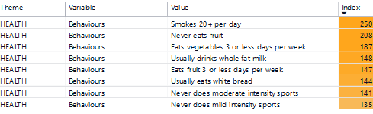
Figure 1: Hardship Heartlands (Health Challenges): Likely rate of smoking 20+ cigarettes per day and other health behaviours associated with this group.
Hardship Heartlands broadly defined as: “The population of these neighbourhoods are more likely to be either living alone or be a lone parent family in a small social rented terrace or flat. These relatively young people are likely to be employed in lower skilled trades with many being long term unemployed.”
Source: Frimley Health and Care System Insights, ACORN smoking profiles for RBWM, 2019

In all three subgroups, smoking 20+ cigarettes per day is more likely than the national average. Individuals in the Hardship Heartlands subgroup are 2.5 times more likely to smoke 20+ cigarettes per day than the national average. Individuals in the Perilous Futures and Struggling Smokers sub-groups are 2.28 and 2.08 times, respectively, more likely to smoke 20+ cigarettes per day than the national average.

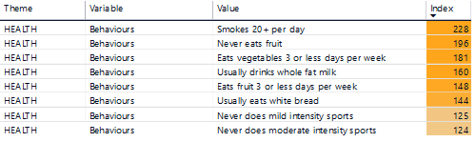
Figure 2: Perilous Futures (At Risk): Likely rate of smoking 20+ cigarettes per day and other health behaviours associated with this group.
Perilous Futures broadly defined as: “The population in these neighbourhoods tend to be younger with many children. Much of the housing is social rented with a mix of terraces and flats. These households are likely to suffer from a shortage of space whilst the residents feel that noise and vandalism and crime are an issue in their neighbourhoods. They are often found in the less affluent pockets of commuter belt towns in areas such as Ashford (Kent), the outskirts of Glasgow and areas to the north of Bury St Edmunds in Suffolk.”
Source: Frimley Health and Care System Insights, ACORN smoking profiles for RBWM, 2019

Figure 3: Struggling smokers (At Risk): Likely rate of smoking 20+ cigarettes per day and other health behaviours associated with this group.
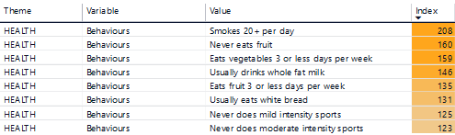
Struggling Smokers broadly defined as: “In these neighbourhoods the residents, often younger adults, are likely to be living in large, terraced and semi-detached homes with many school age children. The proportion in receipt of Job Seeker’s Allowance and Illness or disability benefits are more than double the national average. Those that are in work tend to be in routine occupations.”

Source: ACORN smoking profiles for RBWM, 2019

3.1 Total number of people who smoke in RBWM
The latest available data, outlined below, are based on best estimates (rather than confirmed count) generated by the PHOF, derived from the Annual Population Survey (APS) or General Practice Patient Survey (GPPS).
Predictive analysis based on data sourced from the APS suggests that 9.8% of RBWM’s 18+ population (11,445 adults) were current smokers in 2019. This is statistically better than the South East (SE) regional average (12.2%) and England average (13.9%) (Figure 4) (PHOF, 2019, Local Tobacco Control Profiles - Data - PHE).
Figure 4: Smoking Prevalence in adults (18+) – current smokers (APS) for Windsor and Maidenhead.
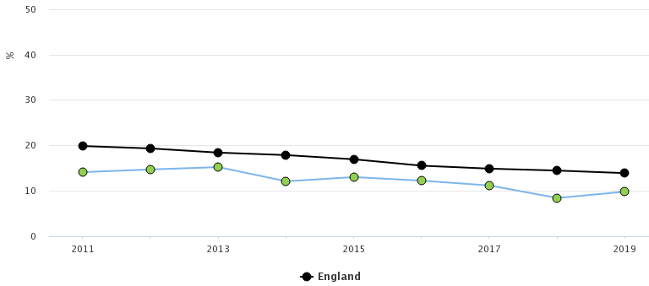

Source: APS, Local Tobacco Control Profiles - Data - PHE. England (black circles). RBWM (green circles).

The smoking prevalence in adults (18+) has been declining in RBWM, the South East, and England between 2011 and 2019. Prevalence in RBWM has consistently remained significantly lower than the England average over this period. Since 2011, the lowest recorded prevalence in RBWM was in 2018, at 8.4% (9,785 adults) (Local Tobacco Control Profiles - Data - PHE).
In 2019, the UK Government released a green paper announcing the ambition to go ‘smoke free’ in England by 2030 (Advancing our health: prevention in the 2020s (publishing.service.gov.uk)), equating to an adult smoking prevalence of 5% or less. This is a far more aggressive reduction in national smoking prevalence than that predicted by scientists (Source: BMJ, 2020, Future smoking prevalence by socioeconomic status in England: a computational modelling study | Tobacco Control (bmj.com)) (GOV.UK, 2019, Health matters: stopping smoking – what works? - GOV.UK (www.gov.uk)).
Of RBWM’s “statistical neighbours”, RBWM ranks 2nd for lowest prevalence of smokers aged 18+ (Figure 5); but this prevalence is only statistically significantly different to Milton Keynes and Wiltshire.
Figure 5: Number of people (count) and percentage (value) who smoke in RBWM and statistical neighbours.
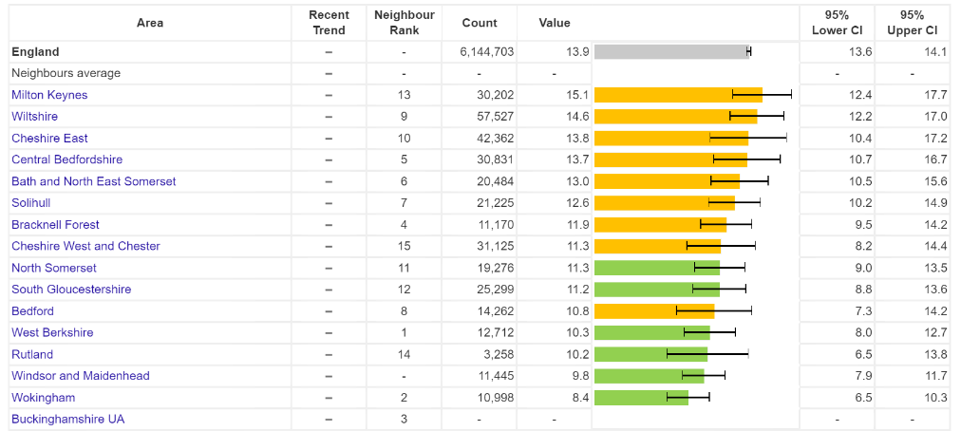

Source: APS, 2019 Local Tobacco Control Profiles - Data - PHE
Smoking Status is a health information filter on the local insights dashboard found on Frimley Health and Care ICS’ System Insights. The current RBWM population size is 162,406 (Frimley Health and Care ICS System Insights, Local Insights Report. Data Accessed 17/12/21) of which:
- 9.97% (16,195 people) are current smokers.
- 17.58% (28,557 people) have smoked in the past.
- 49.64% (80,617 people) have never smoked.
- 22.81% (37,037 people) do not have their smoking status recorded.

It is important to note that the data above, taken from System Insights, includes all ages. Whereas data in Figures 4 and 5, only includes adults aged 18 and above.

A caveat of the data on System Insights is that the data relies on clinical coding on patient records. This is explained further in section 3.0. The NICE guidance states that when identifying and quantifying people’s smoking, health and social care professionals should ask people if they smoke or have recently stopped smoking at every opportunity (Tobacco: preventing uptake, promoting quitting and treating dependence (nice.org.uk)).
Recommendation 1: To work collaboratively with Frimley ICS, Primary Care Networks, and General Practices to identify any current gaps to improve how smoking status data is recorded on patient records.

3.2 Smoking prevalence by age
Of the 16,195 known current smokers in RBWM, 6,495 are female and 9,700 are male. The highest prevalence of smokers (females and males) is the 30-39 age group, followed by the 40-49 age group. In both sexes, smoking prevalence increases from 0-39 years and decreases in people aged 40 and above, as shown in Figure 6.
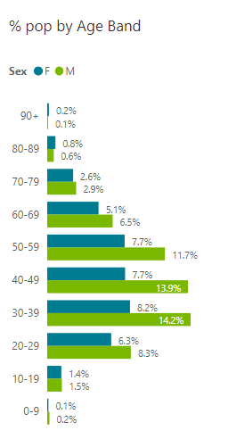
Figure 6: Percentage of population (by age range and sex) who are current smokers in RBWM as recorded on General Practice records.

Source: Frimley Health and Care ICS, System Insights. Data Accessed 17/12/21.
The data shown in Figure 6 is coherent with the predictive ACORN data shown in Figure 7. Based on the top three sub-group types, ACORN predicts an over representation of smoking behaviours within the 30 – 39 age range. This differs slightly from predictive analysis provided by PHOF, where it is suggested slightly higher rates of smoking may be seen in the 25 – 29 age range. Note these two datasets are defined/filtered differently, therefore a degree of caution must be applied when comparing.
Figure 7: ACORN profile of smoking prevalence within the RBWM population, by age groups (in top three sub-groups predicted to have the highest smoking rates compared with the national average).
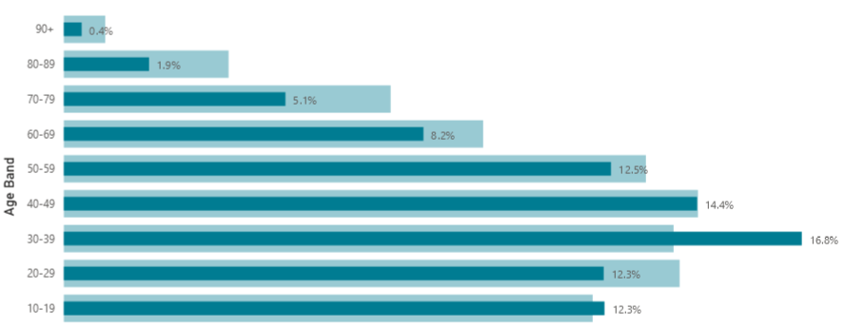

Source: Frimley Health and Care System Insights, ACORN smoking profiles for RBWM, 2019
Please note that over representation within the 10 – 19 age range could be skewed by children and young people who reside within geographical locations where greater rates of smoking has been predicted, but might not actually be smoking themselves (i.e., those under the age of 18). Therefore, caution should be applied when interpreting these data.
3.3 Smoking Prevalence by ethnicity
The APS data provides a breakdown of smoking prevalence by ethnicity for England in 2019 (Figures 8 & 9). This shows higher prevalence rates in males from mixed and other ethnic groups. Prevalence rates in females are highest in mixed and white ethnic groups.
Figures 8 & 9: Percentage of England residents (18+) in each ethnic group who are current smokers (2019).
Source: APS, 2019 Local Tobacco Control Profiles - Data - PHE
More locally, of the 16,195 current smokers in RBWM, 77.7% are white ethnicity, 8.7% are from Black, Asian Minority Ethnic (BAME) groups, and 0.8% are from other ethnic groups. There is insufficient data to group the remaining 12.9% by ethnicity (Frimley Health and Care ICS, System Insights. Data Accessed 17/12/21). This breakdown of current smokers in RBWM by ethnicity, is similar in the ACORN predicted data, with Figure 10 showing that those of White ethnicity are more likely to have smoking 20+ cigarettes per day behaviours that other ethnicities.
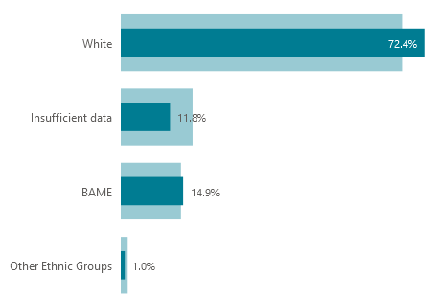
Figure 10: ACORN profile of smoking prevalence within RBWM population, by Ethnicity (in top three sub-groups predicted to have the highest smoking rates compared with the national average).

Source: Frimley Health and Care System Insights, ACORN smoking profiles for RBWM, 2019
This supports data provided by PHOF. There is indication that a disproportionate number of people from BAME communities in RBWM are smokers, which supports predictive analysis data from PHOF.
3.4 Smoking Prevalence by Geographical Location
It is possible to examine the percentage of current smokers in RBWM at ward level (Figure 11). Of the 16,195 people that are current smokers in RBWM, 8.0% live in the Eaton and Castle ward, and 7.6% live in Clewer and Dedworth East.

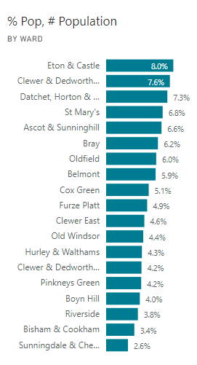
Figure 11: Percentage of Current Smokers (as recorded on General Practice records) in each ward in RBWM.

Source: Frimley Health and Care ICS, System Insights. Data Accessed 17/12/21.
However, each ward in RBWM has a different population size which is important to consider when interpreting the data. Figure 12 highlights which wards have a disproportionate number of current smokers given the ward’s population size.
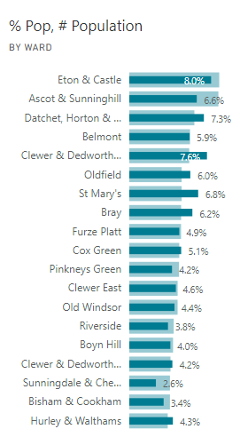
Figure 12: Percentage of current smokers (as recorded on General Practice records) in each ward in RBWM (dark blue line), compared to the percentage of the RBWM population that live in each ward (light blue line).

Source: Frimley Health and Care ICS, System Insights. Data Accessed 17/12/21.
Where the dark blue line exceeds the light blue line, there is a disproportionate number of current smokers in these wards, given the ward’s population size. Using Clewer and Dedworth East as an example; 7.6% of current smokers in RBWM live in the Clewer and Dedwroth East ward, but only 5.9% of the RBWM population live in Clewer and Dedworth East. Therefore, there is a disproportionate number of current smokers in this ward.
Looking at these data, it can be concluded that the wards with a disproportionately high number of current smokers are:
- Datchet, Horton and Wraysbury
- Clewer and Dedworth East
- Oldfield
- St Mary’s
- Bray
- Cox Green
- Clewer and Dedworth West
- Hurley and Walthams
This conclusion is supported by the predicted data from the ACORN segment. Figure 13 identifies small geographical areas in RBWM where the three sub-groups, predicted to have the highest smoking rates compared with the national average, may live (based on predictive analysis). These three sub-groups are called: Hardship Heartlands, Perilous Futures and Struggling Smokers.
Co-existing behaviours associated with these sub-groups (e.g., “never does mild intensity sport”) could help to identify additional/compounding factors to smoking. Other wider determinants, such as neighbourhood type or housing/living situation, may also provide further factors that could be impacting on smoking rates within these given groups. For further information on groups in the Wellbeing ACORN profile data, visit CACI Wellbeing Acorn User Guide.
Figure 13: ACORN profiling of heat map of RBWM wards where the top three sub-groups (predicted to have the highest smoking rates compared with the national average) are more likely to be geographically located (2019). This data is PCN level data.
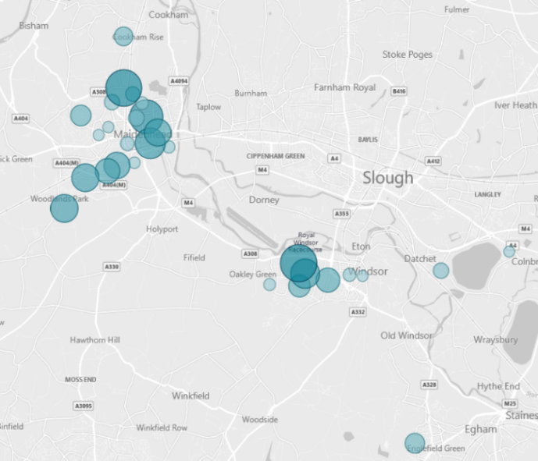
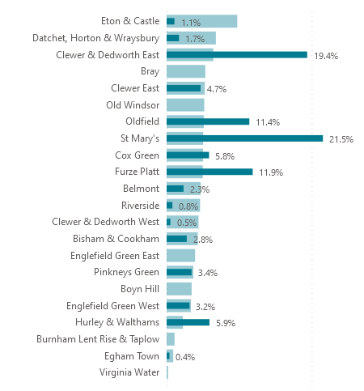
Source: Frimley Health and Care System Insights, ACORN smoking profiles for RBWM, 2019.
Where the blue bubbles intersect in Figure 13, there is likely to be greater prevalence of ACORN segments with higher concentrations of excessive smoking behaviours (Hardship Heartlands, Perilous Futures, and Struggling Smokers). The pale blue line on the right-hand side of Figure 13 represents the proportion of the population within each RBWM ward, in relation to the total RBWM population. Where the dark blue line exceeds the length of the pale blue line, there is an over-representation of the ACORN segments where smoking 20+ cigarettes per day is more likely than the national average. Where the dark blue line is equal to the length of the light blue line, there is a proportionate representation of individuals smoking in that ward, relative to the population size. Therefore, a disproportionately high prevalence of smoking 20+ cigarettes per day is predicted within the wards of:
- St Mary’s
- Clewer & Dedworth East
- Furze Platt
- Oldfield
- Hurley & Walthams
- Cox Green
From this predicted data, five out of the six wards highlighted above are also highlighted from the Frimley ICS System Insights data.
3.5 Smoking Prevalence and Deprivation
People living in deprived areas are more likely to smoke than those living in affluent areas. The Index of Multiple Deprivation (IMD) is used to classify the level of deprivation of specific areas. In this instance, the IMD Decile is giving the average IMD Decile for smokers in these wards, not the deprivation for the ward as a whole. A lower IMD Decile indicates greater deprivation. Figure 14 highlights deprivation levels in current smokers in RBWM, and the number of people that are currently smokers in each ward.
Figure 14: Average Index of Multiple Deprivation (IMD) Decile for smokers in each ward in RBWM, and the number of people that are currently smokers in each ward.
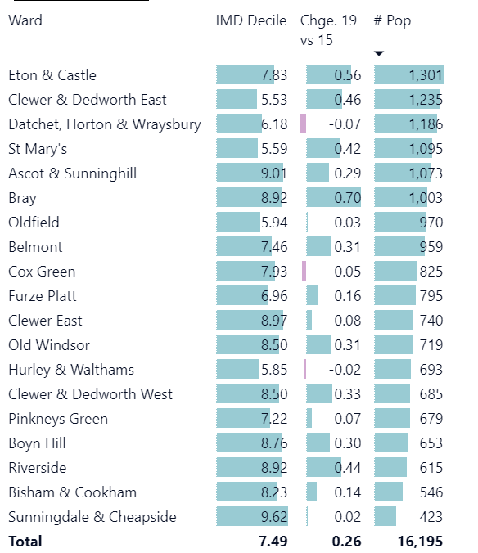

Source: Frimley Health and Care ICS, System Insights. Data Accessed 17/12/21.
According to these IMD deciles, the most deprived people who smoke in RBWM are in the following wards: Clewer and Dedworth East, St Mary’s, Hurley and Walthams, Oldfield, Datchet, Horton and Wraysbury, and Furze Platt.
Recommendation 2: Undertake targeted work, in the most appropriate format, with those residents and communities who have disproportionately high rates of smoking.

3.6 Smoking prevalence by occupational status
Latest data (2019) for RBWM show that the prevalence of smoking amongst adults (18-64) in routine or manual occupations was 20.8%. This is statistically similar to the SE region of 23.7% and the England average (23.2%) (PHOF, 2019, Local Tobacco Control Profiles - Data - PHE). Trends show an overall reduction in prevalence within this cohort both nationally and locally, from 2011 to 2019 (Figure 15).
Figure 15: Percentage of people in routine & manual occupations (aged 18-64) who are current smokers in England (black circles) and RBWM (amber circles).

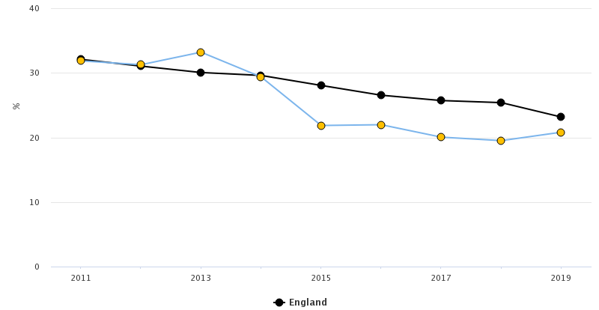

Source: APS, (2011-19): Local Tobacco Control Profiles - Data - PHE
3.7 Smoking prevalence in adults with long term mental health conditions
The prevalence of smoking amongst adults (18+) in RBWM with long term mental health conditions is 19.5%. This is statistically similar to the SE regional average of 24.0% and the England average (25.8%) (PHOF, 2019/20, Local Tobacco Control Profiles - Data - PHE]). In England, smoking prevalence in adults with long term mental health conditions has on average declined in recent years; this pattern has been similar in RBWM (Figure 16).
Figure 16: Percentage of adults with long-term mental health conditions who smoke in England (black circles) and RBWM (amber circles).
Source: GPPS Local Tobacco Control Profiles - Data - PHE
3.8 Smoking in pregnancy
Smoking during pregnancy can cause premature births, miscarriage and perinatal deaths. It also increases risk of stillbirth, complications in pregnancy, low birthweight, and the child developing other conditions in later life. This is a key area of health inequalities that is one of the priorities of the NHS LTP.
Prevalence of smoking in early pregnancy (up to 12 weeks gestation) & smoking at time of delivery (SATOD) was 6.4% & 6.5% (94 women SATOD) respectively (PHOF, 2018/19 & 2019/20 respectively). Both rank statistically better than the South East regional averages (11.3% & 9.7%) and England averages (12.8% & 10.4%) (PHOF, 2018/19 & 2019/20 respectively, Local Tobacco Control Profiles - Data - PHE).
Smoking in early pregnancy has only been recorded by maternity services since 2018/19 and no further data are available, therefore trends cannot be identified. Trends from PHE of smoking at time of delivery (Figure 17) shows that on average prevalence has decreased since 2010/11.
Figure 17: Percentage of women Smoking at Time of Delivery (SATOD) in England (black circles) and RBWM (green circles) (2010-19).
Source: PHE/NHS Digital return SATOD: Local Tobacco Control Profiles - Data - PHE
Premature birth and low birth weight are two potential outcomes associated with ante-natal smoking (direct or second-hand), which can lead to poor health outcomes and health inequalities for those babies later in life. Whilst smoking is not the sole cause of these outcomes, they could provide proxy indicators to health inequalities caused by smoking within the local population.
Between 2016 and 2018, 411 incidents of premature births (<37 week gestation) were recorded in RBWM, equating to a prevalence of 82.2 per 1,000 (latest figures for rate of premature live births [gestational age between 24-36 weeks] and all stillbirths per 1000). This is statistically similar to the South East regional average of 78.1 per 1000 births and England average of 81.2 per 1000 (PHOF, 2019, Local Tobacco Control Profiles - Data - PHE).
In 2019, 33 incidents of low birth weight of term babies were recorded, equating to a prevalence of 2.4%. This was statistically similar to the South East regional average of 2.5% and the England average of 2.9% (PHOF, 2019, Local Tobacco Control Profiles - Data - PHE).
3.9 Hospital admissions
In line with lower overall smoking prevalence in RBWM, smoking attributable hospital admissions (749 per 100,000 population) were also significantly better than that of the SE, (1012 per 100,000) and England (1612 per 100,000) (PHOF, 2018/19 and 2019/20 respectively, Local Tobacco Control Profiles - Data - PHE).

4.0 Conclusion from latest data
Key findings suggest:
- The smoking prevalence in RBWM is better (lower) than the England and South East averages as well as statistical neighbours.
- The rates of smoking are higher in RBWM residents in routine or manual occupations or those with mental health conditions, in line with the national picture.
- Residents who identify as White are more likely to be current smokers than individuals from other ethnicities.
- Residents aged 30-39 (particularly men) are most likely to be current smokers, closely followed by the 40-49 age group.
- ACORN insights suggest that disproportionately higher rates of residents smoking 20+ cigarettes per day are found in people:
  - Aged 30-39 age range.
  - Who identify as White or Black, Asian and Minority Ethnic groups.
  - Live in St Mary’s, Clewer and Dedworth East, Furze Platt, Oldfield, Hurley and Walthams, and Cox Green.

5.0 Best Practice
5.1 Universal Support
NICE suggests all frontline health professionals (inclusive of Social Prescribers, Community Champions and voluntary sector workers) provide either brief advice (BA) or very brief advice (VBA) to anyone they come into contact with, identified as a smoker (Tobacco: preventing uptake, promoting quitting and treating dependence (nice.org.uk)). For information on V/BA, visit 6 Glossary | Behaviour change: individual approaches | Guidance | NICE. This builds upon the Making Every Contact Count (MECC) approach; a nationally recognised framework, seeking to create positive behaviour change through opportunistic interactions with the public, thus improved health outcomes for the community (both individually and as a whole). Best practice suggests health professionals should encourage smokers to reduce or quit smoking (Tobacco: preventing uptake, promoting quitting and treating dependence (nice.org.uk)). It is also advised that NRT/nicotine containing electronic cigarettes use should be given (if the health professional is trained to do so). For more information on MECC, visit Making Every Contact Count (nice.org.uk). NRT means products that are medicinally licensed for use as a stop smoking aid and for harm reduction (Tobacco: preventing uptake, promoting quitting and treating dependence (nice.org.uk)).
Where structured support for smoking cessation is not desired (as part of NICE clinical guidance 138; treating patients with dignity and respect), signposting to universal [digital/remote] resources is recommended. A Cochrane review assessing effectiveness of self-help materials vs. having no intervention, on quit rates, concluded that “standard self-help materials may increase quit rates compared to no intervention, but the effect is likely to be small.” Furthermore, tailored self-help materials vs. standard self-help materials may prove more helpful toward quit success. This may partly be due to additional contact or assessment required to obtain individuals’ data (Lancaster & Stead, 2009, Self-help interventions for smoking cessation (ncsct.co.uk)).
5.2 Structured Support
NICE suggest services should aim to treat at least 5% of the smoking population per annum. Of those accessing services for smoking cessation support, ≥ 35% should achieve a successful 4 week quit (Tobacco: preventing uptake, promoting quitting and treating dependence (nice.org.uk)). Additional recommendations are made to confirm successful quit via CO testing, showing <10 parts per million (ppm) at point of test (4 weeks on from quit date).
Along with brief advice/very brief advice, NICE recommends behavioural / psychosocial support and pharmacotherapy is made available to adults that smoke (Tobacco: preventing uptake, promoting quitting and treating dependence (nice.org.uk)). Pharmacotherapy covers medication licensed for smoking cessation such as varenicline or bupropion, as well as NRT. Services should provide advice on these and agree an approach with service users, based on the individual’s preferences. In cases where NRT is prescribed/used, it is recommended that a combination of both short-action and long-action forms are used in conjunction (Tobacco: preventing uptake, promoting quitting and treating dependence (nice.org.uk)).
Behavioural support is an evidence-based approach for behaviour change, utilising a variety of methods (such as ‘Cognitive behavioural therapy’, ‘motivational interviewing’ and ‘strengths-based approach’), aimed to improve health outcomes via lifestyle/behavioural adaptations.
5.3 NHS LTP
The NHS LTP sets out to increase provision for smoking related interventions across Integrated Care Systems, with specific focus on; Acute, Mental Health, and Maternity settings. The aim being to increase opportunities to identify and/or support those seen within those services to quit smoking.
The NHS LTP sets out new commitments for action that the NHS will take to improve prevention. For smoking the actions are:
- The NHS will make a significant new contribution to making England a smoke-free society, by supporting people in contact with NHS services to quit based on a proven model implemented in Canada and Manchester Building the case for comprehensive hospital-based tobacco addiction services: Applying the Ottawa Model to the City of Manchester - Lung Cancer (lungcancerjournal.info). By 2023/24, all people admitted to hospital who smoke will be offered NHS-funded tobacco treatment services.
- The model will be adapted for expectant mothers, and their partners, with a new smoke-free pregnancy pathway including focused sessions and treatments.
- A new universal smoking cessation offer will also be available as part of specialist mental health services for long-term users of specialist mental health, and in learning disability services. On the advice of PHE, this will include the option to switch to e-cigarettes while in inpatient settings.
6.0 Current Service Provision in RBWM
6.1 National campaigns and resources
There are a number of national campaigns that support smoking cessation:
- Stoptober (national stop smoking campaign over the month of October)
- Love your lungs week in June (British Lung Foundation)
- No Smoking Day in March (British Heart Foundation)
- Smokefree by 2030 (national initiative to get smoking rates below 5% of total population)
Early-help/digital resources include:
- Smokefree national helpline (0300 123 1044, England only)
- NHS Quit Smoking app (Quit smoking - Better Heath - NHS (www.nhs.uk))
- Daily email support (https://quitnow.smokefree.nhs.uk/)
These are free and available to everyone. These options provide much of the community Universal / Tier 1 (low-level) intervention / support, in achieving a successful quit. This forms the initial “fabric” of a “patchwork effect” of provisions and services that aim to reduce rates of current smokers within the community. The benefits of national resources are that they are wide reaching, accessible to many (with access to computers or smart phones) and incur no cost to the service users or local authorities.
6.2 NHS services
There is currently no in-house Tobacco Dependency service for maternity or inpatients within Frimley Health NHS Foundation Trust. However, there is NRT available on all wards to support inpatient smokers.
The NHS provision for smoking cessation is currently changing in line with the ambitions set out by the NHS LTP (section 5.3). The NHS LTP sets out its ambition to support a smoke-free society through providing an effective smoking cessation offer. This includes comprehensive inpatient tobacco treatment, a smoke-free pregnancy pathway for expectant mothers and their partners, and a universal smoking cessation offer for long-term users of specialist mental health services. This means everyone admitted to hospital who smokes, will be offered help and support to quit, offering NHS-funded tobacco treatment services to all inpatients who smoke, regardless of why they are in hospital, by 2023/24. There will be timely access to medications and specialist support, provided as an ‘opt-out’ model with all healthcare professionals taking responsibility for their part in the service.
Maternity
At antenatal booking appointments, all women are CO monitored. If the woman is a person who smokes, the risks of smoking are explained, and an onward referral is made to the community smoking cessation service.
In line with the requirements of Saving Babies’ Lives Care Version Two (saving-babies-lives-care-bundle-version-two-v5.pdf (england.nhs.uk)), all women are CO monitored throughout pregnancy and are made aware of the hospital’s smoke free policy. Women are provided with NRT to help them prepare to be smoke free during their time in the hospital.
In line with NHS LTP commitments, a delivery model for maternity services has been co-developed with a range of national, regional, and system partners with an aim to support delivery of NHS-funded tobacco dependence treatment services in maternity settings. Plans are being made on how an ‘in-house’ service could be piloted and implemented. The expectation is it will be in addition to the community smoking cessation service.
Primary care
Primary care settings/workers (including General Practices (GPs), Social Prescribers, Health Coaches, Health Champions and Community Navigators) form a critical element of support, resources, and signposting. This is a significant area where the public may intersect with health services and health care professionals. It can often be the initial interface with a health professional where very brief / brief advice can be given, signposting / onward referral provided and building of rapport between the individual / community and services begin – all contributing to MECC. Though smoking may often not be a primary cause of engagement or concern to service users, these interactions can provide key opportunities to raise conversations, provide information, motivate behaviour change and signpost to relevant services (where appropriate/desired). In the case of smoking cessation, this can often be a challenging conversation to raise, especially for individuals who are ambivalent (pre-contemplative) around their smoking. Primary care settings are a fundamental referral source to locally commissioned services and help to initiate or continue positive behaviour change with their service users.
Pharmacotherapy is not currently commissioned locally in RBWM, so it is up to the discretion of GPs whether they wish to prescribe pharmacotherapy. It is important to note that there has been a supply issue with Champix (produced by Pfizer) in the UK since June 2021. The NICE guidance highlights that in November 2021, Champix was unavailable in the UK.
Pharmacies are able to give out pharmacotherapy based on a prescription. Pharmacotherapy is not currently commissioned locally in RBWM, so pharmacies can provide over the counter NRT products, at a cost to the patient.
6.3 Community smoking cessation service
The public health ring-fenced grant funds a smoking cessation service, which is delivered by Cranstoun. This service includes a smoking cessation specialist practitioner, who provides behavioural support for adult (18+) residents with current smoking behaviours. Service users are supported through a one-to-one format, receiving 4 sessions over the course of 4 weeks (1 session per week) prior to reviewing outcome of intervention. This model of approach is recommended by NICE (Tobacco: preventing uptake, promoting quitting and treating dependence (nice.org.uk)) and reflected in training for practitioners by NCSCT (Stop smoking interventions and services (NICE, 2018) (ncsct.co.uk)).
RBWM’s stop smoking service does not use CO validation to confirm quits. Successful quits are self-reported by service users.
Referrals
The smoking cessation service in RBWM receives referrals through multiple pathways. In Quarter 2 of 2021/22 (July-September 2021) there were 40 referrals, and in Quarter 3 of 2021/22 (October-December 2021), the service received 49 referrals. The total number of referrals in Quarter 2 and 3 2021/22 was 89 individuals. Of these 89:
- 28 Service Users reported no support needed
- 42 Service Users reported support needed
- 17 Service Users have now been closed (unable to make contact after 3 attempts)
- 2 Service Users have moved out of borough

Nicotine Replacement Therapy (NRT)
NRT is not currently offered as part of RBWM’s stop smoking service but advice around NRT use is provided (where appropriate). Licensed NRT products are available over the counter across a wide range of outlets within RBWM. NRT is competitively priced, respective to combustible tobacco products. NRT is available in a wide range of application options (patches, gum, inhalation cartridges, sublingual tablets, lozenges, and mouth and nasal sprays) providing choice, based on the individual’s preference. Electronic cigarettes are not currently licensed in the UK for medical use but can be advised as a viable alternative to traditional smoking cessation aids; as outlined in the South East Position Statement on Electronic Cigarettes (adph-south-east-newposition-statement-on-electronic-cigarettes-sps-v9.pdf (stopforlifeoxon.org)).
Recommendation 3: Use the evidence within the Health Needs Assessment to start discussions and develop a costed appraisal to determine the health impact of providing pharmacotherapy with psychosocial support, balanced against the financial impact.

6.4 Service level data for community smoking cessation service
Data from 2019/20, show that 55 smokers accessed the service. Everyone referred in must complete an assessment and is then encouraged to set a 4-week quit date. If a service user disengages prior to setting a quit date (pre or post assessment), these individuals are not counted toward numbers outlined below. RBWM service level data is sourced from (NHS Digital, 2019/20, Local Tobacco Control Profiles - Data - PHE).
The type of interaction was through drop-in clinics (45%), one-to-one support (49%), telephone (5%) and other (1%). The coronavirus pandemic has reshaped the way in which the service has engaged service users; far greater numbers of service users (since April 2020) will have engaged with support in digital/remote forms, due to national restrictions and guidance.
In 2019/20, those accessing the service were more likely to be women (Figure 22), older adults aged 45-59 (Figure 23) and from a White ethnic background (Figure 24).
People setting a quit date
Data from 2019/20 (most recent annual figures), show that 55 smokers set a quit date giving a rate of 465 per 100,000 smokers aged 16+ (Public health profiles - OHID (phe.org.uk)). As outlined in Figure 18 this is significantly lower than the South East (3884 per 100,000) and England (3512 per 100,000) averages.
Figure 18: Smokers setting a quit date per 100,000 smokers aged 16+ in England (black circles) and RBWM (amber, green and red circles) (2013-20).
Source: Public health profiles - OHID (phe.org.uk)
A full annual report has not been published for 2020/21, but data from April -December 2020 (9 months) shows that 20 people accessed the community smoking cessation service during this period.
All individuals accessing the service are required to set a 4-week quit date at point of assessment.
Recommendation 4: Continue to commission a psychosocial support service that delivers a combination of in person, online and telephone support for any adult in RBWM that wishes to quit smoking. Focusing on increasing access in line with NICE guidance for smoking cessation services to treat 5% of current smokers each year, working towards an ambition to achieve a smoke-free society by 2030.

Smokers that have successfully quit in 4-weeks
In 2019/20, 40 out of 55 setting a quit date had successfully quit (73% success rate). This is higher than the 53% success rate of all setting a quit date within the SE (NHS Digital, 2019/20 Local Tobacco Control Profiles - Data - PHE).
This represents a rate of successful quitters at 4-weeks of 338 per 100,000 smokers aged 16+. As outlined in Figure 19 this is significantly lower than the South East (2060 per 100,000) and England (1808 per 100,000) averages.
Figure 19: Smokers that have successfully quit at 4-weeks per 100,000 smokers aged 16+ in England (black circles) and RBWM (amber, green and red circles) (2013-20).
Source: Local Tobacco Control Profiles - Data - OHID (phe.org.uk)
Between April 2020 – December 2020, 13 out of 20 setting a quit date had successfully quit (65% success rate).
Figures 20-22 show the successful quit rates by gender, age, and ethnicity. The low number of service users mean it is difficult to draw conclusions, but both male and female service users had a similar successful quit rate (72% and 73%, respectively).

Figure 20: Number of residents accessing community stop smoking services in 2019/20, segmented by sex.

Source: NHS Digital Stop Smoking Services annual report, 2019/20

Figure 21: Number of residents accessing community stop smoking services in 2019/20, segmented by age group.

Source: NHS Digital Stop Smoking Services annual report, 2019/20

Figure 22: Number of residents accessing community stop smoking services in 2019/20, segmented by ethnicity.

Source: NHS Digital Stop Smoking Services annual report, 2019/20

6.5 Conclusions on current service provision
- Recommendations for incumbent provider to continue to record and report on referral sources to assess and target work with stakeholders to increase referrals into service / referral pathways. This would work toward the guidelines set by NICE, to see >5% of the smoking population per annum (Tobacco: preventing uptake, promoting quitting and treating dependence (nice.org.uk)), comparatively to the 0.5% seen in 2019/20. Though rates of successful 4 week quits are 73%, which is over double that recommended by NICE (35%) (Tobacco: preventing uptake, promoting quitting and treating dependence (nice.org.uk)). This should be interpreted with caution as the number of people using the service is low.
- Numbers of males and females “setting a quit date” & “successful quitters” are similar, thus low evidence of inequity. Though more females access community support, despite estimated smoking prevalence being lower amongst females. This could be indicative of evidence that shows women (in general) are more likely to seek support and/or access health services. Recommendations could be made to target men to increase engagement with locally commissioned services.
- Individuals from the age group 45-59 were the most likely to access community services and more likely to successfully quit, compared with all other age groups. Though data from Frimley System Insights suggests that residents between the age of 30-39 are more likely to be smokers.
- Individuals identifying as White make up the majority presenting to the community service. This is reflected by ethnic breakdown of the RBWM population.
- Work associated to the NHS LTP could influence referral rates to community-based smoking cessation services. This could increase or decrease referral rates, depending on effectiveness of treatment, referral pathways and patient/service user engagement (with the above services).
- Most appointments in 2019/20 (94%) were delivered through a face-to-face means. This percentage decreased due to the coronavirus pandemic where behavioural support was remote, delivered through telephone and digital means. Recommendations could be made that a hybrid model of access/treatment be made available.
- Recommendations could be made that a hybrid model of access/treatment be made available.
7.0 Comparisons with services across Berkshire
7.1 Variation in outcomes across the South East
There is variation across Berkshire and the South East, in the rate of smokers setting a quit date (Figure 23) and the rate of smokers that have successfully quit at 4 weeks (Figure 24).
Figure 23: Smokers that have set a quit date per 100,000 smokers aged 16+ in Local Authorities across the South East region, 2019/20.
Source: Public health profiles - OHID (phe.org.uk)
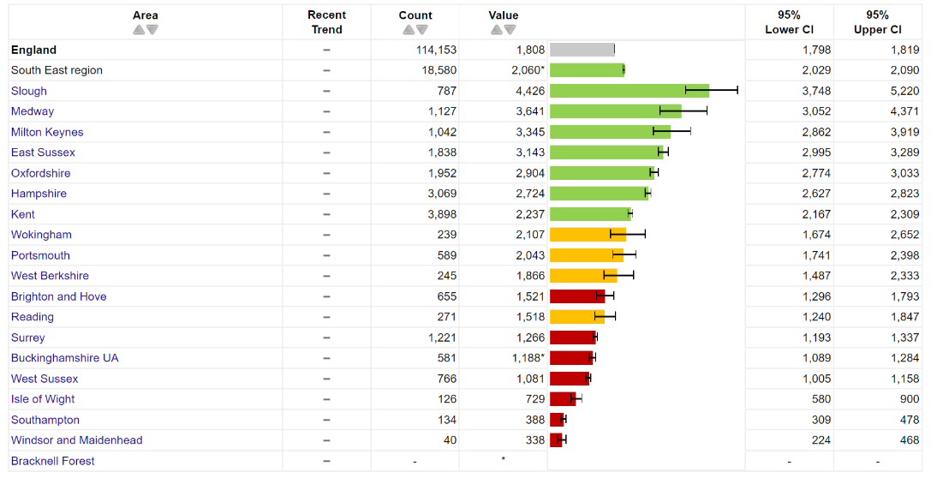
Figure 24: Smokers that have successfully quit at 4-weeks per 100,000 smokers aged 16+ in Local Authorities across the South East region, 2019/20.
Source: Local Tobacco Control Profiles - Data - OHID (phe.org.uk)
Figures 23 and 24 highlight that in 2019/20, RBWM had one of the lowest rates of residents setting 4-week quit dates and successfully quitting smoking at 4-weeks in the South East. There are many factors which may explain these findings. For example, variation in underlying smoking rates and differences in age, ethnicity, or levels of deprivation.
7.2 Variation in service delivery across Berkshire
The way in which smoking services are delivered varies across Berkshire. The three local authorities in Berkshire West (Reading, West Berkshire, and Wokingham) jointly commission the Berkshire West Stop Smoking Service (Smokefreelife Berkshire). They also jointly commission the Berkshire West Tobacco Control Alliance.
Slough’s smoking cessation service sits within its integrated wellbeing service. This may be advantageous, as negatively impacting health behaviours rarely exist in isolation (as suggested by Acorn profiles).
In Bracknell Forest and RBWM, the smoking cessation services are commissioned as individual services.
All Local Authorities within Berkshire and Frimley ICS provide behavioural support and pharmacotherapy (in the form of NRT) as part of treatment; aside from RBWM which only provides behavioural support and not pharmacotherapy.
Recommendation 5: Explore opportunities for joint commissioning with Frimley ICS, and East Berkshire Public Health and Commissioning colleagues, to procure a joint smoking cessation contract in the future. Consideration should also be given to including smoking cessation as an integral part of an integrated healthy behaviours service, which has the potential to improve outcomes by taking a person-centred approach to health behaviour needs.

8.0 Feedback from professionals
Professionals within maternity and respiratory physiotherapy services have suggested that because RBWM do not commission NRT provision within their community smoking cessation service, there is an inequity with the other Local Authorities within Frimley ICS (all of which do commission NRT through their community services). No evidence is available to understand how many RBWM residents are unable to access NRT as a result of the local commissioning arrangement or how prescriptive provision of NRT would affect quit rates seen within the RBWM community service.

9.0 Feedback from servicer users, patients, and residents
RBWM’s smoking cessation service does not currently receive feedback provided by service users.
Recommendation 6: Acquire in depth quantitative and qualitative feedback from the local service and service users, to build an evidence base to drive future commissioning proposals and decisions.

10.0 Cost-effective solutions
A PHE publication in September 2015, showed a cost to benefit analysis that for every £1 spent on tobacco control interventions, we could save £2.07 by year 5, £3.92 by year 10 and approximately £11.38 over a lifetime of a smoker who quits. These would be savings from a combination of reduced demands on primary care / NHS resources and productivity gains from quality adjust life years (PHE, 2015, Health matters: smoking and quitting in England - GOV.UK (www.gov.uk)).
A 2019 Cochrane review has found that financial incentives (vs. no incentives) for smoking cessation in pregnancy increased [smoking] abstinence in late pregnancy/post-partum from 7.2% to 17%. As previously discussed, this can lead to onward savings (stated above) for both mother and child (Cochrane, 2019, Incentives for smoking cessation - Notley, C - 2019 | Cochrane Library).

