Tackling loneliness in the Royal Borough of Windsor & Maidenhead

Contents
Introduction 4
What do we mean by the terms loneliness and social isolation? 4
What is loneliness? 4
What is social isolation? 4
Avoiding stigma in our language 4
What do we know about loneliness in the Royal Borough? 5
The Royal Borough residents survey 2022 5
National survey data 6
Loneliness life triggers 8
Local Heat maps 10
Covid-19 11
What is the impact of loneliness? 11
What works for tackling loneliness? 12
A framework for tackling loneliness 14
Conclusion 15
Reference list: 16

What is social isolation and loneliness and how does is impact our residents?

Introduction
Loneliness can affect anyone of any age and background and is increasingly understood to be a serious condition that adversely affects our mental and physical health.
Due to its complex nature, understanding the factors that contribute towards people in the borough feeling lonely and assessing which approaches or interventions work best to address this is challenging.
This report provides a summary of what we currently know about loneliness, who is most at risk, and the impact on our individual health and wellbeing and local public services. It also highlights where there are gaps in our current understanding.
We are grateful to colleagues at the London Borough of Bromley for support in developing this report. Further information on its campaign is available here.

What do we mean by the terms loneliness and social isolation?
The terms loneliness and social isolation are often used interchangeably, and while there is overlap between them each has a distinct meaning and independent impacts on our health and wellbeing.

What is loneliness?
“Loneliness is a subjective, unwelcome feeling of lack or loss of companionship. It happens when we have a mismatch between the quantity and quality of social relationships that we have, and those that we want¹”

Loneliness is a subjective negative feeling associated with the perception we have about our own social relationships¹.
For the most part, this report will focus on loneliness due to its exclusively negative impact on wellbeing.

What is social isolation?
Social isolation is an objective measure of the number of contacts people have day to day. It is about the quantity, not the quality of relationships².
It is important to realise that someone can feel lonely despite having lots of social interactions or have very few social interactions but not feel lonely. This therefore means there is no one size fits all approach to support people experiencing the negative impacts of social isolation and/or loneliness.

Avoiding stigma in our language
Social stigma refers to characteristics or behaviours deemed ‘undesirable’ by members of society which can lead to the exclusion or marginalisation of people displaying those attributes. People who feel lonely are often described in negative terms and there is sometimes a perception that lonely people lack social skills rather than recognising the life circumstances and events that might be contributing to these states³. This can lead to people concealing they feel lonely, meaning the true extent of the issue might be underestimated. Fear of being stigmatised may also prevent people from engaging with services or seeking support^{3,4}.
To reduce stigma, it is important to be mindful of the language used when describing people or groups who might be experiencing loneliness or social isolation and the services that support them.
National campaigns, for example the 'Let’s Talk Loneliness’ campaign, have been designed to tackle the stigma of feeling alone⁵.

What do we know about loneliness in the Royal Borough?
The Royal Borough of Windsor & Maidenhead is one of six unitary authorities in Berkshire in the Southeast of England. In 2021, the total population estimate of the Borough was 153,500. Some 18% of residents are under age 15, and 18% are aged 65+⁶.
Data on loneliness is not routinely collected. Yet there are number of national and local surveys which help us to estimate the numbers of people in the borough who are experiencing loneliness and understand some of the reasons behind this.

The Royal Borough residents survey 2022
The Royal Borough of Windsor & Maidenhead undertook a survey of residents’ views, attitudes and priorities in the summer of 2022 which included a representative sample of 1,740 residents aged 18+⁷. The survey results are available here.
Residents were asked, “How often do you feel lonely” which is a standard question used nationally, allowing comparisons with other areas and over time. The following groups reported higher levels of loneliness:

Figure 1: Factors associated with loneliness identified in the Royal Borough residents’ survey⁷
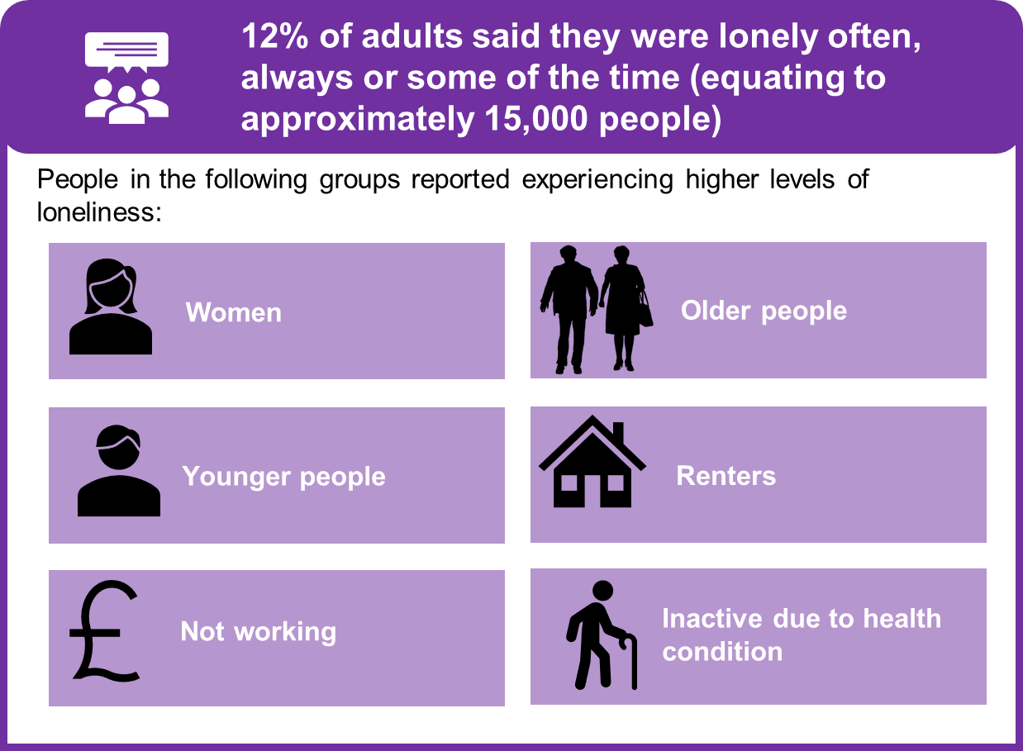
This is the most recent data on loneliness available locally.

National survey data
National surveys including the Community Life Survey⁸ (adults) and Good Childhood Index Survey⁹ (children) sample a larger number of people and record information on a broader range of characteristics than is possible locally. This allows us to identify additional factors associated with loneliness, although these may not necessarily all reflect the experiences of people in the Royal Borough. The factors identified are described below:

Figure 2: factors associated with loneliness identified in national surveys^{8–10}
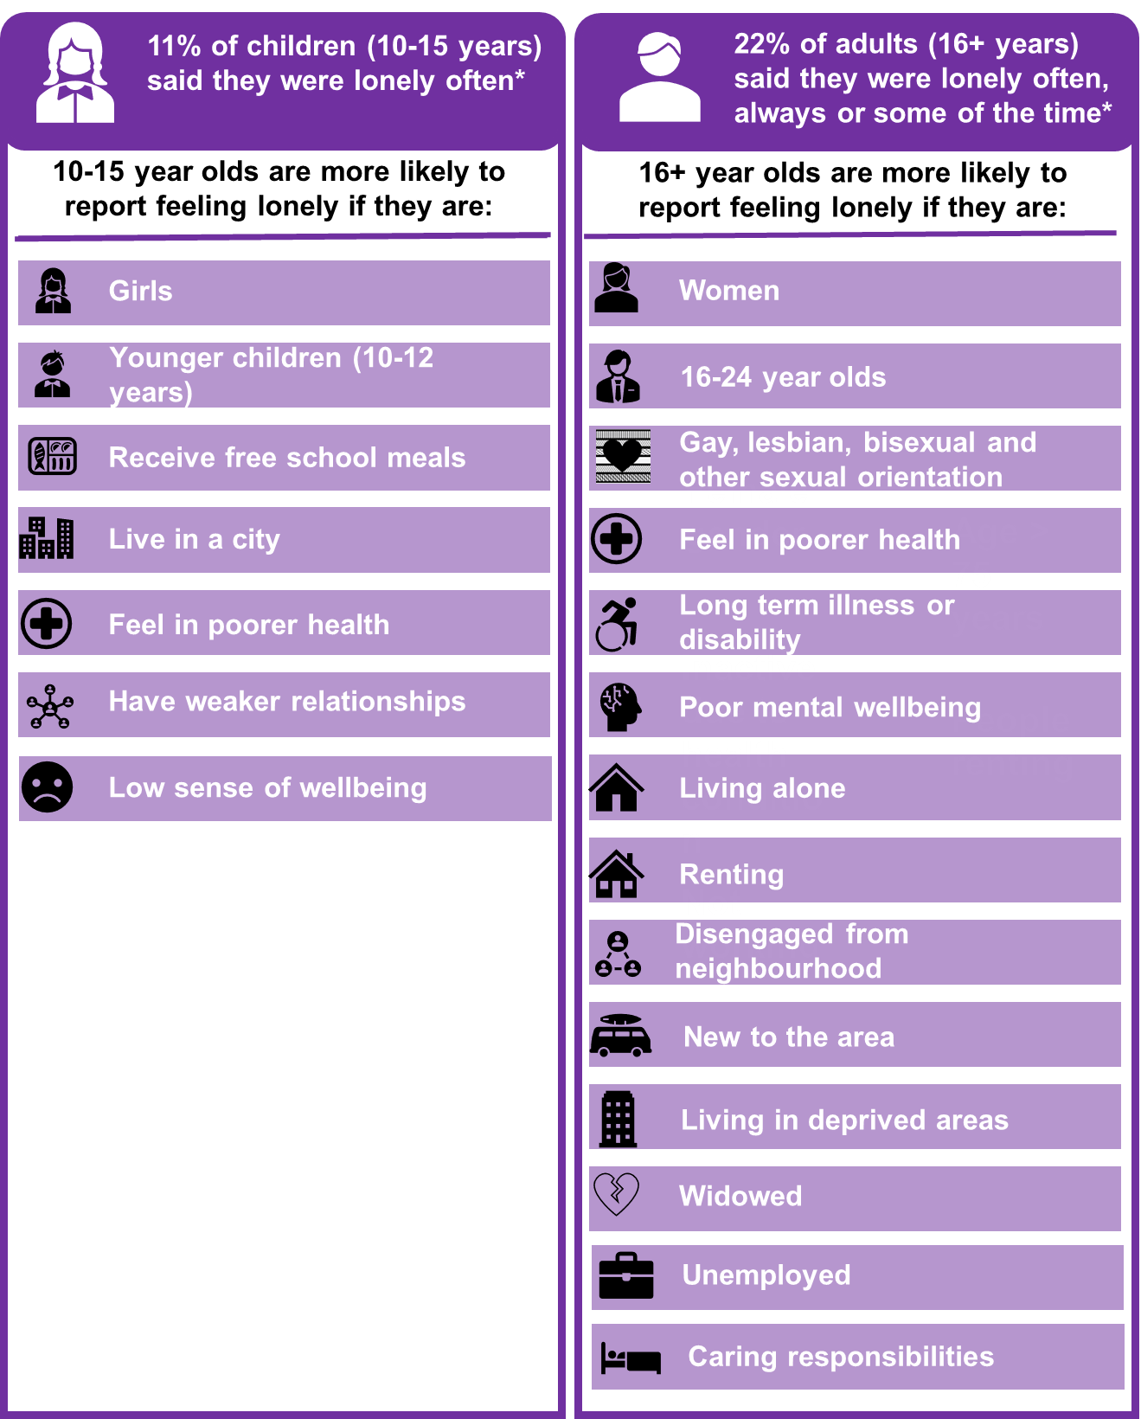
*Children and adults were asked the question ‘how often do you feel lonely.’ In the Children’s survey 3 response options are available (‘hardly ever or never’, ‘some of the time’, ‘often’). In the adult survey 5 response options are available (‘often/always’, ‘some of the time’, ‘occasionally’, ‘hardly ever’, ‘never’).
National surveys of loneliness have consistently found that younger age groups (16-24) are at the highest risk of chronic loneliness¹¹ (our residents survey only included adults aged 18+). The types of responses to tackling loneliness will differ among different ages and characteristics. It is also important to note that there might be differences in how people across different demographics interpret and answer the survey questions.

Loneliness life triggers
Certain life events, for example a bereavement or becoming unemployed, may trigger temporary or longer-term loneliness. Triggers for loneliness are more likely to happen at different stages of a person’s life, or during certain transition points - for example during the transition from childhood into adulthood. Loneliness may come and go during a person’s lifetime. Understanding more about the factors influencing people at different stages of life means evidence-based interventions can be targeted towards these stages of life to support people in different ways depending on their individual needs. This is known as the life course approach¹². Some key stages of the life course and potential loneliness triggers are described below:

Figure 3: Key triggers for loneliness over the life course (adapted from London Borough of Bromley¹³)

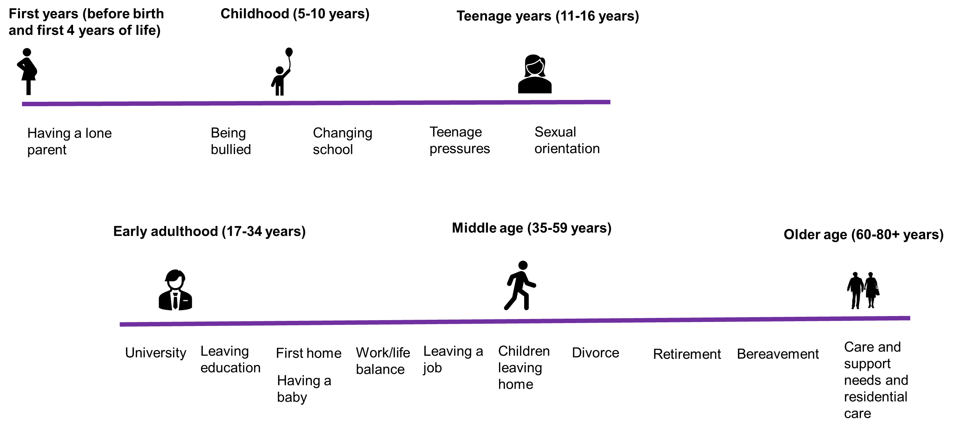

Local Heat maps
Age UK has developed a loneliness heat map showing the areas in the Royal Borough where older people are at the highest risk of loneliness, relative to other areas within the borough. It is based on information from the 2011 Census and considers the age profile, marital status, health status and typical household size of residents in each area. It uses this information to predict areas which might have higher numbers of people at risk of experiencing loneliness¹⁴.
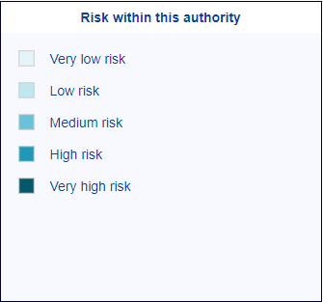
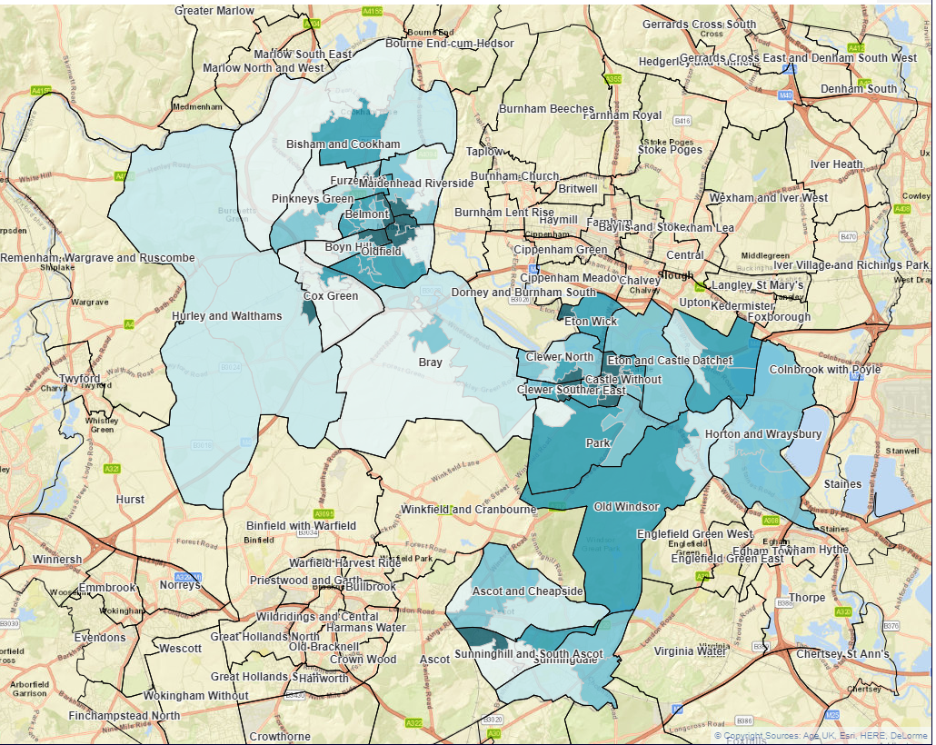
The darker areas of the map represent areas where there might be a higher proportion of older people experiencing loneliness, compared to elsewhere in the borough. Using this type of risk stratification approach can provide useful information to support organisations target activities in particular communities. There are several limitations with this approach, however. In particular, the fact that proxy measures are used to assess the risk of loneliness and that the data is now more than a decade old, means these maps should be interpreted cautiously. It is also important to recognise that there will be people experiencing loneliness in all areas of the borough and what is observed at a ward level, will not reflect the experiences of all of the people living within that ward.

Covid-19
Loneliness increased among certain groups during the pandemic, in particular young people, people with low household income, and those living alone¹⁵. In contrast, loneliness decreased among some groups during the pandemic. This was typically among those who were the least lonely before the pandemic and who had strong social networks¹⁵.
Data is not yet available about the longer-term impacts of the Covid-19 pandemic on social isolation and loneliness. The likely longer-term shift to more homeworking can provide additional flexibility and work-life balance, yet a reliance on virtual connections and reduced social contact may also increase the risk of loneliness and social isolation for some individuals¹⁶. This is an emerging area that could be considered by workplaces in their approaches to staff wellbeing.

What is the impact of loneliness?
Loneliness can negatively impact our physical and mental health leading to lower life expectancy, with some studies estimating the negative health impacts to be similar to those associated with smoking and obesity^{17,18}. People who are experiencing loneliness are also more likely to rely on public services which has an organisational and resource impact¹⁹.

Figure 3: impact of loneliness on individual health and wellbeing and on public services^{19,20}
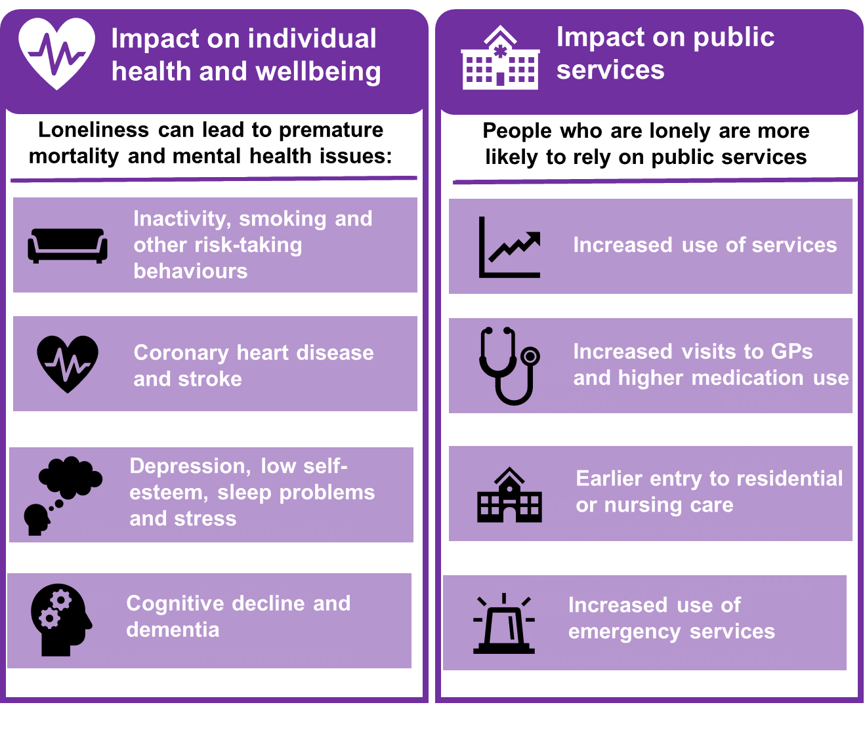
Assessing the financial cost of loneliness is challenging. Researchers, however, have estimated that the combined wellbeing, health, and productivity impacts are some £10k per person experiencing severe loneliness per year²¹.

What works for tackling loneliness?
As the evidence has grown around the negative impacts of loneliness, the importance of developing approaches to tackle the issue has increased and many initiatives have been developed across the UK and internationally. A range of different approaches exist, although typically these have focussed on older adults. Some of the types of programmes are described below:

Figure 4: Types of programmes aimed at alleviating loneliness
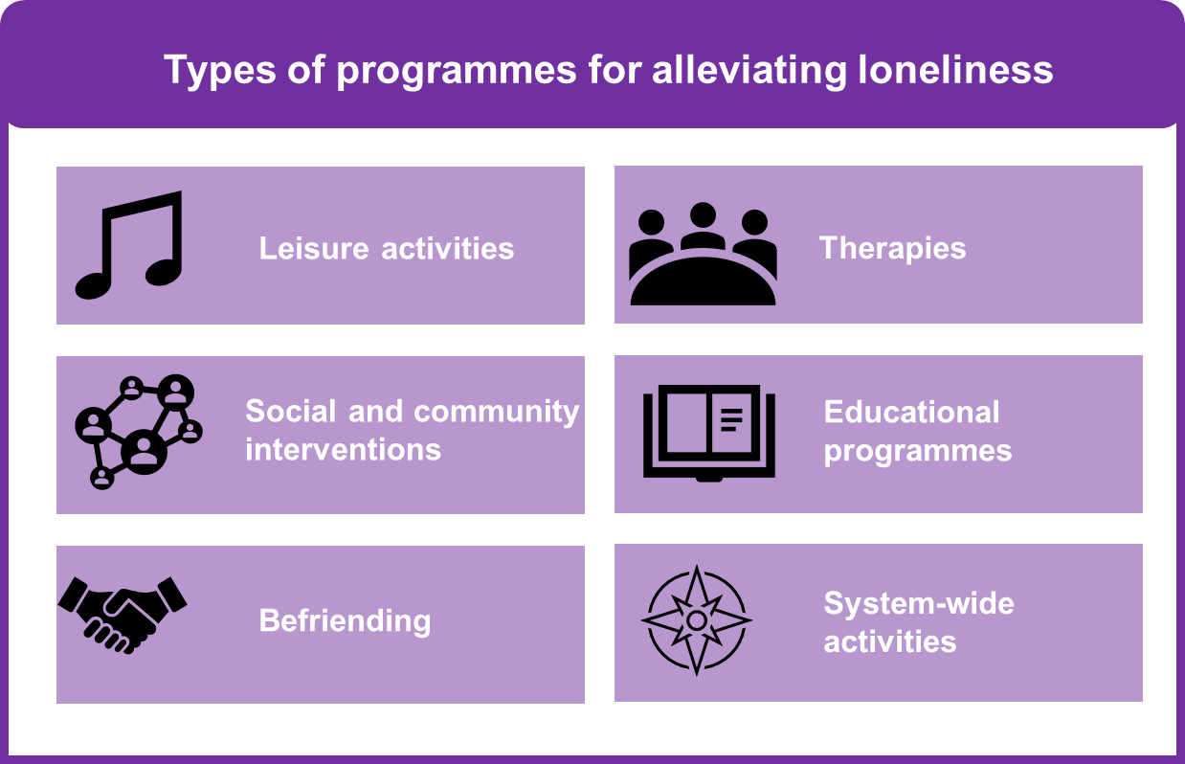
There isn’t strong evidence to show which approach is the most effective in tackling loneliness¹⁶ and loneliness is a complex problem. As the previous sections have described, there are multiple factors that can contribute to someone feeling lonely, and this can impact individuals in different ways. Measuring the effectiveness of interventions to address loneliness is challenging for several reasons²²:
- Inconsistent methods for describing and measuring loneliness and how it differs from social isolation (frequently the terms are used interchangeably) across different studies.
- Limited information on, if, or how programmes were tailored to different population groups.
- Lack of formal programme evaluation – many interventions are not part of a formal study and have not undergone a rigorous evaluation.
There is limited evidence on which interventions are effective in younger people.
Despite these challenges, some key themes have emerged from the research²²:
- There is no one-size fits all approach to alleviating loneliness and tailored approaches are more likely to be effective.
- It is important to ensure interventions do not increase the stigma associated with loneliness or reinforce isolation, although further research is needed in this area¹⁶.
- Building on existing community assets and networks to reduce loneliness was a key feature in several of the interventions studied. These interventions used an Asset-Based Community Development approach to tailor services and reconnect people to their community^{23–25}.
The evidence of group-based interventions versus those delivered in one-to-one settings was inconclusive. Some technology-based approaches are not suitable for everyone and could reinforce a sense of social isolation without a proper assessment of people’s capacity to use technical equipment²².

A framework for tackling loneliness
The Campaign to End Loneliness has developed a framework to inform approaches to tackling loneliness and social isolation²⁶. The framework is centred around four themes that focus not just on interventions to address individual loneliness, but also the broader conditions, infrastructure and systems in which loneliness exists.
Figure 5: framework for tackling loneliness (adapted from the Campaign to End Loneliness ²⁶)
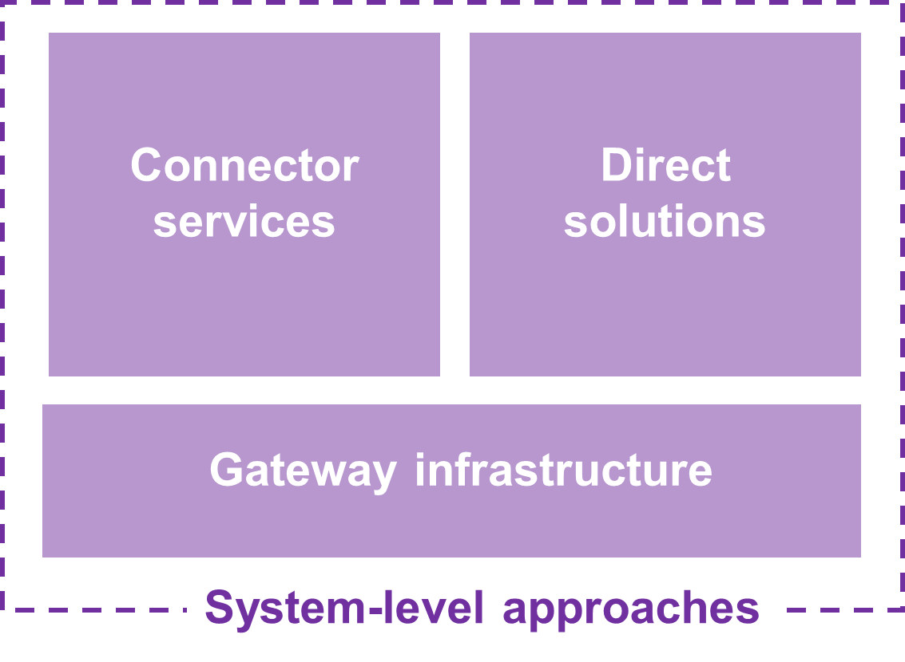
- Connector services are used to identify lonely individuals and understand their individual needs. They support lonely people to access appropriate services and overcome barriers.
- Direct solutions are groups and activities directly aimed at increasing the number and quality of social connections among people experiencing loneliness and social isolation. They support people to maintain existing connections, make new ones and change their thinking about their social relationships.
- Gateway infrastructure is about improving transport, technology, the built environment, and other enablers that help people retain connections and independence.
- System level approaches are not interventions, but strategic policies that help to create the right conditions for tackling loneliness. These include neighbourhood approaches, asset-based community development, age-friendly communities, and volunteering.

Conclusion
This report has provided an overview of loneliness and social isolation, and why it is an issue for residents in our borough. This includes the impact on our physical and mental health, and on public services. It has also described some of the challenges in measuring and addressing loneliness and highlighted the importance of different approaches.
Within the Royal Borough there are many public, community, and voluntary services available to support people experiencing loneliness and social isolation. The council is working with these organisations, and other stakeholders, through a tackling loneliness working group. The aim of this group is to co-develop a joined-up approach to tackle this important and complex issue across the Royal Borough.

Reference list:

1. Duck, S. & Gilmour, R. Personal relationships. (Academic Press, 1981).
2. National Academies of Sciences, Engineering & Medicine. Social Isolation and Loneliness in Older Adults: Opportunities for the Health Care System. (The National Academies Press, 2020). doi:10.17226/25663.
3. Barreto, M. et al. Exploring the nature and variation of the stigma associated with loneliness. J. Soc. Pers. Relatsh. 39, 2658–2679 (2022).
4. Department for Digital, Culture, Media and Sport. Mental health and loneliness: the relationship across life stages. https://www.gov.uk/government/publications/mental-health-and-loneliness-the-relationship-across-life-stages/mental-health-and-loneliness-the-relationship-across-life-stages (2022).
5. HM Government. ‘Let’s Talk Loneliness’ campaign launched to tackle stigma of feeling alone. https://www.gov.uk/government/news/lets-talk-loneliness-campaign-launched-to-tackle-stigma-of-feeling-alone (2019).
6. Office for National Statistics. Census 2021. https://census.gov.uk/.
7. Royal Borough of Windsor and Maidenhead. Residents’ survey 2022. https://www.rbwm.gov.uk/sites/default/files/2022-10/2022_residents_survey_full_report.pdf (2022).
8. Office for National Statistics. Loneliness - What characteristics and circumstances are associated with feeling lonely? https://www.ons.gov.uk/peoplepopulationandcommunity/wellbeing/articles/lonelinesswhatcharacteristicsandcircumstancesareassociatedwithfeelinglonely/2018-04-10 (2018).
9. Office for National Statistics. Children’s and young people’s experiences of loneliness: 2018. https://www.ons.gov.uk/peoplepopulationandcommunity/wellbeing/articles/childrensandyoungpeoplesexperiencesofloneliness/2018 (2018).
10. Department for Digital, Culture, Media and Sport. Investigating factors associated with loneliness in adults in England. https://www.gov.uk/government/publications/factors-associated-with-loneliness-in-adults-in-england/investigating-factors-associated-with-loneliness-in-adults-in-england#executive-summary (2022).
11. Department for Digital, Culture, Media and Sport. Wellbeing and Loneliness - Community Life Survey 2020/21. https://www.gov.uk/government/publications/factors-associated-with-loneliness-in-adults-in-england/investigating-factors-associated-with-loneliness-in-adults-in-england#executive-summary (2022).
12. Public Health England. Health matters: Prevention - a life course approach. https://www.gov.uk/government/publications/health-matters-life-course-approach-to-prevention/health-matters-prevention-a-life-course-approach (2019).
13. London Borough of Bromley. Tackling Loneliness - A strategy for Bromley 2022 to 2026. https://www.bromley.gov.uk/downloads/file/1165/tackling-loneliness-a-strategy-for-bromley-2022-to-2026 (2022).
14. Age UK. Age UK Loneliness Maps. Loneliness research and resources https://www.ageuk.org.uk/our-impact/policy-research/loneliness-research-and-resources/loneliness-maps/.
15. What Works Centre for Wellbeing. How has Covid-19 affected loneliness? https://whatworkswellbeing.org/resources/loneliness-lockdown-and-covid/#:~:text=People%20who%20felt%20most%20lonely,the%20UK%2C%20in%20March%202020.
16. Department for Digital, Culture, Media and Sport. Tackling loneliness evidence review: main report. https://www.gov.uk/government/publications/tackling-loneliness-evidence-review/tackling-loneliness-evidence-review-full-report#how-can-we-improve-the-evidence-base-by-filling-the-evidence-gaps (2022).
17. Holt-Lunstad, J., Smith, T. B. & Layton, J. B. Social Relationships and Mortality Risk: A Meta-analytic Review. PLOS Med. 7, e1000316 (2010).
18. Holt-Lunstad, J., Smith, T. B., Baker, M., Harris, T. & Stephenson, D. Loneliness and social isolation as risk factors for mortality: a meta-analytic review. Perspect. Psychol. Sci. J. Assoc. Psychol. Sci. 10, 227–237 (2015).
19. LGA. Combatting Loneliness: A guide for local authorities. https://www.local.gov.uk/sites/default/files/documents/combating-loneliness-guid-24e_march_2018.pdf (2018).
20. Melissa Macdonald & Aaron Kulakiewicz. Tackling loneliness. https://researchbriefings.files.parliament.uk/documents/CBP-8514/CBP-8514.pdf.
21. Department for Digital, Culture, Media and Sport. Loneliness Monetisation Report. https://www.gov.uk/government/publications/loneliness-monetisation-report (2020).
22. what works wellbeing. An overview of reviews: the effectiveness of interventions to address loneliness at all stages of the life-course. https://whatworkswellbeing.org/wp-content/uploads/2020/01/Full-report-Tackling-loneliness-Oct-2018_0151580300.pdf (2018).
23. Serio. Agein Well Torbay: Overall Findings 2015-2020. https://ageingwelltorbay.com/wp-content/uploads/2021/04/Ageing-Well-Torbay-Key-Learning-Report-2021-Final-220421.pdf (21AD).
24. Bristol Ageing Better. Community Webs Final Evaluation Report. file:///C:/Users/WWH881/Downloads/Community%20Webs%20Final%20Evaluation%20Report.pdf (2018).
25. Social Enterprise Kent. Ageless Thanet: Wellbeing Report. https://drive.google.com/file/d/1W091GV0Nm7xZNAeSRGvsYe4bCeLULkzf/view (2022).
26. Campaign to End Loneliness. Promising Approaches Revisited: Effective action on loneliness in later life. https://www.campaigntoendloneliness.org/wp-content/uploads/Promising_Approaches_Revisited_FULL_REPORT.pdf (2020).

