Cox Green Ward Profile
This document contains key information regarding Cox Green, a ward situated within the Royal Borough of Windsor & Maidenhead (RBWM). This information is correct as at 28th November 2023.

Populations and Demographics
Population and demographic |  | Cox Green | RBWM
Total Population (2021) | People  Males  Females | 7,606  49.4% (3,759)  50.6% (3,847) | 153,496  49.1% (75,416)  51% (78,080)
Age breakdown (2021) | 0 to 15 years  15 to 64 years  65 years and over | 21% (1,619)  59% (4,505)  20% (1,490) | 19% (29,821)  62% (95,353)  19% (28,321)
Ethnicity (2021) | Ethnic minority groups (excluding white minorities)  Ethnic minority groups (including white minorities) | 12%  17% | 23%  14%
Life expectancy at birth (2016 - 2020) | Male  Female | 81.5 years  86.9 years | 81.6 years  84.7 years

Economy & Employment
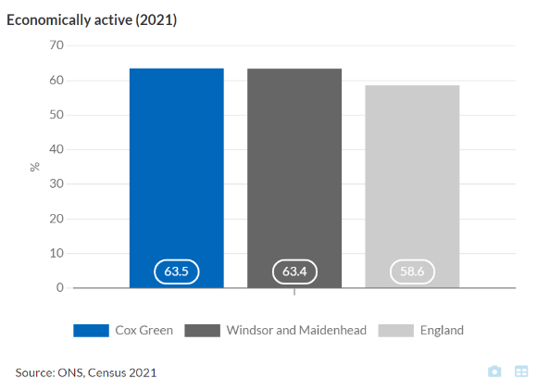
As of 2021 64% of the population (3,554 people) within Cox Green were economically active (It is a measure of whether or not a person was an active participant in the labour market during this period), (Census 2021). 45% of these people worked mainly from home in 2021, (Census 2021).

Furthermore, in 2021 residents of Cox Green reported to mainly use a car or van to travel to their workplace (44%), whilst 1% reported to use a bicycle and 3.6% of residents aged 16 years and over in employment reported to walk, (Census 2021).

In 2021 12% of the population were not in employment but worked in the last 12 months. This is due to a unique period of rapid change following the covid pandemic, (Census 2021).

In October 2023, 90 people aged 16 years and over who were out of work in Cox Green were claiming Universal Credit benefits. This was 2.1% of all 16 to 64 year olds, compared to 2.1% in RBWM and 3.7% in England, (ONS Claimant Count).

Housing
The 2021 census identified 2,905 houses in Cox Green and 3.1% were overcrowded (fewer rooms than required for number of people living there), (Census 2021).

11% of these households were occupied by people aged 66 and over who were living alone, compared to 13% in RBWM, (ONS Household composition).

6% of households were lone parents with dependent children, compared to 5% in RBWM, (Census 2021).
In Cox Green, 2.7% of households don’t have anyone who can speak English (79 households). These people may not be able to access services or may struggle to fill out important documents, (Census 2021).

Children, Young People and Education
Within Cox Green, 31% of the working age population are educated to degree level or above, compared to 36% in RBWM and 28% in England, (Census 2021).

Further to this, there are similar percentage of children living in poverty due to being affected by income deprivation in Cox Green (6.0%) compared to RBWM’s (6.7%) in 2019, (OHID Local Health Profile).

Health
20% of residents in Cox Green are in decile 5 suggesting that they are reported to be living in higher health deprivation in 2019, (IMD 2019).
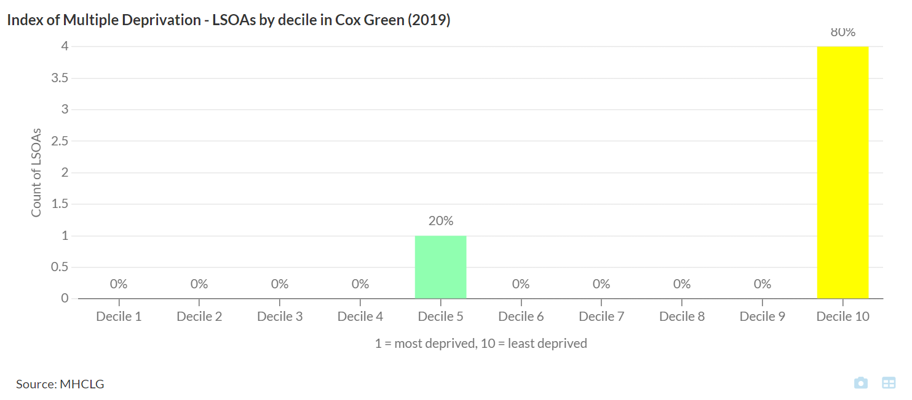12% of the population are identified as having a disability under the Equality Act (2010) which may affect their day-to-day activities, (Census 2021).
The prevalence of obesity (including severe obesity) for children in reception in Cox Green was 4.5% in 2020/21 to 2022/23. This compares to 6.7% in RBWM and 9.7% in England. (Not all special/independent schools are included), (OHID). – (incomplete data set - this data for this ward is underrepresented due to paused measurements in March 2020 due to covid).
The prevalence of obesity (including severe obesity) for children in year 6 was 18% in the same time-period, compared to 17% in RBWM and 23% in England. (Not all special/independent schools are included), (OHID).

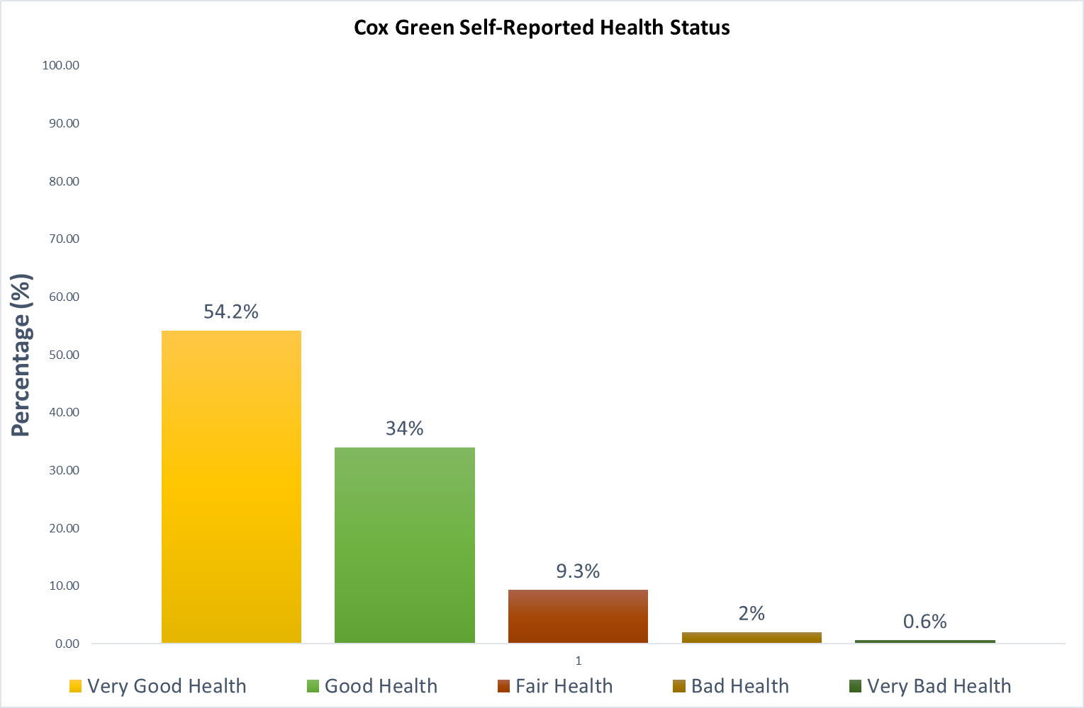Furthermore, in 2021 54% of residents living in Cox Green had a self-reported health status considered to be ‘very good’ (4,122 people) and 34% in ‘good health’ (2,585 people), (Census 2021).
The percentage of children in care who were up to date with their routine NHS vaccinations in 2022 was 74% (67 children) in RBWM. This was significantly worse than England's prevalence of 85%, (Data not available at ward level) (OHID).
In RBWM, 92% (1,427 children) of 2-year-old children had received one dose of MMR in 2022/23, which was significantly better than England's rate of 89%, (OHID). 89% (1,628 children) of 5-year-old children had received two doses of MMR in 2022/23, which was significantly better than England's rate of 85%, (OHID). However, both did not reach the national vaccination coverage target of 95% (Data not available at ward level).
Deprivation
The Index of Multiple Deprivation (IMD) 2019 is the official measure of relative deprivation for small areas (or neighbourhoods) in England. The IMD ranks every small area (Lower Super Output Area) in England from 1 (most deprived) to 32,844 (least deprived). For larger areas we can look at the proportion of LSOAs within the area that lie within each decile. Decile 1 represents the most deprived 10% of LSOAs in England while decile 10 shows the least deprived 10% of LSOAs.
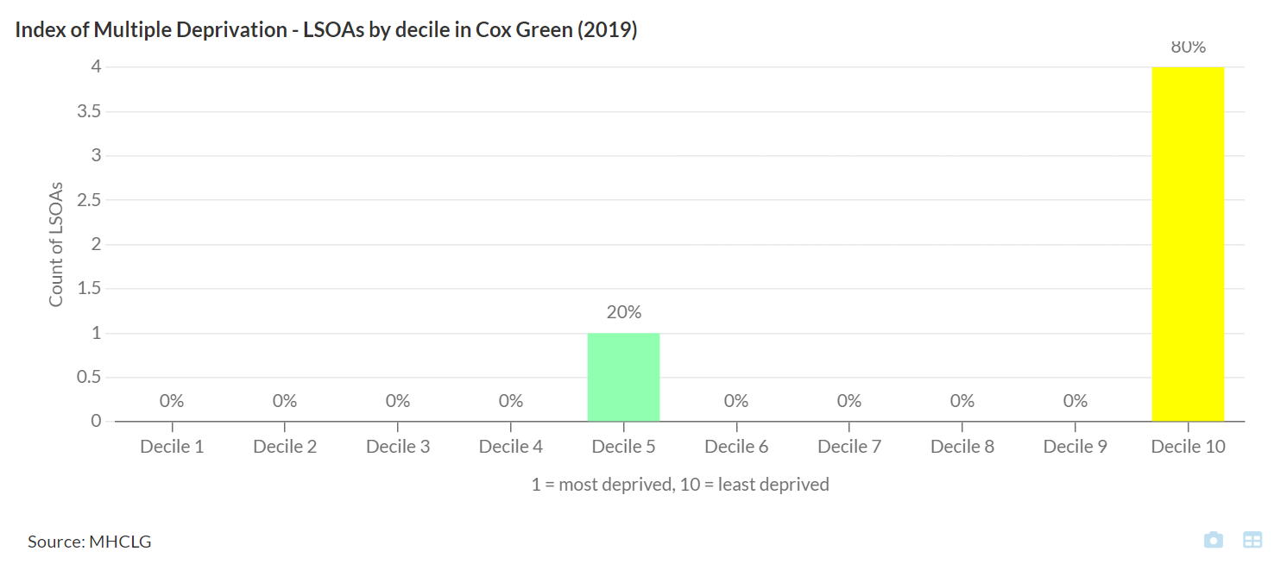Cox Green has low levels of deprivation with one LSOA having higher levels of deprivation.

5.3% of older people were reported to be living in poverty due to income deprivation in 2019. This was significantly better than RBWM (8%), (OHID Local Health Profile).

In 2020, 5% of households were reported to be experiencing fuel poverty in Cox Green, (OHID Local Health Profile).

41% of households face deprivation in one or more dimensions including education, health, employment and housing, (Census 2021).
Deprivation dimensions:
- Education: A household is classified as deprived in the education dimension if no one has at least level 2 education and no one aged 16 to 18 years is a full-time student.
- Employment: A household is classified as deprived in the employment dimension if any member, not a full-time student, is either unemployed or economically inactive due to long-term sickness or disability.
- Health: A household is classified as deprived in the health dimension if any person in the household has general health that is bad or very bad or is identified as disabled. People who have assessed their day-to-day activities as limited by long-term physical or mental health conditions or illnesses are considered disabled. This definition of a disabled person meets the harmonised standard for measuring disability and is in line with the Equality Act (2010).
- Housing: A household is classified as deprived in the housing dimension if the household's accommodation is either overcrowded, in a shared dwelling, or has no central heating

Summary of need
- The life expectancy at birth for males in Cox Green is lower compared to females.
- There are a low number of residents reporting to be using active travel methods to access their place of work
- 20% of the population experience high levels of health deprivation which means that they may have health conditions which may not be treated.
- There is a higher percentage of lone parent households with dependent children compared to RBWM. They may face challenges and need additional support.

